[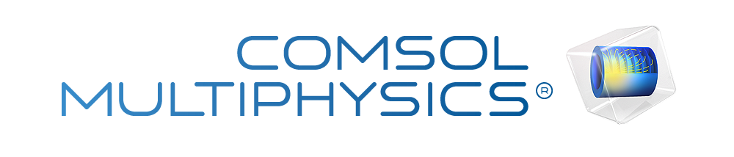](https://www.comsol.com/)

Prestressed Bolts in a Tube Connection

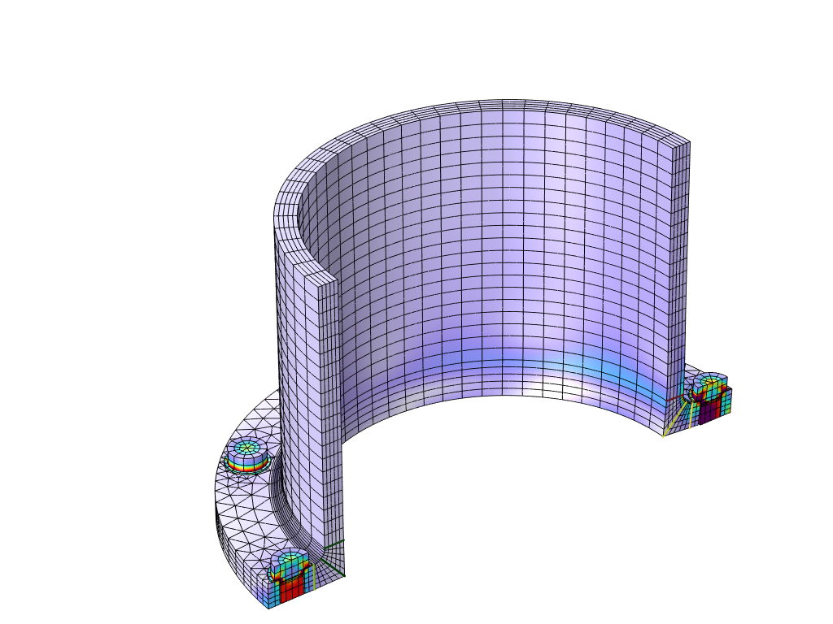

|  |  |
| --- | --- |
| Author | COMSOL |
| Report date | Aug 21, 2025, 10:22:03 PM |

Summary

This example analyzes a tube connection with prestressed bolts. The tube is subjected to an internal pressure and an external bending moment. The stress in the bolts as a function of the applied external load is calculated. Membrane and bending stresses are computed along a number of stress classification lines.

Contents

1. Global Definitions

1.1. Parameters

1.2. Geometry Parts

1.3. Shared Properties

2. Component 1

2.1. Definitions

2.2. Geometry 1

2.3. Materials

2.4. Solid Mechanics

2.5. Mesh 1

3. Study 1

3.1. Bolt Pretension

3.2. Stationary

3.3. Solver Configurations

4. Results

4.1. Datasets

4.2. Plot Groups

4.3. Evaluation Groups

# Global Definitions

|  |  |
| --- | --- |
| Author | COMSOL |
| Date | Aug 21, 2025, 9:28:25 PM |

Global settings

|  |  |
| --- | --- |
| Name | Mặt bích JIS B2220 – 5K, DN200-2.mph |
| Path | E:\BBKH 2026\Bu lông dự ứng lực trong kết nối ống\mặt bích JIS B2220 – 5K, DN200-2.mph |
| Version | COMSOL Multiphysics 6.2 (Build: 339) |
| Unit system | SI |

Used products

|  |
| --- |
| Structural Mechanics Module |
| COMSOL Multiphysics |

Computer information

|  |  |
| --- | --- |
| CPU | Intel(R) Core(TM) i5-6500 CPU @ 3.20GHz, 4 cores, 15.94 GB RAM |
| Operating system | Windows 10 |

## Parameters

Parameters 1

| **Name** | **Expression** | **Value** | **Description** |
| --- | --- | --- | --- |
| pipeDiameter | 196.3[mm] | 0.1963 m | Inner diameter of pipe |
| pipeThickness | 10[mm] | 0.01 m | Pipe wall thickness |
| pipeOuterDiameter | pipeDiameter + 2*pipeThickness | 0.2163 m | Outer diameter of pipe |
| pipeLength | 5*sqrt(pipeDiameter/2*pipeThickness) | 0.15664 m | Length of pipe, to avoid end effects |
| flangeThickness | 20[mm] | 0.02 m | Flange thickness |
| flangeDiameter | 320[mm] | 0.32 m | Outer diameter of flange |
| filletRadius | 8[mm] | 0.008 m | Fillet radius, flange to pipe |
| numBolts | 8 | 8 | Number of bolts |
| boltHeadDiameter | 1.5*boltDiameter | 0.03 m | Diameter of bolt head |
| boltHeadThickness | 0.6*boltDiameter | 0.012 m | Thickness of bolt head |
| boltDiameter | 20[mm] | 0.02 m | Bolt diameter |
| boltHoleClearance | 2[mm] | 0.002 m | Diameter clearance between bolt hole and bolt |
| boltHoleDiameter | boltDiameter + boltHoleClearance | 0.022 m | Bolt hole diameter |
| boltCircle | 280[mm] | 0.28 m | Diameter of bolt circle |
| washerDiameter | boltHeadDiameter*1.15 | 0.0345 m | Washer diameter |
| washerThickness | 1.5[mm] | 0.0015 m | Washer thickness |
| axialForce | 500[kN] | 5E5 N | Axial Force |
| bendingMoment | 40[kN*m] | 40000 N·m | Bending moment |
| pressure | 5[bar] | 5E5 Pa | Internal pipe pressure |
| boltPrestressForce | 110[kN] | 1.1E5 N | Bolt prestress force |
| ps | 1 | 1 | Parameter for spring relaxation |
| lp | 0 | 0 | Loading parameter |

## Geometry Parts

### Simple Bolt, No Thread, With Drill

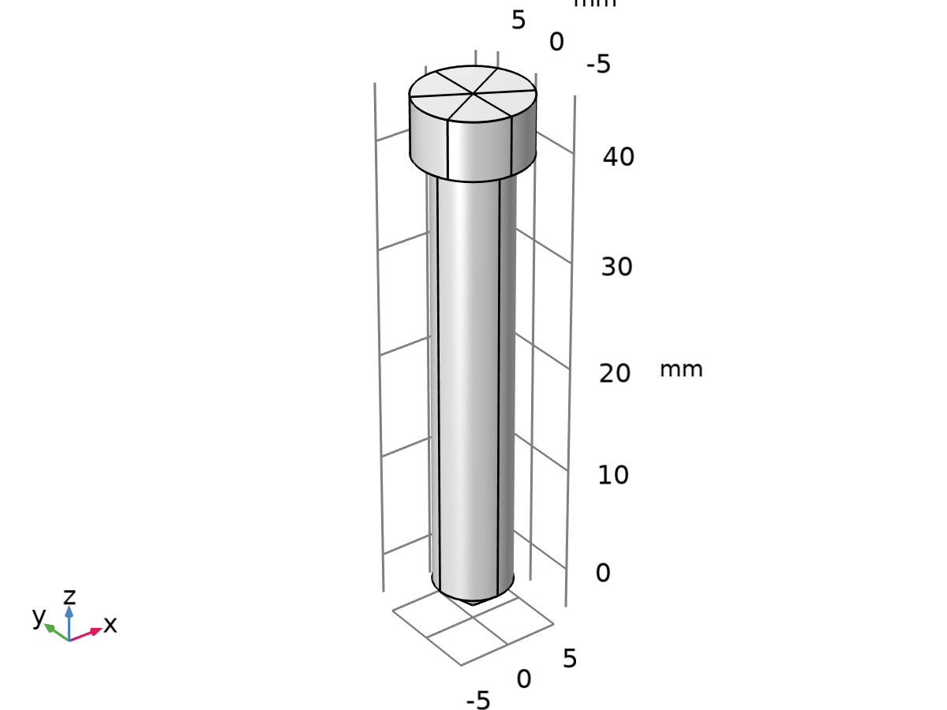

Simple Bolt, No Thread, With Drill

Units

|  |  |
| --- | --- |
| Length unit | mm |
| Angular unit | deg |

Geometry statistics

| **Description** | **Value** |
| --- | --- |
| Space dimension | 3 |

### Flat Washer

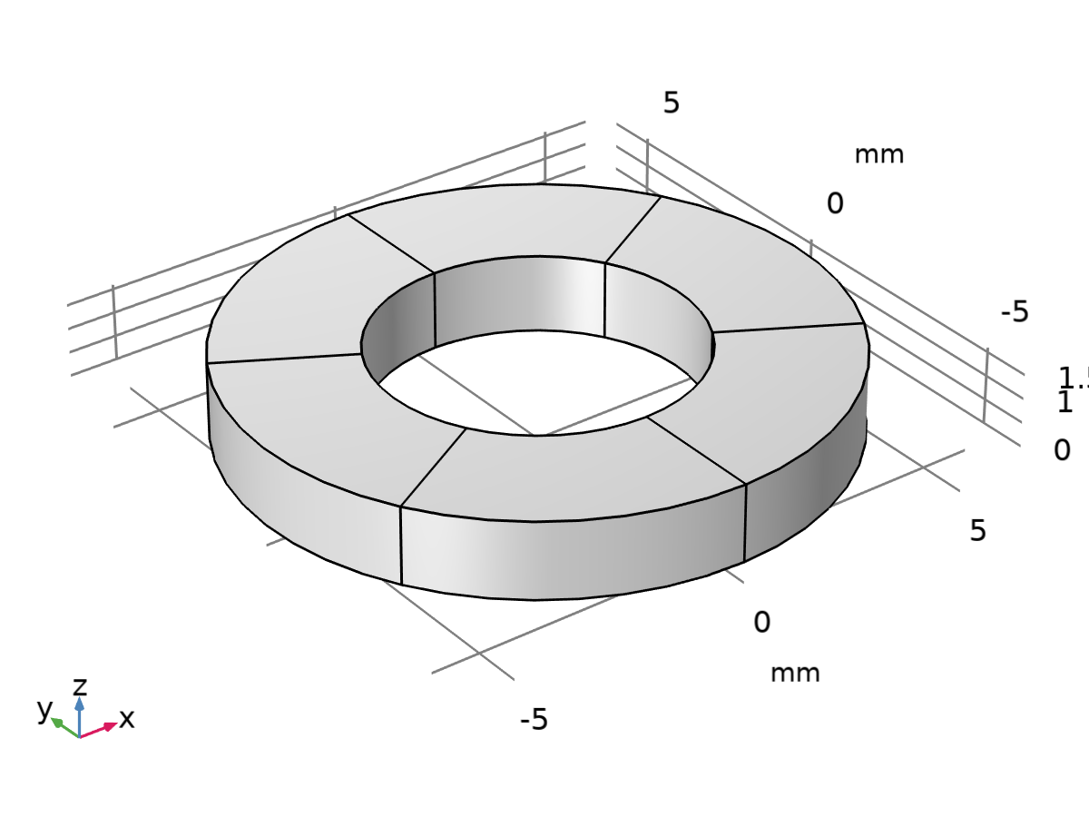

Flat Washer

Units

|  |  |
| --- | --- |
| Length unit | mm |
| Angular unit | deg |

Geometry statistics

| **Description** | **Value** |
| --- | --- |
| Space dimension | 3 |

## Shared Properties

### Default Model Inputs

|  |  |
| --- | --- |
| Tag | cminpt |

# Component 1

|  |  |
| --- | --- |
| Author | COMSOL |
| Date | Oct 1, 2023, 3:27:48 AM |

Settings

| **Description** | **Value** |
| --- | --- |
| Unit system | Same as global system (SI) |
| Geometry shape function | Automatic |

Spatial frame coordinates

| **First** | **Second** | **Third** |
| --- | --- | --- |
| x | y | z |

Material frame coordinates

| **First** | **Second** | **Third** |
| --- | --- | --- |
| X | Y | Z |

Geometry frame coordinates

| **First** | **Second** | **Third** |
| --- | --- | --- |
| Xg | Yg | Zg |

Mesh frame coordinates

| **First** | **Second** | **Third** |
| --- | --- | --- |
| Xm | Ym | Zm |

## Definitions

### Selections

#### Bolts Symmetry

| **Selection type** |
| --- |
| Explicit |

| **Selection** |
| --- |
| Boundaries 162, 173, 180, 206–207, 217, 228, 236–237, 272–273, 283, 294, 302–303, 338–339, 349, 360, 368–369, 396, 407, 414 |

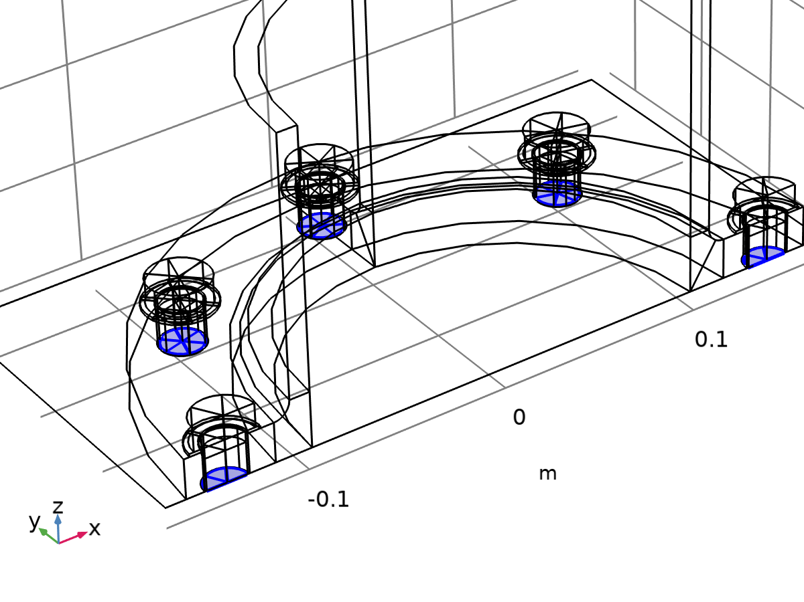

Bolts Symmetry

#### Symmetry Boundaries (xz-plane)

| **Selection type** |
| --- |
| Box |

| **Selection** |
| --- |
| Boundaries 2, 9–10, 14, 19, 47–49, 51, 55–56, 69, 142, 155–156, 161, 164, 179, 182, 185, 390, 395, 398, 413, 416, 419 |

Geometric entity level

| **Description** | **Value** |
| --- | --- |
| Level | Boundary |

Output entities

| **Description** | **Value** |
| --- | --- |
| Include entity if | Entity inside box |

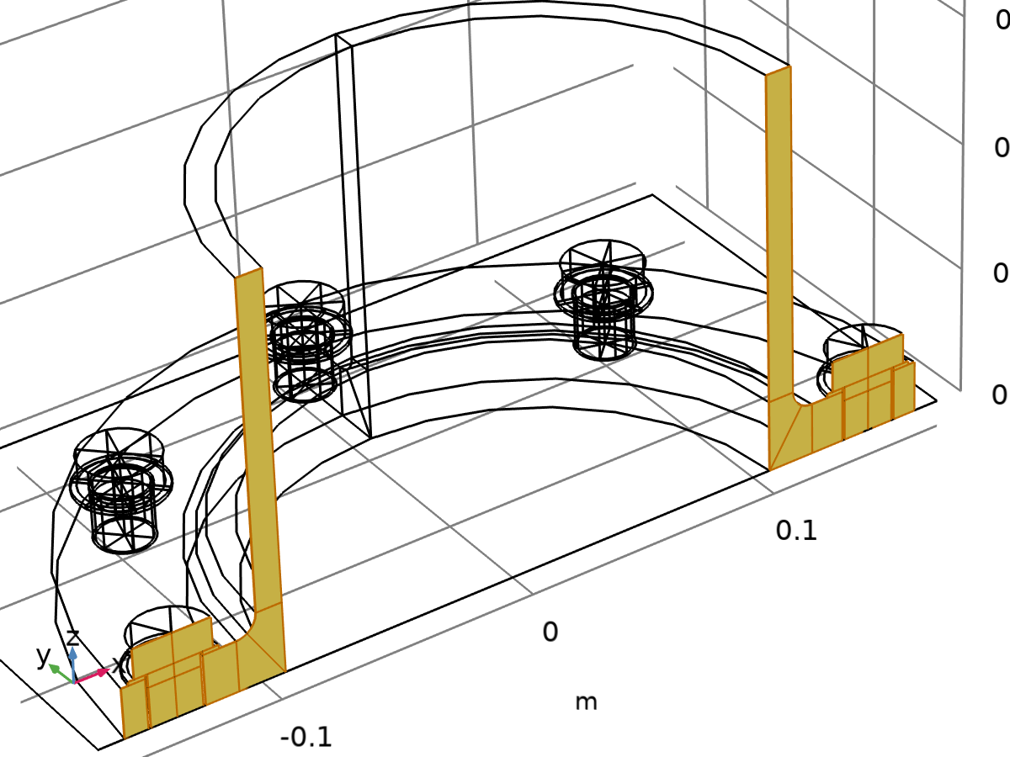

Symmetry Boundaries (xz-plane)

#### Symmetry

| **Selection type** |
| --- |
| Union |

| **Selection** |
| --- |
| Boundaries 2, 9–10, 14, 19, 47–49, 51, 55–56, 69, 142, 155–156, 161–162, 164, 173, 179–180, 182, 185, 206–207, 217, 228, 236–237, 272–273, 283, 294, 302–303, 338–339, 349, 360, 368–369, 390, 395–396, 398, 407, 413–414, 416, 419 |

Geometric entity level

| **Description** | **Value** |
| --- | --- |
| Level | Boundary |

Input entities

| **Description** | **Value** |
| --- | --- |
| Selections to add | {Bolts Symmetry, Symmetry Boundaries (xz - plane)} |

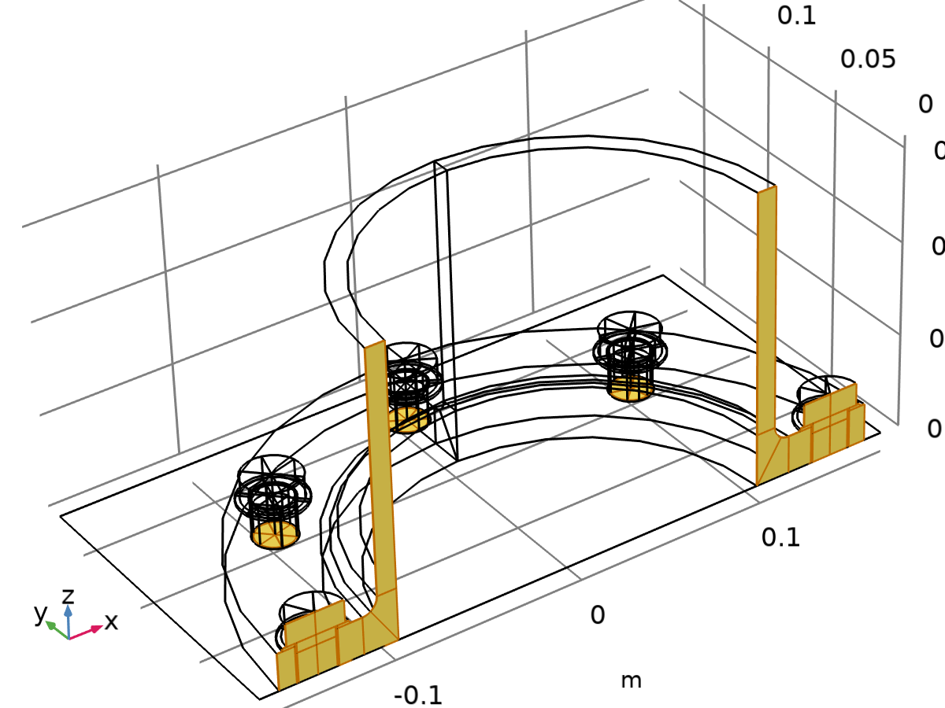

Symmetry

#### Bolt Pretension, Cut 1

| **Selection type** |
| --- |
| Explicit |

| **Selection** |
| --- |
| Boundaries 165, 176, 183 |

Explicit props

| **Description** | **Value** |
| --- | --- |
| Group by continuous tangent | On |

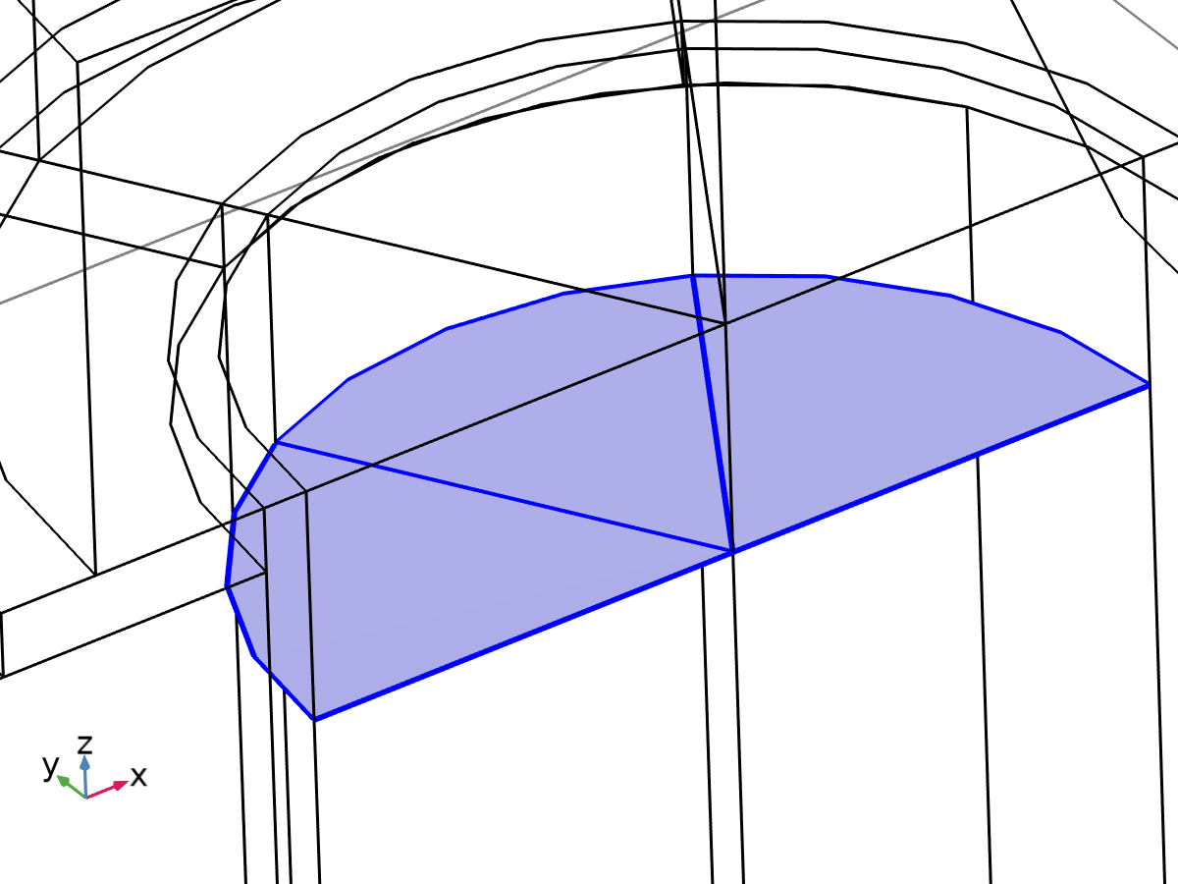

Bolt Pretension, Cut 1

#### Bolt Pretension, Cut 2

| **Selection type** |
| --- |
| Explicit |

| **Selection** |
| --- |
| Boundaries 211–212, 220, 231, 241–242 |

Explicit props

| **Description** | **Value** |
| --- | --- |
| Group by continuous tangent | On |

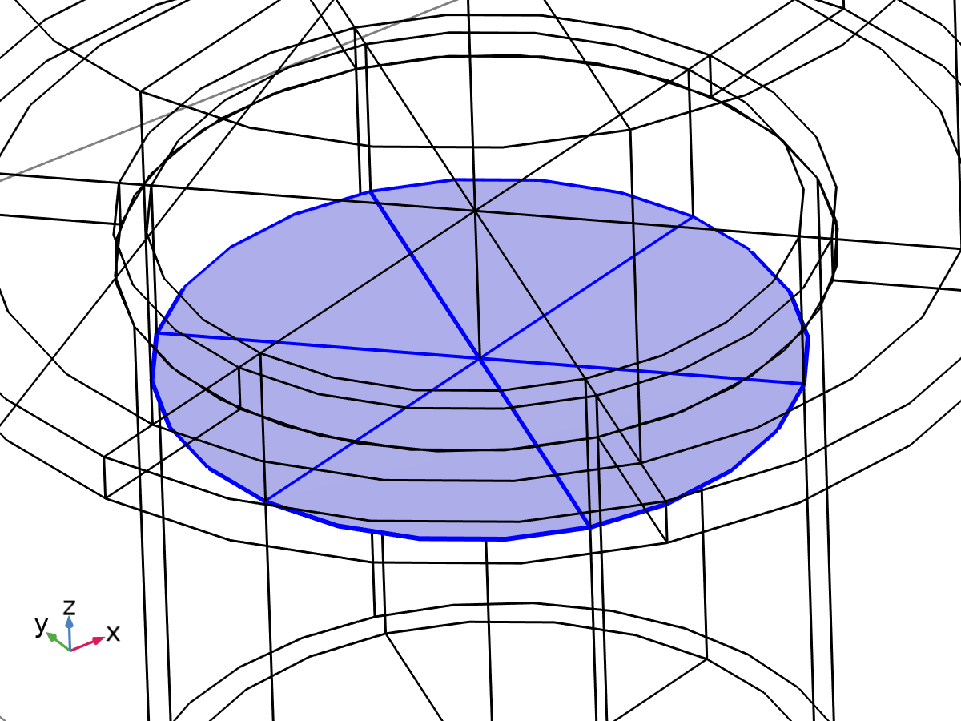

Bolt Pretension, Cut 2

#### Bolt Pretension, Cut 3

| **Selection type** |
| --- |
| Explicit |

| **Selection** |
| --- |
| Boundaries 277–278, 286, 297, 307–308 |

Explicit props

| **Description** | **Value** |
| --- | --- |
| Group by continuous tangent | On |

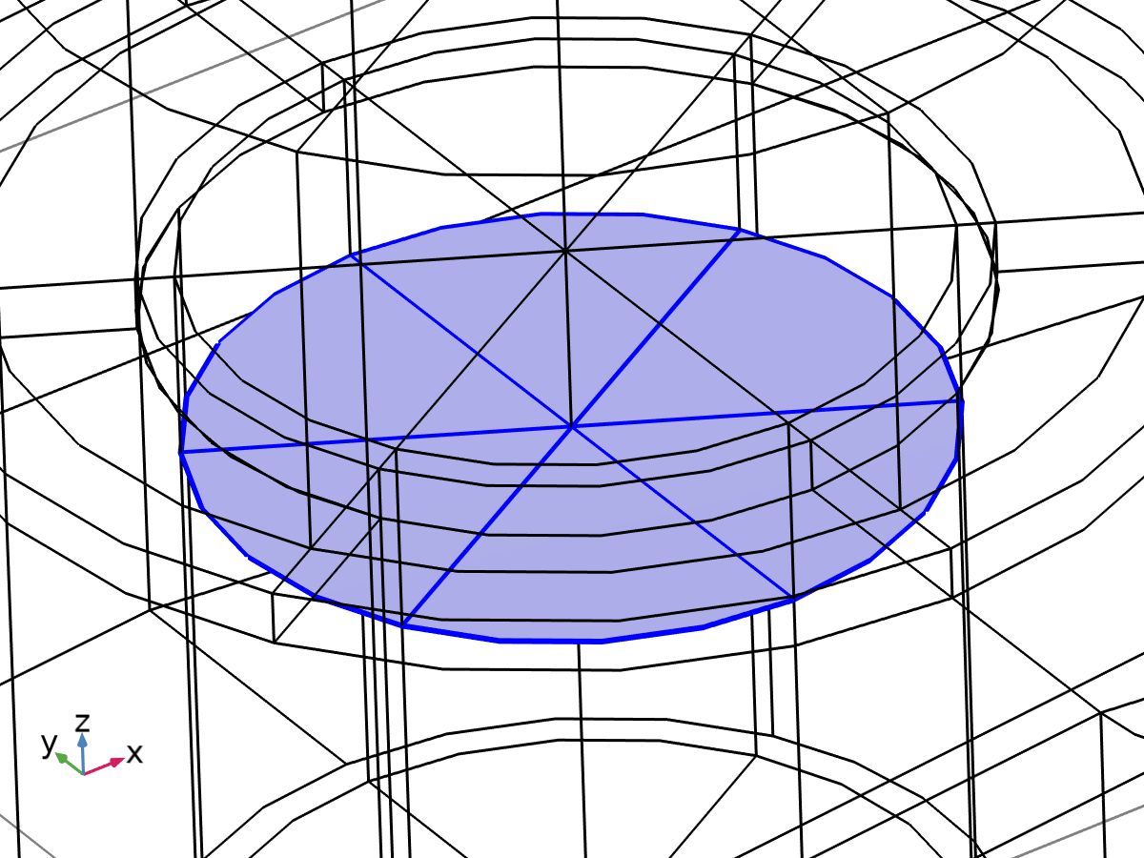

Bolt Pretension, Cut 3

#### Bolt Pretension, Cut 4

| **Selection type** |
| --- |
| Explicit |

| **Selection** |
| --- |
| Boundaries 343–344, 352, 363, 373–374 |

Explicit props

| **Description** | **Value** |
| --- | --- |
| Group by continuous tangent | On |

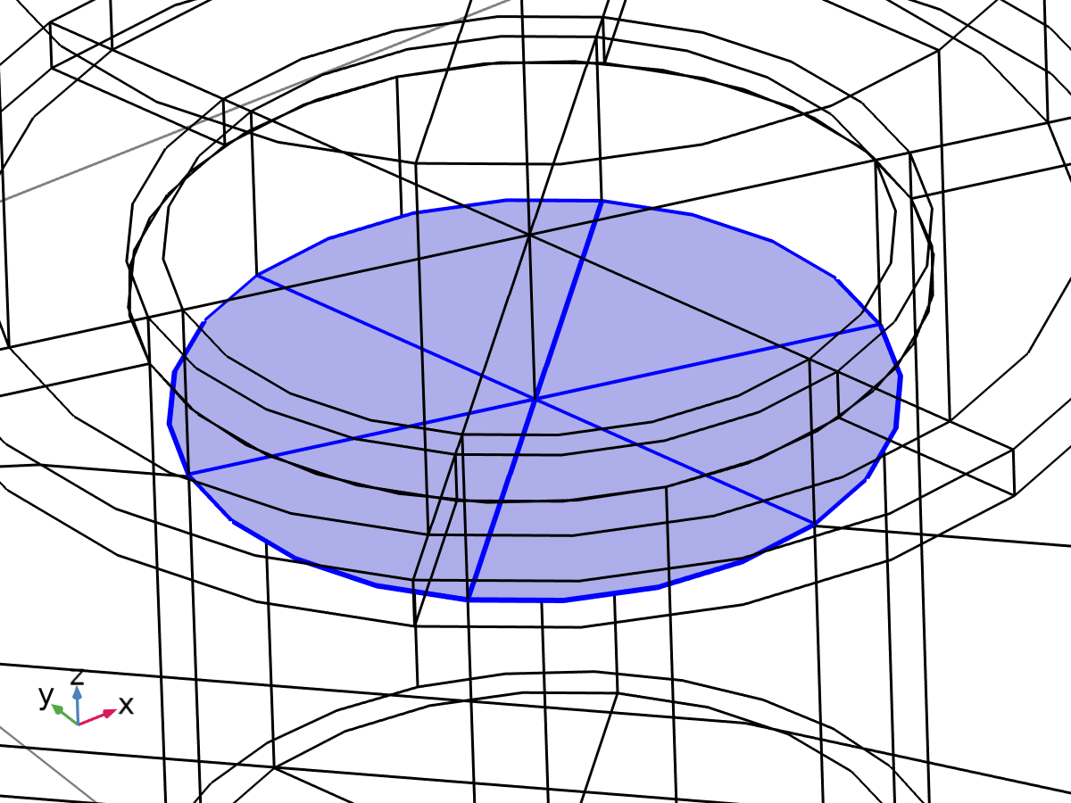

Bolt Pretension, Cut 4

#### Bolt Pretension, Cut 5

| **Selection type** |
| --- |
| Explicit |

| **Selection** |
| --- |
| Boundaries 399, 410, 417 |

Explicit props

| **Description** | **Value** |
| --- | --- |
| Group by continuous tangent | On |

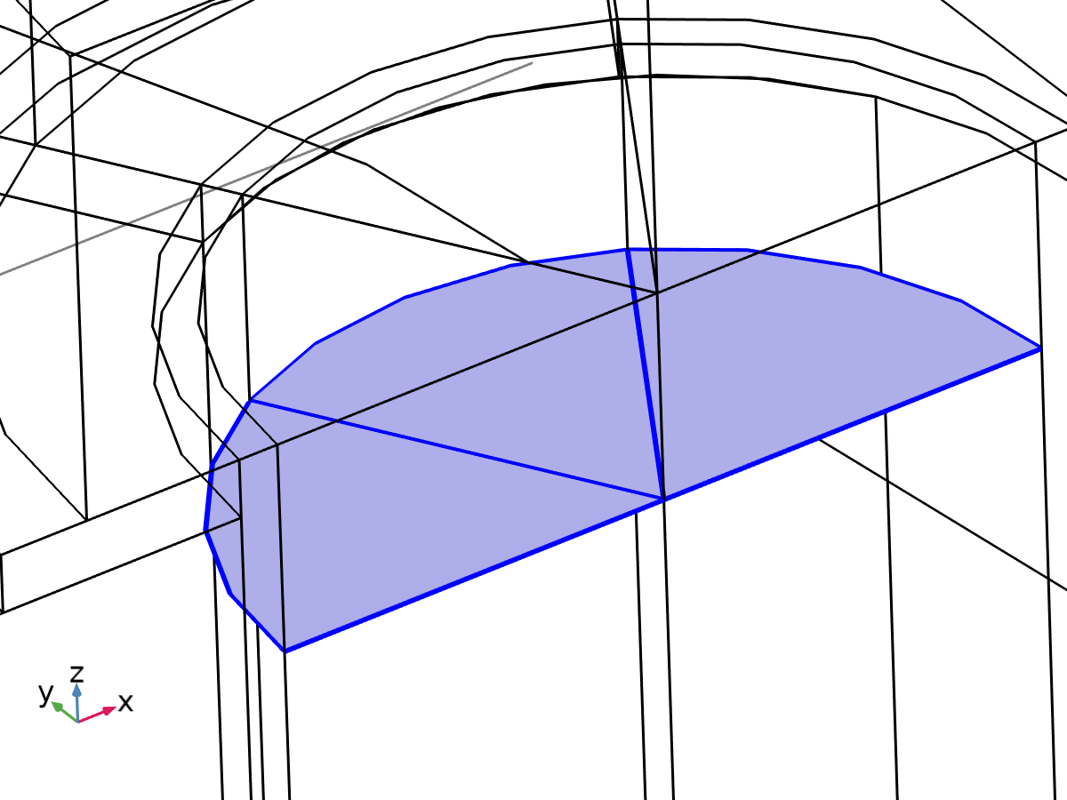

Bolt Pretension, Cut 5

### Pairs

#### Contact Pair 1a

|  |  |
| --- | --- |
| Pair type | Identity pair |
| Pair name | ap1 |

Source selection

|  |  |
| --- | --- |
| Geometric entity level | Boundary |
| Selection | Geometry geom1: Dimension 2: Boundary 1 |

Destination selection

|  |  |
| --- | --- |
| Geometric entity level | Boundary |
| Selection | Geometry geom1: Dimension 2: Boundaries 4, 12, 32, 40 |

Settings

| **Name** | **Value** |
| --- | --- |
| Search method | hierarchical |
| Extrapolation tolerance | 1e-4 |

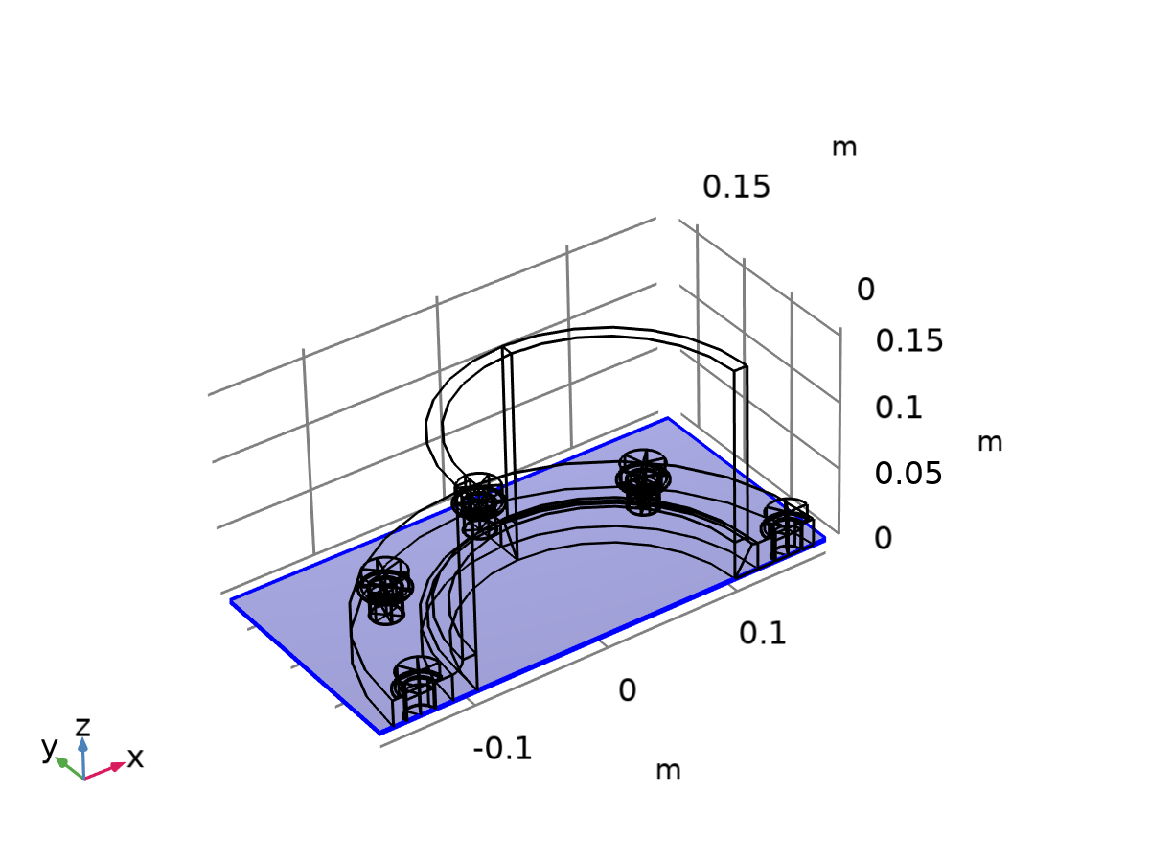

Source selection

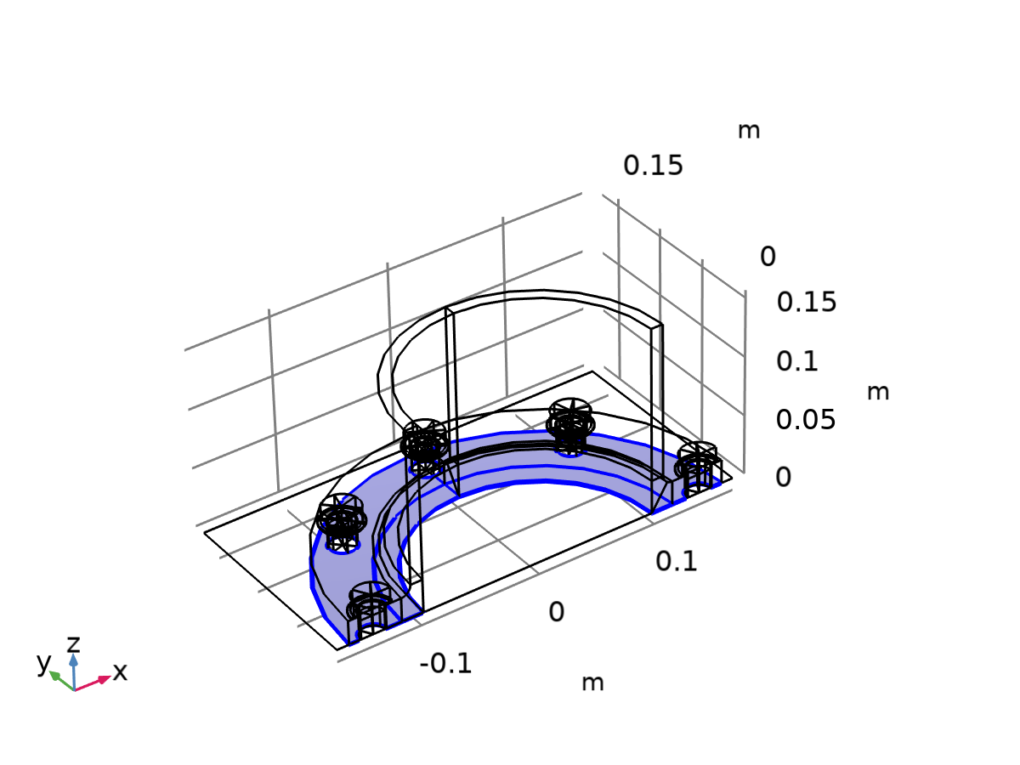

Destination selection

#### Contact Pair 3a

|  |  |
| --- | --- |
| Pair type | Identity pair |
| Pair name | ap3 |

Source selection

|  |  |
| --- | --- |
| Geometric entity level | Boundary |
| Selection | Geometry geom1: Dimension 2: Boundaries 58, 62, 66, 72–73, 77, 83, 87, 91, 96–97, 101, 107, 111, 115, 120–121, 125, 131, 135, 139, 144, 148, 152 |

Destination selection

|  |  |
| --- | --- |
| Geometric entity level | Boundary |
| Selection | Geometry geom1: Dimension 2: Boundaries 5, 41 |

Settings

| **Name** | **Value** |
| --- | --- |
| Search method | hierarchical |
| Extrapolation tolerance | 1e-4 |

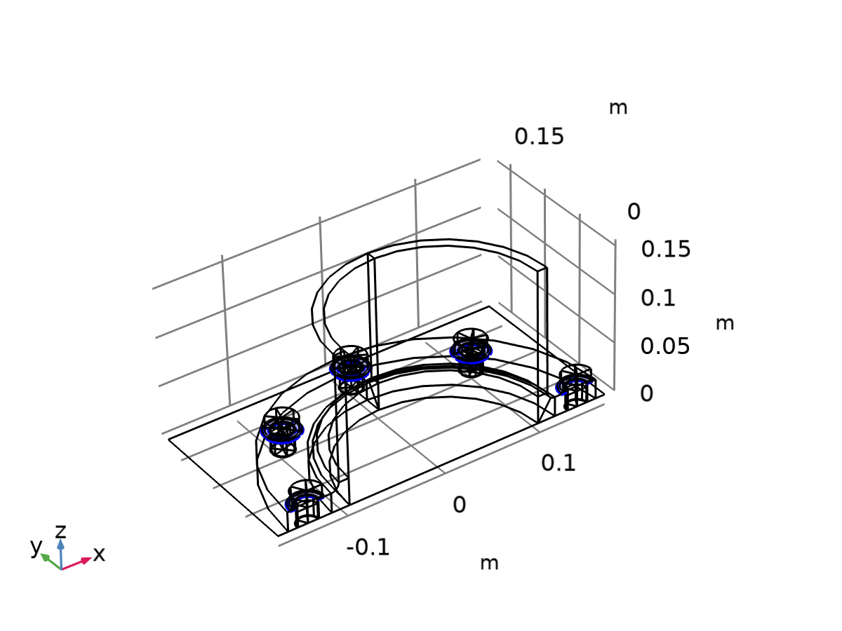

Source selection

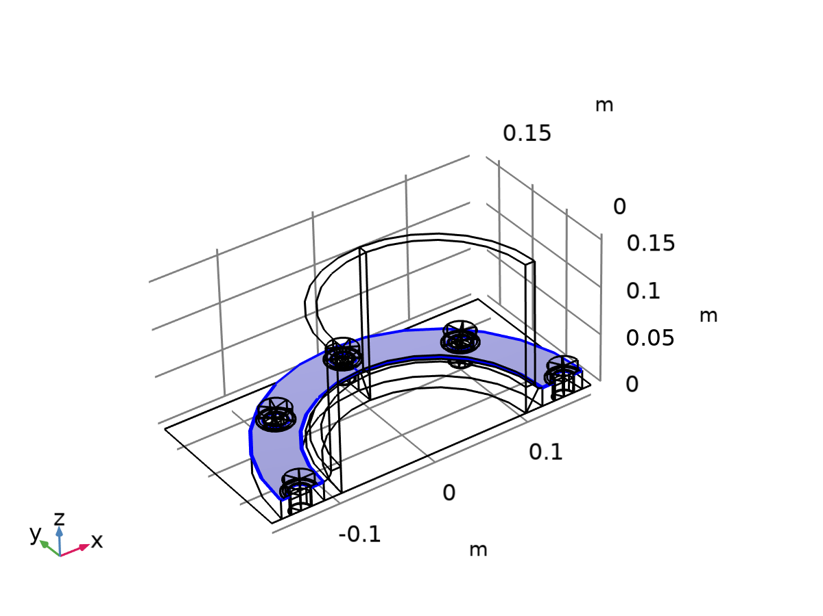

Destination selection

#### Identity Boundary Pair 4

|  |  |
| --- | --- |
| Pair type | Identity pair |
| Pair name | ap4 |

Source selection

|  |  |
| --- | --- |
| Geometric entity level | Boundary |
| Selection | Geometry geom1: Dimension 2: Boundaries 59, 63, 67, 74–75, 78, 84, 88, 92, 98–99, 102, 108, 112, 116, 122–123, 126, 132, 136, 140, 145, 149, 153 |

Destination selection

|  |  |
| --- | --- |
| Geometric entity level | Boundary |
| Selection | Geometry geom1: Dimension 2: Boundaries 158, 169, 190, 195–196, 201, 224, 252, 256, 261–262, 267, 290, 318, 322, 327–328, 333, 356, 384, 388, 392, 403, 424 |

Settings

| **Name** | **Value** |
| --- | --- |
| Search method | hierarchical |
| Extrapolation tolerance | 1e-4 |

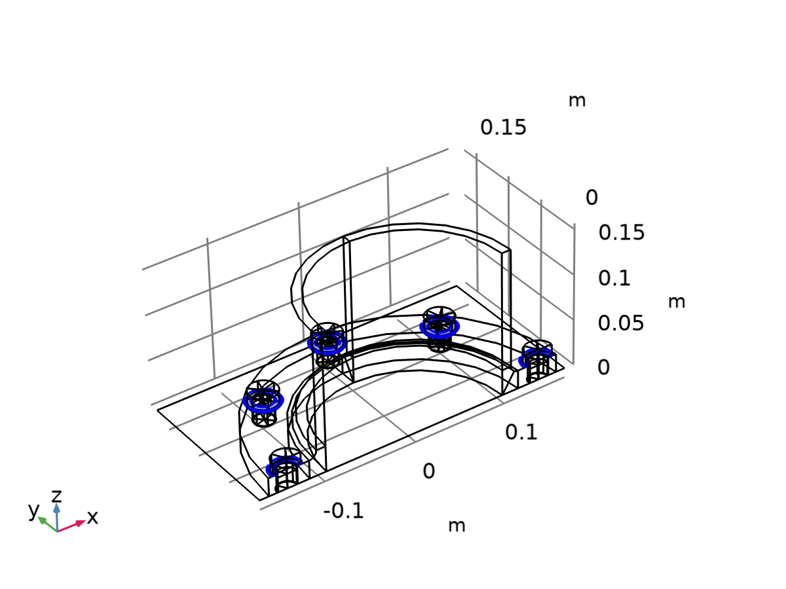

Source selection

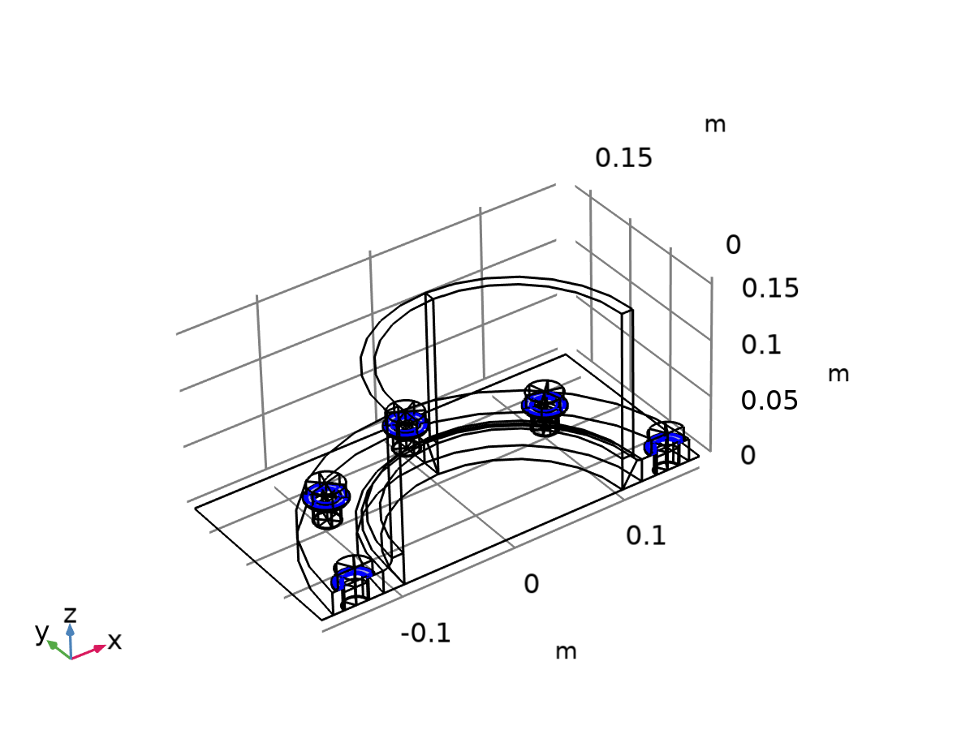

Destination selection

#### Contact Pair 5

|  |  |
| --- | --- |
| Pair type | Identity pair |
| Pair name | ap5 |

Source selection

|  |  |
| --- | --- |
| Geometric entity level | Boundary |
| Selection | Geometry geom1: Dimension 2: Boundary 1 |

Destination selection

|  |  |
| --- | --- |
| Geometric entity level | Boundary |
| Selection | Geometry geom1: Dimension 2: Boundaries 162, 173, 180, 206–207, 217, 228, 236–237, 272–273, 283, 294, 302–303, 338–339, 349, 360, 368–369, 396, 407, 414 |

Settings

| **Name** | **Value** |
| --- | --- |
| Search method | hierarchical |
| Extrapolation tolerance | 1e-4 |



Source selection

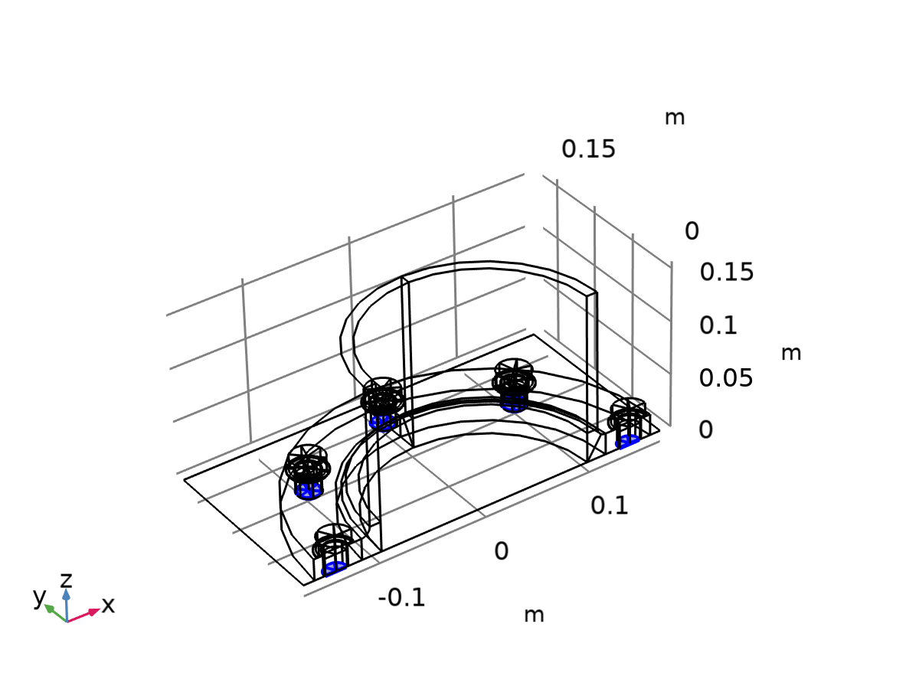

Destination selection

### Coordinate Systems

#### Boundary System 1

|  |  |
| --- | --- |
| Coordinate system type | Boundary system |
| Tag | sys1 |

Coordinate names

| **First** | **Second** | **Third** |
| --- | --- | --- |
| t1 | t2 | n |

Settings

| **Description** | **Value** |
| --- | --- |
| Axis | x |

## Geometry 1

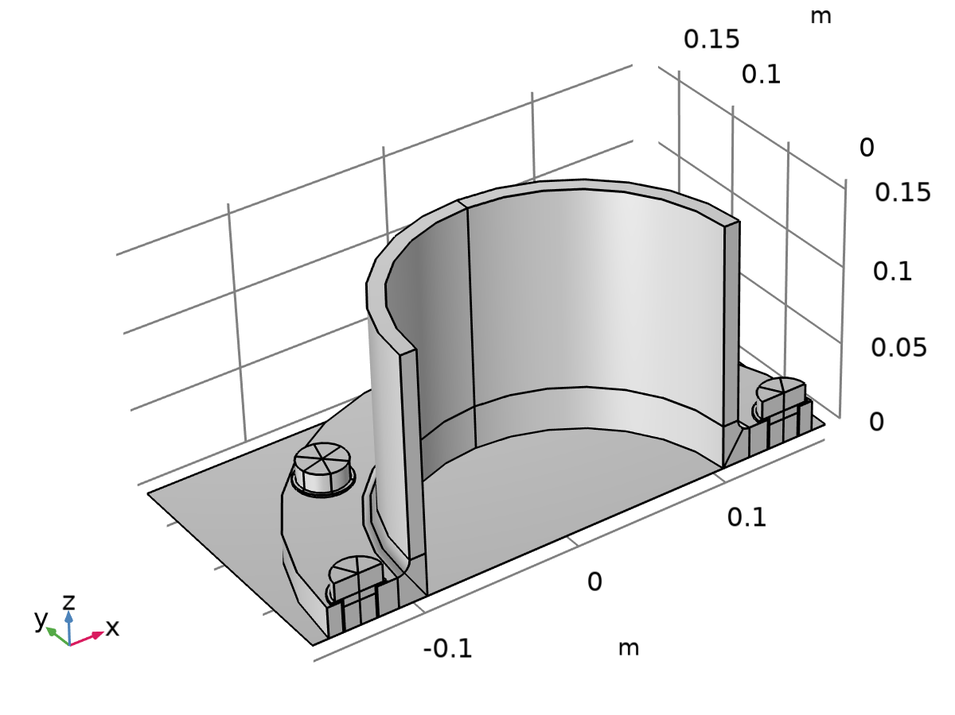

Geometry 1

Units

|  |  |
| --- | --- |
| Length unit | m |
| Angular unit | deg |

Geometry statistics

| **Description** | **Value** |
| --- | --- |
| Space dimension | 3 |
| Number of domains | 81 |
| Number of boundaries | 425 |
| Number of edges | 672 |
| Number of vertices | 332 |

### Work Plane 1 (wp1)

Plane definition

| **Description** | **Value** |
| --- | --- |
| Plane | xz - plane |

Unite objects

| **Description** | **Value** |
| --- | --- |
| Unite objects | On |

Information

| **Description** | **Value** |
| --- | --- |
| Last build time | < 1 second |
| Built with | COMSOL 6.2.0.339 (win64), Aug 20, 2025, 5:19:42 PM |

#### Plane Geometry (sequence2D)

##### Rectangle 1 (r1)

Position

| **Description** | **Value** |
| --- | --- |
| Position | {pipeDiameter/2, 0} |

Size

| **Description** | **Value** |
| --- | --- |
| Width | (flangeDiameter - pipeDiameter)/2 |
| Height | pipeLength |

Information

| **Description** | **Value** |
| --- | --- |
| Last build time | < 1 second |
| Built with | COMSOL 6.2.0.339 (win64), Aug 20, 2025, 5:19:42 PM |

##### Rectangle 2 (r2)

Position

| **Description** | **Value** |
| --- | --- |
| Position | {pipeDiameter/2 + pipeThickness, flangeThickness} |

Size

| **Description** | **Value** |
| --- | --- |
| Width | (flangeDiameter - pipeDiameter)/2 - pipeThickness |
| Height | pipeLength - flangeThickness |

Information

| **Description** | **Value** |
| --- | --- |
| Last build time | < 1 second |
| Built with | COMSOL 6.2.0.339 (win64), Aug 20, 2025, 5:19:42 PM |

##### Difference 1 (dif1)

Information

| **Description** | **Value** |
| --- | --- |
| Last build time | < 1 second |
| Built with | COMSOL 6.2.0.339 (win64), Aug 20, 2025, 5:19:42 PM |

##### Fillet 1 (fil1)

Settings

| **Description** | **Value** |
| --- | --- |
| Select in sketch | On |
| Radius | filletRadius |

Information

| **Description** | **Value** |
| --- | --- |
| Last build time | < 1 second |
| Built with | COMSOL 6.2.0.339 (win64), Aug 20, 2025, 5:19:42 PM |

##### Line Segment 1 (ls1)

Settings

| **Description** | **Value** |
| --- | --- |
| Specify | Coordinates |
| Coordinates | {pipeDiameter/2, flangeThickness + filletRadius} |
| Specify | Coordinates |
| Coordinates | {pipeDiameter/2 + pipeThickness, flangeThickness + filletRadius} |

Information

| **Description** | **Value** |
| --- | --- |
| Last build time | < 1 second |
| Built with | COMSOL 6.2.0.339 (win64), Aug 20, 2025, 5:19:42 PM |

##### Line Segment 2 (ls2)

Settings

| **Description** | **Value** |
| --- | --- |
| Specify | Coordinates |
| Coordinates | {pipeDiameter/2 + pipeThickness + filletRadius, 0} |
| Specify | Coordinates |
| Coordinates | {pipeDiameter/2 + pipeThickness + filletRadius, flangeThickness} |

Information

| **Description** | **Value** |
| --- | --- |
| Last build time | < 1 second |
| Built with | COMSOL 6.2.0.339 (win64), Aug 20, 2025, 5:19:42 PM |

##### Line Segment 3 (ls3)

Settings

| **Description** | **Value** |
| --- | --- |
| Specify | Coordinates |
| Coordinates | {pipeDiameter/2, 0} |
| Specify | Coordinates |
| Coordinates | {pipeDiameter/2 + pipeThickness + filletRadius, flangeThickness + filletRadius} |

Information

| **Description** | **Value** |
| --- | --- |
| Last build time | < 1 second |
| Built with | COMSOL 6.2.0.339 (win64), Aug 20, 2025, 5:19:42 PM |

##### Convert to Solid 1 (csol1)

Information

| **Description** | **Value** |
| --- | --- |
| Last build time | < 1 second |
| Built with | COMSOL 6.2.0.339 (win64), Aug 20, 2025, 5:19:42 PM |

### Revolve 1 (rev1)

General

| **Description** | **Value** |
| --- | --- |
| Work plane | Work Plane 1 (wp1) |

Revolution angles

| **Description** | **Value** |
| --- | --- |
| Angles | {0, 2*pi} |
| End angle | 180 |

Revolution axis

| **Description** | **Value** |
| --- | --- |
| Point on the revolution axis | {0, 0} |
| Direction of revolution axis | {0, 1} |
| Revolution axis | {{0, 0}, {0, 1}} |

Information

| **Description** | **Value** |
| --- | --- |
| Last build time | < 1 second |
| Built with | COMSOL 6.2.0.339 (win64), Aug 20, 2025, 5:19:42 PM |

### Simple Bolt, No Thread, With Drill 1 (pi1)

Part

| **Description** | **Value** |
| --- | --- |
| Part | Simple Bolt, No Thread, With Drill |

Input parameters

| **Name** | **Expression** | **Value** | **Description** |
| --- | --- | --- | --- |
| hdia | boltHeadDiameter | 0.03 m | Head diameter |
| hthic | boltHeadThickness | 0.012 m | Head thickness |
| ndia | boltDiameter | 0.02 m | Nominal diameter |
| blen | flangeThickness+washerThickness | 0.0215 m | Bolt length |
| drill | 1 | 1 | Include drill geometry (boolean) |
| dhrc | boltHoleClearance/2 | 0.001 m | Drill radius clearance |
| dhtc | 0 | 0 mm | Drill tip clearance |
| dta | 0 | 0 | Drill tip angle |

Position and orientation of output

| **Description** | **Value** |
| --- | --- |
| Displacement | {boltCircle/2, 0, 0} |
| Axis type | zw - axis |
| Rotation angle | 30 |

Object selections

| **Name** | **Keep** | **Contribute to** |
| --- | --- | --- |
| Drill | Off | None |

Object selections

| **Name** | **Keep** | **Contribute to** |
| --- | --- | --- |
| Drill | Off | None |

Object selections

| **Name** | **Keep** | **Contribute to** |
| --- | --- | --- |
| Drill | Off | None |

Boundary selections

| **Name** | **Keep** | **Physics** | **Contribute to** |
| --- | --- | --- | --- |
| Exterior | Off | On | None |
| Shank | Off | On | None |
| Head, free surface | Off | On | None |
| Head, contact surface | Off | On | None |
| Pretension cut | Off | On | None |

Boundary selections

| **Name** | **Keep** | **Physics** | **Contribute to** |
| --- | --- | --- | --- |
| Exterior | Off | On | None |
| Shank | Off | On | None |
| Head, free surface | Off | On | None |
| Head, contact surface | Off | On | None |
| Pretension cut | Off | On | None |

Boundary selections

| **Name** | **Keep** | **Physics** | **Contribute to** |
| --- | --- | --- | --- |
| Exterior | Off | On | None |
| Shank | Off | On | None |
| Head, free surface | Off | On | None |
| Head, contact surface | Off | On | None |
| Pretension cut | Off | On | None |

Boundary selections

| **Name** | **Keep** | **Physics** | **Contribute to** |
| --- | --- | --- | --- |
| Exterior | Off | On | None |
| Shank | Off | On | None |
| Head, free surface | Off | On | None |
| Head, contact surface | Off | On | None |
| Pretension cut | Off | On | None |

Domain selections

| **Name** | **Keep** | **Physics** | **Contribute to** |
| --- | --- | --- | --- |
| All | Off | On | None |
| Bolt | Off | On | None |

Domain selections

| **Name** | **Keep** | **Physics** | **Contribute to** |
| --- | --- | --- | --- |
| All | Off | On | None |
| Bolt | Off | On | None |

Domain selections

| **Name** | **Keep** | **Physics** | **Contribute to** |
| --- | --- | --- | --- |
| All | Off | On | None |
| Bolt | Off | On | None |

Domain selections

| **Name** | **Keep** | **Physics** | **Contribute to** |
| --- | --- | --- | --- |
| All | Off | On | None |
| Bolt | Off | On | None |

Selection settings

| **Description** | **Value** |
| --- | --- |
| Keep noncontributing selections | Off |

Information

| **Description** | **Value** |
| --- | --- |
| Last build time | < 1 second |
| Built with | COMSOL 6.2.0.339 (win64), Aug 20, 2025, 5:19:42 PM |

### Rotate 1 (rot1)

Selections of resulting entities

| **Description** | **Value** |
| --- | --- |
| Resulting objects selection | On |
| Show in physics | Off |

Settings

| **Description** | **Value** |
| --- | --- |
| Point on axis of rotation | {0, 0, 0} |
| Axis type | z - axis |
| Angle | {0, 45, 90, 135, 180} |

Information

| **Description** | **Value** |
| --- | --- |
| Last build time | < 1 second |
| Built with | COMSOL 6.2.0.339 (win64), Aug 20, 2025, 5:19:42 PM |

### Difference 1 (dif1)

Information

| **Description** | **Value** |
| --- | --- |
| Last build time | < 1 second |
| Built with | COMSOL 6.2.0.339 (win64), Aug 20, 2025, 5:19:43 PM |

### Bolts (rot2)

Selections of resulting entities

| **Description** | **Value** |
| --- | --- |
| Resulting objects selection | On |

Settings

| **Description** | **Value** |
| --- | --- |
| Point on axis of rotation | {0, 0, 0} |
| Axis type | z - axis |
| Angle | {0, 45, 90, 135, 180} |

Information

| **Description** | **Value** |
| --- | --- |
| Last build time | < 1 second |
| Built with | COMSOL 6.2.0.339 (win64), Aug 20, 2025, 5:19:43 PM |

### Flat Washer 1 (pi2)

Part

| **Description** | **Value** |
| --- | --- |
| Part | Flat Washer |

Input parameters

| **Name** | **Expression** | **Value** | **Description** |
| --- | --- | --- | --- |
| odia | washerDiameter | 0.0345 m | Outer diameter |
| idia | boltDiameter+boltHoleClearance | 0.022 m | Inner diameter |
| thickness | washerThickness | 0.0015 m | Thickness |

Position and orientation of output

| **Description** | **Value** |
| --- | --- |
| Displacement | {boltCircle/2, 0, flangeThickness} |
| Axis type | zw - axis |
| Rotation angle | 30 |

Boundary selections

| **Name** | **Keep** | **Physics** | **Contribute to** |
| --- | --- | --- | --- |
| Exterior | Off | On | None |
| Inner face | Off | On | None |
| Outer face | Off | On | None |
| Hole faces | Off | On | None |

Boundary selections

| **Name** | **Keep** | **Physics** | **Contribute to** |
| --- | --- | --- | --- |
| Exterior | Off | On | None |
| Inner face | Off | On | None |
| Outer face | Off | On | None |
| Hole faces | Off | On | None |

Boundary selections

| **Name** | **Keep** | **Physics** | **Contribute to** |
| --- | --- | --- | --- |
| Exterior | Off | On | None |
| Inner face | Off | On | None |
| Outer face | Off | On | None |
| Hole faces | Off | On | None |

Boundary selections

| **Name** | **Keep** | **Physics** | **Contribute to** |
| --- | --- | --- | --- |
| Exterior | Off | On | None |
| Inner face | Off | On | None |
| Outer face | Off | On | None |
| Hole faces | Off | On | None |

Domain selections

| **Name** | **Keep** | **Physics** | **Contribute to** |
| --- | --- | --- | --- |
| All | Off | On | None |

Domain selections

| **Name** | **Keep** | **Physics** | **Contribute to** |
| --- | --- | --- | --- |
| All | Off | On | None |

Domain selections

| **Name** | **Keep** | **Physics** | **Contribute to** |
| --- | --- | --- | --- |
| All | Off | On | None |

Domain selections

| **Name** | **Keep** | **Physics** | **Contribute to** |
| --- | --- | --- | --- |
| All | Off | On | None |

Selection settings

| **Description** | **Value** |
| --- | --- |
| Keep noncontributing selections | Off |

Information

| **Description** | **Value** |
| --- | --- |
| Last build time | < 1 second |
| Built with | COMSOL 6.2.0.339 (win64), Aug 20, 2025, 5:19:43 PM |

### Washers (rot3)

Selections of resulting entities

| **Description** | **Value** |
| --- | --- |
| Resulting objects selection | On |

Settings

| **Description** | **Value** |
| --- | --- |
| Point on axis of rotation | {0, 0, 0} |
| Axis type | z - axis |
| Angle | {0, 45, 90, 135, 180} |

Information

| **Description** | **Value** |
| --- | --- |
| Last build time | < 1 second |
| Built with | COMSOL 6.2.0.339 (win64), Aug 20, 2025, 5:19:43 PM |

### Union 1 (uni1)

Compose

| **Description** | **Value** |
| --- | --- |
| Keep interior boundaries | Off |

Information

| **Description** | **Value** |
| --- | --- |
| Last build time | < 1 second |
| Built with | COMSOL 6.2.0.339 (win64), Aug 20, 2025, 5:19:43 PM |

### Partition Domains 1 (pard1)

Settings

| **Description** | **Value** |
| --- | --- |
| Work plane | Work Plane 1 (wp1) |

Information

| **Description** | **Value** |
| --- | --- |
| Last build time | < 1 second |
| Built with | COMSOL 6.2.0.339 (win64), Aug 20, 2025, 5:19:43 PM |

### Partition Domains 2 (pard2)

Settings

| **Description** | **Value** |
| --- | --- |
| Work plane | Work Plane 1 (wp1) |

Information

| **Description** | **Value** |
| --- | --- |
| Last build time | < 1 second |
| Built with | COMSOL 6.2.0.339 (win64), Aug 20, 2025, 5:19:43 PM |

### Box Selection 1 (boxsel1)

Geometric entity level

| **Description** | **Value** |
| --- | --- |
| Level | Domain |

Output entities

| **Description** | **Value** |
| --- | --- |
| Include entity if | Entity inside box |

Resulting selection

| **Description** | **Value** |
| --- | --- |
| Show in physics | Off |

Information

| **Description** | **Value** |
| --- | --- |
| Last build time | < 1 second |
| Built with | COMSOL 6.2.0.339 (win64), Aug 20, 2025, 5:19:43 PM |

### Delete Entities 1 (del1)

Information

| **Description** | **Value** |
| --- | --- |
| Last build time | < 1 second |
| Built with | COMSOL 6.2.0.339 (win64), Aug 20, 2025, 5:19:43 PM |

### Work Plane 2 (wp2)

Unite objects

| **Description** | **Value** |
| --- | --- |
| Unite objects | On |

Information

| **Description** | **Value** |
| --- | --- |
| Last build time | < 1 second |
| Built with | COMSOL 6.2.0.339 (win64), Aug 20, 2025, 5:19:43 PM |

#### Plane Geometry (sequence2D)

##### Rectangle 1 (r1)

Position

| **Description** | **Value** |
| --- | --- |
| Position | {-(flangeDiameter + flangeThickness)/2, 0} |

Size

| **Description** | **Value** |
| --- | --- |
| Width | flangeDiameter + flangeThickness |
| Height | (flangeDiameter + flangeThickness)/2 |

Information

| **Description** | **Value** |
| --- | --- |
| Last build time | < 1 second |
| Built with | COMSOL 6.2.0.339 (win64), Aug 20, 2025, 5:19:43 PM |

### Union 2 (uni2)

Information

| **Description** | **Value** |
| --- | --- |
| Last build time | < 1 second |
| Built with | COMSOL 6.2.0.339 (win64), Aug 20, 2025, 5:19:43 PM |

### Union 3 (uni3)

Information

| **Description** | **Value** |
| --- | --- |
| Last build time | < 1 second |
| Built with | COMSOL 6.2.0.339 (win64), Aug 20, 2025, 5:19:43 PM |

### Form Assembly (fin)

Settings

| **Description** | **Value** |
| --- | --- |
| Action | Form an assembly |
| Pair type | Contact pair |
| Frame for identity pairs | Material (X, Y, Z) |

Information

| **Description** | **Value** |
| --- | --- |
| Details | {Formed assembly of 3 solid objects and 1 surface object., Assembly has 81 domains, 425 boundaries, 672 edges, and 332 vertices.} |
| Last build time | < 1 second |
| Built with | COMSOL 6.2.0.339 (win64), Aug 20, 2025, 5:19:44 PM |

## Materials

### Structural steel

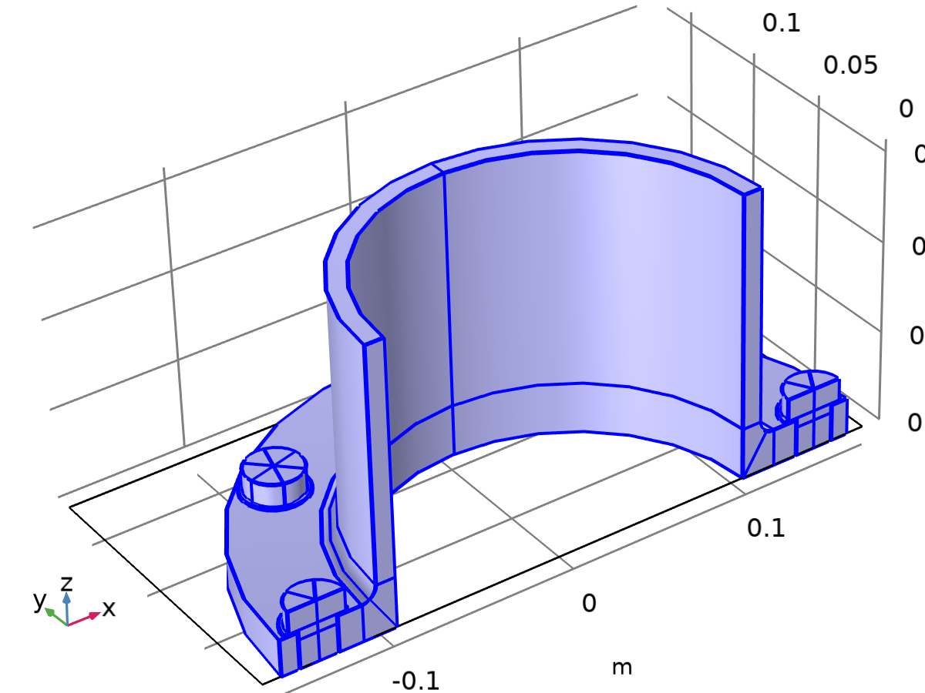

Structural steel

Selection

|  |  |
| --- | --- |
| Geometric entity level | Domain |
| Selection | Geometry geom1: Dimension 3: All domains |

Material parameters

| **Name** | **Value** | **Unit** | **Property group** |
| --- | --- | --- | --- |
| Density | 7850 | kg/m³ | Basic |
| Young's modulus | E(T) | Pa | Young's modulus and Poisson's ratio |
| Poisson's ratio | nu(T) | 1 | Young's modulus and Poisson's ratio |

Basic

| **Description** | **Value** | **Unit** |
| --- | --- | --- |
| Density | 7850 | kg/m³ |

Young's modulus and Poisson's ratio

| **Description** | **Value** | **Unit** |
| --- | --- | --- |
| Young's modulus | E(T) | Pa |
| Poisson's ratio | nu(T) | 1 |

Functions

| **Function name** | **Type** |
| --- | --- |
| E | Interpolation |
| nu | Interpolation |

#### Interpolation 1

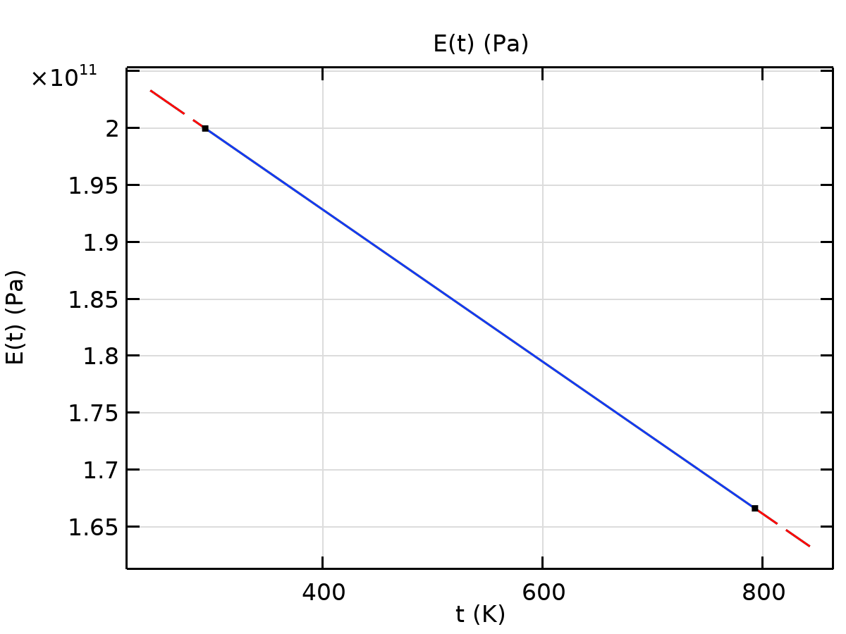

E

#### Interpolation 2

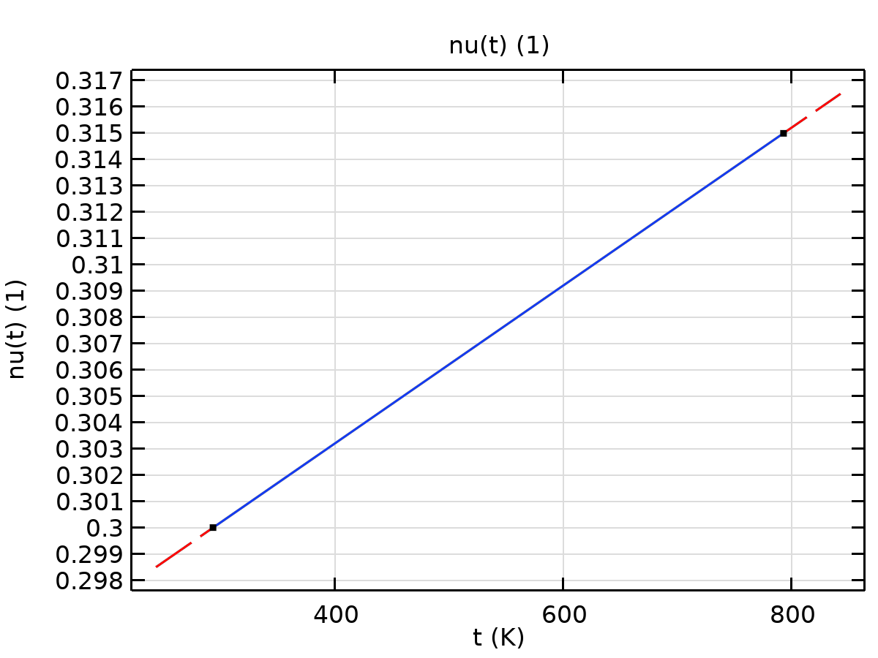

nu

Functions

| **Function name** | **Type** |
| --- | --- |
| a | Interpolation |

#### Interpolation 1

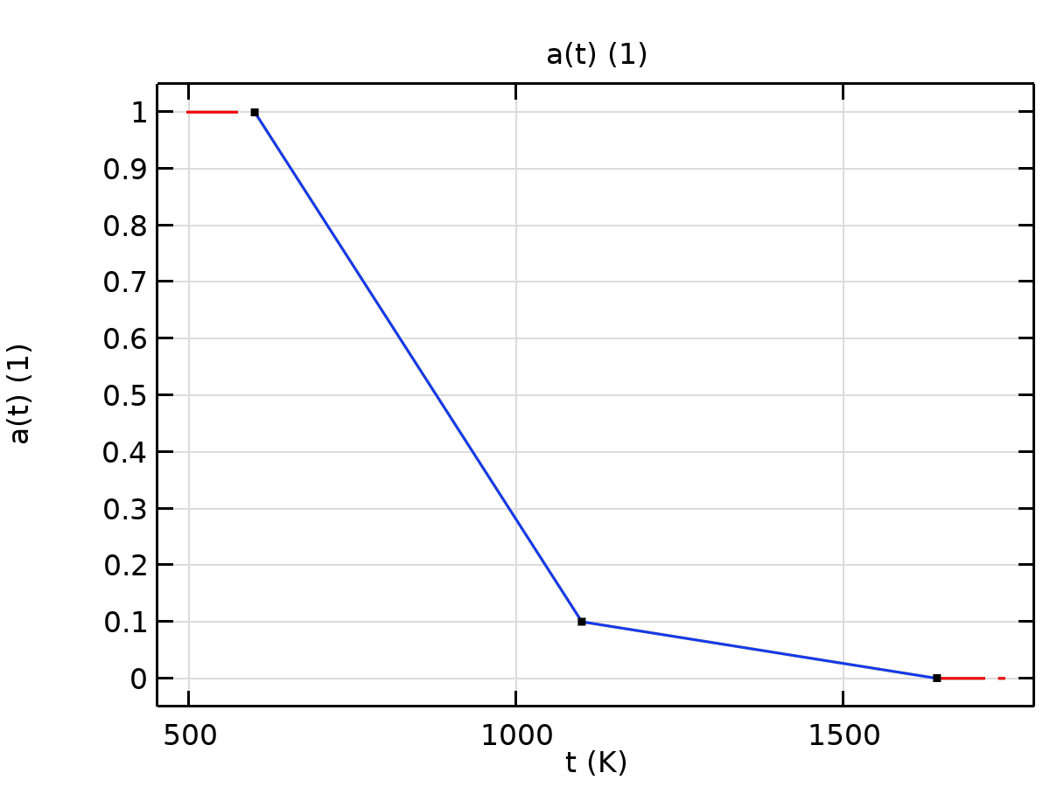

a

Functions

| **Function name** | **Type** |
| --- | --- |
| a | Interpolation |

#### Interpolation 1



a

Functions

| **Function name** | **Type** |
| --- | --- |
| a | Interpolation |

#### Interpolation 1



a

Functions

| **Function name** | **Type** |
| --- | --- |
| a | Interpolation |

#### Interpolation 1



a

Functions

| **Function name** | **Type** |
| --- | --- |
| a | Interpolation |

#### Interpolation 1



a

## Solid Mechanics

Used products

|  |
| --- |
| Structural Mechanics Module |
| COMSOL Multiphysics |



Solid Mechanics

Selection

|  |  |
| --- | --- |
| Geometric entity level | Domain |
| Selection | Geometry geom1: Dimension 3: All domains |

Equations

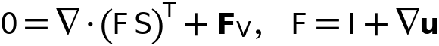

### Interface Settings

#### Physics Symbols

Settings

| **Description** | **Value** |
| --- | --- |
| Enable physics symbols | Off |

#### Discretization

Settings

| **Description** | **Value** |
| --- | --- |
| Displacement field | Quadratic serendipity |

#### Structural Transient Behavior

Settings

| **Description** | **Value** |
| --- | --- |
| Structural transient behavior | Include inertial terms |

#### Transient Solver Settings

Settings

| **Description** | **Value** |
| --- | --- |
| Description | Changes made to these settings only take effect when the default solver is generated. |
| Maximum frequency to resolve | Off |

#### Typical Wave Speed for Perfectly Matched Layers

Settings

| **Description** | **Value** | **Unit** |
| --- | --- | --- |
| Typical wave speed for perfectly matched layers | solid.cp | m/s |

#### Port Sweep Settings

Settings

| **Description** | **Value** |
| --- | --- |
| Port sweep settings | No port sweep |

### Variables

| **Name** | **Expression** | **Unit** | **Description** | **Selection** | **Details** |
| --- | --- | --- | --- | --- | --- |
| solid.X | X | m | Material coordinates, X-component | Domains 1–81 |  |
| solid.Y | Y | m | Material coordinates, Y-component | Domains 1–81 |  |
| solid.Z | Z | m | Material coordinates, Z-component | Domains 1–81 |  |
| solid.X | X | m | Material coordinates, X-component | Boundaries 2–425 |  |
| solid.Y | Y | m | Material coordinates, Y-component | Boundaries 2–425 |  |
| solid.Z | Z | m | Material coordinates, Z-component | Boundaries 2–425 |  |
| solid.x | x | m | Spatial coordinates, x-component | Domains 1–81 |  |
| solid.y | y | m | Spatial coordinates, y-component | Domains 1–81 |  |
| solid.z | z | m | Spatial coordinates, z-component | Domains 1–81 |  |
| solid.x | x | m | Spatial coordinates, x-component | Boundaries 2–425 |  |
| solid.y | y | m | Spatial coordinates, y-component | Boundaries 2–425 |  |
| solid.z | z | m | Spatial coordinates, z-component | Boundaries 2–425 |  |
| solid.uf | u | m | Displacement field, X-component | Domains 1–81 |  |
| solid.vf | v | m | Displacement field, Y-component | Domains 1–81 |  |
| solid.wf | w | m | Displacement field, Z-component | Domains 1–81 |  |
| solid.uf | u | m | Displacement field, X-component | Boundaries 2–425 |  |
| solid.vf | v | m | Displacement field, Y-component | Boundaries 2–425 |  |
| solid.wf | w | m | Displacement field, Z-component | Boundaries 2–425 |  |
| solid.nX | nX | 1 | Normal vector, X-component | Boundaries 11, 16, 21, 31, 34, 39, 165–167, 171, 174, 176–178, 181, 183–184, 186, 193, 199, 205, 210–215, 218, 220–222, 226, 229, 231–235, 238–247, 259, 265, 271, 276–281, 284, 286–288, 292, 295, 297–301, 304–313, 325, 331, 337, 342–347, 350, 352–354, 358, 361, 363–367, 370–379, 399–401, 405, 408, 410–412, 415, 417–418, 420 |  |
| solid.nY | nY | 1 | Normal vector, Y-component | Boundaries 11, 16, 21, 31, 34, 39, 165–167, 171, 174, 176–178, 181, 183–184, 186, 193, 199, 205, 210–215, 218, 220–222, 226, 229, 231–235, 238–247, 259, 265, 271, 276–281, 284, 286–288, 292, 295, 297–301, 304–313, 325, 331, 337, 342–347, 350, 352–354, 358, 361, 363–367, 370–379, 399–401, 405, 408, 410–412, 415, 417–418, 420 |  |
| solid.nZ | nZ | 1 | Normal vector, Z-component | Boundaries 11, 16, 21, 31, 34, 39, 165–167, 171, 174, 176–178, 181, 183–184, 186, 193, 199, 205, 210–215, 218, 220–222, 226, 229, 231–235, 238–247, 259, 265, 271, 276–281, 284, 286–288, 292, 295, 297–301, 304–313, 325, 331, 337, 342–347, 350, 352–354, 358, 361, 363–367, 370–379, 399–401, 405, 408, 410–412, 415, 417–418, 420 |  |
| solid.nX | dnX | 1 | Normal vector, X-component | Boundaries 2–10, 12–15, 17–20, 22–30, 32–33, 35–38, 40–164, 168–170, 172–173, 175, 179–180, 182, 185, 187–192, 194–198, 200–204, 206–209, 216–217, 219, 223–225, 227–228, 230, 236–237, 248–258, 260–264, 266–270, 272–275, 282–283, 285, 289–291, 293–294, 296, 302–303, 314–324, 326–330, 332–336, 338–341, 348–349, 351, 355–357, 359–360, 362, 368–369, 380–398, 402–404, 406–407, 409, 413–414, 416, 419, 421–425 |  |
| solid.nY | dnY | 1 | Normal vector, Y-component | Boundaries 2–10, 12–15, 17–20, 22–30, 32–33, 35–38, 40–164, 168–170, 172–173, 175, 179–180, 182, 185, 187–192, 194–198, 200–204, 206–209, 216–217, 219, 223–225, 227–228, 230, 236–237, 248–258, 260–264, 266–270, 272–275, 282–283, 285, 289–291, 293–294, 296, 302–303, 314–324, 326–330, 332–336, 338–341, 348–349, 351, 355–357, 359–360, 362, 368–369, 380–398, 402–404, 406–407, 409, 413–414, 416, 419, 421–425 |  |
| solid.nZ | dnZ | 1 | Normal vector, Z-component | Boundaries 2–10, 12–15, 17–20, 22–30, 32–33, 35–38, 40–164, 168–170, 172–173, 175, 179–180, 182, 185, 187–192, 194–198, 200–204, 206–209, 216–217, 219, 223–225, 227–228, 230, 236–237, 248–258, 260–264, 266–270, 272–275, 282–283, 285, 289–291, 293–294, 296, 302–303, 314–324, 326–330, 332–336, 338–341, 348–349, 351, 355–357, 359–360, 362, 368–369, 380–398, 402–404, 406–407, 409, 413–414, 416, 419, 421–425 |  |
| solid.nx | nx | 1 | Normal vector, x-component | Boundaries 11, 16, 21, 31, 34, 39, 165–167, 171, 174, 176–178, 181, 183–184, 186, 193, 199, 205, 210–215, 218, 220–222, 226, 229, 231–235, 238–247, 259, 265, 271, 276–281, 284, 286–288, 292, 295, 297–301, 304–313, 325, 331, 337, 342–347, 350, 352–354, 358, 361, 363–367, 370–379, 399–401, 405, 408, 410–412, 415, 417–418, 420 |  |
| solid.ny | ny | 1 | Normal vector, y-component | Boundaries 11, 16, 21, 31, 34, 39, 165–167, 171, 174, 176–178, 181, 183–184, 186, 193, 199, 205, 210–215, 218, 220–222, 226, 229, 231–235, 238–247, 259, 265, 271, 276–281, 284, 286–288, 292, 295, 297–301, 304–313, 325, 331, 337, 342–347, 350, 352–354, 358, 361, 363–367, 370–379, 399–401, 405, 408, 410–412, 415, 417–418, 420 |  |
| solid.nz | nz | 1 | Normal vector, z-component | Boundaries 11, 16, 21, 31, 34, 39, 165–167, 171, 174, 176–178, 181, 183–184, 186, 193, 199, 205, 210–215, 218, 220–222, 226, 229, 231–235, 238–247, 259, 265, 271, 276–281, 284, 286–288, 292, 295, 297–301, 304–313, 325, 331, 337, 342–347, 350, 352–354, 358, 361, 363–367, 370–379, 399–401, 405, 408, 410–412, 415, 417–418, 420 |  |
| solid.nx | dnx | 1 | Normal vector, x-component | Boundaries 2–10, 12–15, 17–20, 22–30, 32–33, 35–38, 40–164, 168–170, 172–173, 175, 179–180, 182, 185, 187–192, 194–198, 200–204, 206–209, 216–217, 219, 223–225, 227–228, 230, 236–237, 248–258, 260–264, 266–270, 272–275, 282–283, 285, 289–291, 293–294, 296, 302–303, 314–324, 326–330, 332–336, 338–341, 348–349, 351, 355–357, 359–360, 362, 368–369, 380–398, 402–404, 406–407, 409, 413–414, 416, 419, 421–425 |  |
| solid.ny | dny | 1 | Normal vector, y-component | Boundaries 2–10, 12–15, 17–20, 22–30, 32–33, 35–38, 40–164, 168–170, 172–173, 175, 179–180, 182, 185, 187–192, 194–198, 200–204, 206–209, 216–217, 219, 223–225, 227–228, 230, 236–237, 248–258, 260–264, 266–270, 272–275, 282–283, 285, 289–291, 293–294, 296, 302–303, 314–324, 326–330, 332–336, 338–341, 348–349, 351, 355–357, 359–360, 362, 368–369, 380–398, 402–404, 406–407, 409, 413–414, 416, 419, 421–425 |  |
| solid.nz | dnz | 1 | Normal vector, z-component | Boundaries 2–10, 12–15, 17–20, 22–30, 32–33, 35–38, 40–164, 168–170, 172–173, 175, 179–180, 182, 185, 187–192, 194–198, 200–204, 206–209, 216–217, 219, 223–225, 227–228, 230, 236–237, 248–258, 260–264, 266–270, 272–275, 282–283, 285, 289–291, 293–294, 296, 302–303, 314–324, 326–330, 332–336, 338–341, 348–349, 351, 355–357, 359–360, 362, 368–369, 380–398, 402–404, 406–407, 409, 413–414, 416, 419, 421–425 |  |
| solid.nXmesh | nXmesh | 1 | Normal vector (mesh), X-component | Boundaries 11, 16, 21, 31, 34, 39, 165–167, 171, 174, 176–178, 181, 183–184, 186, 193, 199, 205, 210–215, 218, 220–222, 226, 229, 231–235, 238–247, 259, 265, 271, 276–281, 284, 286–288, 292, 295, 297–301, 304–313, 325, 331, 337, 342–347, 350, 352–354, 358, 361, 363–367, 370–379, 399–401, 405, 408, 410–412, 415, 417–418, 420 |  |
| solid.nYmesh | nYmesh | 1 | Normal vector (mesh), Y-component | Boundaries 11, 16, 21, 31, 34, 39, 165–167, 171, 174, 176–178, 181, 183–184, 186, 193, 199, 205, 210–215, 218, 220–222, 226, 229, 231–235, 238–247, 259, 265, 271, 276–281, 284, 286–288, 292, 295, 297–301, 304–313, 325, 331, 337, 342–347, 350, 352–354, 358, 361, 363–367, 370–379, 399–401, 405, 408, 410–412, 415, 417–418, 420 |  |
| solid.nZmesh | nZmesh | 1 | Normal vector (mesh), Z-component | Boundaries 11, 16, 21, 31, 34, 39, 165–167, 171, 174, 176–178, 181, 183–184, 186, 193, 199, 205, 210–215, 218, 220–222, 226, 229, 231–235, 238–247, 259, 265, 271, 276–281, 284, 286–288, 292, 295, 297–301, 304–313, 325, 331, 337, 342–347, 350, 352–354, 358, 361, 363–367, 370–379, 399–401, 405, 408, 410–412, 415, 417–418, 420 |  |
| solid.nXmesh | dnXmesh | 1 | Normal vector (mesh), X-component | Boundaries 2–10, 12–15, 17–20, 22–30, 32–33, 35–38, 40–164, 168–170, 172–173, 175, 179–180, 182, 185, 187–192, 194–198, 200–204, 206–209, 216–217, 219, 223–225, 227–228, 230, 236–237, 248–258, 260–264, 266–270, 272–275, 282–283, 285, 289–291, 293–294, 296, 302–303, 314–324, 326–330, 332–336, 338–341, 348–349, 351, 355–357, 359–360, 362, 368–369, 380–398, 402–404, 406–407, 409, 413–414, 416, 419, 421–425 |  |
| solid.nYmesh | dnYmesh | 1 | Normal vector (mesh), Y-component | Boundaries 2–10, 12–15, 17–20, 22–30, 32–33, 35–38, 40–164, 168–170, 172–173, 175, 179–180, 182, 185, 187–192, 194–198, 200–204, 206–209, 216–217, 219, 223–225, 227–228, 230, 236–237, 248–258, 260–264, 266–270, 272–275, 282–283, 285, 289–291, 293–294, 296, 302–303, 314–324, 326–330, 332–336, 338–341, 348–349, 351, 355–357, 359–360, 362, 368–369, 380–398, 402–404, 406–407, 409, 413–414, 416, 419, 421–425 |  |
| solid.nZmesh | dnZmesh | 1 | Normal vector (mesh), Z-component | Boundaries 2–10, 12–15, 17–20, 22–30, 32–33, 35–38, 40–164, 168–170, 172–173, 175, 179–180, 182, 185, 187–192, 194–198, 200–204, 206–209, 216–217, 219, 223–225, 227–228, 230, 236–237, 248–258, 260–264, 266–270, 272–275, 282–283, 285, 289–291, 293–294, 296, 302–303, 314–324, 326–330, 332–336, 338–341, 348–349, 351, 355–357, 359–360, 362, 368–369, 380–398, 402–404, 406–407, 409, 413–414, 416, 419, 421–425 |  |
| solid.nxmesh | nxmesh | 1 | Normal vector (mesh), x-component | Boundaries 11, 16, 21, 31, 34, 39, 165–167, 171, 174, 176–178, 181, 183–184, 186, 193, 199, 205, 210–215, 218, 220–222, 226, 229, 231–235, 238–247, 259, 265, 271, 276–281, 284, 286–288, 292, 295, 297–301, 304–313, 325, 331, 337, 342–347, 350, 352–354, 358, 361, 363–367, 370–379, 399–401, 405, 408, 410–412, 415, 417–418, 420 |  |
| solid.nymesh | nymesh | 1 | Normal vector (mesh), y-component | Boundaries 11, 16, 21, 31, 34, 39, 165–167, 171, 174, 176–178, 181, 183–184, 186, 193, 199, 205, 210–215, 218, 220–222, 226, 229, 231–235, 238–247, 259, 265, 271, 276–281, 284, 286–288, 292, 295, 297–301, 304–313, 325, 331, 337, 342–347, 350, 352–354, 358, 361, 363–367, 370–379, 399–401, 405, 408, 410–412, 415, 417–418, 420 |  |
| solid.nzmesh | nzmesh | 1 | Normal vector (mesh), z-component | Boundaries 11, 16, 21, 31, 34, 39, 165–167, 171, 174, 176–178, 181, 183–184, 186, 193, 199, 205, 210–215, 218, 220–222, 226, 229, 231–235, 238–247, 259, 265, 271, 276–281, 284, 286–288, 292, 295, 297–301, 304–313, 325, 331, 337, 342–347, 350, 352–354, 358, 361, 363–367, 370–379, 399–401, 405, 408, 410–412, 415, 417–418, 420 |  |
| solid.nxmesh | dnxmesh | 1 | Normal vector (mesh), x-component | Boundaries 2–10, 12–15, 17–20, 22–30, 32–33, 35–38, 40–164, 168–170, 172–173, 175, 179–180, 182, 185, 187–192, 194–198, 200–204, 206–209, 216–217, 219, 223–225, 227–228, 230, 236–237, 248–258, 260–264, 266–270, 272–275, 282–283, 285, 289–291, 293–294, 296, 302–303, 314–324, 326–330, 332–336, 338–341, 348–349, 351, 355–357, 359–360, 362, 368–369, 380–398, 402–404, 406–407, 409, 413–414, 416, 419, 421–425 |  |
| solid.nymesh | dnymesh | 1 | Normal vector (mesh), y-component | Boundaries 2–10, 12–15, 17–20, 22–30, 32–33, 35–38, 40–164, 168–170, 172–173, 175, 179–180, 182, 185, 187–192, 194–198, 200–204, 206–209, 216–217, 219, 223–225, 227–228, 230, 236–237, 248–258, 260–264, 266–270, 272–275, 282–283, 285, 289–291, 293–294, 296, 302–303, 314–324, 326–330, 332–336, 338–341, 348–349, 351, 355–357, 359–360, 362, 368–369, 380–398, 402–404, 406–407, 409, 413–414, 416, 419, 421–425 |  |
| solid.nzmesh | dnzmesh | 1 | Normal vector (mesh), z-component | Boundaries 2–10, 12–15, 17–20, 22–30, 32–33, 35–38, 40–164, 168–170, 172–173, 175, 179–180, 182, 185, 187–192, 194–198, 200–204, 206–209, 216–217, 219, 223–225, 227–228, 230, 236–237, 248–258, 260–264, 266–270, 272–275, 282–283, 285, 289–291, 293–294, 296, 302–303, 314–324, 326–330, 332–336, 338–341, 348–349, 351, 355–357, 359–360, 362, 368–369, 380–398, 402–404, 406–407, 409, 413–414, 416, 419, 421–425 |  |
| solid.incontact | 0 | 1 | In contact control variable | Points 5–332 | || operation |
| solid.incontact | 0 | 1 | In contact control variable | Edges 5–672 | || operation |
| solid.incontact | 0 | 1 | In contact control variable | Boundaries 2–425 | || operation |
| solid.cref | solid.cp | m/s | Typical wave speed for perfectly matched layers | Domains 1–81 |  |
| solid.isGeomNon | 1 | 1 | Geometric nonlinearity variable | Global |  |
| solid.Ws_tot | 0 | J | Total elastic strain energy | Global | + operation |
| solid.Wl_tot | 0 | J | Total potential energy of applied loads | Global | + operation |
| solid.W_tot | solid.Ws_tot+solid.Wl_tot | J | Total potential energy | Global | + operation |
| solid.activation_multiplier | 1 | 1 | Activation multiplier | Domains 1–81 |  |
| solid.geomsize | 0.41386960782310445 | m | Bounding box | Global |  |
| solid.timestep | 0 | s | Time step | Domains 1–81 |  |
| solid.RFtotalx | solid.sumreaction(solid.RFx)+solid.RFfsx+solid.RFfdx | N | Total reaction force, x-component | Global | + operation |
| solid.RFtotaly | solid.sumreaction(solid.RFy)+solid.RFfsy+solid.RFfdy | N | Total reaction force, y-component | Global | + operation |
| solid.RFtotalz | solid.sumreaction(solid.RFz)+solid.RFfsz+solid.RFfdz | N | Total reaction force, z-component | Global | + operation |
| solid.RMtotalx | solid.sumreaction(solid.RMx)+solid.RMmsx+solid.RMmdx | N·m | Total reaction moment, x-component | Global | + operation |
| solid.RMtotaly | solid.sumreaction(solid.RMy)+solid.RMmsy+solid.RMmdy | N·m | Total reaction moment, y-component | Global | + operation |
| solid.RMtotalz | solid.sumreaction(solid.RMz)+solid.RMmsz+solid.RMmdz | N·m | Total reaction moment, z-component | Global | + operation |
| solid.beta_dK | 0 | s | Stiffness damping parameter | Domains 1–81 | + operation |
| xt | d(x,TIME) | m/s | Mesh velocity, x-component | Global |  |
| yt | d(y,TIME) | m/s | Mesh velocity, y-component | Global |  |
| zt | d(z,TIME) | m/s | Mesh velocity, z-component | Global |  |

### Linear Elastic Material 1



Linear Elastic Material 1

Selection

|  |  |
| --- | --- |
| Geometric entity level | Domain |
| Selection | Geometry geom1: Dimension 3: All domains |

Equations

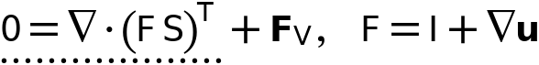



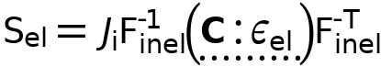

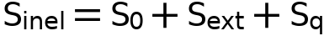

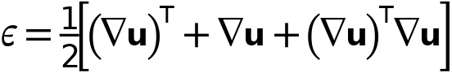

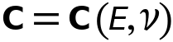

#### Linear Elastic Material

Settings

| **Description** | **Value** |
| --- | --- |
| Material symmetry | Isotropic |
| Specify | Young's modulus and Poisson's ratio |
| Young's modulus | From material |
| Poisson's ratio | From material |
| Density | From material |
| Use mixed formulation | None |

#### Geometric Nonlinearity

Settings

| **Description** | **Value** |
| --- | --- |
| Formulation | From study step |
| Strain decomposition | Automatic |

#### Quadrature Settings

Settings

| **Description** | **Value** |
| --- | --- |
| Reduced integration | Off |

#### Coordinate System Selection

Settings

| **Description** | **Value** |
| --- | --- |
| Coordinate system | Global coordinate system |

#### Model Input

Settings

| **Description** | **Value** |
| --- | --- |
| Temperature | Common model input |

Used products

|  |
| --- |
| COMSOL Multiphysics |

Properties from material

| **Property** | **Material** | **Property group** |
| --- | --- | --- |
| Young's modulus | Structural steel | Young's modulus and Poisson's ratio |
| Poisson's ratio | Structural steel | Young's modulus and Poisson's ratio |
| Density | Structural steel | Basic |

#### Variables

| **Name** | **Expression** | **Unit** | **Description** | **Selection** | **Details** |
| --- | --- | --- | --- | --- | --- |
| solid.disp | sqrteps(real(u)^2+real(v)^2+real(w)^2) | m | Displacement magnitude | Domains 1–81 |  |
| solid.curlUX | solid.gradUzY-solid.gradUyZ | 1 | Curl of displacement, X-component | Domains 1–81 |  |
| solid.curlUY | solid.gradUxZ-solid.gradUzX | 1 | Curl of displacement, Y-component | Domains 1–81 |  |
| solid.curlUZ | solid.gradUyX-solid.gradUxY | 1 | Curl of displacement, Z-component | Domains 1–81 |  |
| solid.gradUxX | uX | 1 | Displacement gradient, xX-component | Domains 1–81 |  |
| solid.gradUyX | vX | 1 | Displacement gradient, yX-component | Domains 1–81 |  |
| solid.gradUzX | wX | 1 | Displacement gradient, zX-component | Domains 1–81 |  |
| solid.gradUxY | uY | 1 | Displacement gradient, xY-component | Domains 1–81 |  |
| solid.gradUyY | vY | 1 | Displacement gradient, yY-component | Domains 1–81 |  |
| solid.gradUzY | wY | 1 | Displacement gradient, zY-component | Domains 1–81 |  |
| solid.gradUxZ | uZ | 1 | Displacement gradient, xZ-component | Domains 1–81 |  |
| solid.gradUyZ | vZ | 1 | Displacement gradient, yZ-component | Domains 1–81 |  |
| solid.gradUzZ | wZ | 1 | Displacement gradient, zZ-component | Domains 1–81 |  |
| solid.FdxX | 1+solid.gradUxX | 1 | Deformation gradient, xX-component | Domains 1–81 |  |
| solid.FdyX | solid.gradUyX | 1 | Deformation gradient, yX-component | Domains 1–81 |  |
| solid.FdzX | solid.gradUzX | 1 | Deformation gradient, zX-component | Domains 1–81 |  |
| solid.FdxY | solid.gradUxY | 1 | Deformation gradient, xY-component | Domains 1–81 |  |
| solid.FdyY | 1+solid.gradUyY | 1 | Deformation gradient, yY-component | Domains 1–81 |  |
| solid.FdzY | solid.gradUzY | 1 | Deformation gradient, zY-component | Domains 1–81 |  |
| solid.FdxZ | solid.gradUxZ | 1 | Deformation gradient, xZ-component | Domains 1–81 |  |
| solid.FdyZ | solid.gradUyZ | 1 | Deformation gradient, yZ-component | Domains 1–81 |  |
| solid.FdzZ | 1+solid.gradUzZ | 1 | Deformation gradient, zZ-component | Domains 1–81 |  |
| solid.FdiXx | (solid.FdyY*solid.FdzZ-solid.FdyZ*solid.FdzY)/solid.J | 1 | Deformation gradient inverse, Xx-component | Domains 1–81 |  |
| solid.FdiYx | (solid.FdyZ*solid.FdzX-solid.FdyX*solid.FdzZ)/solid.J | 1 | Deformation gradient inverse, Yx-component | Domains 1–81 |  |
| solid.FdiZx | (solid.FdyX*solid.FdzY-solid.FdyY*solid.FdzX)/solid.J | 1 | Deformation gradient inverse, Zx-component | Domains 1–81 |  |
| solid.FdiXy | (solid.FdxZ*solid.FdzY-solid.FdxY*solid.FdzZ)/solid.J | 1 | Deformation gradient inverse, Xy-component | Domains 1–81 |  |
| solid.FdiYy | (solid.FdxX*solid.FdzZ-solid.FdxZ*solid.FdzX)/solid.J | 1 | Deformation gradient inverse, Yy-component | Domains 1–81 |  |
| solid.FdiZy | (solid.FdxY*solid.FdzX-solid.FdxX*solid.FdzY)/solid.J | 1 | Deformation gradient inverse, Zy-component | Domains 1–81 |  |
| solid.FdiXz | (solid.FdxY*solid.FdyZ-solid.FdxZ*solid.FdyY)/solid.J | 1 | Deformation gradient inverse, Xz-component | Domains 1–81 |  |
| solid.FdiYz | (solid.FdxZ*solid.FdyX-solid.FdxX*solid.FdyZ)/solid.J | 1 | Deformation gradient inverse, Yz-component | Domains 1–81 |  |
| solid.FdiZz | (solid.FdxX*solid.FdyY-solid.FdxY*solid.FdyX)/solid.J | 1 | Deformation gradient inverse, Zz-component | Domains 1–81 |  |
| solid.J | solid.FdxX*solid.FdyY*solid.FdzZ+solid.FdxY*solid.FdyZ*solid.FdzX+solid.FdxZ*solid.FdyX*solid.FdzY-solid.FdxX*solid.FdyZ*solid.FdzY-solid.FdxY*solid.FdyX*solid.FdzZ-solid.FdxZ*solid.FdyY*solid.FdzX | 1 | Volume ratio | Domains 1–81 |  |
| solid.Fdlx1 | solid.FdxX | 1 | Deformation gradient, local, x1-component | Domains 1–81 |  |
| solid.Fdly1 | solid.FdyX | 1 | Deformation gradient, local, y1-component | Domains 1–81 |  |
| solid.Fdlz1 | solid.FdzX | 1 | Deformation gradient, local, z1-component | Domains 1–81 |  |
| solid.Fdlx2 | solid.FdxY | 1 | Deformation gradient, local, x2-component | Domains 1–81 |  |
| solid.Fdly2 | solid.FdyY | 1 | Deformation gradient, local, y2-component | Domains 1–81 |  |
| solid.Fdlz2 | solid.FdzY | 1 | Deformation gradient, local, z2-component | Domains 1–81 |  |
| solid.Fdlx3 | solid.FdxZ | 1 | Deformation gradient, local, x3-component | Domains 1–81 |  |
| solid.Fdly3 | solid.FdyZ | 1 | Deformation gradient, local, y3-component | Domains 1–81 |  |
| solid.Fdlz3 | solid.FdzZ | 1 | Deformation gradient, local, z3-component | Domains 1–81 |  |
| solid.Fdil1x | (solid.Fdly2*solid.Fdlz3-solid.Fdly3*solid.Fdlz2)/solid.J | 1 | Deformation gradient inverse, local coordinate system, 1x-component | Domains 1–81 |  |
| solid.Fdil2x | (solid.Fdly3*solid.Fdlz1-solid.Fdly1*solid.Fdlz3)/solid.J | 1 | Deformation gradient inverse, local coordinate system, 2x-component | Domains 1–81 |  |
| solid.Fdil3x | (solid.Fdly1*solid.Fdlz2-solid.Fdly2*solid.Fdlz1)/solid.J | 1 | Deformation gradient inverse, local coordinate system, 3x-component | Domains 1–81 |  |
| solid.Fdil1y | (solid.Fdlx3*solid.Fdlz2-solid.Fdlx2*solid.Fdlz3)/solid.J | 1 | Deformation gradient inverse, local coordinate system, 1y-component | Domains 1–81 |  |
| solid.Fdil2y | (solid.Fdlx1*solid.Fdlz3-solid.Fdlx3*solid.Fdlz1)/solid.J | 1 | Deformation gradient inverse, local coordinate system, 2y-component | Domains 1–81 |  |
| solid.Fdil3y | (solid.Fdlx2*solid.Fdlz1-solid.Fdlx1*solid.Fdlz2)/solid.J | 1 | Deformation gradient inverse, local coordinate system, 3y-component | Domains 1–81 |  |
| solid.Fdil1z | (solid.Fdlx2*solid.Fdly3-solid.Fdlx3*solid.Fdly2)/solid.J | 1 | Deformation gradient inverse, local coordinate system, 1z-component | Domains 1–81 |  |
| solid.Fdil2z | (solid.Fdlx3*solid.Fdly1-solid.Fdlx1*solid.Fdly3)/solid.J | 1 | Deformation gradient inverse, local coordinate system, 2z-component | Domains 1–81 |  |
| solid.Fdil3z | (solid.Fdlx1*solid.Fdly2-solid.Fdlx2*solid.Fdly1)/solid.J | 1 | Deformation gradient inverse, local coordinate system, 3z-component | Domains 1–81 |  |
| solid.Ji | 1/(solid.Fiil11*solid.Fiil22*solid.Fiil33+solid.Fiil12*solid.Fiil23*solid.Fiil31+solid.Fiil13*solid.Fiil21*solid.Fiil32-solid.Fiil11*solid.Fiil23*solid.Fiil32-solid.Fiil12*solid.Fiil21*solid.Fiil33-solid.Fiil13*solid.Fiil22*solid.Fiil31) | 1 | Inelastic volume ratio | Domains 1–81 |  |
| solid.Fil11 | (solid.Fiil22*solid.Fiil33-solid.Fiil23*solid.Fiil32)*solid.Ji | 1 | Inelastic deformation gradient, local coordinate system, 11-component | Domains 1–81 | Matrix multiplication |
| solid.Fil21 | (solid.Fiil23*solid.Fiil31-solid.Fiil21*solid.Fiil33)*solid.Ji | 1 | Inelastic deformation gradient, local coordinate system, 21-component | Domains 1–81 | Matrix multiplication |
| solid.Fil31 | (solid.Fiil21*solid.Fiil32-solid.Fiil22*solid.Fiil31)*solid.Ji | 1 | Inelastic deformation gradient, local coordinate system, 31-component | Domains 1–81 | Matrix multiplication |
| solid.Fil12 | (solid.Fiil13*solid.Fiil32-solid.Fiil12*solid.Fiil33)*solid.Ji | 1 | Inelastic deformation gradient, local coordinate system, 12-component | Domains 1–81 | Matrix multiplication |
| solid.Fil22 | (solid.Fiil11*solid.Fiil33-solid.Fiil13*solid.Fiil31)*solid.Ji | 1 | Inelastic deformation gradient, local coordinate system, 22-component | Domains 1–81 | Matrix multiplication |
| solid.Fil32 | (solid.Fiil12*solid.Fiil31-solid.Fiil11*solid.Fiil32)*solid.Ji | 1 | Inelastic deformation gradient, local coordinate system, 32-component | Domains 1–81 | Matrix multiplication |
| solid.Fil13 | (solid.Fiil12*solid.Fiil23-solid.Fiil13*solid.Fiil22)*solid.Ji | 1 | Inelastic deformation gradient, local coordinate system, 13-component | Domains 1–81 | Matrix multiplication |
| solid.Fil23 | (solid.Fiil13*solid.Fiil21-solid.Fiil11*solid.Fiil23)*solid.Ji | 1 | Inelastic deformation gradient, local coordinate system, 23-component | Domains 1–81 | Matrix multiplication |
| solid.Fil33 | (solid.Fiil11*solid.Fiil22-solid.Fiil12*solid.Fiil21)*solid.Ji | 1 | Inelastic deformation gradient, local coordinate system, 33-component | Domains 1–81 | Matrix multiplication |
| solid.Fiil11 | 1 | 1 | Inelastic deformation gradient inverse, local coordinate system, 11-component | Domains 1–81 | Matrix multiplication |
| solid.Fiil21 | 0 | 1 | Inelastic deformation gradient inverse, local coordinate system, 21-component | Domains 1–81 | Matrix multiplication |
| solid.Fiil31 | 0 | 1 | Inelastic deformation gradient inverse, local coordinate system, 31-component | Domains 1–81 | Matrix multiplication |
| solid.Fiil12 | 0 | 1 | Inelastic deformation gradient inverse, local coordinate system, 12-component | Domains 1–81 | Matrix multiplication |
| solid.Fiil22 | 1 | 1 | Inelastic deformation gradient inverse, local coordinate system, 22-component | Domains 1–81 | Matrix multiplication |
| solid.Fiil32 | 0 | 1 | Inelastic deformation gradient inverse, local coordinate system, 32-component | Domains 1–81 | Matrix multiplication |
| solid.Fiil13 | 0 | 1 | Inelastic deformation gradient inverse, local coordinate system, 13-component | Domains 1–81 | Matrix multiplication |
| solid.Fiil23 | 0 | 1 | Inelastic deformation gradient inverse, local coordinate system, 23-component | Domains 1–81 | Matrix multiplication |
| solid.Fiil33 | 1 | 1 | Inelastic deformation gradient inverse, local coordinate system, 33-component | Domains 1–81 | Matrix multiplication |
| solid.Felx1 | solid.Fdlx1*solid.Fiil11+solid.Fdlx2*solid.Fiil21+solid.Fdlx3*solid.Fiil31 | 1 | Elastic deformation gradient, local coordinate system, x1-component | Domains 1–81 |  |
| solid.Fely1 | solid.Fdly1*solid.Fiil11+solid.Fdly2*solid.Fiil21+solid.Fdly3*solid.Fiil31 | 1 | Elastic deformation gradient, local coordinate system, y1-component | Domains 1–81 |  |
| solid.Felz1 | solid.Fdlz1*solid.Fiil11+solid.Fdlz2*solid.Fiil21+solid.Fdlz3*solid.Fiil31 | 1 | Elastic deformation gradient, local coordinate system, z1-component | Domains 1–81 |  |
| solid.Felx2 | solid.Fdlx1*solid.Fiil12+solid.Fdlx2*solid.Fiil22+solid.Fdlx3*solid.Fiil32 | 1 | Elastic deformation gradient, local coordinate system, x2-component | Domains 1–81 |  |
| solid.Fely2 | solid.Fdly1*solid.Fiil12+solid.Fdly2*solid.Fiil22+solid.Fdly3*solid.Fiil32 | 1 | Elastic deformation gradient, local coordinate system, y2-component | Domains 1–81 |  |
| solid.Felz2 | solid.Fdlz1*solid.Fiil12+solid.Fdlz2*solid.Fiil22+solid.Fdlz3*solid.Fiil32 | 1 | Elastic deformation gradient, local coordinate system, z2-component | Domains 1–81 |  |
| solid.Felx3 | solid.Fdlx1*solid.Fiil13+solid.Fdlx2*solid.Fiil23+solid.Fdlx3*solid.Fiil33 | 1 | Elastic deformation gradient, local coordinate system, x3-component | Domains 1–81 |  |
| solid.Fely3 | solid.Fdly1*solid.Fiil13+solid.Fdly2*solid.Fiil23+solid.Fdly3*solid.Fiil33 | 1 | Elastic deformation gradient, local coordinate system, y3-component | Domains 1–81 |  |
| solid.Felz3 | solid.Fdlz1*solid.Fiil13+solid.Fdlz2*solid.Fiil23+solid.Fdlz3*solid.Fiil33 | 1 | Elastic deformation gradient, local coordinate system, z3-component | Domains 1–81 |  |
| solid.Jel | sqrt(solid.Cel11*solid.Cel22*solid.Cel33+2*solid.Cel12*solid.Cel23*solid.Cel13-solid.Cel11*solid.Cel23^2-solid.Cel12^2*solid.Cel33-solid.Cel22*solid.Cel13^2) | 1 | Elastic volume ratio | Domains 1–81 |  |
| solid.CXX | solid.FdxX^2+solid.FdyX^2+solid.FdzX^2 | 1 | Cauchy–Green tensor, XX-component | Domains 1–81 |  |
| solid.CXY | solid.FdxX*solid.FdxY+solid.FdyX*solid.FdyY+solid.FdzX*solid.FdzY | 1 | Cauchy–Green tensor, XY-component | Domains 1–81 |  |
| solid.CXZ | solid.FdxX*solid.FdxZ+solid.FdyX*solid.FdyZ+solid.FdzX*solid.FdzZ | 1 | Cauchy–Green tensor, XZ-component | Domains 1–81 |  |
| solid.CYY | solid.FdxY^2+solid.FdyY^2+solid.FdzY^2 | 1 | Cauchy–Green tensor, YY-component | Domains 1–81 |  |
| solid.CYZ | solid.FdxY*solid.FdxZ+solid.FdyY*solid.FdyZ+solid.FdzY*solid.FdzZ | 1 | Cauchy–Green tensor, YZ-component | Domains 1–81 |  |
| solid.CZZ | solid.FdxZ^2+solid.FdyZ^2+solid.FdzZ^2 | 1 | Cauchy–Green tensor, ZZ-component | Domains 1–81 |  |
| solid.Cl11 | 1+2*solid.el11 | 1 | Cauchy–Green tensor, local coordinate system, 11-component | Domains 1–81 |  |
| solid.Cl12 | 2*solid.el12 | 1 | Cauchy–Green tensor, local coordinate system, 12-component | Domains 1–81 |  |
| solid.Cl13 | 2*solid.el13 | 1 | Cauchy–Green tensor, local coordinate system, 13-component | Domains 1–81 |  |
| solid.Cl22 | 1+2*solid.el22 | 1 | Cauchy–Green tensor, local coordinate system, 22-component | Domains 1–81 |  |
| solid.Cl23 | 2*solid.el23 | 1 | Cauchy–Green tensor, local coordinate system, 23-component | Domains 1–81 |  |
| solid.Cl33 | 1+2*solid.el33 | 1 | Cauchy–Green tensor, local coordinate system, 33-component | Domains 1–81 |  |
| solid.Cel11 | solid.FiilCl11*solid.Fiil11+solid.FiilCl12*solid.Fiil21+solid.FiilCl13*solid.Fiil31 | 1 | Elastic Cauchy–Green tensor, local coordinate system, 11-component | Domains 1–81 |  |
| solid.Cel12 | solid.FiilCl11*solid.Fiil12+solid.FiilCl12*solid.Fiil22+solid.FiilCl13*solid.Fiil32 | 1 | Elastic Cauchy–Green tensor, local coordinate system, 12-component | Domains 1–81 |  |
| solid.Cel13 | solid.FiilCl11*solid.Fiil13+solid.FiilCl12*solid.Fiil23+solid.FiilCl13*solid.Fiil33 | 1 | Elastic Cauchy–Green tensor, local coordinate system, 13-component | Domains 1–81 |  |
| solid.Cel22 | solid.FiilCl21*solid.Fiil12+solid.FiilCl22*solid.Fiil22+solid.FiilCl23*solid.Fiil32 | 1 | Elastic Cauchy–Green tensor, local coordinate system, 22-component | Domains 1–81 |  |
| solid.Cel23 | solid.FiilCl21*solid.Fiil13+solid.FiilCl22*solid.Fiil23+solid.FiilCl23*solid.Fiil33 | 1 | Elastic Cauchy–Green tensor, local coordinate system, 23-component | Domains 1–81 |  |
| solid.Cel33 | solid.FiilCl31*solid.Fiil13+solid.FiilCl32*solid.Fiil23+solid.FiilCl33*solid.Fiil33 | 1 | Elastic Cauchy–Green tensor, local coordinate system, 33-component | Domains 1–81 |  |
| solid.Ceil11 | (solid.Cel22*solid.Cel33-solid.Cel23^2)/(solid.Cel11*solid.Cel22*solid.Cel33+2*solid.Cel12*solid.Cel23*solid.Cel13-solid.Cel11*solid.Cel23^2-solid.Cel12^2*solid.Cel33-solid.Cel22*solid.Cel13^2) | 1 | Elastic Cauchy–Green tensor inverse, local coordinate system, 11-component | Domains 1–81 |  |
| solid.Ceil12 | (solid.Cel23*solid.Cel13-solid.Cel12*solid.Cel33)/(solid.Cel11*solid.Cel22*solid.Cel33+2*solid.Cel12*solid.Cel23*solid.Cel13-solid.Cel11*solid.Cel23^2-solid.Cel12^2*solid.Cel33-solid.Cel22*solid.Cel13^2) | 1 | Elastic Cauchy–Green tensor inverse, local coordinate system, 12-component | Domains 1–81 |  |
| solid.Ceil13 | (solid.Cel12*solid.Cel23-solid.Cel22*solid.Cel13)/(solid.Cel11*solid.Cel22*solid.Cel33+2*solid.Cel12*solid.Cel23*solid.Cel13-solid.Cel11*solid.Cel23^2-solid.Cel12^2*solid.Cel33-solid.Cel22*solid.Cel13^2) | 1 | Elastic Cauchy–Green tensor inverse, local coordinate system, 13-component | Domains 1–81 |  |
| solid.Ceil22 | (solid.Cel11*solid.Cel33-solid.Cel13^2)/(solid.Cel11*solid.Cel22*solid.Cel33+2*solid.Cel12*solid.Cel23*solid.Cel13-solid.Cel11*solid.Cel23^2-solid.Cel12^2*solid.Cel33-solid.Cel22*solid.Cel13^2) | 1 | Elastic Cauchy–Green tensor inverse, local coordinate system, 22-component | Domains 1–81 |  |
| solid.Ceil23 | (solid.Cel12*solid.Cel13-solid.Cel11*solid.Cel23)/(solid.Cel11*solid.Cel22*solid.Cel33+2*solid.Cel12*solid.Cel23*solid.Cel13-solid.Cel11*solid.Cel23^2-solid.Cel12^2*solid.Cel33-solid.Cel22*solid.Cel13^2) | 1 | Elastic Cauchy–Green tensor inverse, local coordinate system, 23-component | Domains 1–81 |  |
| solid.Ceil33 | (solid.Cel11*solid.Cel22-solid.Cel12^2)/(solid.Cel11*solid.Cel22*solid.Cel33+2*solid.Cel12*solid.Cel23*solid.Cel13-solid.Cel11*solid.Cel23^2-solid.Cel12^2*solid.Cel33-solid.Cel22*solid.Cel13^2) | 1 | Elastic Cauchy–Green tensor inverse, local coordinate system, 33-component | Domains 1–81 |  |
| solid.eXX | 0.5*(2*solid.gradUxX+solid.gradUxX^2+solid.gradUyX^2+solid.gradUzX^2) | 1 | Strain tensor, XX-component | Domains 1–81 | + operation |
| solid.eXY | 0.5*(solid.gradUxY+solid.gradUyX+solid.gradUxX*solid.gradUxY+solid.gradUyX*solid.gradUyY+solid.gradUzX*solid.gradUzY) | 1 | Strain tensor, XY-component | Domains 1–81 | + operation |
| solid.eXZ | 0.5*(solid.gradUxZ+solid.gradUzX+solid.gradUxX*solid.gradUxZ+solid.gradUyX*solid.gradUyZ+solid.gradUzX*solid.gradUzZ) | 1 | Strain tensor, XZ-component | Domains 1–81 | + operation |
| solid.eYY | 0.5*(2*solid.gradUyY+solid.gradUxY^2+solid.gradUyY^2+solid.gradUzY^2) | 1 | Strain tensor, YY-component | Domains 1–81 | + operation |
| solid.eYZ | 0.5*(solid.gradUyZ+solid.gradUzY+solid.gradUxY*solid.gradUxZ+solid.gradUyY*solid.gradUyZ+solid.gradUzY*solid.gradUzZ) | 1 | Strain tensor, YZ-component | Domains 1–81 | + operation |
| solid.eZZ | 0.5*(2*solid.gradUzZ+solid.gradUxZ^2+solid.gradUyZ^2+solid.gradUzZ^2) | 1 | Strain tensor, ZZ-component | Domains 1–81 | + operation |
| solid.el11 | solid.eXX | 1 | Strain tensor, local coordinate system, 11-component | Domains 1–81 | + operation |
| solid.el12 | solid.eXY | 1 | Strain tensor, local coordinate system, 12-component | Domains 1–81 | + operation |
| solid.el13 | solid.eXZ | 1 | Strain tensor, local coordinate system, 13-component | Domains 1–81 | + operation |
| solid.el22 | solid.eYY | 1 | Strain tensor, local coordinate system, 22-component | Domains 1–81 | + operation |
| solid.el23 | solid.eYZ | 1 | Strain tensor, local coordinate system, 23-component | Domains 1–81 | + operation |
| solid.el33 | solid.eZZ | 1 | Strain tensor, local coordinate system, 33-component | Domains 1–81 | + operation |
| solid.evol | solid.eXX+solid.eYY+solid.eZZ | 1 | Volumetric strain | Domains 1–81 |  |
| solid.eldev11 | solid.el11-solid.evol/3 | 1 | Deviatoric strain tensor, local coordinate system, 11-component | Domains 1–81 |  |
| solid.eldev12 | solid.el12 | 1 | Deviatoric strain tensor, local coordinate system, 12-component | Domains 1–81 |  |
| solid.eldev13 | solid.el13 | 1 | Deviatoric strain tensor, local coordinate system, 13-component | Domains 1–81 |  |
| solid.eldev22 | solid.el22-solid.evol/3 | 1 | Deviatoric strain tensor, local coordinate system, 22-component | Domains 1–81 |  |
| solid.eldev23 | solid.el23 | 1 | Deviatoric strain tensor, local coordinate system, 23-component | Domains 1–81 |  |
| solid.eldev33 | solid.el33-solid.evol/3 | 1 | Deviatoric strain tensor, local coordinate system, 33-component | Domains 1–81 |  |
| solid.edeve | sqrt(2*(solid.eldev11^2+2*solid.eldev12^2+2*solid.eldev13^2+solid.eldev22^2+2*solid.eldev23^2+solid.eldev33^2)/3+eps^2) | 1 | Equivalent deviatoric strain | Domains 1–81 |  |
| solid.eeXX | solid.eel11 | 1 | Elastic strain tensor, XX-component | Domains 1–81 |  |
| solid.eeXY | solid.eel12 | 1 | Elastic strain tensor, XY-component | Domains 1–81 |  |
| solid.eeXZ | solid.eel13 | 1 | Elastic strain tensor, XZ-component | Domains 1–81 |  |
| solid.eeYY | solid.eel22 | 1 | Elastic strain tensor, YY-component | Domains 1–81 |  |
| solid.eeYZ | solid.eel23 | 1 | Elastic strain tensor, YZ-component | Domains 1–81 |  |
| solid.eeZZ | solid.eel33 | 1 | Elastic strain tensor, ZZ-component | Domains 1–81 |  |
| solid.eel11 | 0.5*(-1+solid.Cel11) | 1 | Elastic strain tensor, local coordinate system, 11-component | Domains 1–81 |  |
| solid.eel12 | 0.5*solid.Cel12 | 1 | Elastic strain tensor, local coordinate system, 12-component | Domains 1–81 |  |
| solid.eel13 | 0.5*solid.Cel13 | 1 | Elastic strain tensor, local coordinate system, 13-component | Domains 1–81 |  |
| solid.eel22 | 0.5*(-1+solid.Cel22) | 1 | Elastic strain tensor, local coordinate system, 22-component | Domains 1–81 |  |
| solid.eel23 | 0.5*solid.Cel23 | 1 | Elastic strain tensor, local coordinate system, 23-component | Domains 1–81 |  |
| solid.eel33 | 0.5*(-1+solid.Cel33) | 1 | Elastic strain tensor, local coordinate system, 33-component | Domains 1–81 |  |
| solid.eeldev11 | solid.eel11-(solid.eel11+solid.eel22+solid.eel33)/3 | 1 | Deviatoric elastic strain tensor, local coordinate system, 11-component | Domains 1–81 |  |
| solid.eeldev12 | solid.eel12 | 1 | Deviatoric elastic strain tensor, local coordinate system, 12-component | Domains 1–81 |  |
| solid.eeldev13 | solid.eel13 | 1 | Deviatoric elastic strain tensor, local coordinate system, 13-component | Domains 1–81 |  |
| solid.eeldev22 | solid.eel22-(solid.eel11+solid.eel22+solid.eel33)/3 | 1 | Deviatoric elastic strain tensor, local coordinate system, 22-component | Domains 1–81 |  |
| solid.eeldev23 | solid.eel23 | 1 | Deviatoric elastic strain tensor, local coordinate system, 23-component | Domains 1–81 |  |
| solid.eeldev33 | solid.eel33-(solid.eel11+solid.eel22+solid.eel33)/3 | 1 | Deviatoric elastic strain tensor, local coordinate system, 33-component | Domains 1–81 |  |
| solid.eelvol | solid.eel11+solid.eel22+solid.eel33 | 1 | Volumetric elastic strain | Domains 1–81 |  |
| solid.eil11 | 0 | 1 | Initial strain tensor, local coordinate system, 11-component | Domains 1–81 | + operation |
| solid.eil12 | 0 | 1 | Initial strain tensor, local coordinate system, 12-component | Domains 1–81 | + operation |
| solid.eil13 | 0 | 1 | Initial strain tensor, local coordinate system, 13-component | Domains 1–81 | + operation |
| solid.eil22 | 0 | 1 | Initial strain tensor, local coordinate system, 22-component | Domains 1–81 | + operation |
| solid.eil23 | 0 | 1 | Initial strain tensor, local coordinate system, 23-component | Domains 1–81 | + operation |
| solid.eil33 | 0 | 1 | Initial strain tensor, local coordinate system, 33-component | Domains 1–81 | + operation |
| solid.eiel11 | 0.5*(-1+solid.Fil11^2+solid.Fil21^2+solid.Fil31^2) | 1 | Inelastic strain tensor, local coordinate system, 11-component | Domains 1–81 | + operation |
| solid.eiel12 | 0.5*(solid.Fil11*solid.Fil12+solid.Fil21*solid.Fil22+solid.Fil31*solid.Fil32) | 1 | Inelastic strain tensor, local coordinate system, 12-component | Domains 1–81 | + operation |
| solid.eiel13 | 0.5*(solid.Fil11*solid.Fil13+solid.Fil21*solid.Fil23+solid.Fil31*solid.Fil33) | 1 | Inelastic strain tensor, local coordinate system, 13-component | Domains 1–81 | + operation |
| solid.eiel22 | 0.5*(-1+solid.Fil12^2+solid.Fil22^2+solid.Fil32^2) | 1 | Inelastic strain tensor, local coordinate system, 22-component | Domains 1–81 | + operation |
| solid.eiel23 | 0.5*(solid.Fil12*solid.Fil13+solid.Fil22*solid.Fil23+solid.Fil32*solid.Fil33) | 1 | Inelastic strain tensor, local coordinate system, 23-component | Domains 1–81 | + operation |
| solid.eiel33 | 0.5*(-1+solid.Fil13^2+solid.Fil23^2+solid.Fil33^2) | 1 | Inelastic strain tensor, local coordinate system, 33-component | Domains 1–81 | + operation |
| solid.II2eel | 0.5*(solid.eeldev11^2+2*solid.eeldev12^2+2*solid.eeldev13^2+solid.eeldev22^2+2*solid.eeldev23^2+solid.eeldev33^2) | 1 | Second invariant of deviatoric elastic strain tensor | Domains 1–81 |  |
| solid.eeGpXX | solid.gpeval(solid.eeXX) | 1 | Elastic strain tensor, XX-component | Domains 1–81 |  |
| solid.eeGpXY | solid.gpeval(solid.eeXY) | 1 | Elastic strain tensor, XY-component | Domains 1–81 |  |
| solid.eeGpXZ | solid.gpeval(solid.eeXZ) | 1 | Elastic strain tensor, XZ-component | Domains 1–81 |  |
| solid.eeGpYY | solid.gpeval(solid.eeYY) | 1 | Elastic strain tensor, YY-component | Domains 1–81 |  |
| solid.eeGpYZ | solid.gpeval(solid.eeYZ) | 1 | Elastic strain tensor, YZ-component | Domains 1–81 |  |
| solid.eeGpZZ | solid.gpeval(solid.eeZZ) | 1 | Elastic strain tensor, ZZ-component | Domains 1–81 |  |
| solid.eelGp11 | solid.gpeval(solid.eel11) | 1 | Elastic strain tensor, local coordinate system, 11-component | Domains 1–81 |  |
| solid.eelGp12 | solid.gpeval(solid.eel12) | 1 | Elastic strain tensor, local coordinate system, 12-component | Domains 1–81 |  |
| solid.eelGp13 | solid.gpeval(solid.eel13) | 1 | Elastic strain tensor, local coordinate system, 13-component | Domains 1–81 |  |
| solid.eelGp22 | solid.gpeval(solid.eel22) | 1 | Elastic strain tensor, local coordinate system, 22-component | Domains 1–81 |  |
| solid.eelGp23 | solid.gpeval(solid.eel23) | 1 | Elastic strain tensor, local coordinate system, 23-component | Domains 1–81 |  |
| solid.eelGp33 | solid.gpeval(solid.eel33) | 1 | Elastic strain tensor, local coordinate system, 33-component | Domains 1–81 |  |
| solid.eeldevGp11 | solid.gpeval(solid.eeldev11) | 1 | Deviatoric elastic strain tensor, local coordinate system, 11-component | Domains 1–81 |  |
| solid.eeldevGp12 | solid.gpeval(solid.eeldev12) | 1 | Deviatoric elastic strain tensor, local coordinate system, 12-component | Domains 1–81 |  |
| solid.eeldevGp13 | solid.gpeval(solid.eeldev13) | 1 | Deviatoric elastic strain tensor, local coordinate system, 13-component | Domains 1–81 |  |
| solid.eeldevGp22 | solid.gpeval(solid.eeldev22) | 1 | Deviatoric elastic strain tensor, local coordinate system, 22-component | Domains 1–81 |  |
| solid.eeldevGp23 | solid.gpeval(solid.eeldev23) | 1 | Deviatoric elastic strain tensor, local coordinate system, 23-component | Domains 1–81 |  |
| solid.eeldevGp33 | solid.gpeval(solid.eeldev33) | 1 | Deviatoric elastic strain tensor, local coordinate system, 33-component | Domains 1–81 |  |
| solid.eelvolGp | solid.gpeval(solid.eelvol) | 1 | Volumetric elastic strain | Domains 1–81 |  |
| solid.eielGp11 | solid.gpeval(solid.eiel11) | 1 | Inelastic strain tensor, local coordinate system, 11-component | Domains 1–81 | + operation |
| solid.eielGp12 | solid.gpeval(solid.eiel12) | 1 | Inelastic strain tensor, local coordinate system, 12-component | Domains 1–81 | + operation |
| solid.eielGp13 | solid.gpeval(solid.eiel13) | 1 | Inelastic strain tensor, local coordinate system, 13-component | Domains 1–81 | + operation |
| solid.eielGp22 | solid.gpeval(solid.eiel22) | 1 | Inelastic strain tensor, local coordinate system, 22-component | Domains 1–81 | + operation |
| solid.eielGp23 | solid.gpeval(solid.eiel23) | 1 | Inelastic strain tensor, local coordinate system, 23-component | Domains 1–81 | + operation |
| solid.eielGp33 | solid.gpeval(solid.eiel33) | 1 | Inelastic strain tensor, local coordinate system, 33-component | Domains 1–81 | + operation |
| solid.II2eelGp | max(0,solid.gpeval(solid.II2eel)) | 1 | Second invariant of deviatoric elastic strain tensor | Domains 1–81 |  |
| solid.FeGpxX | solid.gpeval(solid.FexX) | 1 | Elastic deformation gradient, xX-component | Domains 1–81 |  |
| solid.FeGpyX | solid.gpeval(solid.FeyX) | 1 | Elastic deformation gradient, yX-component | Domains 1–81 |  |
| solid.FeGpzX | solid.gpeval(solid.FezX) | 1 | Elastic deformation gradient, zX-component | Domains 1–81 |  |
| solid.FeGpxY | solid.gpeval(solid.FexY) | 1 | Elastic deformation gradient, xY-component | Domains 1–81 |  |
| solid.FeGpyY | solid.gpeval(solid.FeyY) | 1 | Elastic deformation gradient, yY-component | Domains 1–81 |  |
| solid.FeGpzY | solid.gpeval(solid.FezY) | 1 | Elastic deformation gradient, zY-component | Domains 1–81 |  |
| solid.FeGpxZ | solid.gpeval(solid.FexZ) | 1 | Elastic deformation gradient, xZ-component | Domains 1–81 |  |
| solid.FeGpyZ | solid.gpeval(solid.FeyZ) | 1 | Elastic deformation gradient, yZ-component | Domains 1–81 |  |
| solid.FeGpzZ | solid.gpeval(solid.FezZ) | 1 | Elastic deformation gradient, zZ-component | Domains 1–81 |  |
| solid.FelGpx1 | solid.gpeval(solid.Felx1) | 1 | Elastic deformation gradient, local coordinate system, x1-component | Domains 1–81 |  |
| solid.FelGpy1 | solid.gpeval(solid.Fely1) | 1 | Elastic deformation gradient, local coordinate system, y1-component | Domains 1–81 |  |
| solid.FelGpz1 | solid.gpeval(solid.Felz1) | 1 | Elastic deformation gradient, local coordinate system, z1-component | Domains 1–81 |  |
| solid.FelGpx2 | solid.gpeval(solid.Felx2) | 1 | Elastic deformation gradient, local coordinate system, x2-component | Domains 1–81 |  |
| solid.FelGpy2 | solid.gpeval(solid.Fely2) | 1 | Elastic deformation gradient, local coordinate system, y2-component | Domains 1–81 |  |
| solid.FelGpz2 | solid.gpeval(solid.Felz2) | 1 | Elastic deformation gradient, local coordinate system, z2-component | Domains 1–81 |  |
| solid.FelGpx3 | solid.gpeval(solid.Felx3) | 1 | Elastic deformation gradient, local coordinate system, x3-component | Domains 1–81 |  |
| solid.FelGpy3 | solid.gpeval(solid.Fely3) | 1 | Elastic deformation gradient, local coordinate system, y3-component | Domains 1–81 |  |
| solid.FelGpz3 | solid.gpeval(solid.Felz3) | 1 | Elastic deformation gradient, local coordinate system, z3-component | Domains 1–81 |  |
| solid.JeGp | max(0,solid.gpeval(solid.Je)) | 1 | Elastic volume ratio | Domains 1–81 |  |
| solid.JiGp | max(0,solid.gpeval(solid.Ji)) | 1 | Inelastic volume ratio | Domains 1–81 |  |
| solid.sxx | (solid.Plx1*solid.Fdlx1+solid.Plx2*solid.Fdlx2+solid.Plx3*solid.Fdlx3)/solid.J | N/m² | Stress tensor, xx-component | Domains 1–81 |  |
| solid.sxy | (solid.Plx1*solid.Fdly1+solid.Plx2*solid.Fdly2+solid.Plx3*solid.Fdly3)/solid.J | N/m² | Stress tensor, xy-component | Domains 1–81 |  |
| solid.sxz | (solid.Plx1*solid.Fdlz1+solid.Plx2*solid.Fdlz2+solid.Plx3*solid.Fdlz3)/solid.J | N/m² | Stress tensor, xz-component | Domains 1–81 |  |
| solid.syy | (solid.Ply1*solid.Fdly1+solid.Ply2*solid.Fdly2+solid.Ply3*solid.Fdly3)/solid.J | N/m² | Stress tensor, yy-component | Domains 1–81 |  |
| solid.syz | (solid.Ply1*solid.Fdlz1+solid.Ply2*solid.Fdlz2+solid.Ply3*solid.Fdlz3)/solid.J | N/m² | Stress tensor, yz-component | Domains 1–81 |  |
| solid.szz | (solid.Plz1*solid.Fdlz1+solid.Plz2*solid.Fdlz2+solid.Plz3*solid.Fdlz3)/solid.J | N/m² | Stress tensor, zz-component | Domains 1–81 |  |
| solid.sl11 | solid.sxx | N/m² | Stress tensor, local coordinate system, 11-component | Domains 1–81 |  |
| solid.sl12 | solid.sxy | N/m² | Stress tensor, local coordinate system, 12-component | Domains 1–81 |  |
| solid.sl13 | solid.sxz | N/m² | Stress tensor, local coordinate system, 13-component | Domains 1–81 |  |
| solid.sl22 | solid.syy | N/m² | Stress tensor, local coordinate system, 22-component | Domains 1–81 |  |
| solid.sl23 | solid.syz | N/m² | Stress tensor, local coordinate system, 23-component | Domains 1–81 |  |
| solid.sl33 | solid.szz | N/m² | Stress tensor, local coordinate system, 33-component | Domains 1–81 |  |
| solid.sdevxx | solid.sxx-(solid.sxx+solid.syy+solid.szz)/3 | N/m² | Deviatoric stress tensor, xx-component | Domains 1–81 |  |
| solid.sdevxy | solid.sxy | N/m² | Deviatoric stress tensor, xy-component | Domains 1–81 |  |
| solid.sdevxz | solid.sxz | N/m² | Deviatoric stress tensor, xz-component | Domains 1–81 |  |
| solid.sdevyy | solid.syy-(solid.sxx+solid.syy+solid.szz)/3 | N/m² | Deviatoric stress tensor, yy-component | Domains 1–81 |  |
| solid.sdevyz | solid.syz | N/m² | Deviatoric stress tensor, yz-component | Domains 1–81 |  |
| solid.sdevzz | solid.szz-(solid.sxx+solid.syy+solid.szz)/3 | N/m² | Deviatoric stress tensor, zz-component | Domains 1–81 |  |
| solid.sldev11 | solid.sl11-(solid.sl11+solid.sl22+solid.sl33)/3 | N/m² | Deviatoric stress tensor, local coordinate system, 11-component | Domains 1–81 |  |
| solid.sldev12 | solid.sl12 | N/m² | Deviatoric stress tensor, local coordinate system, 12-component | Domains 1–81 |  |
| solid.sldev13 | solid.sl13 | N/m² | Deviatoric stress tensor, local coordinate system, 13-component | Domains 1–81 |  |
| solid.sldev22 | solid.sl22-(solid.sl11+solid.sl22+solid.sl33)/3 | N/m² | Deviatoric stress tensor, local coordinate system, 22-component | Domains 1–81 |  |
| solid.sldev23 | solid.sl23 | N/m² | Deviatoric stress tensor, local coordinate system, 23-component | Domains 1–81 |  |
| solid.sldev33 | solid.sl33-(solid.sl11+solid.sl22+solid.sl33)/3 | N/m² | Deviatoric stress tensor, local coordinate system, 33-component | Domains 1–81 |  |
| solid.I1s | solid.sl11+solid.sl22+solid.sl33 | N/m² | First principal invariant of stress | Domains 1–81 |  |
| solid.I2s | 0.5*(solid.I1s^2-solid.sl11^2-2*solid.sl12^2-2*solid.sl13^2-solid.sl22^2-2*solid.sl23^2-solid.sl33^2) | kg²/(m²·s⁴) | Second principal invariant of stress | Domains 1–81 |  |
| solid.I3s | solid.sl11*solid.sl22*solid.sl33+2*solid.sl12*solid.sl23*solid.sl13-solid.sl11*solid.sl23^2-solid.sl12^2*solid.sl33-solid.sl22*solid.sl13^2 | kg³/(m³·s⁶) | Third principal invariant of stress | Domains 1–81 |  |
| solid.II2s | 0.5*(solid.sldev11^2+2*solid.sldev12^2+2*solid.sldev13^2+solid.sldev22^2+2*solid.sldev23^2+solid.sldev33^2) | kg²/(m²·s⁴) | Second invariant of stress deviator | Domains 1–81 |  |
| solid.II3s | solid.sldev11*solid.sldev22*solid.sldev33+2*solid.sldev12*solid.sldev23*solid.sldev13-solid.sldev11*solid.sldev23^2-solid.sldev12^2*solid.sldev33-solid.sldev22*solid.sldev13^2 | kg³/(m³·s⁶) | Third invariant of stress deviator | Domains 1–81 |  |
| solid.svol | solid.I1s/3 | N/m² | Hydrostatic stress | Domains 1–81 |  |
| solid.rdev | sqrteps(2*solid.II2s) | N/m² | Norm of stress deviator | Domains 1–81 |  |
| solid.thetaL | atan2(sqrt(max(0.14814814814814814*solid.II2s^3-solid.II3s^2,eps)),solid.II3s)/3 | rad | Lode angle | Domains 1–81 |  |
| solid.Sel11 | solid.Fiil11*solid.Peli11+solid.Fiil12*solid.Peli21+solid.Fiil13*solid.Peli31 | N/m² | Elastic second Piola–Kirchhoff stress, local coordinate system, 11-component | Domains 1–81 |  |
| solid.Sel12 | solid.Fiil11*solid.Peli12+solid.Fiil12*solid.Peli22+solid.Fiil13*solid.Peli32 | N/m² | Elastic second Piola–Kirchhoff stress, local coordinate system, 12-component | Domains 1–81 |  |
| solid.Sel13 | solid.Fiil11*solid.Peli13+solid.Fiil12*solid.Peli23+solid.Fiil13*solid.Peli33 | N/m² | Elastic second Piola–Kirchhoff stress, local coordinate system, 13-component | Domains 1–81 |  |
| solid.Sel22 | solid.Fiil21*solid.Peli12+solid.Fiil22*solid.Peli22+solid.Fiil23*solid.Peli32 | N/m² | Elastic second Piola–Kirchhoff stress, local coordinate system, 22-component | Domains 1–81 |  |
| solid.Sel23 | solid.Fiil21*solid.Peli13+solid.Fiil22*solid.Peli23+solid.Fiil23*solid.Peli33 | N/m² | Elastic second Piola–Kirchhoff stress, local coordinate system, 23-component | Domains 1–81 |  |
| solid.Sel33 | solid.Fiil31*solid.Peli13+solid.Fiil32*solid.Peli23+solid.Fiil33*solid.Peli33 | N/m² | Elastic second Piola–Kirchhoff stress, local coordinate system, 33-component | Domains 1–81 |  |
| solid.Siel11 | 0 | N/m² | Inelastic second Piola–Kirchhoff stress tensor, local coordinate system, 11-component | Domains 1–81 | + operation |
| solid.Siel12 | 0 | N/m² | Inelastic second Piola–Kirchhoff stress tensor, local coordinate system, 12-component | Domains 1–81 | + operation |
| solid.Siel13 | 0 | N/m² | Inelastic second Piola–Kirchhoff stress tensor, local coordinate system, 13-component | Domains 1–81 | + operation |
| solid.Siel22 | 0 | N/m² | Inelastic second Piola–Kirchhoff stress tensor, local coordinate system, 22-component | Domains 1–81 | + operation |
| solid.Siel23 | 0 | N/m² | Inelastic second Piola–Kirchhoff stress tensor, local coordinate system, 23-component | Domains 1–81 | + operation |
| solid.Siel33 | 0 | N/m² | Inelastic second Piola–Kirchhoff stress tensor, local coordinate system, 33-component | Domains 1–81 | + operation |
| solid.SXX | solid.Sl11 | N/m² | Second Piola–Kirchhoff stress, XX-component | Domains 1–81 |  |
| solid.SXY | solid.Sl12 | N/m² | Second Piola–Kirchhoff stress, XY-component | Domains 1–81 |  |
| solid.SXZ | solid.Sl13 | N/m² | Second Piola–Kirchhoff stress, XZ-component | Domains 1–81 |  |
| solid.SYY | solid.Sl22 | N/m² | Second Piola–Kirchhoff stress, YY-component | Domains 1–81 |  |
| solid.SYZ | solid.Sl23 | N/m² | Second Piola–Kirchhoff stress, YZ-component | Domains 1–81 |  |
| solid.SZZ | solid.Sl33 | N/m² | Second Piola–Kirchhoff stress, ZZ-component | Domains 1–81 |  |
| solid.Sl11 | solid.Siel11+solid.Sel11 | N/m² | Second Piola–Kirchhoff stress, local coordinate system, 11-component | Domains 1–81 | + operation |
| solid.Sl12 | solid.Siel12+solid.Sel12 | N/m² | Second Piola–Kirchhoff stress, local coordinate system, 12-component | Domains 1–81 | + operation |
| solid.Sl13 | solid.Siel13+solid.Sel13 | N/m² | Second Piola–Kirchhoff stress, local coordinate system, 13-component | Domains 1–81 | + operation |
| solid.Sl22 | solid.Siel22+solid.Sel22 | N/m² | Second Piola–Kirchhoff stress, local coordinate system, 22-component | Domains 1–81 | + operation |
| solid.Sl23 | solid.Siel23+solid.Sel23 | N/m² | Second Piola–Kirchhoff stress, local coordinate system, 23-component | Domains 1–81 | + operation |
| solid.Sl33 | solid.Siel33+solid.Sel33 | N/m² | Second Piola–Kirchhoff stress, local coordinate system, 33-component | Domains 1–81 | + operation |
| solid.SdevXX | solid.SXX-(solid.SXX+solid.SYY+solid.SZZ)/3 | N/m² | Deviatoric second Piola–Kirchhoff stress, XX-component | Domains 1–81 |  |
| solid.SdevXY | solid.SXY | N/m² | Deviatoric second Piola–Kirchhoff stress, XY-component | Domains 1–81 |  |
| solid.SdevXZ | solid.SXZ | N/m² | Deviatoric second Piola–Kirchhoff stress, XZ-component | Domains 1–81 |  |
| solid.SdevYY | solid.SYY-(solid.SXX+solid.SYY+solid.SZZ)/3 | N/m² | Deviatoric second Piola–Kirchhoff stress, YY-component | Domains 1–81 |  |
| solid.SdevYZ | solid.SYZ | N/m² | Deviatoric second Piola–Kirchhoff stress, YZ-component | Domains 1–81 |  |
| solid.SdevZZ | solid.SZZ-(solid.SXX+solid.SYY+solid.SZZ)/3 | N/m² | Deviatoric second Piola–Kirchhoff stress, ZZ-component | Domains 1–81 |  |
| solid.Sldev11 | solid.Sl11-(solid.Sl11+solid.Sl22+solid.Sl33)/3 | N/m² | Deviatoric second Piola–Kirchhoff stress, local coordinate system, 11-component | Domains 1–81 |  |
| solid.Sldev12 | solid.Sl12 | N/m² | Deviatoric second Piola–Kirchhoff stress, local coordinate system, 12-component | Domains 1–81 |  |
| solid.Sldev13 | solid.Sl13 | N/m² | Deviatoric second Piola–Kirchhoff stress, local coordinate system, 13-component | Domains 1–81 |  |
| solid.Sldev22 | solid.Sl22-(solid.Sl11+solid.Sl22+solid.Sl33)/3 | N/m² | Deviatoric second Piola–Kirchhoff stress, local coordinate system, 22-component | Domains 1–81 |  |
| solid.Sldev23 | solid.Sl23 | N/m² | Deviatoric second Piola–Kirchhoff stress, local coordinate system, 23-component | Domains 1–81 |  |
| solid.Sldev33 | solid.Sl33-(solid.Sl11+solid.Sl22+solid.Sl33)/3 | N/m² | Deviatoric second Piola–Kirchhoff stress, local coordinate system, 33-component | Domains 1–81 |  |
| solid.PxX | solid.FdxX*solid.SXX+solid.FdxY*solid.SXY+solid.FdxZ*solid.SXZ | N/m² | First Piola–Kirchhoff stress, xX-component | Domains 1–81 |  |
| solid.PyX | solid.FdyX*solid.SXX+solid.FdyY*solid.SXY+solid.FdyZ*solid.SXZ | N/m² | First Piola–Kirchhoff stress, yX-component | Domains 1–81 |  |
| solid.PzX | solid.FdzX*solid.SXX+solid.FdzY*solid.SXY+solid.FdzZ*solid.SXZ | N/m² | First Piola–Kirchhoff stress, zX-component | Domains 1–81 |  |
| solid.PxY | solid.FdxX*solid.SXY+solid.FdxY*solid.SYY+solid.FdxZ*solid.SYZ | N/m² | First Piola–Kirchhoff stress, xY-component | Domains 1–81 |  |
| solid.PyY | solid.FdyX*solid.SXY+solid.FdyY*solid.SYY+solid.FdyZ*solid.SYZ | N/m² | First Piola–Kirchhoff stress, yY-component | Domains 1–81 |  |
| solid.PzY | solid.FdzX*solid.SXY+solid.FdzY*solid.SYY+solid.FdzZ*solid.SYZ | N/m² | First Piola–Kirchhoff stress, zY-component | Domains 1–81 |  |
| solid.PxZ | solid.FdxX*solid.SXZ+solid.FdxY*solid.SYZ+solid.FdxZ*solid.SZZ | N/m² | First Piola–Kirchhoff stress, xZ-component | Domains 1–81 |  |
| solid.PyZ | solid.FdyX*solid.SXZ+solid.FdyY*solid.SYZ+solid.FdyZ*solid.SZZ | N/m² | First Piola–Kirchhoff stress, yZ-component | Domains 1–81 |  |
| solid.PzZ | solid.FdzX*solid.SXZ+solid.FdzY*solid.SYZ+solid.FdzZ*solid.SZZ | N/m² | First Piola–Kirchhoff stress, zZ-component | Domains 1–81 |  |
| solid.Plx1 | solid.Fdlx1*solid.Sl11+solid.Fdlx2*solid.Sl12+solid.Fdlx3*solid.Sl13 | N/m² | First Piola–Kirchhoff stress, local coordinate system, x1-component | Domains 1–81 |  |
| solid.Ply1 | solid.Fdly1*solid.Sl11+solid.Fdly2*solid.Sl12+solid.Fdly3*solid.Sl13 | N/m² | First Piola–Kirchhoff stress, local coordinate system, y1-component | Domains 1–81 |  |
| solid.Plz1 | solid.Fdlz1*solid.Sl11+solid.Fdlz2*solid.Sl12+solid.Fdlz3*solid.Sl13 | N/m² | First Piola–Kirchhoff stress, local coordinate system, z1-component | Domains 1–81 |  |
| solid.Plx2 | solid.Fdlx1*solid.Sl12+solid.Fdlx2*solid.Sl22+solid.Fdlx3*solid.Sl23 | N/m² | First Piola–Kirchhoff stress, local coordinate system, x2-component | Domains 1–81 |  |
| solid.Ply2 | solid.Fdly1*solid.Sl12+solid.Fdly2*solid.Sl22+solid.Fdly3*solid.Sl23 | N/m² | First Piola–Kirchhoff stress, local coordinate system, y2-component | Domains 1–81 |  |
| solid.Plz2 | solid.Fdlz1*solid.Sl12+solid.Fdlz2*solid.Sl22+solid.Fdlz3*solid.Sl23 | N/m² | First Piola–Kirchhoff stress, local coordinate system, z2-component | Domains 1–81 |  |
| solid.Plx3 | solid.Fdlx1*solid.Sl13+solid.Fdlx2*solid.Sl23+solid.Fdlx3*solid.Sl33 | N/m² | First Piola–Kirchhoff stress, local coordinate system, x3-component | Domains 1–81 |  |
| solid.Ply3 | solid.Fdly1*solid.Sl13+solid.Fdly2*solid.Sl23+solid.Fdly3*solid.Sl33 | N/m² | First Piola–Kirchhoff stress, local coordinate system, y3-component | Domains 1–81 |  |
| solid.Plz3 | solid.Fdlz1*solid.Sl13+solid.Fdlz2*solid.Sl23+solid.Fdlz3*solid.Sl33 | N/m² | First Piola–Kirchhoff stress, local coordinate system, z3-component | Domains 1–81 |  |
| solid.Sil11 | 0 | N/m² | Initial stress tensor, local coordinate system, 11-component | Domains 1–81 | + operation |
| solid.Sil12 | 0 | N/m² | Initial stress tensor, local coordinate system, 12-component | Domains 1–81 | + operation |
| solid.Sil13 | 0 | N/m² | Initial stress tensor, local coordinate system, 13-component | Domains 1–81 | + operation |
| solid.Sil22 | 0 | N/m² | Initial stress tensor, local coordinate system, 22-component | Domains 1–81 | + operation |
| solid.Sil23 | 0 | N/m² | Initial stress tensor, local coordinate system, 23-component | Domains 1–81 | + operation |
| solid.Sil33 | 0 | N/m² | Initial stress tensor, local coordinate system, 33-component | Domains 1–81 | + operation |
| solid.tresca | max(max(abs(solid.sp1-solid.sp2),abs(solid.sp1-solid.sp3)),abs(solid.sp2-solid.sp3)) | N/m² | Tresca stress | Domains 1–81 |  |
| solid.mises | sqrteps(3*solid.II2s) | N/m² | von Mises stress | Domains 1–81 |  |
| solid.pm | -(solid.sl11+solid.sl22+solid.sl33)/3 | N/m² | Pressure | Domains 1–81 |  |
| solid.Seli11 | solid.D11*solid.eel11+solid.D12*solid.eel22+solid.D13*solid.eel33+2*solid.D14*solid.eel12+2*solid.D15*solid.eel23+2*solid.D16*solid.eel13 | N/m² | Elastic second Piola–Kirchhoff stress, intermediate configuration, 11-component | Domains 1–81 |  |
| solid.Seli12 | solid.D14*solid.eel11+solid.D24*solid.eel22+solid.D34*solid.eel33+2*solid.D44*solid.eel12+2*solid.D45*solid.eel23+2*solid.D46*solid.eel13 | N/m² | Elastic second Piola–Kirchhoff stress, intermediate configuration, 12-component | Domains 1–81 |  |
| solid.Seli13 | solid.D16*solid.eel11+solid.D26*solid.eel22+solid.D36*solid.eel33+2*solid.D46*solid.eel12+2*solid.D56*solid.eel23+2*solid.D66*solid.eel13 | N/m² | Elastic second Piola–Kirchhoff stress, intermediate configuration, 13-component | Domains 1–81 |  |
| solid.Seli22 | solid.D12*solid.eel11+solid.D22*solid.eel22+solid.D23*solid.eel33+2*solid.D24*solid.eel12+2*solid.D25*solid.eel23+2*solid.D26*solid.eel13 | N/m² | Elastic second Piola–Kirchhoff stress, intermediate configuration, 22-component | Domains 1–81 |  |
| solid.Seli23 | solid.D15*solid.eel11+solid.D25*solid.eel22+solid.D35*solid.eel33+2*solid.D45*solid.eel12+2*solid.D55*solid.eel23+2*solid.D56*solid.eel13 | N/m² | Elastic second Piola–Kirchhoff stress, intermediate configuration, 23-component | Domains 1–81 |  |
| solid.Seli33 | solid.D13*solid.eel11+solid.D23*solid.eel22+solid.D33*solid.eel33+2*solid.D34*solid.eel12+2*solid.D35*solid.eel23+2*solid.D36*solid.eel13 | N/m² | Elastic second Piola–Kirchhoff stress, intermediate configuration, 33-component | Domains 1–81 |  |
| solid.Sieli11 | ((solid.Fil11*solid.Siel11+solid.Fil12*solid.Siel12+solid.Fil13*solid.Siel13)*solid.Fil11+(solid.Fil11*solid.Siel12+solid.Fil12*solid.Siel22+solid.Fil13*solid.Siel23)*solid.Fil12+(solid.Fil11*solid.Siel13+solid.Fil12*solid.Siel23+solid.Fil13*solid.Siel33)*solid.Fil13)/solid.Ji | N/m² | Inelastic second Piola–Kirchhoff stress tensor, intermediate configuration, 11-component | Domains 1–81 |  |
| solid.Sieli12 | ((solid.Fil11*solid.Siel11+solid.Fil12*solid.Siel12+solid.Fil13*solid.Siel13)*solid.Fil21+(solid.Fil11*solid.Siel12+solid.Fil12*solid.Siel22+solid.Fil13*solid.Siel23)*solid.Fil22+(solid.Fil11*solid.Siel13+solid.Fil12*solid.Siel23+solid.Fil13*solid.Siel33)*solid.Fil23)/solid.Ji | N/m² | Inelastic second Piola–Kirchhoff stress tensor, intermediate configuration, 12-component | Domains 1–81 |  |
| solid.Sieli13 | ((solid.Fil11*solid.Siel11+solid.Fil12*solid.Siel12+solid.Fil13*solid.Siel13)*solid.Fil31+(solid.Fil11*solid.Siel12+solid.Fil12*solid.Siel22+solid.Fil13*solid.Siel23)*solid.Fil32+(solid.Fil11*solid.Siel13+solid.Fil12*solid.Siel23+solid.Fil13*solid.Siel33)*solid.Fil33)/solid.Ji | N/m² | Inelastic second Piola–Kirchhoff stress tensor, intermediate configuration, 13-component | Domains 1–81 |  |
| solid.Sieli22 | ((solid.Fil21*solid.Siel11+solid.Fil22*solid.Siel12+solid.Fil23*solid.Siel13)*solid.Fil21+(solid.Fil21*solid.Siel12+solid.Fil22*solid.Siel22+solid.Fil23*solid.Siel23)*solid.Fil22+(solid.Fil21*solid.Siel13+solid.Fil22*solid.Siel23+solid.Fil23*solid.Siel33)*solid.Fil23)/solid.Ji | N/m² | Inelastic second Piola–Kirchhoff stress tensor, intermediate configuration, 22-component | Domains 1–81 |  |
| solid.Sieli23 | ((solid.Fil21*solid.Siel11+solid.Fil22*solid.Siel12+solid.Fil23*solid.Siel13)*solid.Fil31+(solid.Fil21*solid.Siel12+solid.Fil22*solid.Siel22+solid.Fil23*solid.Siel23)*solid.Fil32+(solid.Fil21*solid.Siel13+solid.Fil22*solid.Siel23+solid.Fil23*solid.Siel33)*solid.Fil33)/solid.Ji | N/m² | Inelastic second Piola–Kirchhoff stress tensor, intermediate configuration, 23-component | Domains 1–81 |  |
| solid.Sieli33 | ((solid.Fil31*solid.Siel11+solid.Fil32*solid.Siel12+solid.Fil33*solid.Siel13)*solid.Fil31+(solid.Fil31*solid.Siel12+solid.Fil32*solid.Siel22+solid.Fil33*solid.Siel23)*solid.Fil32+(solid.Fil31*solid.Siel13+solid.Fil32*solid.Siel23+solid.Fil33*solid.Siel33)*solid.Fil33)/solid.Ji | N/m² | Inelastic second Piola–Kirchhoff stress tensor, intermediate configuration, 33-component | Domains 1–81 |  |
| solid.Peli11 | solid.Ji*(solid.Seli11*solid.Fiil11+solid.Seli12*solid.Fiil12+solid.Seli13*solid.Fiil13) | N/m² | Elastic first Piola–Kirchhoff stress, intermediate configuration, 11-component | Domains 1–81 |  |
| solid.Peli21 | solid.Ji*(solid.Seli12*solid.Fiil11+solid.Seli22*solid.Fiil12+solid.Seli23*solid.Fiil13) | N/m² | Elastic first Piola–Kirchhoff stress, intermediate configuration, 21-component | Domains 1–81 |  |
| solid.Peli31 | solid.Ji*(solid.Seli13*solid.Fiil11+solid.Seli23*solid.Fiil12+solid.Seli33*solid.Fiil13) | N/m² | Elastic first Piola–Kirchhoff stress, intermediate configuration, 31-component | Domains 1–81 |  |
| solid.Peli12 | solid.Ji*(solid.Seli11*solid.Fiil21+solid.Seli12*solid.Fiil22+solid.Seli13*solid.Fiil23) | N/m² | Elastic first Piola–Kirchhoff stress, intermediate configuration, 12-component | Domains 1–81 |  |
| solid.Peli22 | solid.Ji*(solid.Seli12*solid.Fiil21+solid.Seli22*solid.Fiil22+solid.Seli23*solid.Fiil23) | N/m² | Elastic first Piola–Kirchhoff stress, intermediate configuration, 22-component | Domains 1–81 |  |
| solid.Peli32 | solid.Ji*(solid.Seli13*solid.Fiil21+solid.Seli23*solid.Fiil22+solid.Seli33*solid.Fiil23) | N/m² | Elastic first Piola–Kirchhoff stress, intermediate configuration, 32-component | Domains 1–81 |  |
| solid.Peli13 | solid.Ji*(solid.Seli11*solid.Fiil31+solid.Seli12*solid.Fiil32+solid.Seli13*solid.Fiil33) | N/m² | Elastic first Piola–Kirchhoff stress, intermediate configuration, 13-component | Domains 1–81 |  |
| solid.Peli23 | solid.Ji*(solid.Seli12*solid.Fiil31+solid.Seli22*solid.Fiil32+solid.Seli23*solid.Fiil33) | N/m² | Elastic first Piola–Kirchhoff stress, intermediate configuration, 23-component | Domains 1–81 |  |
| solid.Peli33 | solid.Ji*(solid.Seli13*solid.Fiil31+solid.Seli23*solid.Fiil32+solid.Seli33*solid.Fiil33) | N/m² | Elastic first Piola–Kirchhoff stress, intermediate configuration, 33-component | Domains 1–81 |  |
| solid.Mandel11 | solid.Cel11*solid.Sel11+solid.Cel12*solid.Sel12+solid.Cel13*solid.Sel13 | N/m² | Mandel stress, local coordinate system, 11-component | Domains 1–81 |  |
| solid.Mandel21 | solid.Cel12*solid.Sel11+solid.Cel22*solid.Sel12+solid.Cel23*solid.Sel13 | N/m² | Mandel stress, local coordinate system, 21-component | Domains 1–81 |  |
| solid.Mandel31 | solid.Cel13*solid.Sel11+solid.Cel23*solid.Sel12+solid.Cel33*solid.Sel13 | N/m² | Mandel stress, local coordinate system, 31-component | Domains 1–81 |  |
| solid.Mandel12 | solid.Cel11*solid.Sel12+solid.Cel12*solid.Sel22+solid.Cel13*solid.Sel23 | N/m² | Mandel stress, local coordinate system, 12-component | Domains 1–81 |  |
| solid.Mandel22 | solid.Cel12*solid.Sel12+solid.Cel22*solid.Sel22+solid.Cel23*solid.Sel23 | N/m² | Mandel stress, local coordinate system, 22-component | Domains 1–81 |  |
| solid.Mandel32 | solid.Cel13*solid.Sel12+solid.Cel23*solid.Sel22+solid.Cel33*solid.Sel23 | N/m² | Mandel stress, local coordinate system, 32-component | Domains 1–81 |  |
| solid.Mandel13 | solid.Cel11*solid.Sel13+solid.Cel12*solid.Sel23+solid.Cel13*solid.Sel33 | N/m² | Mandel stress, local coordinate system, 13-component | Domains 1–81 |  |
| solid.Mandel23 | solid.Cel12*solid.Sel13+solid.Cel22*solid.Sel23+solid.Cel23*solid.Sel33 | N/m² | Mandel stress, local coordinate system, 23-component | Domains 1–81 |  |
| solid.Mandel33 | solid.Cel13*solid.Sel13+solid.Cel23*solid.Sel23+solid.Cel33*solid.Sel33 | N/m² | Mandel stress, local coordinate system, 33-component | Domains 1–81 |  |
| solid.sGpxx | solid.gpeval(solid.sxx) | N/m² | Stress tensor, xx-component | Domains 1–81 |  |
| solid.sGpxy | solid.gpeval(solid.sxy) | N/m² | Stress tensor, xy-component | Domains 1–81 |  |
| solid.sGpxz | solid.gpeval(solid.sxz) | N/m² | Stress tensor, xz-component | Domains 1–81 |  |
| solid.sGpyy | solid.gpeval(solid.syy) | N/m² | Stress tensor, yy-component | Domains 1–81 |  |
| solid.sGpyz | solid.gpeval(solid.syz) | N/m² | Stress tensor, yz-component | Domains 1–81 |  |
| solid.sGpzz | solid.gpeval(solid.szz) | N/m² | Stress tensor, zz-component | Domains 1–81 |  |
| solid.slGp11 | solid.gpeval(solid.sl11) | N/m² | Stress tensor, local coordinate system, 11-component | Domains 1–81 |  |
| solid.slGp12 | solid.gpeval(solid.sl12) | N/m² | Stress tensor, local coordinate system, 12-component | Domains 1–81 |  |
| solid.slGp13 | solid.gpeval(solid.sl13) | N/m² | Stress tensor, local coordinate system, 13-component | Domains 1–81 |  |
| solid.slGp22 | solid.gpeval(solid.sl22) | N/m² | Stress tensor, local coordinate system, 22-component | Domains 1–81 |  |
| solid.slGp23 | solid.gpeval(solid.sl23) | N/m² | Stress tensor, local coordinate system, 23-component | Domains 1–81 |  |
| solid.slGp33 | solid.gpeval(solid.sl33) | N/m² | Stress tensor, local coordinate system, 33-component | Domains 1–81 |  |
| solid.sdevGpxx | solid.gpeval(solid.sdevxx) | N/m² | Deviatoric stress tensor, xx-component | Domains 1–81 |  |
| solid.sdevGpxy | solid.gpeval(solid.sdevxy) | N/m² | Deviatoric stress tensor, xy-component | Domains 1–81 |  |
| solid.sdevGpxz | solid.gpeval(solid.sdevxz) | N/m² | Deviatoric stress tensor, xz-component | Domains 1–81 |  |
| solid.sdevGpyy | solid.gpeval(solid.sdevyy) | N/m² | Deviatoric stress tensor, yy-component | Domains 1–81 |  |
| solid.sdevGpyz | solid.gpeval(solid.sdevyz) | N/m² | Deviatoric stress tensor, yz-component | Domains 1–81 |  |
| solid.sdevGpzz | solid.gpeval(solid.sdevzz) | N/m² | Deviatoric stress tensor, zz-component | Domains 1–81 |  |
| solid.sldevGp11 | solid.gpeval(solid.sldev11) | N/m² | Deviatoric stress tensor, 11-component | Domains 1–81 |  |
| solid.sldevGp12 | solid.gpeval(solid.sldev12) | N/m² | Deviatoric stress tensor, 12-component | Domains 1–81 |  |
| solid.sldevGp13 | solid.gpeval(solid.sldev13) | N/m² | Deviatoric stress tensor, 13-component | Domains 1–81 |  |
| solid.sldevGp22 | solid.gpeval(solid.sldev22) | N/m² | Deviatoric stress tensor, 22-component | Domains 1–81 |  |
| solid.sldevGp23 | solid.gpeval(solid.sldev23) | N/m² | Deviatoric stress tensor, 23-component | Domains 1–81 |  |
| solid.sldevGp33 | solid.gpeval(solid.sldev33) | N/m² | Deviatoric stress tensor, 33-component | Domains 1–81 |  |
| solid.I1sGp | solid.gpeval(solid.I1s) | N/m² | First principal invariant of stress | Domains 1–81 |  |
| solid.I2sGp | max(0,solid.gpeval(solid.I2s)) | kg²/(m²·s⁴) | Second principal invariant of stress | Domains 1–81 |  |
| solid.I3sGp | solid.gpeval(solid.I3s) | kg³/(m³·s⁶) | Third principal invariant of stress | Domains 1–81 |  |
| solid.II3sGp | solid.gpeval(solid.II3s) | kg³/(m³·s⁶) | Third invariant of stress deviator | Domains 1–81 |  |
| solid.svolGp | solid.gpeval(solid.svol) | N/m² | Hydrostatic stress | Domains 1–81 |  |
| solid.rdevGp | max(0,solid.gpeval(solid.rdev)) | N/m² | Norm of stress deviator | Domains 1–81 |  |
| solid.thetaLGp | solid.gpeval(solid.thetaL) | rad | Lode angle | Domains 1–81 |  |
| solid.SGpXX | solid.gpeval(solid.SXX) | N/m² | Second Piola–Kirchhoff stress, XX-component | Domains 1–81 |  |
| solid.SGpXY | solid.gpeval(solid.SXY) | N/m² | Second Piola–Kirchhoff stress, XY-component | Domains 1–81 |  |
| solid.SGpXZ | solid.gpeval(solid.SXZ) | N/m² | Second Piola–Kirchhoff stress, XZ-component | Domains 1–81 |  |
| solid.SGpYY | solid.gpeval(solid.SYY) | N/m² | Second Piola–Kirchhoff stress, YY-component | Domains 1–81 |  |
| solid.SGpYZ | solid.gpeval(solid.SYZ) | N/m² | Second Piola–Kirchhoff stress, YZ-component | Domains 1–81 |  |
| solid.SGpZZ | solid.gpeval(solid.SZZ) | N/m² | Second Piola–Kirchhoff stress, ZZ-component | Domains 1–81 |  |
| solid.SlGp11 | solid.gpeval(solid.Sl11) | N/m² | Second Piola–Kirchhoff stress, local coordinate system, 11-component | Domains 1–81 |  |
| solid.SlGp12 | solid.gpeval(solid.Sl12) | N/m² | Second Piola–Kirchhoff stress, local coordinate system, 12-component | Domains 1–81 |  |
| solid.SlGp13 | solid.gpeval(solid.Sl13) | N/m² | Second Piola–Kirchhoff stress, local coordinate system, 13-component | Domains 1–81 |  |
| solid.SlGp22 | solid.gpeval(solid.Sl22) | N/m² | Second Piola–Kirchhoff stress, local coordinate system, 22-component | Domains 1–81 |  |
| solid.SlGp23 | solid.gpeval(solid.Sl23) | N/m² | Second Piola–Kirchhoff stress, local coordinate system, 23-component | Domains 1–81 |  |
| solid.SlGp33 | solid.gpeval(solid.Sl33) | N/m² | Second Piola–Kirchhoff stress, local coordinate system, 33-component | Domains 1–81 |  |
| solid.SdevGpXX | solid.gpeval(solid.SdevXX) | N/m² | Deviatoric second Piola–Kirchhoff stress, XX-component | Domains 1–81 |  |
| solid.SdevGpXY | solid.gpeval(solid.SdevXY) | N/m² | Deviatoric second Piola–Kirchhoff stress, XY-component | Domains 1–81 |  |
| solid.SdevGpXZ | solid.gpeval(solid.SdevXZ) | N/m² | Deviatoric second Piola–Kirchhoff stress, XZ-component | Domains 1–81 |  |
| solid.SdevGpYY | solid.gpeval(solid.SdevYY) | N/m² | Deviatoric second Piola–Kirchhoff stress, YY-component | Domains 1–81 |  |
| solid.SdevGpYZ | solid.gpeval(solid.SdevYZ) | N/m² | Deviatoric second Piola–Kirchhoff stress, YZ-component | Domains 1–81 |  |
| solid.SdevGpZZ | solid.gpeval(solid.SdevZZ) | N/m² | Deviatoric second Piola–Kirchhoff stress, ZZ-component | Domains 1–81 |  |
| solid.SldevGp11 | solid.gpeval(solid.Sldev11) | N/m² | Deviatoric second Piola–Kirchhoff stress, local coordinate system, 11-component | Domains 1–81 |  |
| solid.SldevGp12 | solid.gpeval(solid.Sldev12) | N/m² | Deviatoric second Piola–Kirchhoff stress, local coordinate system, 12-component | Domains 1–81 |  |
| solid.SldevGp13 | solid.gpeval(solid.Sldev13) | N/m² | Deviatoric second Piola–Kirchhoff stress, local coordinate system, 13-component | Domains 1–81 |  |
| solid.SldevGp22 | solid.gpeval(solid.Sldev22) | N/m² | Deviatoric second Piola–Kirchhoff stress, local coordinate system, 22-component | Domains 1–81 |  |
| solid.SldevGp23 | solid.gpeval(solid.Sldev23) | N/m² | Deviatoric second Piola–Kirchhoff stress, local coordinate system, 23-component | Domains 1–81 |  |
| solid.SldevGp33 | solid.gpeval(solid.Sldev33) | N/m² | Deviatoric second Piola–Kirchhoff stress, local coordinate system, 33-component | Domains 1–81 |  |
| solid.PGpxX | solid.gpeval(solid.PxX) | N/m² | First Piola–Kirchhoff stress, xX-component | Domains 1–81 |  |
| solid.PGpyX | solid.gpeval(solid.PyX) | N/m² | First Piola–Kirchhoff stress, yX-component | Domains 1–81 |  |
| solid.PGpzX | solid.gpeval(solid.PzX) | N/m² | First Piola–Kirchhoff stress, zX-component | Domains 1–81 |  |
| solid.PGpxY | solid.gpeval(solid.PxY) | N/m² | First Piola–Kirchhoff stress, xY-component | Domains 1–81 |  |
| solid.PGpyY | solid.gpeval(solid.PyY) | N/m² | First Piola–Kirchhoff stress, yY-component | Domains 1–81 |  |
| solid.PGpzY | solid.gpeval(solid.PzY) | N/m² | First Piola–Kirchhoff stress, zY-component | Domains 1–81 |  |
| solid.PGpxZ | solid.gpeval(solid.PxZ) | N/m² | First Piola–Kirchhoff stress, xZ-component | Domains 1–81 |  |
| solid.PGpyZ | solid.gpeval(solid.PyZ) | N/m² | First Piola–Kirchhoff stress, yZ-component | Domains 1–81 |  |
| solid.PGpzZ | solid.gpeval(solid.PzZ) | N/m² | First Piola–Kirchhoff stress, zZ-component | Domains 1–81 |  |
| solid.PlGpx1 | solid.gpeval(solid.Plx1) | N/m² | First Piola–Kirchhoff stress, local coordinate system, x1-component | Domains 1–81 |  |
| solid.PlGpy1 | solid.gpeval(solid.Ply1) | N/m² | First Piola–Kirchhoff stress, local coordinate system, y1-component | Domains 1–81 |  |
| solid.PlGpz1 | solid.gpeval(solid.Plz1) | N/m² | First Piola–Kirchhoff stress, local coordinate system, z1-component | Domains 1–81 |  |
| solid.PlGpx2 | solid.gpeval(solid.Plx2) | N/m² | First Piola–Kirchhoff stress, local coordinate system, x2-component | Domains 1–81 |  |
| solid.PlGpy2 | solid.gpeval(solid.Ply2) | N/m² | First Piola–Kirchhoff stress, local coordinate system, y2-component | Domains 1–81 |  |
| solid.PlGpz2 | solid.gpeval(solid.Plz2) | N/m² | First Piola–Kirchhoff stress, local coordinate system, z2-component | Domains 1–81 |  |
| solid.PlGpx3 | solid.gpeval(solid.Plx3) | N/m² | First Piola–Kirchhoff stress, local coordinate system, x3-component | Domains 1–81 |  |
| solid.PlGpy3 | solid.gpeval(solid.Ply3) | N/m² | First Piola–Kirchhoff stress, local coordinate system, y3-component | Domains 1–81 |  |
| solid.PlGpz3 | solid.gpeval(solid.Plz3) | N/m² | First Piola–Kirchhoff stress, local coordinate system, z3-component | Domains 1–81 |  |
| solid.misesGp | max(0,solid.gpeval(solid.mises)) | N/m² | von Mises stress | Domains 1–81 |  |
| solid.trescaGp | max(0,solid.gpeval(solid.tresca)) | N/m² | Tresca stress | Domains 1–81 |  |
| solid.pmGp | solid.gpeval(solid.pm) | N/m² | Pressure | Domains 1–81 |  |
| solid.Ws | 0.5*solid.Ji*(solid.Sel11*solid.eel11+2*solid.Sel12*solid.eel12+2*solid.Sel13*solid.eel13+solid.Sel22*solid.eel22+2*solid.Sel23*solid.eel23+solid.Sel33*solid.eel33) | J/m³ | Elastic strain energy density | Domains 1–81 | + operation |
| solid.WsGp | max(0,solid.gpeval(solid.Ws)) | J/m³ | Elastic strain energy density | Domains 1–81 |  |
| solid.Ws_tot | solid.lemm1.intDom(solid.Ws*solid.lemm1.integrand*solid.lemm1.gsv) | J | Total elastic strain energy | Global | + operation |
| solid.Wh | 0.5*solid.Ji*(solid.Sel11*solid.eel11+2*solid.Sel12*solid.eel12+2*solid.Sel13*solid.eel13+solid.Sel22*solid.eel22+2*solid.Sel23*solid.eel23+solid.Sel33*solid.eel33) | J/m³ | Stored energy density | Domains 1–81 | + operation |
| solid.WhGp | max(0,solid.gpeval(solid.Wh)) | J/m³ | Stored energy density | Domains 1–81 |  |
| solid.Wh_tot | solid.lemm1.intDom(solid.Wh*solid.lemm1.integrand*solid.lemm1.gsv) | J | Total stored energy | Global | + operation |
| solid.Eequ | solid.E | Pa | Equivalent Young's modulus | Domains 1–81 |  |
| solid.nuequ | solid.nu | 1 | Equivalent Poisson's ratio | Domains 1–81 |  |
| solid.Gequ | solid.G | N/m² | Equivalent shear modulus | Domains 1–81 |  |
| solid.Kequ | solid.Eequ*solid.Gequ/(3*(3*solid.Gequ-solid.Eequ)) | N/m² | Equivalent bulk modulus | Domains 1–81 |  |
| solid.Eequtot | solid.Eequ | Pa | Total equivalent Young's modulus | Domains 1–81 | + operation |
| solid.Gequtot | solid.Gequ | N/m² | Total equivalent shear modulus | Domains 1–81 | + operation |
| solid.Kequtot | solid.Kequ | N/m² | Total equivalent bulk modulus | Domains 1–81 | + operation |
| solid.K | solid.E/(3*(1-2*solid.nu)) | N/m² | Bulk modulus | Domains 1–81 | * operation |
| solid.D11 | solid.E*(1-solid.nu)/((1+solid.nu)*(1-2*solid.nu)) | Pa | Elasticity matrix, 11-component | Domains 1–81 | * operation |
| solid.D12 | solid.E*solid.nu/((1+solid.nu)*(1-2*solid.nu)) | Pa | Elasticity matrix, 12-component | Domains 1–81 | * operation |
| solid.D13 | solid.E*solid.nu/((1+solid.nu)*(1-2*solid.nu)) | Pa | Elasticity matrix, 13-component | Domains 1–81 | * operation |
| solid.D14 | 0 | Pa | Elasticity matrix, 14-component | Domains 1–81 | * operation |
| solid.D15 | 0 | Pa | Elasticity matrix, 15-component | Domains 1–81 | * operation |
| solid.D16 | 0 | Pa | Elasticity matrix, 16-component | Domains 1–81 | * operation |
| solid.D22 | solid.E*(1-solid.nu)/((1+solid.nu)*(1-2*solid.nu)) | Pa | Elasticity matrix, 22-component | Domains 1–81 | * operation |
| solid.D23 | solid.E*solid.nu/((1+solid.nu)*(1-2*solid.nu)) | Pa | Elasticity matrix, 23-component | Domains 1–81 | * operation |
| solid.D24 | 0 | Pa | Elasticity matrix, 24-component | Domains 1–81 | * operation |
| solid.D25 | 0 | Pa | Elasticity matrix, 25-component | Domains 1–81 | * operation |
| solid.D26 | 0 | Pa | Elasticity matrix, 26-component | Domains 1–81 | * operation |
| solid.D33 | solid.E*(1-solid.nu)/((1+solid.nu)*(1-2*solid.nu)) | Pa | Elasticity matrix, 33-component | Domains 1–81 | * operation |
| solid.D34 | 0 | Pa | Elasticity matrix, 34-component | Domains 1–81 | * operation |
| solid.D35 | 0 | Pa | Elasticity matrix, 35-component | Domains 1–81 | * operation |
| solid.D36 | 0 | Pa | Elasticity matrix, 36-component | Domains 1–81 | * operation |
| solid.D44 | 0.5*solid.E/(1+solid.nu) | Pa | Elasticity matrix, 44-component | Domains 1–81 | * operation |
| solid.D45 | 0 | Pa | Elasticity matrix, 45-component | Domains 1–81 | * operation |
| solid.D46 | 0 | Pa | Elasticity matrix, 46-component | Domains 1–81 | * operation |
| solid.D55 | 0.5*solid.E/(1+solid.nu) | Pa | Elasticity matrix, 55-component | Domains 1–81 | * operation |
| solid.D56 | 0 | Pa | Elasticity matrix, 56-component | Domains 1–81 | * operation |
| solid.D66 | 0.5*solid.E/(1+solid.nu) | Pa | Elasticity matrix, 66-component | Domains 1–81 | * operation |
| solid.DVo11 | solid.D11 | Pa | Elasticity matrix, Voigt notation, 11-component | Domains 1–81 |  |
| solid.DVo12 | solid.D12 | Pa | Elasticity matrix, Voigt notation, 12-component | Domains 1–81 |  |
| solid.DVo13 | solid.D13 | Pa | Elasticity matrix, Voigt notation, 13-component | Domains 1–81 |  |
| solid.DVo14 | solid.D15 | Pa | Elasticity matrix, Voigt notation, 14-component | Domains 1–81 |  |
| solid.DVo15 | solid.D16 | Pa | Elasticity matrix, Voigt notation, 15-component | Domains 1–81 |  |
| solid.DVo16 | solid.D14 | Pa | Elasticity matrix, Voigt notation, 16-component | Domains 1–81 |  |
| solid.DVo22 | solid.D22 | Pa | Elasticity matrix, Voigt notation, 22-component | Domains 1–81 |  |
| solid.DVo23 | solid.D23 | Pa | Elasticity matrix, Voigt notation, 23-component | Domains 1–81 |  |
| solid.DVo24 | solid.D25 | Pa | Elasticity matrix, Voigt notation, 24-component | Domains 1–81 |  |
| solid.DVo25 | solid.D26 | Pa | Elasticity matrix, Voigt notation, 25-component | Domains 1–81 |  |
| solid.DVo26 | solid.D24 | Pa | Elasticity matrix, Voigt notation, 26-component | Domains 1–81 |  |
| solid.DVo33 | solid.D33 | Pa | Elasticity matrix, Voigt notation, 33-component | Domains 1–81 |  |
| solid.DVo34 | solid.D35 | Pa | Elasticity matrix, Voigt notation, 34-component | Domains 1–81 |  |
| solid.DVo35 | solid.D36 | Pa | Elasticity matrix, Voigt notation, 35-component | Domains 1–81 |  |
| solid.DVo36 | solid.D34 | Pa | Elasticity matrix, Voigt notation, 36-component | Domains 1–81 |  |
| solid.DVo44 | solid.D55 | Pa | Elasticity matrix, Voigt notation, 44-component | Domains 1–81 |  |
| solid.DVo45 | solid.D56 | Pa | Elasticity matrix, Voigt notation, 45-component | Domains 1–81 |  |
| solid.DVo46 | solid.D45 | Pa | Elasticity matrix, Voigt notation, 46-component | Domains 1–81 |  |
| solid.DVo55 | solid.D66 | Pa | Elasticity matrix, Voigt notation, 55-component | Domains 1–81 |  |
| solid.DVo56 | solid.D46 | Pa | Elasticity matrix, Voigt notation, 56-component | Domains 1–81 |  |
| solid.DVo66 | solid.D44 | Pa | Elasticity matrix, Voigt notation, 66-component | Domains 1–81 |  |
| solid.Dg11 | solid.D11 | Pa | Elasticity matrix (global), 11-component | Domains 1–81 |  |
| solid.Dg12 | solid.D12 | Pa | Elasticity matrix (global), 12-component | Domains 1–81 |  |
| solid.Dg13 | solid.D13 | Pa | Elasticity matrix (global), 13-component | Domains 1–81 |  |
| solid.Dg14 | solid.D14 | Pa | Elasticity matrix (global), 14-component | Domains 1–81 |  |
| solid.Dg15 | solid.D15 | Pa | Elasticity matrix (global), 15-component | Domains 1–81 |  |
| solid.Dg16 | solid.D16 | Pa | Elasticity matrix (global), 16-component | Domains 1–81 |  |
| solid.Dg22 | solid.D22 | Pa | Elasticity matrix (global), 22-component | Domains 1–81 |  |
| solid.Dg23 | solid.D23 | Pa | Elasticity matrix (global), 23-component | Domains 1–81 |  |
| solid.Dg24 | solid.D24 | Pa | Elasticity matrix (global), 24-component | Domains 1–81 |  |
| solid.Dg25 | solid.D25 | Pa | Elasticity matrix (global), 25-component | Domains 1–81 |  |
| solid.Dg26 | solid.D26 | Pa | Elasticity matrix (global), 26-component | Domains 1–81 |  |
| solid.Dg33 | solid.D33 | Pa | Elasticity matrix (global), 33-component | Domains 1–81 |  |
| solid.Dg34 | solid.D34 | Pa | Elasticity matrix (global), 34-component | Domains 1–81 |  |
| solid.Dg35 | solid.D35 | Pa | Elasticity matrix (global), 35-component | Domains 1–81 |  |
| solid.Dg36 | solid.D36 | Pa | Elasticity matrix (global), 36-component | Domains 1–81 |  |
| solid.Dg44 | solid.D44 | Pa | Elasticity matrix (global), 44-component | Domains 1–81 |  |
| solid.Dg45 | solid.D45 | Pa | Elasticity matrix (global), 45-component | Domains 1–81 |  |
| solid.Dg46 | solid.D46 | Pa | Elasticity matrix (global), 46-component | Domains 1–81 |  |
| solid.Dg55 | solid.D55 | Pa | Elasticity matrix (global), 55-component | Domains 1–81 |  |
| solid.Dg56 | solid.D56 | Pa | Elasticity matrix (global), 56-component | Domains 1–81 |  |
| solid.Dg66 | solid.D66 | Pa | Elasticity matrix (global), 66-component | Domains 1–81 |  |
| solid.DVog11 | solid.DVo11 | Pa | Elasticity matrix, Voigt notation (global), 11-component | Domains 1–81 |  |
| solid.DVog12 | solid.DVo12 | Pa | Elasticity matrix, Voigt notation (global), 12-component | Domains 1–81 |  |
| solid.DVog13 | solid.DVo13 | Pa | Elasticity matrix, Voigt notation (global), 13-component | Domains 1–81 |  |
| solid.DVog14 | solid.DVo14 | Pa | Elasticity matrix, Voigt notation (global), 14-component | Domains 1–81 |  |
| solid.DVog15 | solid.DVo15 | Pa | Elasticity matrix, Voigt notation (global), 15-component | Domains 1–81 |  |
| solid.DVog16 | solid.DVo16 | Pa | Elasticity matrix, Voigt notation (global), 16-component | Domains 1–81 |  |
| solid.DVog22 | solid.DVo22 | Pa | Elasticity matrix, Voigt notation (global), 22-component | Domains 1–81 |  |
| solid.DVog23 | solid.DVo23 | Pa | Elasticity matrix, Voigt notation (global), 23-component | Domains 1–81 |  |
| solid.DVog24 | solid.DVo24 | Pa | Elasticity matrix, Voigt notation (global), 24-component | Domains 1–81 |  |
| solid.DVog25 | solid.DVo25 | Pa | Elasticity matrix, Voigt notation (global), 25-component | Domains 1–81 |  |
| solid.DVog26 | solid.DVo26 | Pa | Elasticity matrix, Voigt notation (global), 26-component | Domains 1–81 |  |
| solid.DVog33 | solid.DVo33 | Pa | Elasticity matrix, Voigt notation (global), 33-component | Domains 1–81 |  |
| solid.DVog34 | solid.DVo34 | Pa | Elasticity matrix, Voigt notation (global), 34-component | Domains 1–81 |  |
| solid.DVog35 | solid.DVo35 | Pa | Elasticity matrix, Voigt notation (global), 35-component | Domains 1–81 |  |
| solid.DVog36 | solid.DVo36 | Pa | Elasticity matrix, Voigt notation (global), 36-component | Domains 1–81 |  |
| solid.DVog44 | solid.DVo44 | Pa | Elasticity matrix, Voigt notation (global), 44-component | Domains 1–81 |  |
| solid.DVog45 | solid.DVo45 | Pa | Elasticity matrix, Voigt notation (global), 45-component | Domains 1–81 |  |
| solid.DVog46 | solid.DVo46 | Pa | Elasticity matrix, Voigt notation (global), 46-component | Domains 1–81 |  |
| solid.DVog55 | solid.DVo55 | Pa | Elasticity matrix, Voigt notation (global), 55-component | Domains 1–81 |  |
| solid.DVog56 | solid.DVo56 | Pa | Elasticity matrix, Voigt notation (global), 56-component | Domains 1–81 |  |
| solid.DVog66 | solid.DVo66 | Pa | Elasticity matrix, Voigt notation (global), 66-component | Domains 1–81 |  |
| solid.Kpar0 | 0 |  | Instantaneous bulk modulus | Domains 1–81 | + operation |
| solid.Qser0 | 0 | 1/Pa | Instantaneous bulk compliance | Domains 1–81 | + operation |
| solid.Jser0 | 0 | 1/Pa | Instantaneous shear compliance | Domains 1–81 | + operation |
| solid.Gpar0 | 0 |  | Instantaneous shear modulus | Domains 1–81 | + operation |
| solid.K0 | 1/(1/(solid.Kequ+solid.Kpar0)+solid.Qser0) | N/m² | Instantaneous bulk modulus | Domains 1–81 |  |
| solid.G0 | 1/(1/(solid.Gequ+solid.Gpar0)+solid.Jser0) | N/m² | Instantaneous shear modulus | Domains 1–81 |  |
| solid.Qh | 0 | W/m³ | Total power dissipation density | Domains 1–81 | + operation |
| uTXt | d(uTX,TIME) | 1/s | Tangential gradient of u, X component, first time derivative | Boundaries 2–425 |  |
| uTYt | d(uTY,TIME) | 1/s | Tangential gradient of u, Y component, first time derivative | Boundaries 2–425 |  |
| uTZt | d(uTZ,TIME) | 1/s | Tangential gradient of u, Z component, first time derivative | Boundaries 2–425 |  |
| uTXtt | d(d(uTX,TIME),TIME) | 1/s² | Tangential gradient of u, X component, second time derivative | Boundaries 2–425 |  |
| uTYtt | d(d(uTY,TIME),TIME) | 1/s² | Tangential gradient of u, Y component, second time derivative | Boundaries 2–425 |  |
| uTZtt | d(d(uTZ,TIME),TIME) | 1/s² | Tangential gradient of u, Z component, second time derivative | Boundaries 2–425 |  |
| vTXt | d(vTX,TIME) | 1/s | Tangential gradient of v, X component, first time derivative | Boundaries 2–425 |  |
| vTYt | d(vTY,TIME) | 1/s | Tangential gradient of v, Y component, first time derivative | Boundaries 2–425 |  |
| vTZt | d(vTZ,TIME) | 1/s | Tangential gradient of v, Z component, first time derivative | Boundaries 2–425 |  |
| vTXtt | d(d(vTX,TIME),TIME) | 1/s² | Tangential gradient of v, X component, second time derivative | Boundaries 2–425 |  |
| vTYtt | d(d(vTY,TIME),TIME) | 1/s² | Tangential gradient of v, Y component, second time derivative | Boundaries 2–425 |  |
| vTZtt | d(d(vTZ,TIME),TIME) | 1/s² | Tangential gradient of v, Z component, second time derivative | Boundaries 2–425 |  |
| wTXt | d(wTX,TIME) | 1/s | Tangential gradient of w, X component, first time derivative | Boundaries 2–425 |  |
| wTYt | d(wTY,TIME) | 1/s | Tangential gradient of w, Y component, first time derivative | Boundaries 2–425 |  |
| wTZt | d(wTZ,TIME) | 1/s | Tangential gradient of w, Z component, first time derivative | Boundaries 2–425 |  |
| wTXtt | d(d(wTX,TIME),TIME) | 1/s² | Tangential gradient of w, X component, second time derivative | Boundaries 2–425 |  |
| wTYtt | d(d(wTY,TIME),TIME) | 1/s² | Tangential gradient of w, Y component, second time derivative | Boundaries 2–425 |  |
| wTZtt | d(d(wTZ,TIME),TIME) | 1/s² | Tangential gradient of w, Z component, second time derivative | Boundaries 2–425 |  |
| ut | d(u,TIME) | m/s | Structural velocity field, X-component | Domains 1–81 |  |
| vt | d(v,TIME) | m/s | Structural velocity field, Y-component | Domains 1–81 |  |
| wt | d(w,TIME) | m/s | Structural velocity field, Z-component | Domains 1–81 |  |
| utt | d(d(u,TIME),TIME) | m/s² | Acceleration field, X-component | Domains 1–81 |  |
| vtt | d(d(v,TIME),TIME) | m/s² | Acceleration field, Y-component | Domains 1–81 |  |
| wtt | d(d(w,TIME),TIME) | m/s² | Acceleration field, Z-component | Domains 1–81 |  |
| solid.rho | material.rho | kg/m³ | Density | Domains 1–81 | Meta, * operation |
| solid.lemm1.integrand | 1 |  | Intermediate variable | Domains 1–81 | Meta |
| solid.lemm1.gsv | 1 |  | Geometry scale factor (volume) | Domains 1–81 |  |
| solid.cp | sqrt((solid.K+4*solid.G/3)/solid.rho) | m/s | Equivalent speed of pressure wave | Domains 1–81 |  |
| solid.cs | sqrt(solid.G/solid.rho) | m/s | Equivalent speed of shear wave | Domains 1–81 |  |
| solid.E | material.E | Pa | Young's modulus | Domains 1–81 | Meta, * operation |
| solid.nu | material.nu | 1 | Poisson's ratio | Domains 1–81 | Meta |
| solid.G | 0.5*solid.E/(1+solid.nu) | N/m² | Shear modulus | Domains 1–81 | * operation |
| solid.lambLame | solid.E*solid.nu/((1+solid.nu)*(1-2*solid.nu)) | N/m² | Lamé parameter λ | Domains 1–81 | * operation |
| solid.muLame | 0.5*solid.E/(1+solid.nu) | N/m² | Lamé parameter μ | Domains 1–81 | * operation |
| solid.Cgl11 | solid.D11+solid.D12+solid.D13 | Pa | C:g tensor, local coordinate system, 11-component | Domains 1–81 |  |
| solid.Cgl12 | solid.D14+solid.D24+solid.D34 | Pa | C:g tensor, local coordinate system, 12-component | Domains 1–81 |  |
| solid.Cgl13 | solid.D16+solid.D26+solid.D36 | Pa | C:g tensor, local coordinate system, 13-component | Domains 1–81 |  |
| solid.Cgl22 | solid.D12+solid.D22+solid.D23 | Pa | C:g tensor, local coordinate system, 22-component | Domains 1–81 |  |
| solid.Cgl23 | solid.D15+solid.D25+solid.D35 | Pa | C:g tensor, local coordinate system, 23-component | Domains 1–81 |  |
| solid.Cgl33 | solid.D13+solid.D23+solid.D33 | Pa | C:g tensor, local coordinate system, 33-component | Domains 1–81 |  |
| solid.elogxx | log(solid.stchp1)*solid.LW11^2+log(solid.stchp2)*solid.LW12^2+log(solid.stchp3)*solid.LW13^2 | 1 | Logarithmic strain tensor, xx-component | Domains 1–81 |  |
| solid.elogxy | log(solid.stchp1)*solid.LW11*solid.LW21+log(solid.stchp2)*solid.LW12*solid.LW22+log(solid.stchp3)*solid.LW13*solid.LW23 | 1 | Logarithmic strain tensor, xy-component | Domains 1–81 |  |
| solid.elogxz | log(solid.stchp1)*solid.LW11*solid.LW31+log(solid.stchp2)*solid.LW12*solid.LW32+log(solid.stchp3)*solid.LW13*solid.LW33 | 1 | Logarithmic strain tensor, xz-component | Domains 1–81 |  |
| solid.elogyy | log(solid.stchp1)*solid.LW21^2+log(solid.stchp2)*solid.LW22^2+log(solid.stchp3)*solid.LW23^2 | 1 | Logarithmic strain tensor, yy-component | Domains 1–81 |  |
| solid.elogyz | log(solid.stchp1)*solid.LW21*solid.LW31+log(solid.stchp2)*solid.LW22*solid.LW32+log(solid.stchp3)*solid.LW23*solid.LW33 | 1 | Logarithmic strain tensor, yz-component | Domains 1–81 |  |
| solid.elogzz | log(solid.stchp1)*solid.LW31^2+log(solid.stchp2)*solid.LW32^2+log(solid.stchp3)*solid.LW33^2 | 1 | Logarithmic strain tensor, zz-component | Domains 1–81 |  |
| solid.ellog11 | (solid.sysT11*solid.elogxx+solid.sysT12*solid.elogxy+solid.sysT13*solid.elogxz)*solid.sysT11+(solid.sysT11*solid.elogxy+solid.sysT12*solid.elogyy+solid.sysT13*solid.elogyz)*solid.sysT12+(solid.sysT11*solid.elogxz+solid.sysT12*solid.elogyz+solid.sysT13*solid.elogzz)*solid.sysT13 | 1 | Logarithmic strain tensor, local coordinate system, 11-component | Domains 1–81 |  |
| solid.ellog12 | (solid.sysT11*solid.elogxx+solid.sysT12*solid.elogxy+solid.sysT13*solid.elogxz)*solid.sysT21+(solid.sysT11*solid.elogxy+solid.sysT12*solid.elogyy+solid.sysT13*solid.elogyz)*solid.sysT22+(solid.sysT11*solid.elogxz+solid.sysT12*solid.elogyz+solid.sysT13*solid.elogzz)*solid.sysT23 | 1 | Logarithmic strain tensor, local coordinate system, 12-component | Domains 1–81 |  |
| solid.ellog13 | (solid.sysT11*solid.elogxx+solid.sysT12*solid.elogxy+solid.sysT13*solid.elogxz)*solid.sysT31+(solid.sysT11*solid.elogxy+solid.sysT12*solid.elogyy+solid.sysT13*solid.elogyz)*solid.sysT32+(solid.sysT11*solid.elogxz+solid.sysT12*solid.elogyz+solid.sysT13*solid.elogzz)*solid.sysT33 | 1 | Logarithmic strain tensor, local coordinate system, 13-component | Domains 1–81 |  |
| solid.ellog22 | (solid.sysT21*solid.elogxx+solid.sysT22*solid.elogxy+solid.sysT23*solid.elogxz)*solid.sysT21+(solid.sysT21*solid.elogxy+solid.sysT22*solid.elogyy+solid.sysT23*solid.elogyz)*solid.sysT22+(solid.sysT21*solid.elogxz+solid.sysT22*solid.elogyz+solid.sysT23*solid.elogzz)*solid.sysT23 | 1 | Logarithmic strain tensor, local coordinate system, 22-component | Domains 1–81 |  |
| solid.ellog23 | (solid.sysT21*solid.elogxx+solid.sysT22*solid.elogxy+solid.sysT23*solid.elogxz)*solid.sysT31+(solid.sysT21*solid.elogxy+solid.sysT22*solid.elogyy+solid.sysT23*solid.elogyz)*solid.sysT32+(solid.sysT21*solid.elogxz+solid.sysT22*solid.elogyz+solid.sysT23*solid.elogzz)*solid.sysT33 | 1 | Logarithmic strain tensor, local coordinate system, 23-component | Domains 1–81 |  |
| solid.ellog33 | (solid.sysT31*solid.elogxx+solid.sysT32*solid.elogxy+solid.sysT33*solid.elogxz)*solid.sysT31+(solid.sysT31*solid.elogxy+solid.sysT32*solid.elogyy+solid.sysT33*solid.elogyz)*solid.sysT32+(solid.sysT31*solid.elogxz+solid.sysT32*solid.elogyz+solid.sysT33*solid.elogzz)*solid.sysT33 | 1 | Logarithmic strain tensor, local coordinate system, 33-component | Domains 1–81 |  |
| solid.u_ttX | d(d(u,TIME),TIME) | m/s² | Acceleration, X-component | Domains 1–81 |  |
| solid.u_ttY | d(d(v,TIME),TIME) | m/s² | Acceleration, Y-component | Domains 1–81 |  |
| solid.u_ttZ | d(d(w,TIME),TIME) | m/s² | Acceleration, Z-component | Domains 1–81 |  |
| solid.u_tX | d(u,TIME) | m/s | Velocity, X-component | Domains 1–81 |  |
| solid.u_tY | d(v,TIME) | m/s | Velocity, Y-component | Domains 1–81 |  |
| solid.u_tZ | d(w,TIME) | m/s | Velocity, Z-component | Domains 1–81 |  |
| solid.afX | 0 | m/s² | Frame acceleration, X-component | Domains 1–81 | + operation |
| solid.afY | 0 | m/s² | Frame acceleration, Y-component | Domains 1–81 | + operation |
| solid.afZ | 0 | m/s² | Frame acceleration, Z-component | Domains 1–81 | + operation |
| solid.accX | solid.u_ttX | m/s² | Effective acceleration, X-component | Domains 1–81 | + operation |
| solid.accY | solid.u_ttY | m/s² | Effective acceleration, Y-component | Domains 1–81 | + operation |
| solid.accZ | solid.u_ttZ | m/s² | Effective acceleration, Z-component | Domains 1–81 | + operation |
| solid.vel | sqrteps(real(solid.u_tX)^2+real(solid.u_tY)^2+real(solid.u_tZ)^2) | m/s | Velocity magnitude | Domains 1–81 |  |
| solid.acc | sqrteps(real(solid.accX)^2+real(solid.accY)^2+real(solid.accZ)^2) | m/s² | Effective acceleration magnitude | Domains 1–81 |  |
| solid.u_tt | sqrteps(real(solid.u_ttX)^2+real(solid.u_ttY)^2+real(solid.u_ttZ)^2) | m/s² | Acceleration magnitude | Domains 1–81 |  |
| solid.Tax | mean(solid.sxx)*solid.nx+mean(solid.sxy)*solid.ny+mean(solid.sxz)*solid.nz | N/m² | Traction (force/area), x-component | Boundaries 2–425 |  |
| solid.Tay | mean(solid.sxy)*solid.nx+mean(solid.syy)*solid.ny+mean(solid.syz)*solid.nz | N/m² | Traction (force/area), y-component | Boundaries 2–425 |  |
| solid.Taz | mean(solid.sxz)*solid.nx+mean(solid.syz)*solid.ny+mean(solid.szz)*solid.nz | N/m² | Traction (force/area), z-component | Boundaries 2–425 |  |
| solid.stn | solid.Tax*solid.nx+solid.Tay*solid.ny+solid.Taz*solid.nz | N/m² | Normal stress | Boundaries 2–425 |  |
| solid.Tanx | solid.stn*solid.nx | N/m² | Normal component of traction, x-component | Boundaries 2–425 |  |
| solid.Tany | solid.stn*solid.ny | N/m² | Normal component of traction, y-component | Boundaries 2–425 |  |
| solid.Tanz | solid.stn*solid.nz | N/m² | Normal component of traction, z-component | Boundaries 2–425 |  |
| solid.Tatx | solid.Tax-solid.Tanx | N/m² | Shear component of traction, x-component | Boundaries 2–425 |  |
| solid.Taty | solid.Tay-solid.Tany | N/m² | Shear component of traction, y-component | Boundaries 2–425 |  |
| solid.Tatz | solid.Taz-solid.Tanz | N/m² | Shear component of traction, z-component | Boundaries 2–425 |  |
| solid.stt | sqrt(solid.Tatx^2+solid.Taty^2+solid.Tatz^2) | N/m² | Shear stress | Boundaries 2–425 |  |
| solid.sysT11 | 1 | 1 | Transform to global system, 11-component | Domains 1–81 |  |
| solid.sysT21 | 0 | 1 | Transform to global system, 21-component | Domains 1–81 |  |
| solid.sysT31 | 0 | 1 | Transform to global system, 31-component | Domains 1–81 |  |
| solid.sysT12 | 0 | 1 | Transform to global system, 12-component | Domains 1–81 |  |
| solid.sysT22 | 1 | 1 | Transform to global system, 22-component | Domains 1–81 |  |
| solid.sysT32 | 0 | 1 | Transform to global system, 32-component | Domains 1–81 |  |
| solid.sysT13 | 0 | 1 | Transform to global system, 13-component | Domains 1–81 |  |
| solid.sysT23 | 0 | 1 | Transform to global system, 23-component | Domains 1–81 |  |
| solid.sysT33 | 1 | 1 | Transform to global system, 33-component | Domains 1–81 |  |
| uXt | d(uX,TIME) | 1/s | Gradient of u, X component, first time derivative | Domains 1–81 |  |
| uYt | d(uY,TIME) | 1/s | Gradient of u, Y component, first time derivative | Domains 1–81 |  |
| uZt | d(uZ,TIME) | 1/s | Gradient of u, Z component, first time derivative | Domains 1–81 |  |
| uXtt | d(d(uX,TIME),TIME) | 1/s² | Gradient of u, X component, second time derivative | Domains 1–81 |  |
| uYtt | d(d(uY,TIME),TIME) | 1/s² | Gradient of u, Y component, second time derivative | Domains 1–81 |  |
| uZtt | d(d(uZ,TIME),TIME) | 1/s² | Gradient of u, Z component, second time derivative | Domains 1–81 |  |
| vXt | d(vX,TIME) | 1/s | Gradient of v, X component, first time derivative | Domains 1–81 |  |
| vYt | d(vY,TIME) | 1/s | Gradient of v, Y component, first time derivative | Domains 1–81 |  |
| vZt | d(vZ,TIME) | 1/s | Gradient of v, Z component, first time derivative | Domains 1–81 |  |
| vXtt | d(d(vX,TIME),TIME) | 1/s² | Gradient of v, X component, second time derivative | Domains 1–81 |  |
| vYtt | d(d(vY,TIME),TIME) | 1/s² | Gradient of v, Y component, second time derivative | Domains 1–81 |  |
| vZtt | d(d(vZ,TIME),TIME) | 1/s² | Gradient of v, Z component, second time derivative | Domains 1–81 |  |
| wXt | d(wX,TIME) | 1/s | Gradient of w, X component, first time derivative | Domains 1–81 |  |
| wYt | d(wY,TIME) | 1/s | Gradient of w, Y component, first time derivative | Domains 1–81 |  |
| wZt | d(wZ,TIME) | 1/s | Gradient of w, Z component, first time derivative | Domains 1–81 |  |
| wXtt | d(d(wX,TIME),TIME) | 1/s² | Gradient of w, X component, second time derivative | Domains 1–81 |  |
| wYtt | d(d(wY,TIME),TIME) | 1/s² | Gradient of w, Y component, second time derivative | Domains 1–81 |  |
| wZtt | d(d(wZ,TIME),TIME) | 1/s² | Gradient of w, Z component, second time derivative | Domains 1–81 |  |
| solid.Ldx | (d(solid.FdxX,TIME)*(solid.FdyY*solid.FdzZ-solid.FdyZ*solid.FdzY)+d(solid.FdxY,TIME)*(solid.FdyZ*solid.FdzX-solid.FdyX*solid.FdzZ)+d(solid.FdxZ,TIME)*(solid.FdyX*solid.FdzY-solid.FdyY*solid.FdzX))/(solid.FdxX*solid.FdyY*solid.FdzZ+solid.FdxY*solid.FdyZ*solid.FdzX+solid.FdxZ*solid.FdyX*solid.FdzY-solid.FdxX*solid.FdyZ*solid.FdzY-solid.FdxY*solid.FdyX*solid.FdzZ-solid.FdxZ*solid.FdyY*solid.FdzX) | 1/s | Rate of strain tensor, x-component | Domains 1–81 |  |
| solid.Ldxy | 0.5*(d(solid.FdxX,TIME)*(solid.FdxZ*solid.FdzY-solid.FdxY*solid.FdzZ)+d(solid.FdxY,TIME)*(solid.FdxX*solid.FdzZ-solid.FdxZ*solid.FdzX)+d(solid.FdxZ,TIME)*(solid.FdxY*solid.FdzX-solid.FdxX*solid.FdzY)+d(solid.FdyX,TIME)*(solid.FdyY*solid.FdzZ-solid.FdyZ*solid.FdzY)+d(solid.FdyY,TIME)*(solid.FdyZ*solid.FdzX-solid.FdyX*solid.FdzZ)+d(solid.FdyZ,TIME)*(solid.FdyX*solid.FdzY-solid.FdyY*solid.FdzX))/(solid.FdxX*solid.FdyY*solid.FdzZ+solid.FdxY*solid.FdyZ*solid.FdzX+solid.FdxZ*solid.FdyX*solid.FdzY-solid.FdxX*solid.FdyZ*solid.FdzY-solid.FdxY*solid.FdyX*solid.FdzZ-solid.FdxZ*solid.FdyY*solid.FdzX) | 1/s | Rate of strain tensor, xy-component | Domains 1–81 |  |
| solid.Ldxz | 0.5*(d(solid.FdxX,TIME)*(solid.FdxY*solid.FdyZ-solid.FdxZ*solid.FdyY)+d(solid.FdxY,TIME)*(solid.FdxZ*solid.FdyX-solid.FdxX*solid.FdyZ)+d(solid.FdxZ,TIME)*(solid.FdxX*solid.FdyY-solid.FdxY*solid.FdyX)+d(solid.FdzX,TIME)*(solid.FdyY*solid.FdzZ-solid.FdyZ*solid.FdzY)+d(solid.FdzY,TIME)*(solid.FdyZ*solid.FdzX-solid.FdyX*solid.FdzZ)+d(solid.FdzZ,TIME)*(solid.FdyX*solid.FdzY-solid.FdyY*solid.FdzX))/(solid.FdxX*solid.FdyY*solid.FdzZ+solid.FdxY*solid.FdyZ*solid.FdzX+solid.FdxZ*solid.FdyX*solid.FdzY-solid.FdxX*solid.FdyZ*solid.FdzY-solid.FdxY*solid.FdyX*solid.FdzZ-solid.FdxZ*solid.FdyY*solid.FdzX) | 1/s | Rate of strain tensor, xz-component | Domains 1–81 |  |
| solid.Ldy | (d(solid.FdyX,TIME)*(solid.FdxZ*solid.FdzY-solid.FdxY*solid.FdzZ)+d(solid.FdyY,TIME)*(solid.FdxX*solid.FdzZ-solid.FdxZ*solid.FdzX)+d(solid.FdyZ,TIME)*(solid.FdxY*solid.FdzX-solid.FdxX*solid.FdzY))/(solid.FdxX*solid.FdyY*solid.FdzZ+solid.FdxY*solid.FdyZ*solid.FdzX+solid.FdxZ*solid.FdyX*solid.FdzY-solid.FdxX*solid.FdyZ*solid.FdzY-solid.FdxY*solid.FdyX*solid.FdzZ-solid.FdxZ*solid.FdyY*solid.FdzX) | 1/s | Rate of strain tensor, y-component | Domains 1–81 |  |
| solid.Ldyz | 0.5*(d(solid.FdyX,TIME)*(solid.FdxY*solid.FdyZ-solid.FdxZ*solid.FdyY)+d(solid.FdyY,TIME)*(solid.FdxZ*solid.FdyX-solid.FdxX*solid.FdyZ)+d(solid.FdyZ,TIME)*(solid.FdxX*solid.FdyY-solid.FdxY*solid.FdyX)+d(solid.FdzX,TIME)*(solid.FdxZ*solid.FdzY-solid.FdxY*solid.FdzZ)+d(solid.FdzY,TIME)*(solid.FdxX*solid.FdzZ-solid.FdxZ*solid.FdzX)+d(solid.FdzZ,TIME)*(solid.FdxY*solid.FdzX-solid.FdxX*solid.FdzY))/(solid.FdxX*solid.FdyY*solid.FdzZ+solid.FdxY*solid.FdyZ*solid.FdzX+solid.FdxZ*solid.FdyX*solid.FdzY-solid.FdxX*solid.FdyZ*solid.FdzY-solid.FdxY*solid.FdyX*solid.FdzZ-solid.FdxZ*solid.FdyY*solid.FdzX) | 1/s | Rate of strain tensor, yz-component | Domains 1–81 |  |
| solid.Ldz | (d(solid.FdzX,TIME)*(solid.FdxY*solid.FdyZ-solid.FdxZ*solid.FdyY)+d(solid.FdzY,TIME)*(solid.FdxZ*solid.FdyX-solid.FdxX*solid.FdyZ)+d(solid.FdzZ,TIME)*(solid.FdxX*solid.FdyY-solid.FdxY*solid.FdyX))/(solid.FdxX*solid.FdyY*solid.FdzZ+solid.FdxY*solid.FdyZ*solid.FdzX+solid.FdxZ*solid.FdyX*solid.FdzY-solid.FdxX*solid.FdyZ*solid.FdzY-solid.FdxY*solid.FdyX*solid.FdzZ-solid.FdxZ*solid.FdyY*solid.FdzX) | 1/s | Rate of strain tensor, z-component | Domains 1–81 |  |
| solid.Lwx | 0 | 1/s | Spin tensor, x-component | Domains 1–81 |  |
| solid.Lwxy | 0.5*(d(solid.FdxX,TIME)*(solid.FdxZ*solid.FdzY-solid.FdxY*solid.FdzZ)+d(solid.FdxY,TIME)*(solid.FdxX*solid.FdzZ-solid.FdxZ*solid.FdzX)+d(solid.FdxZ,TIME)*(solid.FdxY*solid.FdzX-solid.FdxX*solid.FdzY)-d(solid.FdyX,TIME)*(solid.FdyY*solid.FdzZ-solid.FdyZ*solid.FdzY)-d(solid.FdyY,TIME)*(solid.FdyZ*solid.FdzX-solid.FdyX*solid.FdzZ)-d(solid.FdyZ,TIME)*(solid.FdyX*solid.FdzY-solid.FdyY*solid.FdzX))/(solid.FdxX*solid.FdyY*solid.FdzZ+solid.FdxY*solid.FdyZ*solid.FdzX+solid.FdxZ*solid.FdyX*solid.FdzY-solid.FdxX*solid.FdyZ*solid.FdzY-solid.FdxY*solid.FdyX*solid.FdzZ-solid.FdxZ*solid.FdyY*solid.FdzX) | 1/s | Spin tensor, xy-component | Domains 1–81 |  |
| solid.Lwxz | 0.5*(d(solid.FdxX,TIME)*(solid.FdxY*solid.FdyZ-solid.FdxZ*solid.FdyY)+d(solid.FdxY,TIME)*(solid.FdxZ*solid.FdyX-solid.FdxX*solid.FdyZ)+d(solid.FdxZ,TIME)*(solid.FdxX*solid.FdyY-solid.FdxY*solid.FdyX)-d(solid.FdzX,TIME)*(solid.FdyY*solid.FdzZ-solid.FdyZ*solid.FdzY)-d(solid.FdzY,TIME)*(solid.FdyZ*solid.FdzX-solid.FdyX*solid.FdzZ)-d(solid.FdzZ,TIME)*(solid.FdyX*solid.FdzY-solid.FdyY*solid.FdzX))/(solid.FdxX*solid.FdyY*solid.FdzZ+solid.FdxY*solid.FdyZ*solid.FdzX+solid.FdxZ*solid.FdyX*solid.FdzY-solid.FdxX*solid.FdyZ*solid.FdzY-solid.FdxY*solid.FdyX*solid.FdzZ-solid.FdxZ*solid.FdyY*solid.FdzX) | 1/s | Spin tensor, xz-component | Domains 1–81 |  |
| solid.Lwy | 0 | 1/s | Spin tensor, y-component | Domains 1–81 |  |
| solid.Lwyz | 0.5*(d(solid.FdyX,TIME)*(solid.FdxY*solid.FdyZ-solid.FdxZ*solid.FdyY)+d(solid.FdyY,TIME)*(solid.FdxZ*solid.FdyX-solid.FdxX*solid.FdyZ)+d(solid.FdyZ,TIME)*(solid.FdxX*solid.FdyY-solid.FdxY*solid.FdyX)-d(solid.FdzX,TIME)*(solid.FdxZ*solid.FdzY-solid.FdxY*solid.FdzZ)-d(solid.FdzY,TIME)*(solid.FdxX*solid.FdzZ-solid.FdxZ*solid.FdzX)-d(solid.FdzZ,TIME)*(solid.FdxY*solid.FdzX-solid.FdxX*solid.FdzY))/(solid.FdxX*solid.FdyY*solid.FdzZ+solid.FdxY*solid.FdyZ*solid.FdzX+solid.FdxZ*solid.FdyX*solid.FdzY-solid.FdxX*solid.FdyZ*solid.FdzY-solid.FdxY*solid.FdyX*solid.FdzZ-solid.FdxZ*solid.FdyY*solid.FdzX) | 1/s | Spin tensor, yz-component | Domains 1–81 |  |
| solid.Lwz | 0 | 1/s | Spin tensor, z-component | Domains 1–81 |  |
| solid.sp1Gp | solid.gpeval(solid.sp1) | N/m² | First principal stress | Domains 1–81 |  |
| solid.sp2Gp | solid.gpeval(solid.sp2) | N/m² | Second principal stress | Domains 1–81 |  |
| solid.sp3Gp | solid.gpeval(solid.sp3) | N/m² | Third principal stress | Domains 1–81 |  |
| solid.RFx | reacf(u) | N | Reaction force, x-component | Domains 1–81 |  |
| solid.RFy | reacf(v) | N | Reaction force, y-component | Domains 1–81 |  |
| solid.RFz | reacf(w) | N | Reaction force, z-component | Domains 1–81 |  |
| solid.RMx | solid.RFz*(y-solid.refpnty)-solid.RFy*(z-solid.refpntz) | N·m | Reaction moment, x-component | Domains 1–81 |  |
| solid.RMy | -solid.RFz*(x-solid.refpntx)+solid.RFx*(z-solid.refpntz) | N·m | Reaction moment, y-component | Domains 1–81 |  |
| solid.RMz | solid.RFy*(x-solid.refpntx)-solid.RFx*(y-solid.refpnty) | N·m | Reaction moment, z-component | Domains 1–81 |  |

#### Shape functions

| **Name** | **Shape function** | **Unit** | **Description** | **Shape frame** | **Selection** |
| --- | --- | --- | --- | --- | --- |
| u | Nodal serendipity (Quadratic) | m | Displacement field, X-component | Material | Domains 1–81 |
| v | Nodal serendipity (Quadratic) | m | Displacement field, Y-component | Material | Domains 1–81 |
| w | Nodal serendipity (Quadratic) | m | Displacement field, Z-component | Material | Domains 1–81 |

#### Weak Expressions

| **Weak expression** | **Integration order** | **Integration frame** | **Selection** |
| --- | --- | --- | --- |
| -solid.PxX*test(solid.gradUxX)-solid.PxY*test(solid.gradUxY)-solid.PxZ*test(solid.gradUxZ)-solid.PyX*test(solid.gradUyX)-solid.PyY*test(solid.gradUyY)-solid.PyZ*test(solid.gradUyZ)-solid.PzX*test(solid.gradUzX)-solid.PzY*test(solid.gradUzY)-solid.PzZ*test(solid.gradUzZ) | 4 | Material | Domains 1–81 |

### Free 1

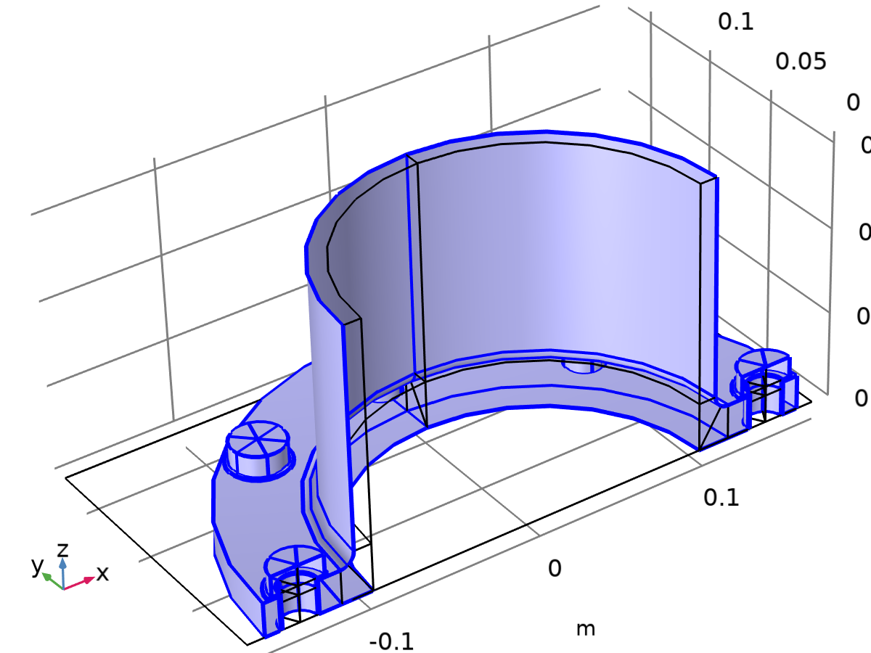

Free 1

Selection

|  |  |
| --- | --- |
| Geometric entity level | Boundary |
| Selection | Geometry geom1: Dimension 2: All boundaries |

Used products

|  |
| --- |
| COMSOL Multiphysics |

### Initial Values 1



Initial Values 1

Selection

|  |  |
| --- | --- |
| Geometric entity level | Domain |
| Selection | Geometry geom1: Dimension 3: All domains |

#### Initial Values

Settings

| **Description** | **Value** | **Unit** |
| --- | --- | --- |
| Displacement field, X-component | 0 | m |
| Displacement field, Y-component | 0 | m |
| Displacement field, Z-component | 0 | m |
| Structural velocity field, X-component | 0 | m/s |
| Structural velocity field, Y-component | 0 | m/s |
| Structural velocity field, Z-component | 0 | m/s |

#### Coordinate System Selection

Settings

| **Description** | **Value** |
| --- | --- |
| Coordinate system | Global coordinate system |

Used products

|  |
| --- |
| COMSOL Multiphysics |

#### Variables

| **Name** | **Expression** | **Unit** | **Description** | **Selection** |
| --- | --- | --- | --- | --- |
| solid.init1.u1 | 0 | m | Initial value of displacement, 1-component | Domains 1–81 |
| solid.init1.u2 | 0 | m | Initial value of displacement, 2-component | Domains 1–81 |
| solid.init1.u3 | 0 | m | Initial value of displacement, 3-component | Domains 1–81 |
| solid.init1.ut1 | 0 | m/s | Initial value of structural velocity, 1-component | Domains 1–81 |
| solid.init1.ut2 | 0 | m/s | Initial value of structural velocity, 2-component | Domains 1–81 |
| solid.init1.ut3 | 0 | m/s | Initial value of structural velocity, 3-component | Domains 1–81 |
| solid.uInitx | solid.init1.u1 | m | Initial value of displacement, x-component | Domains 1–81 |
| solid.uInity | solid.init1.u2 | m | Initial value of displacement, y-component | Domains 1–81 |
| solid.uInitz | solid.init1.u3 | m | Initial value of displacement, z-component | Domains 1–81 |
| solid.utInitx | solid.init1.ut1 | m/s | Initial value of structural velocity, x-component | Domains 1–81 |
| solid.utInity | solid.init1.ut2 | m/s | Initial value of structural velocity, y-component | Domains 1–81 |
| solid.utInitz | solid.init1.ut3 | m/s | Initial value of structural velocity, z-component | Domains 1–81 |

### Contact 1

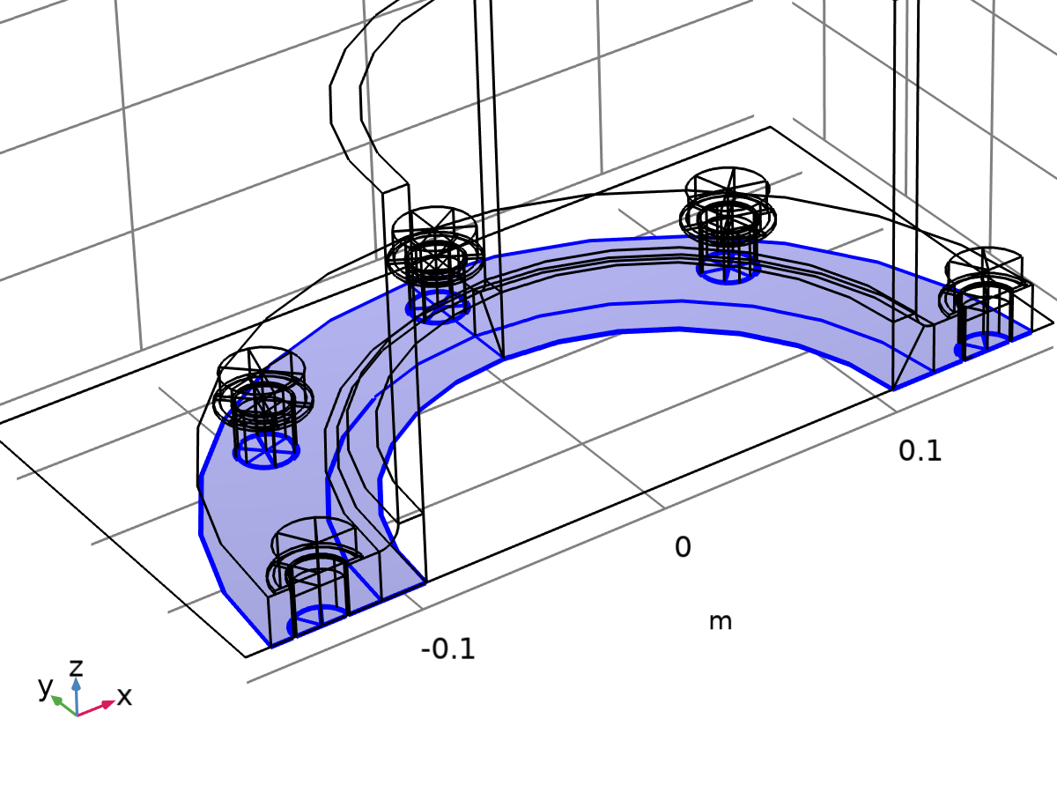

Contact 1

Selection

|  |  |
| --- | --- |
| Geometric entity level | Boundary |
| Selection | Geometry geom1: Dimension 2: All boundaries |

Equations

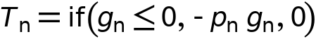

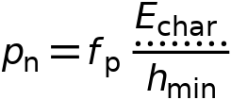

#### Contact Method

Settings

| **Description** | **Value** |
| --- | --- |
| Contact method | Penalty |
| Disconnect pair | Off |

#### Contact Pressure Penalty Factor

Settings

| **Description** | **Value** |
| --- | --- |
| Penalty factor control | Automatic |
| Offset penalty function | Off |

#### Trigger Cutback

Settings

| **Description** | **Value** |
| --- | --- |
| Trigger cutback | Off |

#### Contact Surface Offset and Adjustment

Settings

| **Description** | **Value** | **Unit** |
| --- | --- | --- |
| Offset from destination surface | 0 | m |
| Offset from source surface | 0 | m |
| Force zero initial gap | Off |  |

#### Variables

| **Name** | **Expression** | **Unit** | **Description** | **Selection** | **Details** |
| --- | --- | --- | --- | --- | --- |
| nsign_ap1 | 1 | m² | Contact normal orientation | Boundaries 4, 12, 32, 40 |  |
| ap1.offset | 0 | m | Offset from contact surface | Boundaries 4, 12, 32, 40 | + operation |
| ap1.x | solid.x | m | Contact surface position, 1-component | Boundaries 4, 12, 32, 40 |  |
| ap1.y | solid.y | m | Contact surface position, 2-component | Boundaries 4, 12, 32, 40 |  |
| ap1.z | solid.z | m | Contact surface position, 3-component | Boundaries 4, 12, 32, 40 |  |
| ap1.X | solid.X | m | Contact surface initial position, 1-component | Boundaries 4, 12, 32, 40 |  |
| ap1.Y | solid.Y | m | Contact surface initial position, 2-component | Boundaries 4, 12, 32, 40 |  |
| ap1.Z | solid.Z | m | Contact surface initial position, 3-component | Boundaries 4, 12, 32, 40 |  |
| ap1.ux | solid.uf | m | Displacement, x-component | Boundaries 4, 12, 32, 40 |  |
| ap1.uy | solid.vf | m | Displacement, y-component | Boundaries 4, 12, 32, 40 |  |
| ap1.uz | solid.wf | m | Displacement, z-component | Boundaries 4, 12, 32, 40 |  |
| incontact_ap1 | solid.gap_ap1<solid.dcnt1.tolcontact | 1 | In contact control variable | Boundaries 4, 12, 32, 40 |  |
| nsign_ap5 | 1 | m² | Contact normal orientation | Boundaries 162, 173, 180, 206–207, 217, 228, 236–237, 272–273, 283, 294, 302–303, 338–339, 349, 360, 368–369, 396, 407, 414 |  |
| ap5.offset | 0 | m | Offset from contact surface | Boundaries 162, 173, 180, 206–207, 217, 228, 236–237, 272–273, 283, 294, 302–303, 338–339, 349, 360, 368–369, 396, 407, 414 | + operation |
| ap5.x | solid.x | m | Contact surface position, 1-component | Boundaries 162, 173, 180, 206–207, 217, 228, 236–237, 272–273, 283, 294, 302–303, 338–339, 349, 360, 368–369, 396, 407, 414 |  |
| ap5.y | solid.y | m | Contact surface position, 2-component | Boundaries 162, 173, 180, 206–207, 217, 228, 236–237, 272–273, 283, 294, 302–303, 338–339, 349, 360, 368–369, 396, 407, 414 |  |
| ap5.z | solid.z | m | Contact surface position, 3-component | Boundaries 162, 173, 180, 206–207, 217, 228, 236–237, 272–273, 283, 294, 302–303, 338–339, 349, 360, 368–369, 396, 407, 414 |  |
| ap5.X | solid.X | m | Contact surface initial position, 1-component | Boundaries 162, 173, 180, 206–207, 217, 228, 236–237, 272–273, 283, 294, 302–303, 338–339, 349, 360, 368–369, 396, 407, 414 |  |
| ap5.Y | solid.Y | m | Contact surface initial position, 2-component | Boundaries 162, 173, 180, 206–207, 217, 228, 236–237, 272–273, 283, 294, 302–303, 338–339, 349, 360, 368–369, 396, 407, 414 |  |
| ap5.Z | solid.Z | m | Contact surface initial position, 3-component | Boundaries 162, 173, 180, 206–207, 217, 228, 236–237, 272–273, 283, 294, 302–303, 338–339, 349, 360, 368–369, 396, 407, 414 |  |
| ap5.ux | solid.uf | m | Displacement, x-component | Boundaries 162, 173, 180, 206–207, 217, 228, 236–237, 272–273, 283, 294, 302–303, 338–339, 349, 360, 368–369, 396, 407, 414 |  |
| ap5.uy | solid.vf | m | Displacement, y-component | Boundaries 162, 173, 180, 206–207, 217, 228, 236–237, 272–273, 283, 294, 302–303, 338–339, 349, 360, 368–369, 396, 407, 414 |  |
| ap5.uz | solid.wf | m | Displacement, z-component | Boundaries 162, 173, 180, 206–207, 217, 228, 236–237, 272–273, 283, 294, 302–303, 338–339, 349, 360, 368–369, 396, 407, 414 |  |
| incontact_ap5 | solid.gap_ap5<solid.dcnt1.tolcontact | 1 | In contact control variable | Boundaries 162, 173, 180, 206–207, 217, 228, 236–237, 272–273, 283, 294, 302–303, 338–339, 349, 360, 368–369, 396, 407, 414 |  |
| solid.incontact | solid.dcnt1.incontact | 1 | In contact control variable | Points 5, 7, 9, 11, 13, 15, 18, 22, 24, 27, 29, 31, 33, 35, 41, 43, 45, 47, 49, 51, 53, 55, 57, 60, 64, 67, 69, 71, 73, 75, 77, 185, 190, 193, 197, 202, 211, 214, 219, 222, 226, 231, 234, 245, 248, 253, 256, 260, 265, 268, 279, 282, 287, 290, 294, 299, 302, 311, 316, 319, 323, 328 | || operation |
| solid.incontact | solid.dcnt1.incontact | 1 | In contact control variable | Edges 6–7, 11, 14, 17, 20, 23–24, 31–32, 41, 44, 49, 53–54, 58, 62–63, 76–77, 80, 82–83, 87, 90, 94–95, 99, 103, 108, 115, 118, 121, 124, 127, 336–337, 349–350, 357–358, 368, 393–395, 404–405, 417–418, 425–427, 440, 449, 474–476, 485–486, 498–499, 506–508, 521, 530, 555–557, 566–567, 579–580, 587–589, 602, 611, 629–630, 642–643, 650–651, 661 | || operation |
| solid.incontact | solid.dcnt1.incontact | 1 | In contact control variable | Boundaries 4, 12, 32, 40, 162, 173, 180, 206–207, 217, 228, 236–237, 272–273, 283, 294, 302–303, 338–339, 349, 360, 368–369, 396, 407, 414 | || operation |
| solid.Wh_tot | solid.dcnt1.int(if(isdefined(solid.dcnt1.Wcnt_ap1),solid.dcnt1.gsa_ap1*solid.dcnt1.Wcnt_ap1,0))+solid.dcnt1.int(if(isdefined(solid.dcnt1.Wcnt_ap5),solid.dcnt1.gsa_ap5*solid.dcnt1.Wcnt_ap5,0)) | J | Total stored energy | Global | + operation |
| solid.gap_I | if(isinf(solid.gap_ap1),0,solid.gap_ap1) | m | Intermediate gap variable | Boundaries 4, 12, 32, 40 | + operation |
| solid.gap_I | if(isinf(solid.gap_ap5),0,solid.gap_ap5) | m | Intermediate gap variable | Boundaries 162, 173, 180, 206–207, 217, 228, 236–237, 272–273, 283, 294, 302–303, 338–339, 349, 360, 368–369, 396, 407, 414 | + operation |
| solid.gap | if(solid.nCont==solid.nInfCont,Inf,solid.gap_I) | m | Gap distance including offsets | Boundaries 4, 12, 32, 40 |  |
| solid.gap | if(solid.nCont==solid.nInfCont,Inf,solid.gap_I) | m | Gap distance including offsets | Boundaries 162, 173, 180, 206–207, 217, 228, 236–237, 272–273, 283, 294, 302–303, 338–339, 349, 360, 368–369, 396, 407, 414 |  |
| solid.hmin_dst | solid.dcnt1.min_dst(h) | m | Minimum mesh size on destination | Boundaries 4, 12, 32, 40 |  |
| solid.hmin_dst | solid.dcnt1.min_dst(h) | m | Minimum mesh size on destination | Boundaries 162, 173, 180, 206–207, 217, 228, 236–237, 272–273, 283, 294, 302–303, 338–339, 349, 360, 368–369, 396, 407, 414 |  |
| solid.Tnx | if(isdefined(solid.dcnt1.Tnx_ap1),solid.dcnt1.Tnx_ap1,0) | N/m² | Contact pressure, x-component | Boundaries 4, 12, 32, 40 | + operation |
| solid.Tny | if(isdefined(solid.dcnt1.Tny_ap1),solid.dcnt1.Tny_ap1,0) | N/m² | Contact pressure, y-component | Boundaries 4, 12, 32, 40 | + operation |
| solid.Tnz | if(isdefined(solid.dcnt1.Tnz_ap1),solid.dcnt1.Tnz_ap1,0) | N/m² | Contact pressure, z-component | Boundaries 4, 12, 32, 40 | + operation |
| solid.Tnx | if(isdefined(solid.dcnt1.Tnx_ap5),solid.dcnt1.Tnx_ap5,0) | N/m² | Contact pressure, x-component | Boundaries 162, 173, 180, 206–207, 217, 228, 236–237, 272–273, 283, 294, 302–303, 338–339, 349, 360, 368–369, 396, 407, 414 | + operation |
| solid.Tny | if(isdefined(solid.dcnt1.Tny_ap5),solid.dcnt1.Tny_ap5,0) | N/m² | Contact pressure, y-component | Boundaries 162, 173, 180, 206–207, 217, 228, 236–237, 272–273, 283, 294, 302–303, 338–339, 349, 360, 368–369, 396, 407, 414 | + operation |
| solid.Tnz | if(isdefined(solid.dcnt1.Tnz_ap5),solid.dcnt1.Tnz_ap5,0) | N/m² | Contact pressure, z-component | Boundaries 162, 173, 180, 206–207, 217, 228, 236–237, 272–273, 283, 294, 302–303, 338–339, 349, 360, 368–369, 396, 407, 414 | + operation |
| solid.Tn_totx | solid.dcnt1.Tn_totx_ap1+solid.dcnt1.Tn_totx_ap5 | N | Total contact force, pressure contribution, x-component | Global | + operation |
| solid.Tn_toty | solid.dcnt1.Tn_toty_ap1+solid.dcnt1.Tn_toty_ap5 | N | Total contact force, pressure contribution, y-component | Global | + operation |
| solid.Tn_totz | solid.dcnt1.Tn_totz_ap1+solid.dcnt1.Tn_totz_ap5 | N | Total contact force, pressure contribution, z-component | Global | + operation |
| solid.T_totx | solid.dcnt1.T_totx_ap1+solid.dcnt1.T_totx_ap5 | N | Total contact force, x-component | Global | + operation |
| solid.T_toty | solid.dcnt1.T_toty_ap1+solid.dcnt1.T_toty_ap5 | N | Total contact force, y-component | Global | + operation |
| solid.T_totz | solid.dcnt1.T_totz_ap1+solid.dcnt1.T_totz_ap5 | N | Total contact force, z-component | Global | + operation |
| solid.Wcnt | if(isdefined(solid.dcnt1.Wcnt_ap1),solid.dcnt1.Wcnt_ap1,0) | J/m² | Contact energy density | Boundaries 4, 12, 32, 40 | + operation |
| solid.Wcnt | if(isdefined(solid.dcnt1.Wcnt_ap5),solid.dcnt1.Wcnt_ap5,0) | J/m² | Contact energy density | Boundaries 162, 173, 180, 206–207, 217, 228, 236–237, 272–273, 283, 294, 302–303, 338–339, 349, 360, 368–369, 396, 407, 414 | + operation |
| solid.Wcnt_tot | solid.dcnt1.int(if(isdefined(solid.dcnt1.Wcnt_ap1),solid.dcnt1.gsa_ap1*solid.dcnt1.Wcnt_ap1,0))+solid.dcnt1.int(if(isdefined(solid.dcnt1.Wcnt_ap5),solid.dcnt1.gsa_ap5*solid.dcnt1.Wcnt_ap5,0)) | J | Total contact energy | Global | + operation |
| solid.Tn | if(isdefined(solid.Tn_ap1),solid.Tn_ap1,0) | N/m² | Contact pressure | Boundaries 4, 12, 32, 40 | + operation |
| solid.Tn | if(isdefined(solid.Tn_ap5),solid.Tn_ap5,0) | N/m² | Contact pressure | Boundaries 162, 173, 180, 206–207, 217, 228, 236–237, 272–273, 283, 294, 302–303, 338–339, 349, 360, 368–369, 396, 407, 414 | + operation |
| solid.dcnt1.incontact | incontact_ap1 | 1 | In contact control variable | Boundaries 4, 12, 32, 40 | || operation |
| solid.dcnt1.incontact | incontact_ap5 | 1 | In contact control variable | Boundaries 162, 173, 180, 206–207, 217, 228, 236–237, 272–273, 283, 294, 302–303, 338–339, 349, 360, 368–369, 396, 407, 414 | || operation |
| solid.dcnt1.E_char | solid.Eequ | Pa | Characteristic stiffness | Boundaries 4, 12, 32, 40, 162, 173, 180, 206–207, 217, 228, 236–237, 272–273, 283, 294, 302–303, 338–339, 349, 360, 368–369, 396, 407, 414 |  |
| solid.dcnt1.nx_ap1 | solid.nx | 1 | Contact surface normal direction, contact pair ap1, x component | Boundaries 4, 12, 32, 40 |  |
| solid.dcnt1.ny_ap1 | solid.ny | 1 | Contact surface normal direction, contact pair ap1, y component | Boundaries 4, 12, 32, 40 |  |
| solid.dcnt1.nz_ap1 | solid.nz | 1 | Contact surface normal direction, contact pair ap1, z component | Boundaries 4, 12, 32, 40 |  |
| solid.dcnt1.nx_ap5 | solid.nx | 1 | Contact surface normal direction, contact pair ap5, x component | Boundaries 162, 173, 180, 206–207, 217, 228, 236–237, 272–273, 283, 294, 302–303, 338–339, 349, 360, 368–369, 396, 407, 414 |  |
| solid.dcnt1.ny_ap5 | solid.ny | 1 | Contact surface normal direction, contact pair ap5, y component | Boundaries 162, 173, 180, 206–207, 217, 228, 236–237, 272–273, 283, 294, 302–303, 338–339, 349, 360, 368–369, 396, 407, 414 |  |
| solid.dcnt1.nz_ap5 | solid.nz | 1 | Contact surface normal direction, contact pair ap5, z component | Boundaries 162, 173, 180, 206–207, 217, 228, 236–237, 272–273, 283, 294, 302–303, 338–339, 349, 360, 368–369, 396, 407, 414 |  |
| solid.dcnt1.np_ap1 | if(src2dst_ap1,nojac(ap1.nx*src2dst_ap1(ap1.nx)+ap1.ny*src2dst_ap1(ap1.ny)+ap1.nz*src2dst_ap1(ap1.nz)),-1) | 1 | Source to destination normal correction factor, spatial frame | Boundaries 4, 12, 32, 40 |  |
| solid.dcnt1.np_ap5 | if(src2dst_ap5,nojac(ap5.nx*src2dst_ap5(ap5.nx)+ap5.ny*src2dst_ap5(ap5.ny)+ap5.nz*src2dst_ap5(ap5.nz)),-1) | 1 | Source to destination normal correction factor, spatial frame | Boundaries 162, 173, 180, 206–207, 217, 228, 236–237, 272–273, 283, 294, 302–303, 338–339, 349, 360, 368–369, 396, 407, 414 |  |
| solid.dcnt1.offset_ap1 | ap1.offset+if(src2dst_ap1&&ap1.hasSrcOffset,-src2dst_ap1(ap1.offset)/solid.dcnt1.np_ap1,0) | m | Total offset | Boundaries 4, 12, 32, 40 | + operation |
| solid.dcnt1.offset_ap5 | ap5.offset+if(src2dst_ap5&&ap5.hasSrcOffset,-src2dst_ap5(ap5.offset)/solid.dcnt1.np_ap5,0) | m | Total offset | Boundaries 162, 173, 180, 206–207, 217, 228, 236–237, 272–273, 283, 294, 302–303, 338–339, 349, 360, 368–369, 396, 407, 414 | + operation |
| solid.gap_ap1 | geomgap_dst_ap1-solid.dcnt1.offset_ap1 | m | Gap distance including offsets, contact pair ap1 | Boundaries 4, 12, 32, 40 |  |
| solid.gap_ap5 | geomgap_dst_ap5-solid.dcnt1.offset_ap5 | m | Gap distance including offsets, contact pair ap5 | Boundaries 162, 173, 180, 206–207, 217, 228, 236–237, 272–273, 283, 294, 302–303, 338–339, 349, 360, 368–369, 396, 407, 414 |  |
| solid.dcnt1.tolcontact | 1.0E-4*solid.dcnt1.geomsize | m | Multiphysics contact tolerance | Boundaries 4, 12, 32, 40, 162, 173, 180, 206–207, 217, 228, 236–237, 272–273, 283, 294, 302–303, 338–339, 349, 360, 368–369, 396, 407, 414 |  |
| solid.dcnt1.geomsize | 0.41386960782310445 | m | Bounding box | Global |  |
| solid.dcnt1.gap_I | if(isinf(solid.gap_ap1),0,solid.gap_ap1) | m | Intermediate gap variable | Boundaries 4, 12, 32, 40 | + operation |
| solid.dcnt1.gap_I | if(isinf(solid.gap_ap5),0,solid.gap_ap5) | m | Intermediate gap variable | Boundaries 162, 173, 180, 206–207, 217, 228, 236–237, 272–273, 283, 294, 302–303, 338–339, 349, 360, 368–369, 396, 407, 414 | + operation |
| solid.dcnt1.gap | if(solid.dcnt1.nCont==solid.dcnt1.nInfCont,Inf,solid.dcnt1.gap_I) | m | Gap distance including offsets | Boundaries 4, 12, 32, 40 |  |
| solid.dcnt1.gap | if(solid.dcnt1.nCont==solid.dcnt1.nInfCont,Inf,solid.dcnt1.gap_I) | m | Gap distance including offsets | Boundaries 162, 173, 180, 206–207, 217, 228, 236–237, 272–273, 283, 294, 302–303, 338–339, 349, 360, 368–369, 396, 407, 414 |  |
| solid.gapmin_ap1 | solid.dcnt1.min(if(isdefined(solid.gap_ap1),solid.gap_ap1,Inf)) | m | Minimum gap distance, contact pair ap1 | Global |  |
| solid.gapmin_ap5 | solid.dcnt1.min(if(isdefined(solid.gap_ap5),solid.gap_ap5,Inf)) | m | Minimum gap distance, contact pair ap5 | Global |  |
| solid.dcnt1.pn | solid.dcnt1.fp*solid.dcnt1.E_char/solid.hmin_dst | N/m³ | Contact pressure penalty factor | Boundaries 4, 12, 32, 40 |  |
| solid.dcnt1.pn | solid.dcnt1.fp*solid.dcnt1.E_char/solid.hmin_dst | N/m³ | Contact pressure penalty factor | Boundaries 162, 173, 180, 206–207, 217, 228, 236–237, 272–273, 283, 294, 302–303, 338–339, 349, 360, 368–369, 396, 407, 414 |  |
| solid.dcnt1.fp | 1 | 1 | Penalty factor multiplier | Boundaries 4, 12, 32, 40 |  |
| solid.dcnt1.fp | 1 | 1 | Penalty factor multiplier | Boundaries 162, 173, 180, 206–207, 217, 228, 236–237, 272–273, 283, 294, 302–303, 338–339, 349, 360, 368–369, 396, 407, 414 |  |
| solid.Tn_ap1 | if(solid.gap_ap1<=0,-solid.dcnt1.pn*solid.gap_ap1,0) | N/m² | Contact pressure, contact pair ap1 | Boundaries 4, 12, 32, 40 |  |
| solid.Tn_ap5 | if(solid.gap_ap5<=0,-solid.dcnt1.pn*solid.gap_ap5,0) | N/m² | Contact pressure, contact pair ap5 | Boundaries 162, 173, 180, 206–207, 217, 228, 236–237, 272–273, 283, 294, 302–303, 338–339, 349, 360, 368–369, 396, 407, 414 |  |
| solid.dcnt1.Tx_ap1 | -solid.Tn_ap1*ap1.nX | N/m² | Contact force, contact pair ap1, x component | Boundaries 4, 12, 32, 40 | + operation |
| solid.dcnt1.Ty_ap1 | -solid.Tn_ap1*ap1.nY | N/m² | Contact force, contact pair ap1, y component | Boundaries 4, 12, 32, 40 | + operation |
| solid.dcnt1.Tz_ap1 | -solid.Tn_ap1*ap1.nZ | N/m² | Contact force, contact pair ap1, z component | Boundaries 4, 12, 32, 40 | + operation |
| solid.dcnt1.Tx_ap5 | -solid.Tn_ap5*ap5.nX | N/m² | Contact force, contact pair ap5, x component | Boundaries 162, 173, 180, 206–207, 217, 228, 236–237, 272–273, 283, 294, 302–303, 338–339, 349, 360, 368–369, 396, 407, 414 | + operation |
| solid.dcnt1.Ty_ap5 | -solid.Tn_ap5*ap5.nY | N/m² | Contact force, contact pair ap5, y component | Boundaries 162, 173, 180, 206–207, 217, 228, 236–237, 272–273, 283, 294, 302–303, 338–339, 349, 360, 368–369, 396, 407, 414 | + operation |
| solid.dcnt1.Tz_ap5 | -solid.Tn_ap5*ap5.nZ | N/m² | Contact force, contact pair ap5, z component | Boundaries 162, 173, 180, 206–207, 217, 228, 236–237, 272–273, 283, 294, 302–303, 338–339, 349, 360, 368–369, 396, 407, 414 | + operation |
| solid.dcnt1.Tnx_ap1 | -ap1.nx*solid.Tn_ap1 | N/m² | Contact pressure, contact pair ap1, x component | Boundaries 4, 12, 32, 40 |  |
| solid.dcnt1.Tny_ap1 | -ap1.ny*solid.Tn_ap1 | N/m² | Contact pressure, contact pair ap1, y component | Boundaries 4, 12, 32, 40 |  |
| solid.dcnt1.Tnz_ap1 | -ap1.nz*solid.Tn_ap1 | N/m² | Contact pressure, contact pair ap1, z component | Boundaries 4, 12, 32, 40 |  |
| solid.dcnt1.Tnx_ap5 | -ap5.nx*solid.Tn_ap5 | N/m² | Contact pressure, contact pair ap5, x component | Boundaries 162, 173, 180, 206–207, 217, 228, 236–237, 272–273, 283, 294, 302–303, 338–339, 349, 360, 368–369, 396, 407, 414 |  |
| solid.dcnt1.Tny_ap5 | -ap5.ny*solid.Tn_ap5 | N/m² | Contact pressure, contact pair ap5, y component | Boundaries 162, 173, 180, 206–207, 217, 228, 236–237, 272–273, 283, 294, 302–303, 338–339, 349, 360, 368–369, 396, 407, 414 |  |
| solid.dcnt1.Tnz_ap5 | -ap5.nz*solid.Tn_ap5 | N/m² | Contact pressure, contact pair ap5, z component | Boundaries 162, 173, 180, 206–207, 217, 228, 236–237, 272–273, 283, 294, 302–303, 338–339, 349, 360, 368–369, 396, 407, 414 |  |
| solid.dcnt1.Tn_totx_ap1 | solid.dcnt1.int(if(isdefined(solid.Tn_ap1),solid.dcnt1.gsa_ap1*solid.dcnt1.Tnx_ap1,0)) | N | Total contact force, pressure contribution, contact pair ap1, x component | Global |  |
| solid.dcnt1.Tn_toty_ap1 | solid.dcnt1.int(if(isdefined(solid.Tn_ap1),solid.dcnt1.gsa_ap1*solid.dcnt1.Tny_ap1,0)) | N | Total contact force, pressure contribution, contact pair ap1, y component | Global |  |
| solid.dcnt1.Tn_totz_ap1 | solid.dcnt1.int(if(isdefined(solid.Tn_ap1),solid.dcnt1.gsa_ap1*solid.dcnt1.Tnz_ap1,0)) | N | Total contact force, pressure contribution, contact pair ap1, z component | Global |  |
| solid.dcnt1.Tn_totx_ap5 | solid.dcnt1.int(if(isdefined(solid.Tn_ap5),solid.dcnt1.gsa_ap5*solid.dcnt1.Tnx_ap5,0)) | N | Total contact force, pressure contribution, contact pair ap5, x component | Global |  |
| solid.dcnt1.Tn_toty_ap5 | solid.dcnt1.int(if(isdefined(solid.Tn_ap5),solid.dcnt1.gsa_ap5*solid.dcnt1.Tny_ap5,0)) | N | Total contact force, pressure contribution, contact pair ap5, y component | Global |  |
| solid.dcnt1.Tn_totz_ap5 | solid.dcnt1.int(if(isdefined(solid.Tn_ap5),solid.dcnt1.gsa_ap5*solid.dcnt1.Tnz_ap5,0)) | N | Total contact force, pressure contribution, contact pair ap5, z component | Global |  |
| solid.dcnt1.T_totx_ap1 | solid.dcnt1.Tn_totx_ap1 | N | Total contact force, contact pair ap1, x component | Global | + operation |
| solid.dcnt1.T_toty_ap1 | solid.dcnt1.Tn_toty_ap1 | N | Total contact force, contact pair ap1, y component | Global | + operation |
| solid.dcnt1.T_totz_ap1 | solid.dcnt1.Tn_totz_ap1 | N | Total contact force, contact pair ap1, z component | Global | + operation |
| solid.dcnt1.T_totx_ap5 | solid.dcnt1.Tn_totx_ap5 | N | Total contact force, contact pair ap5, x component | Global | + operation |
| solid.dcnt1.T_toty_ap5 | solid.dcnt1.Tn_toty_ap5 | N | Total contact force, contact pair ap5, y component | Global | + operation |
| solid.dcnt1.T_totz_ap5 | solid.dcnt1.Tn_totz_ap5 | N | Total contact force, contact pair ap5, z component | Global | + operation |
| solid.dcnt1.T_0 | 0 | N/m² | Contact pressure at zero gap | Boundaries 4, 12, 32, 40 |  |
| solid.dcnt1.T_0 | 0 | N/m² | Contact pressure at zero gap | Boundaries 162, 173, 180, 206–207, 217, 228, 236–237, 272–273, 283, 294, 302–303, 338–339, 349, 360, 368–369, 396, 407, 414 |  |
| solid.dcnt1.Tn | if(isdefined(solid.Tn_ap1),solid.Tn_ap1,0) | N/m² | Contact pressure | Boundaries 4, 12, 32, 40 | + operation |
| solid.dcnt1.Tn | if(isdefined(solid.Tn_ap5),solid.Tn_ap5,0) | N/m² | Contact pressure | Boundaries 162, 173, 180, 206–207, 217, 228, 236–237, 272–273, 283, 294, 302–303, 338–339, 349, 360, 368–369, 396, 407, 414 | + operation |
| solid.dcnt1.Tnx | if(isdefined(solid.dcnt1.Tnx_ap1),solid.dcnt1.Tnx_ap1,0) | N/m² | Contact pressure, x-component | Boundaries 4, 12, 32, 40 | + operation |
| solid.dcnt1.Tny | if(isdefined(solid.dcnt1.Tny_ap1),solid.dcnt1.Tny_ap1,0) | N/m² | Contact pressure, y-component | Boundaries 4, 12, 32, 40 | + operation |
| solid.dcnt1.Tnz | if(isdefined(solid.dcnt1.Tnz_ap1),solid.dcnt1.Tnz_ap1,0) | N/m² | Contact pressure, z-component | Boundaries 4, 12, 32, 40 | + operation |
| solid.dcnt1.Tnx | if(isdefined(solid.dcnt1.Tnx_ap5),solid.dcnt1.Tnx_ap5,0) | N/m² | Contact pressure, x-component | Boundaries 162, 173, 180, 206–207, 217, 228, 236–237, 272–273, 283, 294, 302–303, 338–339, 349, 360, 368–369, 396, 407, 414 | + operation |
| solid.dcnt1.Tny | if(isdefined(solid.dcnt1.Tny_ap5),solid.dcnt1.Tny_ap5,0) | N/m² | Contact pressure, y-component | Boundaries 162, 173, 180, 206–207, 217, 228, 236–237, 272–273, 283, 294, 302–303, 338–339, 349, 360, 368–369, 396, 407, 414 | + operation |
| solid.dcnt1.Tnz | if(isdefined(solid.dcnt1.Tnz_ap5),solid.dcnt1.Tnz_ap5,0) | N/m² | Contact pressure, z-component | Boundaries 162, 173, 180, 206–207, 217, 228, 236–237, 272–273, 283, 294, 302–303, 338–339, 349, 360, 368–369, 396, 407, 414 | + operation |
| solid.dcnt1.Tn_totx | solid.dcnt1.Tn_totx_ap1+solid.dcnt1.Tn_totx_ap5 | N | Total contact force, pressure contribution, x-component | Global | + operation |
| solid.dcnt1.Tn_toty | solid.dcnt1.Tn_toty_ap1+solid.dcnt1.Tn_toty_ap5 | N | Total contact force, pressure contribution, y-component | Global | + operation |
| solid.dcnt1.Tn_totz | solid.dcnt1.Tn_totz_ap1+solid.dcnt1.Tn_totz_ap5 | N | Total contact force, pressure contribution, z-component | Global | + operation |
| solid.dcnt1.T_totx | solid.dcnt1.T_totx_ap1+solid.dcnt1.T_totx_ap5 | N | Total contact force, x-component | Global | + operation |
| solid.dcnt1.T_toty | solid.dcnt1.T_toty_ap1+solid.dcnt1.T_toty_ap5 | N | Total contact force, y-component | Global | + operation |
| solid.dcnt1.T_totz | solid.dcnt1.T_totz_ap1+solid.dcnt1.T_totz_ap5 | N | Total contact force, z-component | Global | + operation |
| solid.Tnmax_ap1 | solid.dcnt1.max(if(isdefined(solid.gap_ap1),solid.Tn_ap1,0)) | N/m² | Maximum contact pressure, contact pair ap1 | Global |  |
| solid.Tnmax_ap5 | solid.dcnt1.max(if(isdefined(solid.gap_ap5),solid.Tn_ap5,0)) | N/m² | Maximum contact pressure, contact pair ap5 | Global |  |
| solid.dcnt1.Wcnt_ap1 | 0.5*solid.Tn_ap1*if(isinf(solid.gap_ap1),0,sign(solid.gap_ap1)*solid.gap_ap1) | J/m² | Contact energy density, contact pair ap1 | Boundaries 4, 12, 32, 40 |  |
| solid.dcnt1.Wcnt_ap5 | 0.5*solid.Tn_ap5*if(isinf(solid.gap_ap5),0,sign(solid.gap_ap5)*solid.gap_ap5) | J/m² | Contact energy density, contact pair ap5 | Boundaries 162, 173, 180, 206–207, 217, 228, 236–237, 272–273, 283, 294, 302–303, 338–339, 349, 360, 368–369, 396, 407, 414 |  |
| solid.dcnt1.Wcnt | if(isdefined(solid.dcnt1.Wcnt_ap1),solid.dcnt1.Wcnt_ap1,0) | J/m² | Contact energy density | Boundaries 4, 12, 32, 40 | + operation |
| solid.dcnt1.Wcnt | if(isdefined(solid.dcnt1.Wcnt_ap5),solid.dcnt1.Wcnt_ap5,0) | J/m² | Contact energy density | Boundaries 162, 173, 180, 206–207, 217, 228, 236–237, 272–273, 283, 294, 302–303, 338–339, 349, 360, 368–369, 396, 407, 414 | + operation |
| solid.dcnt1.isContact_ap1 | incontact_ap1 | 1 | Contact variable, contact pair ap1 | Boundaries 4, 12, 32, 40 |  |
| solid.dcnt1.isContact_ap5 | incontact_ap5 | 1 | Contact variable, contact pair ap5 | Boundaries 162, 173, 180, 206–207, 217, 228, 236–237, 272–273, 283, 294, 302–303, 338–339, 349, 360, 368–369, 396, 407, 414 |  |
| ap1.hasSrcOffset | 0 | 1 | Has source offset | Global | || operation |
| ap5.hasSrcOffset | 0 | 1 | Has source offset | Global | || operation |
| solid.dcnt1.dsign | 1 | 1 | Contact direction sign | Boundaries 4, 12, 32, 40, 162, 173, 180, 206–207, 217, 228, 236–237, 272–273, 283, 294, 302–303, 338–339, 349, 360, 368–369, 396, 407, 414 |  |
| solid.dcnt1.src2dstFtxX_ap1 | nojac(src2dst_ap1(dtang(x_ap1,X_ap1))) | 1 | Deformation gradient projected on the tangent plane, xX-component | Boundaries 4, 12, 32, 40 |  |
| solid.dcnt1.src2dstFtyX_ap1 | nojac(src2dst_ap1(dtang(y_ap1,X_ap1))) | 1 | Deformation gradient projected on the tangent plane, yX-component | Boundaries 4, 12, 32, 40 |  |
| solid.dcnt1.src2dstFtzX_ap1 | nojac(src2dst_ap1(dtang(z_ap1,X_ap1))) | 1 | Deformation gradient projected on the tangent plane, zX-component | Boundaries 4, 12, 32, 40 |  |
| solid.dcnt1.src2dstFtxY_ap1 | nojac(src2dst_ap1(dtang(x_ap1,Y_ap1))) | 1 | Deformation gradient projected on the tangent plane, xY-component | Boundaries 4, 12, 32, 40 |  |
| solid.dcnt1.src2dstFtyY_ap1 | nojac(src2dst_ap1(dtang(y_ap1,Y_ap1))) | 1 | Deformation gradient projected on the tangent plane, yY-component | Boundaries 4, 12, 32, 40 |  |
| solid.dcnt1.src2dstFtzY_ap1 | nojac(src2dst_ap1(dtang(z_ap1,Y_ap1))) | 1 | Deformation gradient projected on the tangent plane, zY-component | Boundaries 4, 12, 32, 40 |  |
| solid.dcnt1.src2dstFtxZ_ap1 | nojac(src2dst_ap1(dtang(x_ap1,Z_ap1))) | 1 | Deformation gradient projected on the tangent plane, xZ-component | Boundaries 4, 12, 32, 40 |  |
| solid.dcnt1.src2dstFtyZ_ap1 | nojac(src2dst_ap1(dtang(y_ap1,Z_ap1))) | 1 | Deformation gradient projected on the tangent plane, yZ-component | Boundaries 4, 12, 32, 40 |  |
| solid.dcnt1.src2dstFtzZ_ap1 | nojac(src2dst_ap1(dtang(z_ap1,Z_ap1))) | 1 | Deformation gradient projected on the tangent plane, zZ-component | Boundaries 4, 12, 32, 40 |  |
| solid.dcnt1.src2dstFtxX_ap5 | nojac(src2dst_ap5(dtang(x_ap5,X_ap5))) | 1 | Deformation gradient projected on the tangent plane, xX-component | Boundaries 162, 173, 180, 206–207, 217, 228, 236–237, 272–273, 283, 294, 302–303, 338–339, 349, 360, 368–369, 396, 407, 414 |  |
| solid.dcnt1.src2dstFtyX_ap5 | nojac(src2dst_ap5(dtang(y_ap5,X_ap5))) | 1 | Deformation gradient projected on the tangent plane, yX-component | Boundaries 162, 173, 180, 206–207, 217, 228, 236–237, 272–273, 283, 294, 302–303, 338–339, 349, 360, 368–369, 396, 407, 414 |  |
| solid.dcnt1.src2dstFtzX_ap5 | nojac(src2dst_ap5(dtang(z_ap5,X_ap5))) | 1 | Deformation gradient projected on the tangent plane, zX-component | Boundaries 162, 173, 180, 206–207, 217, 228, 236–237, 272–273, 283, 294, 302–303, 338–339, 349, 360, 368–369, 396, 407, 414 |  |
| solid.dcnt1.src2dstFtxY_ap5 | nojac(src2dst_ap5(dtang(x_ap5,Y_ap5))) | 1 | Deformation gradient projected on the tangent plane, xY-component | Boundaries 162, 173, 180, 206–207, 217, 228, 236–237, 272–273, 283, 294, 302–303, 338–339, 349, 360, 368–369, 396, 407, 414 |  |
| solid.dcnt1.src2dstFtyY_ap5 | nojac(src2dst_ap5(dtang(y_ap5,Y_ap5))) | 1 | Deformation gradient projected on the tangent plane, yY-component | Boundaries 162, 173, 180, 206–207, 217, 228, 236–237, 272–273, 283, 294, 302–303, 338–339, 349, 360, 368–369, 396, 407, 414 |  |
| solid.dcnt1.src2dstFtzY_ap5 | nojac(src2dst_ap5(dtang(z_ap5,Y_ap5))) | 1 | Deformation gradient projected on the tangent plane, zY-component | Boundaries 162, 173, 180, 206–207, 217, 228, 236–237, 272–273, 283, 294, 302–303, 338–339, 349, 360, 368–369, 396, 407, 414 |  |
| solid.dcnt1.src2dstFtxZ_ap5 | nojac(src2dst_ap5(dtang(x_ap5,Z_ap5))) | 1 | Deformation gradient projected on the tangent plane, xZ-component | Boundaries 162, 173, 180, 206–207, 217, 228, 236–237, 272–273, 283, 294, 302–303, 338–339, 349, 360, 368–369, 396, 407, 414 |  |
| solid.dcnt1.src2dstFtyZ_ap5 | nojac(src2dst_ap5(dtang(y_ap5,Z_ap5))) | 1 | Deformation gradient projected on the tangent plane, yZ-component | Boundaries 162, 173, 180, 206–207, 217, 228, 236–237, 272–273, 283, 294, 302–303, 338–339, 349, 360, 368–369, 396, 407, 414 |  |
| solid.dcnt1.src2dstFtzZ_ap5 | nojac(src2dst_ap5(dtang(z_ap5,Z_ap5))) | 1 | Deformation gradient projected on the tangent plane, zZ-component | Boundaries 162, 173, 180, 206–207, 217, 228, 236–237, 272–273, 283, 294, 302–303, 338–339, 349, 360, 368–369, 396, 407, 414 |  |
| solid.dcnt1.src2dstinvFtXx_ap1 | nojac(src2dst_ap1(dtang(X_ap1,x_ap1))) | 1 | Inverse deformation gradient projected on the tangent plane, Xx-component | Boundaries 4, 12, 32, 40 |  |
| solid.dcnt1.src2dstinvFtYx_ap1 | nojac(src2dst_ap1(dtang(Y_ap1,x_ap1))) | 1 | Inverse deformation gradient projected on the tangent plane, Yx-component | Boundaries 4, 12, 32, 40 |  |
| solid.dcnt1.src2dstinvFtZx_ap1 | nojac(src2dst_ap1(dtang(Z_ap1,x_ap1))) | 1 | Inverse deformation gradient projected on the tangent plane, Zx-component | Boundaries 4, 12, 32, 40 |  |
| solid.dcnt1.src2dstinvFtXy_ap1 | nojac(src2dst_ap1(dtang(X_ap1,y_ap1))) | 1 | Inverse deformation gradient projected on the tangent plane, Xy-component | Boundaries 4, 12, 32, 40 |  |
| solid.dcnt1.src2dstinvFtYy_ap1 | nojac(src2dst_ap1(dtang(Y_ap1,y_ap1))) | 1 | Inverse deformation gradient projected on the tangent plane, Yy-component | Boundaries 4, 12, 32, 40 |  |
| solid.dcnt1.src2dstinvFtZy_ap1 | nojac(src2dst_ap1(dtang(Z_ap1,y_ap1))) | 1 | Inverse deformation gradient projected on the tangent plane, Zy-component | Boundaries 4, 12, 32, 40 |  |
| solid.dcnt1.src2dstinvFtXz_ap1 | nojac(src2dst_ap1(dtang(X_ap1,z_ap1))) | 1 | Inverse deformation gradient projected on the tangent plane, Xz-component | Boundaries 4, 12, 32, 40 |  |
| solid.dcnt1.src2dstinvFtYz_ap1 | nojac(src2dst_ap1(dtang(Y_ap1,z_ap1))) | 1 | Inverse deformation gradient projected on the tangent plane, Yz-component | Boundaries 4, 12, 32, 40 |  |
| solid.dcnt1.src2dstinvFtZz_ap1 | nojac(src2dst_ap1(dtang(Z_ap1,z_ap1))) | 1 | Inverse deformation gradient projected on the tangent plane, Zz-component | Boundaries 4, 12, 32, 40 |  |
| solid.dcnt1.src2dstinvFtXx_ap5 | nojac(src2dst_ap5(dtang(X_ap5,x_ap5))) | 1 | Inverse deformation gradient projected on the tangent plane, Xx-component | Boundaries 162, 173, 180, 206–207, 217, 228, 236–237, 272–273, 283, 294, 302–303, 338–339, 349, 360, 368–369, 396, 407, 414 |  |
| solid.dcnt1.src2dstinvFtYx_ap5 | nojac(src2dst_ap5(dtang(Y_ap5,x_ap5))) | 1 | Inverse deformation gradient projected on the tangent plane, Yx-component | Boundaries 162, 173, 180, 206–207, 217, 228, 236–237, 272–273, 283, 294, 302–303, 338–339, 349, 360, 368–369, 396, 407, 414 |  |
| solid.dcnt1.src2dstinvFtZx_ap5 | nojac(src2dst_ap5(dtang(Z_ap5,x_ap5))) | 1 | Inverse deformation gradient projected on the tangent plane, Zx-component | Boundaries 162, 173, 180, 206–207, 217, 228, 236–237, 272–273, 283, 294, 302–303, 338–339, 349, 360, 368–369, 396, 407, 414 |  |
| solid.dcnt1.src2dstinvFtXy_ap5 | nojac(src2dst_ap5(dtang(X_ap5,y_ap5))) | 1 | Inverse deformation gradient projected on the tangent plane, Xy-component | Boundaries 162, 173, 180, 206–207, 217, 228, 236–237, 272–273, 283, 294, 302–303, 338–339, 349, 360, 368–369, 396, 407, 414 |  |
| solid.dcnt1.src2dstinvFtYy_ap5 | nojac(src2dst_ap5(dtang(Y_ap5,y_ap5))) | 1 | Inverse deformation gradient projected on the tangent plane, Yy-component | Boundaries 162, 173, 180, 206–207, 217, 228, 236–237, 272–273, 283, 294, 302–303, 338–339, 349, 360, 368–369, 396, 407, 414 |  |
| solid.dcnt1.src2dstinvFtZy_ap5 | nojac(src2dst_ap5(dtang(Z_ap5,y_ap5))) | 1 | Inverse deformation gradient projected on the tangent plane, Zy-component | Boundaries 162, 173, 180, 206–207, 217, 228, 236–237, 272–273, 283, 294, 302–303, 338–339, 349, 360, 368–369, 396, 407, 414 |  |
| solid.dcnt1.src2dstinvFtXz_ap5 | nojac(src2dst_ap5(dtang(X_ap5,z_ap5))) | 1 | Inverse deformation gradient projected on the tangent plane, Xz-component | Boundaries 162, 173, 180, 206–207, 217, 228, 236–237, 272–273, 283, 294, 302–303, 338–339, 349, 360, 368–369, 396, 407, 414 |  |
| solid.dcnt1.src2dstinvFtYz_ap5 | nojac(src2dst_ap5(dtang(Y_ap5,z_ap5))) | 1 | Inverse deformation gradient projected on the tangent plane, Yz-component | Boundaries 162, 173, 180, 206–207, 217, 228, 236–237, 272–273, 283, 294, 302–303, 338–339, 349, 360, 368–369, 396, 407, 414 |  |
| solid.dcnt1.src2dstinvFtZz_ap5 | nojac(src2dst_ap5(dtang(Z_ap5,z_ap5))) | 1 | Inverse deformation gradient projected on the tangent plane, Zz-component | Boundaries 162, 173, 180, 206–207, 217, 228, 236–237, 272–273, 283, 294, 302–303, 338–339, 349, 360, 368–369, 396, 407, 414 |  |
| solid.dcnt1.gsa_ap1 | dvol_material_ap1/dvol | 1 | Geometry scale factor (area) | Boundaries 4, 12, 32, 40 |  |
| solid.dcnt1.gsa_ap5 | dvol_material_ap5/dvol | 1 | Geometry scale factor (area) | Boundaries 162, 173, 180, 206–207, 217, 228, 236–237, 272–273, 283, 294, 302–303, 338–339, 349, 360, 368–369, 396, 407, 414 |  |

#### Weak Expressions

| **Weak expression** | **Integration order** | **Integration frame** | **Selection** |
| --- | --- | --- | --- |
| if(solid.Tn_ap1>0,solid.Tn_ap1*test(solid.gap_ap1)*solid.dcnt1.gsa_ap1,0) | 4 | Material | Boundaries 4, 12, 32, 40 |
| if(solid.Tn_ap5>0,solid.Tn_ap5*test(solid.gap_ap5)*solid.dcnt1.gsa_ap5,0) | 4 | Material | Boundaries 162, 173, 180, 206–207, 217, 228, 236–237, 272–273, 283, 294, 302–303, 338–339, 349, 360, 368–369, 396, 407, 414 |

### Continuity 1

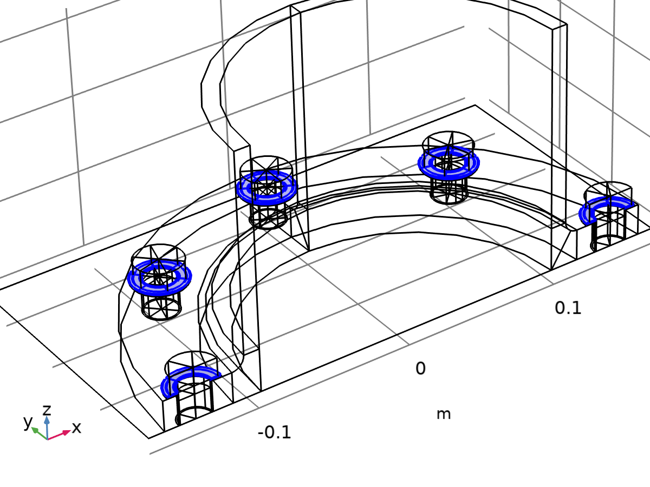

Continuity 1

Selection

|  |  |
| --- | --- |
| Geometric entity level | Boundary |
| Selection | Geometry geom1: Dimension 2: All boundaries |

#### Constraint Settings

Settings

| **Description** | **Value** |
| --- | --- |
| Constraint | Pointwise constraints |
| Apply reaction terms on | All physics (symmetric) |
| Constraint method | Nodal |

#### Advanced

Settings

| **Description** | **Value** |
| --- | --- |
| Disconnect pair | Off |

Used products

|  |
| --- |
| COMSOL Multiphysics |

#### Variables

| **Name** | **Expression** | **Unit** | **Description** | **Selection** | **Details** |
| --- | --- | --- | --- | --- | --- |
| solid.incontact | solid.dcont1.incontact | 1 | In contact control variable | Points 80, 82, 84, 86, 88, 90, 92, 94, 96, 98, 100, 102, 104, 106, 108, 110, 112, 114, 116, 118, 120, 122, 124, 126, 128, 130, 132, 134, 136, 138, 140, 142, 144, 146, 148, 150, 152, 154, 156, 158, 160, 162, 164, 166, 168, 170, 172, 174, 176, 178, 180, 182–183, 187–188, 192, 199–200, 204–205, 207, 209, 213, 216–217, 221, 228–229, 233, 236–237, 239, 241, 243, 247, 250–251, 255, 262–263, 267, 270–271, 273, 275, 277, 281, 284–285, 289, 296–297, 301, 304–305, 307, 309, 313–314, 318, 325–326, 330–331 | || operation |
| solid.incontact | solid.dcont1.incontact | 1 | In contact control variable | Edges 133–134, 137, 141–142, 145, 149–150, 153, 156, 162–164, 168–169, 173–174, 177, 181–182, 185, 189–190, 193, 197–198, 201, 204, 210–212, 216–217, 221–222, 225, 229–230, 233, 237–238, 241, 245–246, 249, 252, 258–260, 264–265, 269–270, 273, 277–278, 281, 285–286, 289, 293–294, 297, 300, 305–306, 309, 313–314, 317, 321–322, 325, 328, 331–332, 341, 344–345, 355, 371–372, 374, 378, 381–383, 388–389, 400–401, 410, 412–413, 423, 443–444, 446, 452–453, 456, 458, 462–464, 469–470, 481–482, 491, 493–494, 504, 524–525, 527, 533–534, 537, 539, 543–545, 550–551, 562–563, 572, 574–575, 585, 605–606, 608, 614–615, 618, 620, 624–625, 634, 637–638, 648, 664–665, 667, 671 | || operation |
| solid.incontact | solid.dcont1.incontact | 1 | In contact control variable | Boundaries 59, 63, 67, 74–75, 78, 84, 88, 92, 98–99, 102, 108, 112, 116, 122–123, 126, 132, 136, 140, 145, 149, 153, 158, 169, 190, 195–196, 201, 224, 252, 256, 261–262, 267, 290, 318, 322, 327–328, 333, 356, 384, 388, 392, 403, 424 | || operation |
| solid.dcont1.incontact | incontact_ap4 |  | In contact control variable | Boundaries 59, 63, 67, 74–75, 78, 84, 88, 92, 98–99, 102, 108, 112, 116, 122–123, 126, 132, 136, 140, 145, 149, 153 | || operation |
| solid.dcont1.incontact | incontact_ap4 |  | In contact control variable | Boundaries 158, 169, 190, 195–196, 201, 224, 252, 256, 261–262, 267, 290, 318, 322, 327–328, 333, 356, 384, 388, 392, 403, 424 | || operation |

#### Constraints

| **Constraint** | **Constraint force** | **Shape function** | **Selection** | **Details** |
| --- | --- | --- | --- | --- |
| if(incontact_ap4,if(incontact_ap4&&u_fld_act&&if(incontact_ap4,src2dst_ap4(u_fld_act),0),src2dst_ap4(u)-u,0),0) | if(incontact_ap4,test(if(incontact_ap4&&u_fld_act&&if(incontact_ap4,src2dst_ap4(u_fld_act),0),src2dst_ap4(u)-u,0)),0) | Nodal serendipity (Quadratic) | Boundaries 158, 169, 190, 195–196, 201, 224, 252, 256, 261–262, 267, 290, 318, 322, 327–328, 333, 356, 384, 388, 392, 403, 424 | Nodal |
| if(incontact_ap4,if(incontact_ap4&&u_fld_act&&if(incontact_ap4,src2dst_ap4(u_fld_act),0),src2dst_ap4(v)-v,0),0) | if(incontact_ap4,test(if(incontact_ap4&&u_fld_act&&if(incontact_ap4,src2dst_ap4(u_fld_act),0),src2dst_ap4(v)-v,0)),0) | Nodal serendipity (Quadratic) | Boundaries 158, 169, 190, 195–196, 201, 224, 252, 256, 261–262, 267, 290, 318, 322, 327–328, 333, 356, 384, 388, 392, 403, 424 | Nodal |
| if(incontact_ap4,if(incontact_ap4&&u_fld_act&&if(incontact_ap4,src2dst_ap4(u_fld_act),0),src2dst_ap4(w)-w,0),0) | if(incontact_ap4,test(if(incontact_ap4&&u_fld_act&&if(incontact_ap4,src2dst_ap4(u_fld_act),0),src2dst_ap4(w)-w,0)),0) | Nodal serendipity (Quadratic) | Boundaries 158, 169, 190, 195–196, 201, 224, 252, 256, 261–262, 267, 290, 318, 322, 327–328, 333, 356, 384, 388, 392, 403, 424 | Nodal |

### Pressure

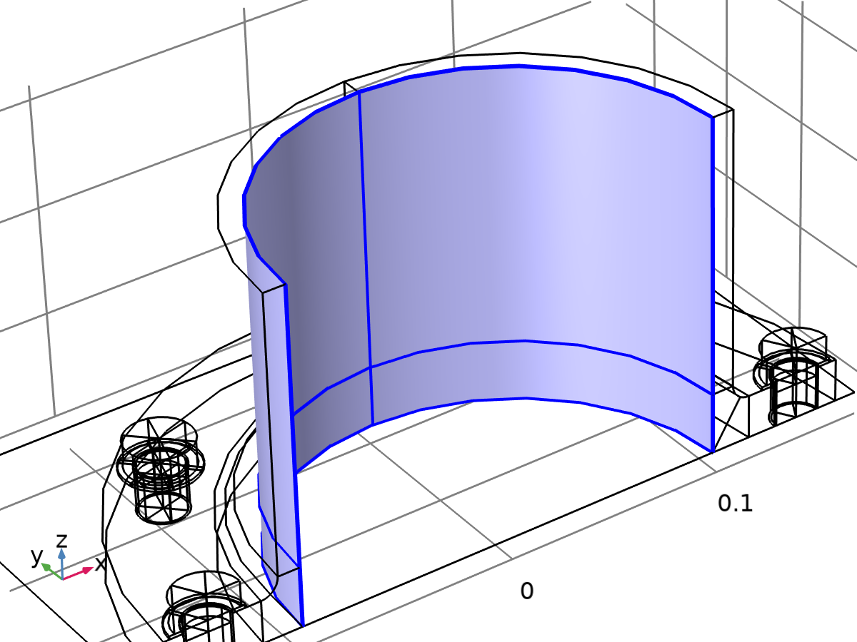

Pressure

Selection

|  |  |
| --- | --- |
| Geometric entity level | Boundary |
| Selection | Geometry geom1: Dimension 2: Boundaries 24–25, 30, 33 |

Equations

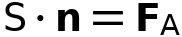

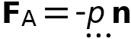

#### Force

Settings

| **Description** | **Value** | **Unit** |
| --- | --- | --- |
| Load type | Pressure |  |
| Pressure | pressure | Pa |
| Force, x-component | 0 | N |
| Force, y-component | 0 | N |
| Force, z-component | 0 | N |
| Moment, x-component | 0 | N·m |
| Moment, y-component | 0 | N·m |
| Moment, z-component | 0 | N·m |
| Application point defined using | Centroid |  |

#### Coordinate System Selection

Settings

| **Description** | **Value** |
| --- | --- |
| Coordinate system | Global coordinate system |

Used products

|  |
| --- |
| COMSOL Multiphysics |

#### Variables

| **Name** | **Expression** | **Unit** | **Description** | **Selection** | **Details** |
| --- | --- | --- | --- | --- | --- |
| solid.Wl_tot | -solid.bndl1.intL(solid.bndl1.F_Ax*solid.bndl1.ux+solid.bndl1.F_Ay*solid.bndl1.uy+solid.bndl1.F_Az*solid.bndl1.uz) | J | Total potential energy of applied loads | Global | Meta, + operation |
| solid.F_Ax | solid.bndl1.FperAreax/solid.J | N/m² | Load, x-component | Boundaries 24–25, 30, 33 | + operation |
| solid.F_Ay | solid.bndl1.FperAreay/solid.J | N/m² | Load, y-component | Boundaries 24–25, 30, 33 | + operation |
| solid.F_Az | solid.bndl1.FperAreaz/solid.J | N/m² | Load, z-component | Boundaries 24–25, 30, 33 | + operation |
| solid.F_A_Mag | sqrteps(real(solid.F_Ax)^2+real(solid.F_Ay)^2+real(solid.F_Az)^2) | N/m² | Load magnitude | Boundaries 24–25, 30, 33 |  |
| solid.bndl1.FollowerPressure | pressure | Pa | Pressure | Boundaries 24–25, 30, 33 | * operation |
| solid.bndl1.ux | u | m | Displacement, x-component | Boundaries 24–25, 30, 33 |  |
| solid.bndl1.uy | v | m | Displacement, y-component | Boundaries 24–25, 30, 33 |  |
| solid.bndl1.uz | w | m | Displacement, z-component | Boundaries 24–25, 30, 33 |  |
| solid.bndl1.F_Ax | solid.bndl1.FperAreax | N/m² | Load, x-component | Boundaries 24–25, 30, 33 |  |
| solid.bndl1.F_Ay | solid.bndl1.FperAreay | N/m² | Load, y-component | Boundaries 24–25, 30, 33 |  |
| solid.bndl1.F_Az | solid.bndl1.FperAreaz | N/m² | Load, z-component | Boundaries 24–25, 30, 33 |  |
| solid.bndl1.F_A_Mag | sqrteps(real(solid.bndl1.F_Ax)^2+real(solid.bndl1.F_Ay)^2+real(solid.bndl1.F_Az)^2) | N/m² | Load magnitude | Boundaries 24–25, 30, 33 |  |
| solid.bndl1.FperAreax | solid.bndl1.FollowerPressure*solid.J*(-(solid.FdyY*solid.FdzZ-solid.FdyZ*solid.FdzY)*solid.nX-(solid.FdyZ*solid.FdzX-solid.FdyX*solid.FdzZ)*solid.nY-(solid.FdyX*solid.FdzY-solid.FdyY*solid.FdzX)*solid.nZ)/(solid.FdxX*solid.FdyY*solid.FdzZ+solid.FdxY*solid.FdyZ*solid.FdzX+solid.FdxZ*solid.FdyX*solid.FdzY-solid.FdxX*solid.FdyZ*solid.FdzY-solid.FdxY*solid.FdyX*solid.FdzZ-solid.FdxZ*solid.FdyY*solid.FdzX) | N/m² | Load, x-component | Boundaries 24–25, 30, 33 |  |
| solid.bndl1.FperAreay | solid.bndl1.FollowerPressure*solid.J*(-(solid.FdxZ*solid.FdzY-solid.FdxY*solid.FdzZ)*solid.nX-(solid.FdxX*solid.FdzZ-solid.FdxZ*solid.FdzX)*solid.nY-(solid.FdxY*solid.FdzX-solid.FdxX*solid.FdzY)*solid.nZ)/(solid.FdxX*solid.FdyY*solid.FdzZ+solid.FdxY*solid.FdyZ*solid.FdzX+solid.FdxZ*solid.FdyX*solid.FdzY-solid.FdxX*solid.FdyZ*solid.FdzY-solid.FdxY*solid.FdyX*solid.FdzZ-solid.FdxZ*solid.FdyY*solid.FdzX) | N/m² | Load, y-component | Boundaries 24–25, 30, 33 |  |
| solid.bndl1.FperAreaz | solid.bndl1.FollowerPressure*solid.J*(-(solid.FdxY*solid.FdyZ-solid.FdxZ*solid.FdyY)*solid.nX-(solid.FdxZ*solid.FdyX-solid.FdxX*solid.FdyZ)*solid.nY-(solid.FdxX*solid.FdyY-solid.FdxY*solid.FdyX)*solid.nZ)/(solid.FdxX*solid.FdyY*solid.FdzZ+solid.FdxY*solid.FdyZ*solid.FdzX+solid.FdxZ*solid.FdyX*solid.FdzY-solid.FdxX*solid.FdyZ*solid.FdzY-solid.FdxY*solid.FdyX*solid.FdzZ-solid.FdxZ*solid.FdyY*solid.FdzX) | N/m² | Load, z-component | Boundaries 24–25, 30, 33 |  |

#### Weak Expressions

| **Weak expression** | **Integration order** | **Integration frame** | **Selection** |
| --- | --- | --- | --- |
| solid.bndl1.F_Ax*test(solid.bndl1.ux)+solid.bndl1.F_Ay*test(solid.bndl1.uy)+solid.bndl1.F_Az*test(solid.bndl1.uz) | 4 | Material | Boundaries 24–25, 30, 33 |

### Bending Moment and Axial Force

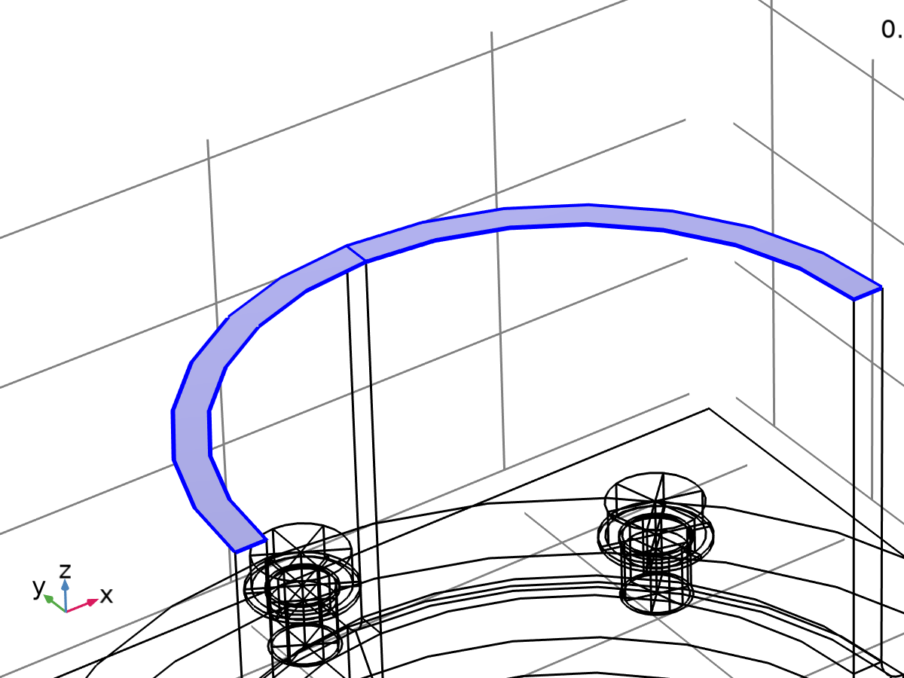

Bending Moment and Axial Force

Selection

|  |  |
| --- | --- |
| Geometric entity level | Boundary |
| Selection | Geometry geom1: Dimension 2: Boundaries 22, 35 |

Equations



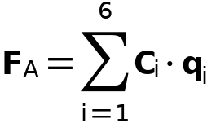

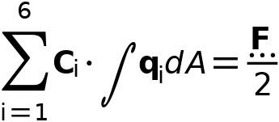

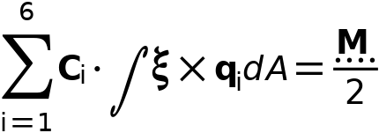

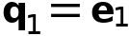

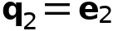

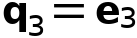

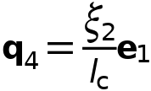

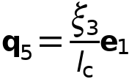

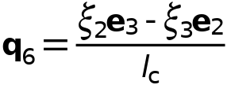

#### Force

Settings

| **Description** | **Value** | **Unit** |
| --- | --- | --- |
| Load type | Resultant |  |
| Force, x-component | 0 | N |
| Force, y-component | 0 | N |
| Force, z-component | axialForce | N |
| Moment, x-component | 0 | N·m |
| Moment, y-component | -lp*bendingMoment | N·m |
| Moment, z-component | 0 | N·m |
| Application point defined using | Centroid |  |

#### Traction Field

Settings

| **Description** | **Value** |
| --- | --- |
| Traction distribution | Beam |

#### Symmetry

Settings

| **Description** | **Value** | **Unit** |
| --- | --- | --- |
|  | Symmetry |  |
| Normal vector, x-component | 0 | 1 |
| Normal vector, y-component | 1 | 1 |
| Normal vector, z-component | 0 | 1 |
| Point, x-component | 0 | m |
| Point, y-component | 0 | m |
| Point, z-component | 0 | m |

#### Coordinate System Selection

Settings

| **Description** | **Value** |
| --- | --- |
| Coordinate system | Global coordinate system |

#### Variables

| **Name** | **Expression** | **Unit** | **Description** | **Selection** | **Details** |
| --- | --- | --- | --- | --- | --- |
| solid.Wl_tot | -solid.bndl2.intL(solid.bndl2.F_Ax*solid.bndl2.ux+solid.bndl2.F_Ay*solid.bndl2.uy+solid.bndl2.F_Az*solid.bndl2.uz) | J | Total potential energy of applied loads | Global | Meta, + operation |
| solid.F_Ax | solid.bndl2.F_Ax | N/m² | Load, x-component | Boundaries 22, 35 | + operation |
| solid.F_Ay | solid.bndl2.F_Ay | N/m² | Load, y-component | Boundaries 22, 35 | + operation |
| solid.F_Az | solid.bndl2.F_Az | N/m² | Load, z-component | Boundaries 22, 35 | + operation |
| solid.F_A_Mag | sqrteps(real(solid.F_Ax)^2+real(solid.F_Ay)^2+real(solid.F_Az)^2) | N/m² | Load magnitude | Boundaries 22, 35 |  |
| solid.bndl2.ux | u | m | Displacement, x-component | Boundaries 22, 35 |  |
| solid.bndl2.uy | v | m | Displacement, y-component | Boundaries 22, 35 |  |
| solid.bndl2.uz | w | m | Displacement, z-component | Boundaries 22, 35 |  |
| solid.bndl2.F_Ax | solid.bndl2.FperAreax | N/m² | Load, x-component | Boundaries 22, 35 |  |
| solid.bndl2.F_Ay | solid.bndl2.FperAreay | N/m² | Load, y-component | Boundaries 22, 35 |  |
| solid.bndl2.F_Az | solid.bndl2.FperAreaz | N/m² | Load, z-component | Boundaries 22, 35 |  |
| solid.bndl2.F_A_Mag | sqrteps(real(solid.bndl2.F_Ax)^2+real(solid.bndl2.F_Ay)^2+real(solid.bndl2.F_Az)^2) | N/m² | Load magnitude | Boundaries 22, 35 |  |
| solid.bndl2.Fx | 0 | N | Force, x-component | Global |  |
| solid.bndl2.Fy | 0 | N | Force, y-component | Global |  |
| solid.bndl2.Fz | 0.5*axialForce | N | Force, z-component | Global |  |
| solid.bndl2.Mx | 0 | N·m | Moment, x-component | Global |  |
| solid.bndl2.My | -0.5*lp*bendingMoment | N·m | Moment, y-component | Global |  |
| solid.bndl2.Mz | 0 | N·m | Moment, z-component | Global |  |
| solid.bndl2.Fgx | solid.bndl2.Fx | N | Resultant force, global system, x-component | Global |  |
| solid.bndl2.Fgy | solid.bndl2.Fy | N | Resultant force, global system, y-component | Global |  |
| solid.bndl2.Fgz | solid.bndl2.Fz | N | Resultant force, global system, z-component | Global |  |
| solid.bndl2.Mgx | solid.bndl2.Mx | N·m | Resultant moment, global system, x-component | Global |  |
| solid.bndl2.Mgy | solid.bndl2.My | N·m | Resultant moment, global system, y-component | Global |  |
| solid.bndl2.Mgz | solid.bndl2.Mz | N·m | Resultant moment, global system, z-component | Global |  |
| solid.bndl2.M_cgx | solid.bndl2.Mgx+(solid.bndl2.CGRz-solid.bndl2.x_agz)*solid.bndl2.Fgy+(-solid.bndl2.CGRy+solid.bndl2.x_agy)*solid.bndl2.Fgz | N·m | Resultant moment at center of rotation, global system, x-component | Global |  |
| solid.bndl2.M_cgy | solid.bndl2.Mgy+(-solid.bndl2.CGRz+solid.bndl2.x_agz)*solid.bndl2.Fgx+(solid.bndl2.CGRx-solid.bndl2.x_agx)*solid.bndl2.Fgz | N·m | Resultant moment at center of rotation, global system, y-component | Global |  |
| solid.bndl2.M_cgz | solid.bndl2.Mgz+(solid.bndl2.CGRy-solid.bndl2.x_agy)*solid.bndl2.Fgx+(-solid.bndl2.CGRx+solid.bndl2.x_agx)*solid.bndl2.Fgy | N·m | Resultant moment at center of rotation, global system, z-component | Global |  |
| solid.bndl2.M_cl1 | 0 | N·m | Resultant moment at center of rotation, principal axes system, 1-component | Boundaries 22, 35 |  |
| solid.bndl2.M_cl2 | solid.bndl2.axis1x*solid.bndl2.M_cgx+solid.bndl2.axis1y*solid.bndl2.M_cgy+solid.bndl2.axis1z*solid.bndl2.M_cgz | N·m | Resultant moment at center of rotation, principal axes system, 2-component | Boundaries 22, 35 |  |
| solid.bndl2.M_cl3 | 0 | N·m | Resultant moment at center of rotation, principal axes system, 3-component | Boundaries 22, 35 |  |
| solid.bndl2.Fl1 | solid.bndl2.nl1*solid.bndl2.Fgx+solid.bndl2.nl2*solid.bndl2.Fgy+solid.bndl2.nl3*solid.bndl2.Fgz | N | Resultant force, principal axes system, 1-component | Boundaries 22, 35 |  |
| solid.bndl2.Fl2 | 0 | N | Resultant force, principal axes system, 2-component | Boundaries 22, 35 |  |
| solid.bndl2.Fl3 | solid.bndl2.axis2x*solid.bndl2.Fgx+solid.bndl2.axis2y*solid.bndl2.Fgy+solid.bndl2.axis2z*solid.bndl2.Fgz | N | Resultant force, principal axes system, 3-component | Boundaries 22, 35 |  |
| solid.bndl2.A | solid.bndl2.int(1) | m² | Area | Global | * operation |
| solid.bndl2.lc | sqrt(solid.bndl2.A) | m | Characteristic length | Global |  |
| solid.bndl2.coordx | X | m | Coordinates, x-component | Boundaries 22, 35 |  |
| solid.bndl2.coordy | Y | m | Coordinates, y-component | Boundaries 22, 35 |  |
| solid.bndl2.coordz | Z | m | Coordinates, z-component | Boundaries 22, 35 |  |
| solid.bndl2.CGRx | solid.bndl2.geomCGRx-(solid.bndl2.axis1x*(solid.bndl2.geomCGRx-solid.bndl2.xs1)+solid.bndl2.axis1y*(solid.bndl2.geomCGRy-solid.bndl2.xs2)+solid.bndl2.axis1z*(solid.bndl2.geomCGRz-solid.bndl2.xs3))*solid.bndl2.axis1x | m | Center of gravity, x-component | Global |  |
| solid.bndl2.CGRy | solid.bndl2.geomCGRy-(solid.bndl2.axis1x*(solid.bndl2.geomCGRx-solid.bndl2.xs1)+solid.bndl2.axis1y*(solid.bndl2.geomCGRy-solid.bndl2.xs2)+solid.bndl2.axis1z*(solid.bndl2.geomCGRz-solid.bndl2.xs3))*solid.bndl2.axis1y | m | Center of gravity, y-component | Global |  |
| solid.bndl2.CGRz | solid.bndl2.geomCGRz-(solid.bndl2.axis1x*(solid.bndl2.geomCGRx-solid.bndl2.xs1)+solid.bndl2.axis1y*(solid.bndl2.geomCGRy-solid.bndl2.xs2)+solid.bndl2.axis1z*(solid.bndl2.geomCGRz-solid.bndl2.xs3))*solid.bndl2.axis1z | m | Center of gravity, z-component | Global |  |
| solid.bndl2.geomCGRx | solid.bndl2.int(X)/solid.bndl2.A | m | Center of gravity, x-component | Global |  |
| solid.bndl2.geomCGRy | solid.bndl2.int(Y)/solid.bndl2.A | m | Center of gravity, y-component | Global |  |
| solid.bndl2.geomCGRz | solid.bndl2.int(Z)/solid.bndl2.A | m | Center of gravity, z-component | Global |  |
| solid.bndl2.xs1 | 0 | m | Point on symmetry, 1-component | Global |  |
| solid.bndl2.xs2 | 0 | m | Point on symmetry, 2-component | Global |  |
| solid.bndl2.xs3 | 0 | m | Point on symmetry, 3-component | Global |  |
| solid.bndl2.x_agx | solid.bndl2.CGRx | m | Resultant force application point, global system, x-component | Global |  |
| solid.bndl2.x_agy | solid.bndl2.CGRy | m | Resultant force application point, global system, y-component | Global |  |
| solid.bndl2.x_agz | solid.bndl2.CGRz | m | Resultant force application point, global system, z-component | Global |  |
| solid.bndl2.t11 | solid.bndl2.Idiag1x | 1 | Local coordinate system, first tangent, 1-component | Global |  |
| solid.bndl2.t12 | solid.bndl2.Idiag1y | 1 | Local coordinate system, first tangent, 2-component | Global |  |
| solid.bndl2.t13 | solid.bndl2.Idiag1z | 1 | Local coordinate system, first tangent, 3-component | Global |  |
| solid.bndl2.t21 | solid.bndl2.Idiag2x | 1 | Local coordinate system, second tangent, 1-component | Global |  |
| solid.bndl2.t22 | solid.bndl2.Idiag2y | 1 | Local coordinate system, second tangent, 2-component | Global |  |
| solid.bndl2.t23 | solid.bndl2.Idiag2z | 1 | Local coordinate system, second tangent, 3-component | Global |  |
| solid.bndl2.nl1 | solid.bndl2.t23*solid.bndl2.t12-solid.bndl2.t22*solid.bndl2.t13 | 1 | Local coordinate system, normal, 1-component | Global |  |
| solid.bndl2.nl2 | -solid.bndl2.t23*solid.bndl2.t11+solid.bndl2.t21*solid.bndl2.t13 | 1 | Local coordinate system, normal, 2-component | Global |  |
| solid.bndl2.nl3 | solid.bndl2.t22*solid.bndl2.t11-solid.bndl2.t21*solid.bndl2.t12 | 1 | Local coordinate system, normal, 3-component | Global |  |
| solid.bndl2.x1 | 0 | m | Principal axes coordinates, 1-component | Boundaries 22, 35 |  |
| solid.bndl2.x2 | solid.bndl2.axis1x*(solid.bndl2.coordx-solid.bndl2.CGRx)+solid.bndl2.axis1y*(solid.bndl2.coordy-solid.bndl2.CGRy)+solid.bndl2.axis1z*(solid.bndl2.coordz-solid.bndl2.CGRz) | m | Principal axes coordinates, 2-component | Boundaries 22, 35 |  |
| solid.bndl2.x3 | solid.bndl2.axis2x*(solid.bndl2.coordx-solid.bndl2.CGRx)+solid.bndl2.axis2y*(solid.bndl2.coordy-solid.bndl2.CGRy)+solid.bndl2.axis2z*(solid.bndl2.coordz-solid.bndl2.CGRz) | m | Principal axes coordinates, 3-component | Boundaries 22, 35 |  |
| solid.bndl2.axis1x | solid.bndl2.nsymx | 1 | Principal axes system, 1-axis, x-component | Global |  |
| solid.bndl2.axis1y | solid.bndl2.nsymy | 1 | Principal axes system, 1-axis, y-component | Global |  |
| solid.bndl2.axis1z | solid.bndl2.nsymz | 1 | Principal axes system, 1-axis, z-component | Global |  |
| solid.bndl2.axis2x | solid.bndl2.axis1z*solid.bndl2.nl2-solid.bndl2.axis1y*solid.bndl2.nl3 | 1 | Principal axes system, 2-axis, x-component | Global |  |
| solid.bndl2.axis2y | -solid.bndl2.axis1z*solid.bndl2.nl1+solid.bndl2.axis1x*solid.bndl2.nl3 | 1 | Principal axes system, 2-axis, y-component | Global |  |
| solid.bndl2.axis2z | solid.bndl2.axis1y*solid.bndl2.nl1-solid.bndl2.axis1x*solid.bndl2.nl2 | 1 | Principal axes system, 2-axis, z-component | Global |  |
| solid.bndl2.weight | 1 | 1 | Weight function | Global |  |
| solid.bndl2.q11 | solid.bndl2.weight | 1 | Traction distribution, 11-component | Boundaries 22, 35 |  |
| solid.bndl2.q21 | 0 | 1 | Traction distribution, 21-component | Boundaries 22, 35 |  |
| solid.bndl2.q31 | 0 | 1 | Traction distribution, 31-component | Boundaries 22, 35 |  |
| solid.bndl2.q41 | solid.bndl2.x2*solid.bndl2.weight/solid.bndl2.lc | 1 | Traction distribution, 41-component | Boundaries 22, 35 |  |
| solid.bndl2.q51 | solid.bndl2.x3*solid.bndl2.weight/solid.bndl2.lc | 1 | Traction distribution, 51-component | Boundaries 22, 35 |  |
| solid.bndl2.q61 | 0 | 1 | Traction distribution, 61-component | Boundaries 22, 35 |  |
| solid.bndl2.q12 | 0 | 1 | Traction distribution, 12-component | Boundaries 22, 35 |  |
| solid.bndl2.q22 | solid.bndl2.weight | 1 | Traction distribution, 22-component | Boundaries 22, 35 |  |
| solid.bndl2.q32 | 0 | 1 | Traction distribution, 32-component | Boundaries 22, 35 |  |
| solid.bndl2.q42 | 0 | 1 | Traction distribution, 42-component | Boundaries 22, 35 |  |
| solid.bndl2.q52 | 0 | 1 | Traction distribution, 52-component | Boundaries 22, 35 |  |
| solid.bndl2.q62 | -solid.bndl2.x3*solid.bndl2.weight/solid.bndl2.lc | 1 | Traction distribution, 62-component | Boundaries 22, 35 |  |
| solid.bndl2.q13 | 0 | 1 | Traction distribution, 13-component | Boundaries 22, 35 |  |
| solid.bndl2.q23 | 0 | 1 | Traction distribution, 23-component | Boundaries 22, 35 |  |
| solid.bndl2.q33 | solid.bndl2.weight | 1 | Traction distribution, 33-component | Boundaries 22, 35 |  |
| solid.bndl2.q43 | 0 | 1 | Traction distribution, 43-component | Boundaries 22, 35 |  |
| solid.bndl2.q53 | 0 | 1 | Traction distribution, 53-component | Boundaries 22, 35 |  |
| solid.bndl2.q63 | solid.bndl2.x2*solid.bndl2.weight/solid.bndl2.lc | 1 | Traction distribution, 63-component | Boundaries 22, 35 |  |
| solid.bndl2.nsymx | 0 | 1 | Normal vector, x-component | Global |  |
| solid.bndl2.nsymy | 1 | 1 | Normal vector, y-component | Global |  |
| solid.bndl2.nsymz | 0 | 1 | Normal vector, z-component | Global |  |
| solid.bndl2.F_Al1 | solid.bndl2.C1*solid.bndl2.q11+solid.bndl2.C2*solid.bndl2.q21+solid.bndl2.C3*solid.bndl2.q31+solid.bndl2.C4*solid.bndl2.q41+solid.bndl2.C5*solid.bndl2.q51+solid.bndl2.C6*solid.bndl2.q61 | N/m² | Load, principal axes system, 1-component | Boundaries 22, 35 |  |
| solid.bndl2.F_Al2 | solid.bndl2.C1*solid.bndl2.q12+solid.bndl2.C2*solid.bndl2.q22+solid.bndl2.C3*solid.bndl2.q32+solid.bndl2.C4*solid.bndl2.q42+solid.bndl2.C5*solid.bndl2.q52+solid.bndl2.C6*solid.bndl2.q62 | N/m² | Load, principal axes system, 2-component | Boundaries 22, 35 |  |
| solid.bndl2.F_Al3 | solid.bndl2.C1*solid.bndl2.q13+solid.bndl2.C2*solid.bndl2.q23+solid.bndl2.C3*solid.bndl2.q33+solid.bndl2.C4*solid.bndl2.q43+solid.bndl2.C5*solid.bndl2.q53+solid.bndl2.C6*solid.bndl2.q63 | N/m² | Load, principal axes system, 3-component | Boundaries 22, 35 |  |
| solid.bndl2.Ixx | solid.bndl2.int((solid.bndl2.coordx-solid.bndl2.CGRx)^2) | m⁴ | Moment of inertia, xx-component | Global |  |
| solid.bndl2.Iyx | solid.bndl2.int((solid.bndl2.coordx-solid.bndl2.CGRx)*(solid.bndl2.coordy-solid.bndl2.CGRy)) | m⁴ | Moment of inertia, yx-component | Global |  |
| solid.bndl2.Izx | solid.bndl2.int((solid.bndl2.coordx-solid.bndl2.CGRx)*(solid.bndl2.coordz-solid.bndl2.CGRz)) | m⁴ | Moment of inertia, zx-component | Global |  |
| solid.bndl2.Ixy | solid.bndl2.int((solid.bndl2.coordx-solid.bndl2.CGRx)*(solid.bndl2.coordy-solid.bndl2.CGRy)) | m⁴ | Moment of inertia, xy-component | Global |  |
| solid.bndl2.Iyy | solid.bndl2.int((solid.bndl2.coordy-solid.bndl2.CGRy)^2) | m⁴ | Moment of inertia, yy-component | Global |  |
| solid.bndl2.Izy | solid.bndl2.int((solid.bndl2.coordy-solid.bndl2.CGRy)*(solid.bndl2.coordz-solid.bndl2.CGRz)) | m⁴ | Moment of inertia, zy-component | Global |  |
| solid.bndl2.Ixz | solid.bndl2.int((solid.bndl2.coordx-solid.bndl2.CGRx)*(solid.bndl2.coordz-solid.bndl2.CGRz)) | m⁴ | Moment of inertia, xz-component | Global |  |
| solid.bndl2.Iyz | solid.bndl2.int((solid.bndl2.coordy-solid.bndl2.CGRy)*(solid.bndl2.coordz-solid.bndl2.CGRz)) | m⁴ | Moment of inertia, yz-component | Global |  |
| solid.bndl2.Izz | solid.bndl2.int((solid.bndl2.coordz-solid.bndl2.CGRz)^2) | m⁴ | Moment of inertia, zz-component | Global |  |
| solid.bndl2.I2 | solid.bndl2.Idiag2 | m⁴ | Smallest principal moment of inertia | Global |  |
| solid.bndl2.I1 | solid.bndl2.Idiag1 | m⁴ | Largest principal moment of inertia | Global |  |
| solid.bndl2.FperAreax | solid.bndl2.nl1*solid.bndl2.F_Al1+solid.bndl2.axis1x*solid.bndl2.F_Al2+solid.bndl2.axis2x*solid.bndl2.F_Al3 | N/m² | Load, x-component | Boundaries 22, 35 | * operation |
| solid.bndl2.FperAreay | solid.bndl2.nl2*solid.bndl2.F_Al1+solid.bndl2.axis1y*solid.bndl2.F_Al2+solid.bndl2.axis2y*solid.bndl2.F_Al3 | N/m² | Load, y-component | Boundaries 22, 35 | * operation |
| solid.bndl2.FperAreaz | solid.bndl2.nl3*solid.bndl2.F_Al1+solid.bndl2.axis1z*solid.bndl2.F_Al2+solid.bndl2.axis2z*solid.bndl2.F_Al3 | N/m² | Load, z-component | Boundaries 22, 35 | * operation |
| solid.bndl2.fm11 | solid.bndl2.f11 | m² | Force moment matrix, 11-component | Global |  |
| solid.bndl2.fm21 | solid.bndl2.f12 | m² | Force moment matrix, 21-component | Global |  |
| solid.bndl2.fm31 | solid.bndl2.f13 | m² | Force moment matrix, 31-component | Global |  |
| solid.bndl2.fm41 | solid.bndl2.m11 | m² | Force moment matrix, 41-component | Global |  |
| solid.bndl2.fm51 | solid.bndl2.m12 | m² | Force moment matrix, 51-component | Global |  |
| solid.bndl2.fm61 | solid.bndl2.m13 | m² | Force moment matrix, 61-component | Global |  |
| solid.bndl2.fm12 | solid.bndl2.f21 | m² | Force moment matrix, 12-component | Global |  |
| solid.bndl2.fm22 | solid.bndl2.f22 | m² | Force moment matrix, 22-component | Global |  |
| solid.bndl2.fm32 | solid.bndl2.f23 | m² | Force moment matrix, 32-component | Global |  |
| solid.bndl2.fm42 | solid.bndl2.m21 | m² | Force moment matrix, 42-component | Global |  |
| solid.bndl2.fm52 | solid.bndl2.m22 | m² | Force moment matrix, 52-component | Global |  |
| solid.bndl2.fm62 | solid.bndl2.m23 | m² | Force moment matrix, 62-component | Global |  |
| solid.bndl2.fm13 | solid.bndl2.f31 | m² | Force moment matrix, 13-component | Global |  |
| solid.bndl2.fm23 | solid.bndl2.f32 | m² | Force moment matrix, 23-component | Global |  |
| solid.bndl2.fm33 | solid.bndl2.f33 | m² | Force moment matrix, 33-component | Global |  |
| solid.bndl2.fm43 | solid.bndl2.m31 | m² | Force moment matrix, 43-component | Global |  |
| solid.bndl2.fm53 | solid.bndl2.m32 | m² | Force moment matrix, 53-component | Global |  |
| solid.bndl2.fm63 | solid.bndl2.m33 | m² | Force moment matrix, 63-component | Global |  |
| solid.bndl2.fm14 | solid.bndl2.f41 | m² | Force moment matrix, 14-component | Global |  |
| solid.bndl2.fm24 | solid.bndl2.f42 | m² | Force moment matrix, 24-component | Global |  |
| solid.bndl2.fm34 | solid.bndl2.f43 | m² | Force moment matrix, 34-component | Global |  |
| solid.bndl2.fm44 | solid.bndl2.m41 | m² | Force moment matrix, 44-component | Global |  |
| solid.bndl2.fm54 | solid.bndl2.m42 | m² | Force moment matrix, 54-component | Global |  |
| solid.bndl2.fm64 | solid.bndl2.m43 | m² | Force moment matrix, 64-component | Global |  |
| solid.bndl2.fm15 | solid.bndl2.f51 | m² | Force moment matrix, 15-component | Global |  |
| solid.bndl2.fm25 | solid.bndl2.f52 | m² | Force moment matrix, 25-component | Global |  |
| solid.bndl2.fm35 | solid.bndl2.f53 | m² | Force moment matrix, 35-component | Global |  |
| solid.bndl2.fm45 | solid.bndl2.m51 | m² | Force moment matrix, 45-component | Global |  |
| solid.bndl2.fm55 | solid.bndl2.m52 | m² | Force moment matrix, 55-component | Global |  |
| solid.bndl2.fm65 | solid.bndl2.m53 | m² | Force moment matrix, 65-component | Global |  |
| solid.bndl2.fm16 | solid.bndl2.f61 | m² | Force moment matrix, 16-component | Global |  |
| solid.bndl2.fm26 | solid.bndl2.f62 | m² | Force moment matrix, 26-component | Global |  |
| solid.bndl2.fm36 | solid.bndl2.f63 | m² | Force moment matrix, 36-component | Global |  |
| solid.bndl2.fm46 | solid.bndl2.m61 | m² | Force moment matrix, 46-component | Global |  |
| solid.bndl2.fm56 | solid.bndl2.m62 | m² | Force moment matrix, 56-component | Global |  |
| solid.bndl2.fm66 | solid.bndl2.m63 | m² | Force moment matrix, 66-component | Global |  |
| solid.bndl2.C1 | solid.bndl2.Fl1/solid.bndl2.f11 | N/m² | Traction distribution coefficients, 1-component | Boundaries 22, 35 |  |
| solid.bndl2.C2 | solid.bndl2.Fl2/solid.bndl2.f22 | N/m² | Traction distribution coefficients, 2-component | Boundaries 22, 35 |  |
| solid.bndl2.C3 | solid.bndl2.Fl3/solid.bndl2.f33 | N/m² | Traction distribution coefficients, 3-component | Boundaries 22, 35 |  |
| solid.bndl2.C4 | solid.bndl2.M_cl3/(solid.bndl2.m43*solid.bndl2.lc) | N/m² | Traction distribution coefficients, 4-component | Boundaries 22, 35 |  |
| solid.bndl2.C5 | solid.bndl2.M_cl2/(solid.bndl2.m52*solid.bndl2.lc) | N/m² | Traction distribution coefficients, 5-component | Boundaries 22, 35 |  |
| solid.bndl2.C6 | solid.bndl2.M_cl1/(solid.bndl2.m61*solid.bndl2.lc) | N/m² | Traction distribution coefficients, 6-component | Boundaries 22, 35 |  |
| solid.bndl2.f11 | solid.bndl2.int(solid.bndl2.q11) | m² | Normalized force, 11-component | Global |  |
| solid.bndl2.f21 | solid.bndl2.int(solid.bndl2.q21) | m² | Normalized force, 21-component | Global |  |
| solid.bndl2.f31 | solid.bndl2.int(solid.bndl2.q31) | m² | Normalized force, 31-component | Global |  |
| solid.bndl2.f41 | solid.bndl2.int(solid.bndl2.q41) | m² | Normalized force, 41-component | Global |  |
| solid.bndl2.f51 | solid.bndl2.int(solid.bndl2.q51) | m² | Normalized force, 51-component | Global |  |
| solid.bndl2.f61 | solid.bndl2.int(solid.bndl2.q61) | m² | Normalized force, 61-component | Global |  |
| solid.bndl2.f12 | solid.bndl2.int(solid.bndl2.q12) | m² | Normalized force, 12-component | Global |  |
| solid.bndl2.f22 | solid.bndl2.int(solid.bndl2.q22) | m² | Normalized force, 22-component | Global |  |
| solid.bndl2.f32 | solid.bndl2.int(solid.bndl2.q32) | m² | Normalized force, 32-component | Global |  |
| solid.bndl2.f42 | solid.bndl2.int(solid.bndl2.q42) | m² | Normalized force, 42-component | Global |  |
| solid.bndl2.f52 | solid.bndl2.int(solid.bndl2.q52) | m² | Normalized force, 52-component | Global |  |
| solid.bndl2.f62 | solid.bndl2.int(solid.bndl2.q62) | m² | Normalized force, 62-component | Global |  |
| solid.bndl2.f13 | solid.bndl2.int(solid.bndl2.q13) | m² | Normalized force, 13-component | Global |  |
| solid.bndl2.f23 | solid.bndl2.int(solid.bndl2.q23) | m² | Normalized force, 23-component | Global |  |
| solid.bndl2.f33 | solid.bndl2.int(solid.bndl2.q33) | m² | Normalized force, 33-component | Global |  |
| solid.bndl2.f43 | solid.bndl2.int(solid.bndl2.q43) | m² | Normalized force, 43-component | Global |  |
| solid.bndl2.f53 | solid.bndl2.int(solid.bndl2.q53) | m² | Normalized force, 53-component | Global |  |
| solid.bndl2.f63 | solid.bndl2.int(solid.bndl2.q63) | m² | Normalized force, 63-component | Global |  |
| solid.bndl2.m11 | solid.bndl2.int(solid.bndl2.q13*solid.bndl2.x2-solid.bndl2.q12*solid.bndl2.x3)/solid.bndl2.lc | m² | Normalized moment, 11-component | Global |  |
| solid.bndl2.m21 | solid.bndl2.int(solid.bndl2.q23*solid.bndl2.x2-solid.bndl2.q22*solid.bndl2.x3)/solid.bndl2.lc | m² | Normalized moment, 21-component | Global |  |
| solid.bndl2.m31 | solid.bndl2.int(solid.bndl2.q33*solid.bndl2.x2-solid.bndl2.q32*solid.bndl2.x3)/solid.bndl2.lc | m² | Normalized moment, 31-component | Global |  |
| solid.bndl2.m41 | solid.bndl2.int(solid.bndl2.q43*solid.bndl2.x2-solid.bndl2.q42*solid.bndl2.x3)/solid.bndl2.lc | m² | Normalized moment, 41-component | Global |  |
| solid.bndl2.m51 | solid.bndl2.int(solid.bndl2.q53*solid.bndl2.x2-solid.bndl2.q52*solid.bndl2.x3)/solid.bndl2.lc | m² | Normalized moment, 51-component | Global |  |
| solid.bndl2.m61 | solid.bndl2.int(solid.bndl2.q63*solid.bndl2.x2-solid.bndl2.q62*solid.bndl2.x3)/solid.bndl2.lc | m² | Normalized moment, 61-component | Global |  |
| solid.bndl2.m12 | solid.bndl2.int(-solid.bndl2.q13*solid.bndl2.x1+solid.bndl2.q11*solid.bndl2.x3)/solid.bndl2.lc | m² | Normalized moment, 12-component | Global |  |
| solid.bndl2.m22 | solid.bndl2.int(-solid.bndl2.q23*solid.bndl2.x1+solid.bndl2.q21*solid.bndl2.x3)/solid.bndl2.lc | m² | Normalized moment, 22-component | Global |  |
| solid.bndl2.m32 | solid.bndl2.int(-solid.bndl2.q33*solid.bndl2.x1+solid.bndl2.q31*solid.bndl2.x3)/solid.bndl2.lc | m² | Normalized moment, 32-component | Global |  |
| solid.bndl2.m42 | solid.bndl2.int(-solid.bndl2.q43*solid.bndl2.x1+solid.bndl2.q41*solid.bndl2.x3)/solid.bndl2.lc | m² | Normalized moment, 42-component | Global |  |
| solid.bndl2.m52 | solid.bndl2.int(-solid.bndl2.q53*solid.bndl2.x1+solid.bndl2.q51*solid.bndl2.x3)/solid.bndl2.lc | m² | Normalized moment, 52-component | Global |  |
| solid.bndl2.m62 | solid.bndl2.int(-solid.bndl2.q63*solid.bndl2.x1+solid.bndl2.q61*solid.bndl2.x3)/solid.bndl2.lc | m² | Normalized moment, 62-component | Global |  |
| solid.bndl2.m13 | solid.bndl2.int(solid.bndl2.q12*solid.bndl2.x1-solid.bndl2.q11*solid.bndl2.x2)/solid.bndl2.lc | m² | Normalized moment, 13-component | Global |  |
| solid.bndl2.m23 | solid.bndl2.int(solid.bndl2.q22*solid.bndl2.x1-solid.bndl2.q21*solid.bndl2.x2)/solid.bndl2.lc | m² | Normalized moment, 23-component | Global |  |
| solid.bndl2.m33 | solid.bndl2.int(solid.bndl2.q32*solid.bndl2.x1-solid.bndl2.q31*solid.bndl2.x2)/solid.bndl2.lc | m² | Normalized moment, 33-component | Global |  |
| solid.bndl2.m43 | solid.bndl2.int(solid.bndl2.q42*solid.bndl2.x1-solid.bndl2.q41*solid.bndl2.x2)/solid.bndl2.lc | m² | Normalized moment, 43-component | Global |  |
| solid.bndl2.m53 | solid.bndl2.int(solid.bndl2.q52*solid.bndl2.x1-solid.bndl2.q51*solid.bndl2.x2)/solid.bndl2.lc | m² | Normalized moment, 53-component | Global |  |
| solid.bndl2.m63 | solid.bndl2.int(solid.bndl2.q62*solid.bndl2.x1-solid.bndl2.q61*solid.bndl2.x2)/solid.bndl2.lc | m² | Normalized moment, 63-component | Global |  |

#### Weak Expressions

| **Weak expression** | **Integration order** | **Integration frame** | **Selection** |
| --- | --- | --- | --- |
| solid.bndl2.F_Ax*test(solid.bndl2.ux)+solid.bndl2.F_Ay*test(solid.bndl2.uy)+solid.bndl2.F_Az*test(solid.bndl2.uz) | 4 | Material | Boundaries 22, 35 |

### Bolt Pretension 1

Selection

|  |  |
| --- | --- |
| Geometric entity level | Entire model |

#### Bolt Label

Settings

| **Description** | **Value** |
| --- | --- |
| Bolt label | Bolt |

#### Bolt Pretension

Settings

| **Description** | **Value** | **Unit** |
| --- | --- | --- |
| Pretension type | Pretension force |  |
| Pretension force | boltPrestressForce | N |
| Compute tightening torque | Off |  |

#### Variables

| **Name** | **Expression** | **Unit** | **Description** | **Selection** |
| --- | --- | --- | --- | --- |
| solid.pblt1.F_pre | boltPrestressForce | N | Pretension force | Global |

#### Bolt Selection 1



Bolt Selection 1

Selection

|  |  |
| --- | --- |
| Geometric entity level | Boundary |
| Name | Bolt Pretension, Cut 1 |
| Selection | Named sel2: Geometry geom1: Dimension 2: Boundaries 165, 176, 183 |

##### Bolt Label

Settings

| **Description** | **Value** |
| --- | --- |
|  | Bolt_1 |

##### Bolt Pretension

Settings

| **Description** | **Value** | **Unit** |
| --- | --- | --- |
| Pretension type | From parent |  |
| Relaxation | 0 | m |
| Sequential tightening | Off |  |

##### Symmetry Detection

Settings

| **Description** | **Value** |
| --- | --- |
| Automatic symmetry detection | On |

Used products

|  |
| --- |
| COMSOL Multiphysics |

##### Variables

| **Name** | **Expression** | **Unit** | **Description** | **Selection** |
| --- | --- | --- | --- | --- |
| uTXt | d(uTX,TIME) | 1/s | Tangential gradient of u, X component, first time derivative | Boundaries 165, 176, 183 |
| uTYt | d(uTY,TIME) | 1/s | Tangential gradient of u, Y component, first time derivative | Boundaries 165, 176, 183 |
| uTZt | d(uTZ,TIME) | 1/s | Tangential gradient of u, Z component, first time derivative | Boundaries 165, 176, 183 |
| uTXtt | d(d(uTX,TIME),TIME) | 1/s² | Tangential gradient of u, X component, second time derivative | Boundaries 165, 176, 183 |
| uTYtt | d(d(uTY,TIME),TIME) | 1/s² | Tangential gradient of u, Y component, second time derivative | Boundaries 165, 176, 183 |
| uTZtt | d(d(uTZ,TIME),TIME) | 1/s² | Tangential gradient of u, Z component, second time derivative | Boundaries 165, 176, 183 |
| vTXt | d(vTX,TIME) | 1/s | Tangential gradient of v, X component, first time derivative | Boundaries 165, 176, 183 |
| vTYt | d(vTY,TIME) | 1/s | Tangential gradient of v, Y component, first time derivative | Boundaries 165, 176, 183 |
| vTZt | d(vTZ,TIME) | 1/s | Tangential gradient of v, Z component, first time derivative | Boundaries 165, 176, 183 |
| vTXtt | d(d(vTX,TIME),TIME) | 1/s² | Tangential gradient of v, X component, second time derivative | Boundaries 165, 176, 183 |
| vTYtt | d(d(vTY,TIME),TIME) | 1/s² | Tangential gradient of v, Y component, second time derivative | Boundaries 165, 176, 183 |
| vTZtt | d(d(vTZ,TIME),TIME) | 1/s² | Tangential gradient of v, Z component, second time derivative | Boundaries 165, 176, 183 |
| wTXt | d(wTX,TIME) | 1/s | Tangential gradient of w, X component, first time derivative | Boundaries 165, 176, 183 |
| wTYt | d(wTY,TIME) | 1/s | Tangential gradient of w, Y component, first time derivative | Boundaries 165, 176, 183 |
| wTZt | d(wTZ,TIME) | 1/s | Tangential gradient of w, Z component, first time derivative | Boundaries 165, 176, 183 |
| wTXtt | d(d(wTX,TIME),TIME) | 1/s² | Tangential gradient of w, X component, second time derivative | Boundaries 165, 176, 183 |
| wTYtt | d(d(wTY,TIME),TIME) | 1/s² | Tangential gradient of w, Y component, second time derivative | Boundaries 165, 176, 183 |
| wTZtt | d(d(wTZ,TIME),TIME) | 1/s² | Tangential gradient of w, Z component, second time derivative | Boundaries 165, 176, 183 |
| ut | d(u,TIME) | m/s | Structural velocity field, X-component | Boundaries 165, 176, 183 |
| vt | d(v,TIME) | m/s | Structural velocity field, Y-component | Boundaries 165, 176, 183 |
| wt | d(w,TIME) | m/s | Structural velocity field, Z-component | Boundaries 165, 176, 183 |
| utt | d(d(u,TIME),TIME) | m/s² | Acceleration field, X-component | Boundaries 165, 176, 183 |
| vtt | d(d(v,TIME),TIME) | m/s² | Acceleration field, Y-component | Boundaries 165, 176, 183 |
| wtt | d(d(w,TIME),TIME) | m/s² | Acceleration field, Z-component | Boundaries 165, 176, 183 |
| solid.pblt1.sblt1.relax | 0 | m | Relaxation | Boundaries 165, 176, 183 |
| solid.pblt1.sblt1.Area | if(solid.pblt1.sblt1.isSymmetric,2,1)*solid.pblt1.sblt1.intop1(1) | m² | Bolt cross-section area | Global |
| solid.pblt1.sblt1.Area_meas | solid.pblt1.sblt1.intop1(1) | m² | Area | Global |
| solid.pblt1.sblt1.Diam | sqrt(4*solid.pblt1.sblt1.Area/pi) | m | Bolt diameter | Global |
| solid.pblt1.sblt1.s_pre | solid.pblt1.sblt1.F_pre/solid.pblt1.sblt1.Area | N/m² | Pretension stress | Global |
| solid.pblt1.sblt1.F_pre | solid.pblt1.F_pre | N | Pretension force | Global |
| solid.pblt1.sblt1.M_pre | solid.pblt1.sblt1.F_pre*(root.comp1.solid.pblt1.muh*root.comp1.solid.pblt1.sblt1.re+0.5*root.comp1.solid.pblt1.sblt1.dt*tan(root.comp1.solid.pblt1.sblt1.phi+root.comp1.solid.pblt1.sblt1.epsilon)) | N·m | Tightening torque | Global |
| solid.pblt1.sblt1.isSymmetric | solid.pblt1.sblt1.C^2/solid.pblt1.sblt1.Area_meas>16.4 | 1 | Bolt cross-section symmetry | Global |
| solid.pblt1.sblt1.F_bolt | solid.pblt1.sblt1.FreacX*solid.pblt1.sblt1.navX+solid.pblt1.sblt1.FreacY*solid.pblt1.sblt1.navY+solid.pblt1.sblt1.FreacZ*solid.pblt1.sblt1.navZ | N | Bolt force | Global |
| solid.pblt1.sblt1.nsymX | solid.pblt1.sblt1.isSymmetric*solid.pblt1.sblt1.Idiag2X | 1 | Normal vector, X-component | Global |
| solid.pblt1.sblt1.nsymY | solid.pblt1.sblt1.isSymmetric*solid.pblt1.sblt1.Idiag2Y | 1 | Normal vector, Y-component | Global |
| solid.pblt1.sblt1.nsymZ | solid.pblt1.sblt1.isSymmetric*solid.pblt1.sblt1.Idiag2Z | 1 | Normal vector, Z-component | Global |
| solid.pblt1.sblt1.FreacX | if(solid.pblt1.sblt1.isSymmetric,2,1)*solid.pblt1.sblt1.sumop1(down(reacf(u)))*(1-solid.pblt1.sblt1.nsymX) | N | Reaction force, X-component | Global |
| solid.pblt1.sblt1.FreacY | if(solid.pblt1.sblt1.isSymmetric,2,1)*solid.pblt1.sblt1.sumop1(down(reacf(v)))*(1-solid.pblt1.sblt1.nsymY) | N | Reaction force, Y-component | Global |
| solid.pblt1.sblt1.FreacZ | if(solid.pblt1.sblt1.isSymmetric,2,1)*solid.pblt1.sblt1.sumop1(down(reacf(w)))*(1-solid.pblt1.sblt1.nsymZ) | N | Reaction force, Z-component | Global |
| solid.pblt1.sblt1.F_shear | sqrt((solid.pblt1.sblt1.FreacX-solid.pblt1.sblt1.F_bolt*solid.pblt1.sblt1.navX)^2+(solid.pblt1.sblt1.FreacY-solid.pblt1.sblt1.F_bolt*solid.pblt1.sblt1.navY)^2+(solid.pblt1.sblt1.FreacZ-solid.pblt1.sblt1.F_bolt*solid.pblt1.sblt1.navZ)^2) | N | Bolt shear force | Global |
| solid.pblt1.sblt1.C | solid.pblt1.sblt1.intop2(1) | m | Bolt cross-section circumference | Global |
| solid.pblt1.sblt1.CGRX | solid.pblt1.sblt1.intop1(X)/solid.pblt1.sblt1.Area_meas | m | Center of gravity, X-component | Global |
| solid.pblt1.sblt1.CGRY | solid.pblt1.sblt1.intop1(Y)/solid.pblt1.sblt1.Area_meas | m | Center of gravity, Y-component | Global |
| solid.pblt1.sblt1.CGRZ | solid.pblt1.sblt1.intop1(Z)/solid.pblt1.sblt1.Area_meas | m | Center of gravity, Z-component | Global |
| solid.pblt1.sblt1.IXX | solid.pblt1.sblt1.intop1((X-solid.pblt1.sblt1.CGRX)^2) | m⁴ | Moment of inertia, XX-component | Global |
| solid.pblt1.sblt1.IXY | solid.pblt1.sblt1.intop1((X-solid.pblt1.sblt1.CGRX)*(Y-solid.pblt1.sblt1.CGRY)) | m⁴ | Moment of inertia, XY-component | Global |
| solid.pblt1.sblt1.IXZ | solid.pblt1.sblt1.intop1((X-solid.pblt1.sblt1.CGRX)*(Z-solid.pblt1.sblt1.CGRZ)) | m⁴ | Moment of inertia, XZ-component | Global |
| solid.pblt1.sblt1.IYY | solid.pblt1.sblt1.intop1((Y-solid.pblt1.sblt1.CGRY)^2) | m⁴ | Moment of inertia, YY-component | Global |
| solid.pblt1.sblt1.IYZ | solid.pblt1.sblt1.intop1((Y-solid.pblt1.sblt1.CGRY)*(Z-solid.pblt1.sblt1.CGRZ)) | m⁴ | Moment of inertia, YZ-component | Global |
| solid.pblt1.sblt1.IZZ | solid.pblt1.sblt1.intop1((Z-solid.pblt1.sblt1.CGRZ)^2) | m⁴ | Moment of inertia, ZZ-component | Global |
| solid.pblt1.sblt1.navX | solid.pblt1.sblt1.aveop1(solid.nX)/sqrt(solid.pblt1.sblt1.aveop1(solid.nX)^2+solid.pblt1.sblt1.aveop1(solid.nY)^2+solid.pblt1.sblt1.aveop1(solid.nZ)^2) | 1 | Average normal vector, X-component | Global |
| solid.pblt1.sblt1.navY | solid.pblt1.sblt1.aveop1(solid.nY)/sqrt(solid.pblt1.sblt1.aveop1(solid.nX)^2+solid.pblt1.sblt1.aveop1(solid.nY)^2+solid.pblt1.sblt1.aveop1(solid.nZ)^2) | 1 | Average normal vector, Y-component | Global |
| solid.pblt1.sblt1.navZ | solid.pblt1.sblt1.aveop1(solid.nZ)/sqrt(solid.pblt1.sblt1.aveop1(solid.nX)^2+solid.pblt1.sblt1.aveop1(solid.nY)^2+solid.pblt1.sblt1.aveop1(solid.nZ)^2) | 1 | Average normal vector, Z-component | Global |

##### Shape functions

| **Name** | **Shape function** | **Unit** | **Description** | **Shape frame** | **Selection** | **Details** |
| --- | --- | --- | --- | --- | --- | --- |
| u | Nodal serendipity (Quadratic) | m | Displacement field, X-component | Material | Boundaries 165, 176, 183 | Slit |
| v | Nodal serendipity (Quadratic) | m | Displacement field, Y-component | Material | Boundaries 165, 176, 183 | Slit |
| w | Nodal serendipity (Quadratic) | m | Displacement field, Z-component | Material | Boundaries 165, 176, 183 | Slit |
| solid.pblt1.sblt1.d_pre | ODE | m | Predeformation |  | Global |  |

##### Weak Expressions

| **Weak expression** | **Integration order** | **Integration frame** | **Selection** |
| --- | --- | --- | --- |
| solid.pblt1.sblt1.s_pre*test(solid.pblt1.sblt1.d_pre) | 4 | Material | Boundaries 165, 176, 183 |

##### Constraints

| **Constraint** | **Constraint force** | **Shape function** | **Selection** | **Details** |
| --- | --- | --- | --- | --- |
| down(u)-up(u)-(solid.pblt1.sblt1.d_pre-solid.pblt1.sblt1.relax)*solid.pblt1.sblt1.navX | test(down(u)-up(u)-(solid.pblt1.sblt1.d_pre-solid.pblt1.sblt1.relax)*solid.pblt1.sblt1.navX) | Nodal serendipity (Quadratic) | Boundaries 165, 176, 183 | Elemental |
| down(v)-up(v)-(solid.pblt1.sblt1.d_pre-solid.pblt1.sblt1.relax)*solid.pblt1.sblt1.navY | test(down(v)-up(v)-(solid.pblt1.sblt1.d_pre-solid.pblt1.sblt1.relax)*solid.pblt1.sblt1.navY) | Nodal serendipity (Quadratic) | Boundaries 165, 176, 183 | Elemental |
| down(w)-up(w)-(solid.pblt1.sblt1.d_pre-solid.pblt1.sblt1.relax)*solid.pblt1.sblt1.navZ | test(down(w)-up(w)-(solid.pblt1.sblt1.d_pre-solid.pblt1.sblt1.relax)*solid.pblt1.sblt1.navZ) | Nodal serendipity (Quadratic) | Boundaries 165, 176, 183 | Elemental |

#### Bolt Selection 2



Bolt Selection 2

Selection

|  |  |
| --- | --- |
| Geometric entity level | Boundary |
| Name | Bolt Pretension, Cut 2 |
| Selection | Named sel3: Geometry geom1: Dimension 2: Boundaries 211–212, 220, 231, 241–242 |

##### Bolt Label

Settings

| **Description** | **Value** |
| --- | --- |
|  | Bolt_2 |

##### Bolt Pretension

Settings

| **Description** | **Value** | **Unit** |
| --- | --- | --- |
| Pretension type | From parent |  |
| Relaxation | 0 | m |
| Sequential tightening | Off |  |

##### Symmetry Detection

Settings

| **Description** | **Value** |
| --- | --- |
| Automatic symmetry detection | On |

Used products

|  |
| --- |
| COMSOL Multiphysics |

##### Variables

| **Name** | **Expression** | **Unit** | **Description** | **Selection** |
| --- | --- | --- | --- | --- |
| uTXt | d(uTX,TIME) | 1/s | Tangential gradient of u, X component, first time derivative | Boundaries 211–212, 220, 231, 241–242 |
| uTYt | d(uTY,TIME) | 1/s | Tangential gradient of u, Y component, first time derivative | Boundaries 211–212, 220, 231, 241–242 |
| uTZt | d(uTZ,TIME) | 1/s | Tangential gradient of u, Z component, first time derivative | Boundaries 211–212, 220, 231, 241–242 |
| uTXtt | d(d(uTX,TIME),TIME) | 1/s² | Tangential gradient of u, X component, second time derivative | Boundaries 211–212, 220, 231, 241–242 |
| uTYtt | d(d(uTY,TIME),TIME) | 1/s² | Tangential gradient of u, Y component, second time derivative | Boundaries 211–212, 220, 231, 241–242 |
| uTZtt | d(d(uTZ,TIME),TIME) | 1/s² | Tangential gradient of u, Z component, second time derivative | Boundaries 211–212, 220, 231, 241–242 |
| vTXt | d(vTX,TIME) | 1/s | Tangential gradient of v, X component, first time derivative | Boundaries 211–212, 220, 231, 241–242 |
| vTYt | d(vTY,TIME) | 1/s | Tangential gradient of v, Y component, first time derivative | Boundaries 211–212, 220, 231, 241–242 |
| vTZt | d(vTZ,TIME) | 1/s | Tangential gradient of v, Z component, first time derivative | Boundaries 211–212, 220, 231, 241–242 |
| vTXtt | d(d(vTX,TIME),TIME) | 1/s² | Tangential gradient of v, X component, second time derivative | Boundaries 211–212, 220, 231, 241–242 |
| vTYtt | d(d(vTY,TIME),TIME) | 1/s² | Tangential gradient of v, Y component, second time derivative | Boundaries 211–212, 220, 231, 241–242 |
| vTZtt | d(d(vTZ,TIME),TIME) | 1/s² | Tangential gradient of v, Z component, second time derivative | Boundaries 211–212, 220, 231, 241–242 |
| wTXt | d(wTX,TIME) | 1/s | Tangential gradient of w, X component, first time derivative | Boundaries 211–212, 220, 231, 241–242 |
| wTYt | d(wTY,TIME) | 1/s | Tangential gradient of w, Y component, first time derivative | Boundaries 211–212, 220, 231, 241–242 |
| wTZt | d(wTZ,TIME) | 1/s | Tangential gradient of w, Z component, first time derivative | Boundaries 211–212, 220, 231, 241–242 |
| wTXtt | d(d(wTX,TIME),TIME) | 1/s² | Tangential gradient of w, X component, second time derivative | Boundaries 211–212, 220, 231, 241–242 |
| wTYtt | d(d(wTY,TIME),TIME) | 1/s² | Tangential gradient of w, Y component, second time derivative | Boundaries 211–212, 220, 231, 241–242 |
| wTZtt | d(d(wTZ,TIME),TIME) | 1/s² | Tangential gradient of w, Z component, second time derivative | Boundaries 211–212, 220, 231, 241–242 |
| ut | d(u,TIME) | m/s | Structural velocity field, X-component | Boundaries 211–212, 220, 231, 241–242 |
| vt | d(v,TIME) | m/s | Structural velocity field, Y-component | Boundaries 211–212, 220, 231, 241–242 |
| wt | d(w,TIME) | m/s | Structural velocity field, Z-component | Boundaries 211–212, 220, 231, 241–242 |
| utt | d(d(u,TIME),TIME) | m/s² | Acceleration field, X-component | Boundaries 211–212, 220, 231, 241–242 |
| vtt | d(d(v,TIME),TIME) | m/s² | Acceleration field, Y-component | Boundaries 211–212, 220, 231, 241–242 |
| wtt | d(d(w,TIME),TIME) | m/s² | Acceleration field, Z-component | Boundaries 211–212, 220, 231, 241–242 |
| solid.pblt1.sblt2.relax | 0 | m | Relaxation | Boundaries 211–212, 220, 231, 241–242 |
| solid.pblt1.sblt2.Area | if(solid.pblt1.sblt2.isSymmetric,2,1)*solid.pblt1.sblt2.intop1(1) | m² | Bolt cross-section area | Global |
| solid.pblt1.sblt2.Area_meas | solid.pblt1.sblt2.intop1(1) | m² | Area | Global |
| solid.pblt1.sblt2.Diam | sqrt(4*solid.pblt1.sblt2.Area/pi) | m | Bolt diameter | Global |
| solid.pblt1.sblt2.s_pre | solid.pblt1.sblt2.F_pre/solid.pblt1.sblt2.Area | N/m² | Pretension stress | Global |
| solid.pblt1.sblt2.F_pre | solid.pblt1.F_pre | N | Pretension force | Global |
| solid.pblt1.sblt2.M_pre | solid.pblt1.sblt2.F_pre*(root.comp1.solid.pblt1.muh*root.comp1.solid.pblt1.sblt2.re+0.5*root.comp1.solid.pblt1.sblt2.dt*tan(root.comp1.solid.pblt1.sblt2.phi+root.comp1.solid.pblt1.sblt2.epsilon)) | N·m | Tightening torque | Global |
| solid.pblt1.sblt2.isSymmetric | solid.pblt1.sblt2.C^2/solid.pblt1.sblt2.Area_meas>16.4 | 1 | Bolt cross-section symmetry | Global |
| solid.pblt1.sblt2.F_bolt | solid.pblt1.sblt2.FreacX*solid.pblt1.sblt2.navX+solid.pblt1.sblt2.FreacY*solid.pblt1.sblt2.navY+solid.pblt1.sblt2.FreacZ*solid.pblt1.sblt2.navZ | N | Bolt force | Global |
| solid.pblt1.sblt2.nsymX | solid.pblt1.sblt2.isSymmetric*solid.pblt1.sblt2.Idiag2X | 1 | Normal vector, X-component | Global |
| solid.pblt1.sblt2.nsymY | solid.pblt1.sblt2.isSymmetric*solid.pblt1.sblt2.Idiag2Y | 1 | Normal vector, Y-component | Global |
| solid.pblt1.sblt2.nsymZ | solid.pblt1.sblt2.isSymmetric*solid.pblt1.sblt2.Idiag2Z | 1 | Normal vector, Z-component | Global |
| solid.pblt1.sblt2.FreacX | if(solid.pblt1.sblt2.isSymmetric,2,1)*solid.pblt1.sblt2.sumop1(down(reacf(u)))*(1-solid.pblt1.sblt2.nsymX) | N | Reaction force, X-component | Global |
| solid.pblt1.sblt2.FreacY | if(solid.pblt1.sblt2.isSymmetric,2,1)*solid.pblt1.sblt2.sumop1(down(reacf(v)))*(1-solid.pblt1.sblt2.nsymY) | N | Reaction force, Y-component | Global |
| solid.pblt1.sblt2.FreacZ | if(solid.pblt1.sblt2.isSymmetric,2,1)*solid.pblt1.sblt2.sumop1(down(reacf(w)))*(1-solid.pblt1.sblt2.nsymZ) | N | Reaction force, Z-component | Global |
| solid.pblt1.sblt2.F_shear | sqrt((solid.pblt1.sblt2.FreacX-solid.pblt1.sblt2.F_bolt*solid.pblt1.sblt2.navX)^2+(solid.pblt1.sblt2.FreacY-solid.pblt1.sblt2.F_bolt*solid.pblt1.sblt2.navY)^2+(solid.pblt1.sblt2.FreacZ-solid.pblt1.sblt2.F_bolt*solid.pblt1.sblt2.navZ)^2) | N | Bolt shear force | Global |
| solid.pblt1.sblt2.C | solid.pblt1.sblt2.intop2(1) | m | Bolt cross-section circumference | Global |
| solid.pblt1.sblt2.CGRX | solid.pblt1.sblt2.intop1(X)/solid.pblt1.sblt2.Area_meas | m | Center of gravity, X-component | Global |
| solid.pblt1.sblt2.CGRY | solid.pblt1.sblt2.intop1(Y)/solid.pblt1.sblt2.Area_meas | m | Center of gravity, Y-component | Global |
| solid.pblt1.sblt2.CGRZ | solid.pblt1.sblt2.intop1(Z)/solid.pblt1.sblt2.Area_meas | m | Center of gravity, Z-component | Global |
| solid.pblt1.sblt2.IXX | solid.pblt1.sblt2.intop1((X-solid.pblt1.sblt2.CGRX)^2) | m⁴ | Moment of inertia, XX-component | Global |
| solid.pblt1.sblt2.IXY | solid.pblt1.sblt2.intop1((X-solid.pblt1.sblt2.CGRX)*(Y-solid.pblt1.sblt2.CGRY)) | m⁴ | Moment of inertia, XY-component | Global |
| solid.pblt1.sblt2.IXZ | solid.pblt1.sblt2.intop1((X-solid.pblt1.sblt2.CGRX)*(Z-solid.pblt1.sblt2.CGRZ)) | m⁴ | Moment of inertia, XZ-component | Global |
| solid.pblt1.sblt2.IYY | solid.pblt1.sblt2.intop1((Y-solid.pblt1.sblt2.CGRY)^2) | m⁴ | Moment of inertia, YY-component | Global |
| solid.pblt1.sblt2.IYZ | solid.pblt1.sblt2.intop1((Y-solid.pblt1.sblt2.CGRY)*(Z-solid.pblt1.sblt2.CGRZ)) | m⁴ | Moment of inertia, YZ-component | Global |
| solid.pblt1.sblt2.IZZ | solid.pblt1.sblt2.intop1((Z-solid.pblt1.sblt2.CGRZ)^2) | m⁴ | Moment of inertia, ZZ-component | Global |
| solid.pblt1.sblt2.navX | solid.pblt1.sblt2.aveop1(solid.nX)/sqrt(solid.pblt1.sblt2.aveop1(solid.nX)^2+solid.pblt1.sblt2.aveop1(solid.nY)^2+solid.pblt1.sblt2.aveop1(solid.nZ)^2) | 1 | Average normal vector, X-component | Global |
| solid.pblt1.sblt2.navY | solid.pblt1.sblt2.aveop1(solid.nY)/sqrt(solid.pblt1.sblt2.aveop1(solid.nX)^2+solid.pblt1.sblt2.aveop1(solid.nY)^2+solid.pblt1.sblt2.aveop1(solid.nZ)^2) | 1 | Average normal vector, Y-component | Global |
| solid.pblt1.sblt2.navZ | solid.pblt1.sblt2.aveop1(solid.nZ)/sqrt(solid.pblt1.sblt2.aveop1(solid.nX)^2+solid.pblt1.sblt2.aveop1(solid.nY)^2+solid.pblt1.sblt2.aveop1(solid.nZ)^2) | 1 | Average normal vector, Z-component | Global |

##### Shape functions

| **Name** | **Shape function** | **Unit** | **Description** | **Shape frame** | **Selection** | **Details** |
| --- | --- | --- | --- | --- | --- | --- |
| u | Nodal serendipity (Quadratic) | m | Displacement field, X-component | Material | Boundaries 211–212, 220, 231, 241–242 | Slit |
| v | Nodal serendipity (Quadratic) | m | Displacement field, Y-component | Material | Boundaries 211–212, 220, 231, 241–242 | Slit |
| w | Nodal serendipity (Quadratic) | m | Displacement field, Z-component | Material | Boundaries 211–212, 220, 231, 241–242 | Slit |
| solid.pblt1.sblt2.d_pre | ODE | m | Predeformation |  | Global |  |

##### Weak Expressions

| **Weak expression** | **Integration order** | **Integration frame** | **Selection** |
| --- | --- | --- | --- |
| solid.pblt1.sblt2.s_pre*test(solid.pblt1.sblt2.d_pre) | 4 | Material | Boundaries 211–212, 220, 231, 241–242 |

##### Constraints

| **Constraint** | **Constraint force** | **Shape function** | **Selection** | **Details** |
| --- | --- | --- | --- | --- |
| down(u)-up(u)-(solid.pblt1.sblt2.d_pre-solid.pblt1.sblt2.relax)*solid.pblt1.sblt2.navX | test(down(u)-up(u)-(solid.pblt1.sblt2.d_pre-solid.pblt1.sblt2.relax)*solid.pblt1.sblt2.navX) | Nodal serendipity (Quadratic) | Boundaries 211–212, 220, 231, 241–242 | Elemental |
| down(v)-up(v)-(solid.pblt1.sblt2.d_pre-solid.pblt1.sblt2.relax)*solid.pblt1.sblt2.navY | test(down(v)-up(v)-(solid.pblt1.sblt2.d_pre-solid.pblt1.sblt2.relax)*solid.pblt1.sblt2.navY) | Nodal serendipity (Quadratic) | Boundaries 211–212, 220, 231, 241–242 | Elemental |
| down(w)-up(w)-(solid.pblt1.sblt2.d_pre-solid.pblt1.sblt2.relax)*solid.pblt1.sblt2.navZ | test(down(w)-up(w)-(solid.pblt1.sblt2.d_pre-solid.pblt1.sblt2.relax)*solid.pblt1.sblt2.navZ) | Nodal serendipity (Quadratic) | Boundaries 211–212, 220, 231, 241–242 | Elemental |

#### Bolt Selection 3



Bolt Selection 3

Selection

|  |  |
| --- | --- |
| Geometric entity level | Boundary |
| Name | Bolt Pretension, Cut 3 |
| Selection | Named sel4: Geometry geom1: Dimension 2: Boundaries 277–278, 286, 297, 307–308 |

##### Bolt Label

Settings

| **Description** | **Value** |
| --- | --- |
|  | Bolt_3 |

##### Bolt Pretension

Settings

| **Description** | **Value** | **Unit** |
| --- | --- | --- |
| Pretension type | From parent |  |
| Relaxation | 0 | m |
| Sequential tightening | Off |  |

##### Symmetry Detection

Settings

| **Description** | **Value** |
| --- | --- |
| Automatic symmetry detection | On |

Used products

|  |
| --- |
| COMSOL Multiphysics |

##### Variables

| **Name** | **Expression** | **Unit** | **Description** | **Selection** |
| --- | --- | --- | --- | --- |
| uTXt | d(uTX,TIME) | 1/s | Tangential gradient of u, X component, first time derivative | Boundaries 277–278, 286, 297, 307–308 |
| uTYt | d(uTY,TIME) | 1/s | Tangential gradient of u, Y component, first time derivative | Boundaries 277–278, 286, 297, 307–308 |
| uTZt | d(uTZ,TIME) | 1/s | Tangential gradient of u, Z component, first time derivative | Boundaries 277–278, 286, 297, 307–308 |
| uTXtt | d(d(uTX,TIME),TIME) | 1/s² | Tangential gradient of u, X component, second time derivative | Boundaries 277–278, 286, 297, 307–308 |
| uTYtt | d(d(uTY,TIME),TIME) | 1/s² | Tangential gradient of u, Y component, second time derivative | Boundaries 277–278, 286, 297, 307–308 |
| uTZtt | d(d(uTZ,TIME),TIME) | 1/s² | Tangential gradient of u, Z component, second time derivative | Boundaries 277–278, 286, 297, 307–308 |
| vTXt | d(vTX,TIME) | 1/s | Tangential gradient of v, X component, first time derivative | Boundaries 277–278, 286, 297, 307–308 |
| vTYt | d(vTY,TIME) | 1/s | Tangential gradient of v, Y component, first time derivative | Boundaries 277–278, 286, 297, 307–308 |
| vTZt | d(vTZ,TIME) | 1/s | Tangential gradient of v, Z component, first time derivative | Boundaries 277–278, 286, 297, 307–308 |
| vTXtt | d(d(vTX,TIME),TIME) | 1/s² | Tangential gradient of v, X component, second time derivative | Boundaries 277–278, 286, 297, 307–308 |
| vTYtt | d(d(vTY,TIME),TIME) | 1/s² | Tangential gradient of v, Y component, second time derivative | Boundaries 277–278, 286, 297, 307–308 |
| vTZtt | d(d(vTZ,TIME),TIME) | 1/s² | Tangential gradient of v, Z component, second time derivative | Boundaries 277–278, 286, 297, 307–308 |
| wTXt | d(wTX,TIME) | 1/s | Tangential gradient of w, X component, first time derivative | Boundaries 277–278, 286, 297, 307–308 |
| wTYt | d(wTY,TIME) | 1/s | Tangential gradient of w, Y component, first time derivative | Boundaries 277–278, 286, 297, 307–308 |
| wTZt | d(wTZ,TIME) | 1/s | Tangential gradient of w, Z component, first time derivative | Boundaries 277–278, 286, 297, 307–308 |
| wTXtt | d(d(wTX,TIME),TIME) | 1/s² | Tangential gradient of w, X component, second time derivative | Boundaries 277–278, 286, 297, 307–308 |
| wTYtt | d(d(wTY,TIME),TIME) | 1/s² | Tangential gradient of w, Y component, second time derivative | Boundaries 277–278, 286, 297, 307–308 |
| wTZtt | d(d(wTZ,TIME),TIME) | 1/s² | Tangential gradient of w, Z component, second time derivative | Boundaries 277–278, 286, 297, 307–308 |
| ut | d(u,TIME) | m/s | Structural velocity field, X-component | Boundaries 277–278, 286, 297, 307–308 |
| vt | d(v,TIME) | m/s | Structural velocity field, Y-component | Boundaries 277–278, 286, 297, 307–308 |
| wt | d(w,TIME) | m/s | Structural velocity field, Z-component | Boundaries 277–278, 286, 297, 307–308 |
| utt | d(d(u,TIME),TIME) | m/s² | Acceleration field, X-component | Boundaries 277–278, 286, 297, 307–308 |
| vtt | d(d(v,TIME),TIME) | m/s² | Acceleration field, Y-component | Boundaries 277–278, 286, 297, 307–308 |
| wtt | d(d(w,TIME),TIME) | m/s² | Acceleration field, Z-component | Boundaries 277–278, 286, 297, 307–308 |
| solid.pblt1.sblt3.relax | 0 | m | Relaxation | Boundaries 277–278, 286, 297, 307–308 |
| solid.pblt1.sblt3.Area | if(solid.pblt1.sblt3.isSymmetric,2,1)*solid.pblt1.sblt3.intop1(1) | m² | Bolt cross-section area | Global |
| solid.pblt1.sblt3.Area_meas | solid.pblt1.sblt3.intop1(1) | m² | Area | Global |
| solid.pblt1.sblt3.Diam | sqrt(4*solid.pblt1.sblt3.Area/pi) | m | Bolt diameter | Global |
| solid.pblt1.sblt3.s_pre | solid.pblt1.sblt3.F_pre/solid.pblt1.sblt3.Area | N/m² | Pretension stress | Global |
| solid.pblt1.sblt3.F_pre | solid.pblt1.F_pre | N | Pretension force | Global |
| solid.pblt1.sblt3.M_pre | solid.pblt1.sblt3.F_pre*(root.comp1.solid.pblt1.muh*root.comp1.solid.pblt1.sblt3.re+0.5*root.comp1.solid.pblt1.sblt3.dt*tan(root.comp1.solid.pblt1.sblt3.phi+root.comp1.solid.pblt1.sblt3.epsilon)) | N·m | Tightening torque | Global |
| solid.pblt1.sblt3.isSymmetric | solid.pblt1.sblt3.C^2/solid.pblt1.sblt3.Area_meas>16.4 | 1 | Bolt cross-section symmetry | Global |
| solid.pblt1.sblt3.F_bolt | solid.pblt1.sblt3.FreacX*solid.pblt1.sblt3.navX+solid.pblt1.sblt3.FreacY*solid.pblt1.sblt3.navY+solid.pblt1.sblt3.FreacZ*solid.pblt1.sblt3.navZ | N | Bolt force | Global |
| solid.pblt1.sblt3.nsymX | solid.pblt1.sblt3.isSymmetric*solid.pblt1.sblt3.Idiag2X | 1 | Normal vector, X-component | Global |
| solid.pblt1.sblt3.nsymY | solid.pblt1.sblt3.isSymmetric*solid.pblt1.sblt3.Idiag2Y | 1 | Normal vector, Y-component | Global |
| solid.pblt1.sblt3.nsymZ | solid.pblt1.sblt3.isSymmetric*solid.pblt1.sblt3.Idiag2Z | 1 | Normal vector, Z-component | Global |
| solid.pblt1.sblt3.FreacX | if(solid.pblt1.sblt3.isSymmetric,2,1)*solid.pblt1.sblt3.sumop1(down(reacf(u)))*(1-solid.pblt1.sblt3.nsymX) | N | Reaction force, X-component | Global |
| solid.pblt1.sblt3.FreacY | if(solid.pblt1.sblt3.isSymmetric,2,1)*solid.pblt1.sblt3.sumop1(down(reacf(v)))*(1-solid.pblt1.sblt3.nsymY) | N | Reaction force, Y-component | Global |
| solid.pblt1.sblt3.FreacZ | if(solid.pblt1.sblt3.isSymmetric,2,1)*solid.pblt1.sblt3.sumop1(down(reacf(w)))*(1-solid.pblt1.sblt3.nsymZ) | N | Reaction force, Z-component | Global |
| solid.pblt1.sblt3.F_shear | sqrt((solid.pblt1.sblt3.FreacX-solid.pblt1.sblt3.F_bolt*solid.pblt1.sblt3.navX)^2+(solid.pblt1.sblt3.FreacY-solid.pblt1.sblt3.F_bolt*solid.pblt1.sblt3.navY)^2+(solid.pblt1.sblt3.FreacZ-solid.pblt1.sblt3.F_bolt*solid.pblt1.sblt3.navZ)^2) | N | Bolt shear force | Global |
| solid.pblt1.sblt3.C | solid.pblt1.sblt3.intop2(1) | m | Bolt cross-section circumference | Global |
| solid.pblt1.sblt3.CGRX | solid.pblt1.sblt3.intop1(X)/solid.pblt1.sblt3.Area_meas | m | Center of gravity, X-component | Global |
| solid.pblt1.sblt3.CGRY | solid.pblt1.sblt3.intop1(Y)/solid.pblt1.sblt3.Area_meas | m | Center of gravity, Y-component | Global |
| solid.pblt1.sblt3.CGRZ | solid.pblt1.sblt3.intop1(Z)/solid.pblt1.sblt3.Area_meas | m | Center of gravity, Z-component | Global |
| solid.pblt1.sblt3.IXX | solid.pblt1.sblt3.intop1((X-solid.pblt1.sblt3.CGRX)^2) | m⁴ | Moment of inertia, XX-component | Global |
| solid.pblt1.sblt3.IXY | solid.pblt1.sblt3.intop1((X-solid.pblt1.sblt3.CGRX)*(Y-solid.pblt1.sblt3.CGRY)) | m⁴ | Moment of inertia, XY-component | Global |
| solid.pblt1.sblt3.IXZ | solid.pblt1.sblt3.intop1((X-solid.pblt1.sblt3.CGRX)*(Z-solid.pblt1.sblt3.CGRZ)) | m⁴ | Moment of inertia, XZ-component | Global |
| solid.pblt1.sblt3.IYY | solid.pblt1.sblt3.intop1((Y-solid.pblt1.sblt3.CGRY)^2) | m⁴ | Moment of inertia, YY-component | Global |
| solid.pblt1.sblt3.IYZ | solid.pblt1.sblt3.intop1((Y-solid.pblt1.sblt3.CGRY)*(Z-solid.pblt1.sblt3.CGRZ)) | m⁴ | Moment of inertia, YZ-component | Global |
| solid.pblt1.sblt3.IZZ | solid.pblt1.sblt3.intop1((Z-solid.pblt1.sblt3.CGRZ)^2) | m⁴ | Moment of inertia, ZZ-component | Global |
| solid.pblt1.sblt3.navX | solid.pblt1.sblt3.aveop1(solid.nX)/sqrt(solid.pblt1.sblt3.aveop1(solid.nX)^2+solid.pblt1.sblt3.aveop1(solid.nY)^2+solid.pblt1.sblt3.aveop1(solid.nZ)^2) | 1 | Average normal vector, X-component | Global |
| solid.pblt1.sblt3.navY | solid.pblt1.sblt3.aveop1(solid.nY)/sqrt(solid.pblt1.sblt3.aveop1(solid.nX)^2+solid.pblt1.sblt3.aveop1(solid.nY)^2+solid.pblt1.sblt3.aveop1(solid.nZ)^2) | 1 | Average normal vector, Y-component | Global |
| solid.pblt1.sblt3.navZ | solid.pblt1.sblt3.aveop1(solid.nZ)/sqrt(solid.pblt1.sblt3.aveop1(solid.nX)^2+solid.pblt1.sblt3.aveop1(solid.nY)^2+solid.pblt1.sblt3.aveop1(solid.nZ)^2) | 1 | Average normal vector, Z-component | Global |

##### Shape functions

| **Name** | **Shape function** | **Unit** | **Description** | **Shape frame** | **Selection** | **Details** |
| --- | --- | --- | --- | --- | --- | --- |
| u | Nodal serendipity (Quadratic) | m | Displacement field, X-component | Material | Boundaries 277–278, 286, 297, 307–308 | Slit |
| v | Nodal serendipity (Quadratic) | m | Displacement field, Y-component | Material | Boundaries 277–278, 286, 297, 307–308 | Slit |
| w | Nodal serendipity (Quadratic) | m | Displacement field, Z-component | Material | Boundaries 277–278, 286, 297, 307–308 | Slit |
| solid.pblt1.sblt3.d_pre | ODE | m | Predeformation |  | Global |  |

##### Weak Expressions

| **Weak expression** | **Integration order** | **Integration frame** | **Selection** |
| --- | --- | --- | --- |
| solid.pblt1.sblt3.s_pre*test(solid.pblt1.sblt3.d_pre) | 4 | Material | Boundaries 277–278, 286, 297, 307–308 |

##### Constraints

| **Constraint** | **Constraint force** | **Shape function** | **Selection** | **Details** |
| --- | --- | --- | --- | --- |
| down(u)-up(u)-(solid.pblt1.sblt3.d_pre-solid.pblt1.sblt3.relax)*solid.pblt1.sblt3.navX | test(down(u)-up(u)-(solid.pblt1.sblt3.d_pre-solid.pblt1.sblt3.relax)*solid.pblt1.sblt3.navX) | Nodal serendipity (Quadratic) | Boundaries 277–278, 286, 297, 307–308 | Elemental |
| down(v)-up(v)-(solid.pblt1.sblt3.d_pre-solid.pblt1.sblt3.relax)*solid.pblt1.sblt3.navY | test(down(v)-up(v)-(solid.pblt1.sblt3.d_pre-solid.pblt1.sblt3.relax)*solid.pblt1.sblt3.navY) | Nodal serendipity (Quadratic) | Boundaries 277–278, 286, 297, 307–308 | Elemental |
| down(w)-up(w)-(solid.pblt1.sblt3.d_pre-solid.pblt1.sblt3.relax)*solid.pblt1.sblt3.navZ | test(down(w)-up(w)-(solid.pblt1.sblt3.d_pre-solid.pblt1.sblt3.relax)*solid.pblt1.sblt3.navZ) | Nodal serendipity (Quadratic) | Boundaries 277–278, 286, 297, 307–308 | Elemental |

#### Bolt Selection 4



Bolt Selection 4

Selection

|  |  |
| --- | --- |
| Geometric entity level | Boundary |
| Name | Bolt Pretension, Cut 4 |
| Selection | Named sel5: Geometry geom1: Dimension 2: Boundaries 343–344, 352, 363, 373–374 |

##### Bolt Label

Settings

| **Description** | **Value** |
| --- | --- |
|  | Bolt_4 |

##### Bolt Pretension

Settings

| **Description** | **Value** | **Unit** |
| --- | --- | --- |
| Pretension type | From parent |  |
| Relaxation | 0 | m |
| Sequential tightening | Off |  |

##### Symmetry Detection

Settings

| **Description** | **Value** |
| --- | --- |
| Automatic symmetry detection | On |

Used products

|  |
| --- |
| COMSOL Multiphysics |

##### Variables

| **Name** | **Expression** | **Unit** | **Description** | **Selection** |
| --- | --- | --- | --- | --- |
| uTXt | d(uTX,TIME) | 1/s | Tangential gradient of u, X component, first time derivative | Boundaries 343–344, 352, 363, 373–374 |
| uTYt | d(uTY,TIME) | 1/s | Tangential gradient of u, Y component, first time derivative | Boundaries 343–344, 352, 363, 373–374 |
| uTZt | d(uTZ,TIME) | 1/s | Tangential gradient of u, Z component, first time derivative | Boundaries 343–344, 352, 363, 373–374 |
| uTXtt | d(d(uTX,TIME),TIME) | 1/s² | Tangential gradient of u, X component, second time derivative | Boundaries 343–344, 352, 363, 373–374 |
| uTYtt | d(d(uTY,TIME),TIME) | 1/s² | Tangential gradient of u, Y component, second time derivative | Boundaries 343–344, 352, 363, 373–374 |
| uTZtt | d(d(uTZ,TIME),TIME) | 1/s² | Tangential gradient of u, Z component, second time derivative | Boundaries 343–344, 352, 363, 373–374 |
| vTXt | d(vTX,TIME) | 1/s | Tangential gradient of v, X component, first time derivative | Boundaries 343–344, 352, 363, 373–374 |
| vTYt | d(vTY,TIME) | 1/s | Tangential gradient of v, Y component, first time derivative | Boundaries 343–344, 352, 363, 373–374 |
| vTZt | d(vTZ,TIME) | 1/s | Tangential gradient of v, Z component, first time derivative | Boundaries 343–344, 352, 363, 373–374 |
| vTXtt | d(d(vTX,TIME),TIME) | 1/s² | Tangential gradient of v, X component, second time derivative | Boundaries 343–344, 352, 363, 373–374 |
| vTYtt | d(d(vTY,TIME),TIME) | 1/s² | Tangential gradient of v, Y component, second time derivative | Boundaries 343–344, 352, 363, 373–374 |
| vTZtt | d(d(vTZ,TIME),TIME) | 1/s² | Tangential gradient of v, Z component, second time derivative | Boundaries 343–344, 352, 363, 373–374 |
| wTXt | d(wTX,TIME) | 1/s | Tangential gradient of w, X component, first time derivative | Boundaries 343–344, 352, 363, 373–374 |
| wTYt | d(wTY,TIME) | 1/s | Tangential gradient of w, Y component, first time derivative | Boundaries 343–344, 352, 363, 373–374 |
| wTZt | d(wTZ,TIME) | 1/s | Tangential gradient of w, Z component, first time derivative | Boundaries 343–344, 352, 363, 373–374 |
| wTXtt | d(d(wTX,TIME),TIME) | 1/s² | Tangential gradient of w, X component, second time derivative | Boundaries 343–344, 352, 363, 373–374 |
| wTYtt | d(d(wTY,TIME),TIME) | 1/s² | Tangential gradient of w, Y component, second time derivative | Boundaries 343–344, 352, 363, 373–374 |
| wTZtt | d(d(wTZ,TIME),TIME) | 1/s² | Tangential gradient of w, Z component, second time derivative | Boundaries 343–344, 352, 363, 373–374 |
| ut | d(u,TIME) | m/s | Structural velocity field, X-component | Boundaries 343–344, 352, 363, 373–374 |
| vt | d(v,TIME) | m/s | Structural velocity field, Y-component | Boundaries 343–344, 352, 363, 373–374 |
| wt | d(w,TIME) | m/s | Structural velocity field, Z-component | Boundaries 343–344, 352, 363, 373–374 |
| utt | d(d(u,TIME),TIME) | m/s² | Acceleration field, X-component | Boundaries 343–344, 352, 363, 373–374 |
| vtt | d(d(v,TIME),TIME) | m/s² | Acceleration field, Y-component | Boundaries 343–344, 352, 363, 373–374 |
| wtt | d(d(w,TIME),TIME) | m/s² | Acceleration field, Z-component | Boundaries 343–344, 352, 363, 373–374 |
| solid.pblt1.sblt4.relax | 0 | m | Relaxation | Boundaries 343–344, 352, 363, 373–374 |
| solid.pblt1.sblt4.Area | if(solid.pblt1.sblt4.isSymmetric,2,1)*solid.pblt1.sblt4.intop1(1) | m² | Bolt cross-section area | Global |
| solid.pblt1.sblt4.Area_meas | solid.pblt1.sblt4.intop1(1) | m² | Area | Global |
| solid.pblt1.sblt4.Diam | sqrt(4*solid.pblt1.sblt4.Area/pi) | m | Bolt diameter | Global |
| solid.pblt1.sblt4.s_pre | solid.pblt1.sblt4.F_pre/solid.pblt1.sblt4.Area | N/m² | Pretension stress | Global |
| solid.pblt1.sblt4.F_pre | solid.pblt1.F_pre | N | Pretension force | Global |
| solid.pblt1.sblt4.M_pre | solid.pblt1.sblt4.F_pre*(root.comp1.solid.pblt1.muh*root.comp1.solid.pblt1.sblt4.re+0.5*root.comp1.solid.pblt1.sblt4.dt*tan(root.comp1.solid.pblt1.sblt4.phi+root.comp1.solid.pblt1.sblt4.epsilon)) | N·m | Tightening torque | Global |
| solid.pblt1.sblt4.isSymmetric | solid.pblt1.sblt4.C^2/solid.pblt1.sblt4.Area_meas>16.4 | 1 | Bolt cross-section symmetry | Global |
| solid.pblt1.sblt4.F_bolt | solid.pblt1.sblt4.FreacX*solid.pblt1.sblt4.navX+solid.pblt1.sblt4.FreacY*solid.pblt1.sblt4.navY+solid.pblt1.sblt4.FreacZ*solid.pblt1.sblt4.navZ | N | Bolt force | Global |
| solid.pblt1.sblt4.nsymX | solid.pblt1.sblt4.isSymmetric*solid.pblt1.sblt4.Idiag2X | 1 | Normal vector, X-component | Global |
| solid.pblt1.sblt4.nsymY | solid.pblt1.sblt4.isSymmetric*solid.pblt1.sblt4.Idiag2Y | 1 | Normal vector, Y-component | Global |
| solid.pblt1.sblt4.nsymZ | solid.pblt1.sblt4.isSymmetric*solid.pblt1.sblt4.Idiag2Z | 1 | Normal vector, Z-component | Global |
| solid.pblt1.sblt4.FreacX | if(solid.pblt1.sblt4.isSymmetric,2,1)*solid.pblt1.sblt4.sumop1(down(reacf(u)))*(1-solid.pblt1.sblt4.nsymX) | N | Reaction force, X-component | Global |
| solid.pblt1.sblt4.FreacY | if(solid.pblt1.sblt4.isSymmetric,2,1)*solid.pblt1.sblt4.sumop1(down(reacf(v)))*(1-solid.pblt1.sblt4.nsymY) | N | Reaction force, Y-component | Global |
| solid.pblt1.sblt4.FreacZ | if(solid.pblt1.sblt4.isSymmetric,2,1)*solid.pblt1.sblt4.sumop1(down(reacf(w)))*(1-solid.pblt1.sblt4.nsymZ) | N | Reaction force, Z-component | Global |
| solid.pblt1.sblt4.F_shear | sqrt((solid.pblt1.sblt4.FreacX-solid.pblt1.sblt4.F_bolt*solid.pblt1.sblt4.navX)^2+(solid.pblt1.sblt4.FreacY-solid.pblt1.sblt4.F_bolt*solid.pblt1.sblt4.navY)^2+(solid.pblt1.sblt4.FreacZ-solid.pblt1.sblt4.F_bolt*solid.pblt1.sblt4.navZ)^2) | N | Bolt shear force | Global |
| solid.pblt1.sblt4.C | solid.pblt1.sblt4.intop2(1) | m | Bolt cross-section circumference | Global |
| solid.pblt1.sblt4.CGRX | solid.pblt1.sblt4.intop1(X)/solid.pblt1.sblt4.Area_meas | m | Center of gravity, X-component | Global |
| solid.pblt1.sblt4.CGRY | solid.pblt1.sblt4.intop1(Y)/solid.pblt1.sblt4.Area_meas | m | Center of gravity, Y-component | Global |
| solid.pblt1.sblt4.CGRZ | solid.pblt1.sblt4.intop1(Z)/solid.pblt1.sblt4.Area_meas | m | Center of gravity, Z-component | Global |
| solid.pblt1.sblt4.IXX | solid.pblt1.sblt4.intop1((X-solid.pblt1.sblt4.CGRX)^2) | m⁴ | Moment of inertia, XX-component | Global |
| solid.pblt1.sblt4.IXY | solid.pblt1.sblt4.intop1((X-solid.pblt1.sblt4.CGRX)*(Y-solid.pblt1.sblt4.CGRY)) | m⁴ | Moment of inertia, XY-component | Global |
| solid.pblt1.sblt4.IXZ | solid.pblt1.sblt4.intop1((X-solid.pblt1.sblt4.CGRX)*(Z-solid.pblt1.sblt4.CGRZ)) | m⁴ | Moment of inertia, XZ-component | Global |
| solid.pblt1.sblt4.IYY | solid.pblt1.sblt4.intop1((Y-solid.pblt1.sblt4.CGRY)^2) | m⁴ | Moment of inertia, YY-component | Global |
| solid.pblt1.sblt4.IYZ | solid.pblt1.sblt4.intop1((Y-solid.pblt1.sblt4.CGRY)*(Z-solid.pblt1.sblt4.CGRZ)) | m⁴ | Moment of inertia, YZ-component | Global |
| solid.pblt1.sblt4.IZZ | solid.pblt1.sblt4.intop1((Z-solid.pblt1.sblt4.CGRZ)^2) | m⁴ | Moment of inertia, ZZ-component | Global |
| solid.pblt1.sblt4.navX | solid.pblt1.sblt4.aveop1(solid.nX)/sqrt(solid.pblt1.sblt4.aveop1(solid.nX)^2+solid.pblt1.sblt4.aveop1(solid.nY)^2+solid.pblt1.sblt4.aveop1(solid.nZ)^2) | 1 | Average normal vector, X-component | Global |
| solid.pblt1.sblt4.navY | solid.pblt1.sblt4.aveop1(solid.nY)/sqrt(solid.pblt1.sblt4.aveop1(solid.nX)^2+solid.pblt1.sblt4.aveop1(solid.nY)^2+solid.pblt1.sblt4.aveop1(solid.nZ)^2) | 1 | Average normal vector, Y-component | Global |
| solid.pblt1.sblt4.navZ | solid.pblt1.sblt4.aveop1(solid.nZ)/sqrt(solid.pblt1.sblt4.aveop1(solid.nX)^2+solid.pblt1.sblt4.aveop1(solid.nY)^2+solid.pblt1.sblt4.aveop1(solid.nZ)^2) | 1 | Average normal vector, Z-component | Global |

##### Shape functions

| **Name** | **Shape function** | **Unit** | **Description** | **Shape frame** | **Selection** | **Details** |
| --- | --- | --- | --- | --- | --- | --- |
| u | Nodal serendipity (Quadratic) | m | Displacement field, X-component | Material | Boundaries 343–344, 352, 363, 373–374 | Slit |
| v | Nodal serendipity (Quadratic) | m | Displacement field, Y-component | Material | Boundaries 343–344, 352, 363, 373–374 | Slit |
| w | Nodal serendipity (Quadratic) | m | Displacement field, Z-component | Material | Boundaries 343–344, 352, 363, 373–374 | Slit |
| solid.pblt1.sblt4.d_pre | ODE | m | Predeformation |  | Global |  |

##### Weak Expressions

| **Weak expression** | **Integration order** | **Integration frame** | **Selection** |
| --- | --- | --- | --- |
| solid.pblt1.sblt4.s_pre*test(solid.pblt1.sblt4.d_pre) | 4 | Material | Boundaries 343–344, 352, 363, 373–374 |

##### Constraints

| **Constraint** | **Constraint force** | **Shape function** | **Selection** | **Details** |
| --- | --- | --- | --- | --- |
| down(u)-up(u)-(solid.pblt1.sblt4.d_pre-solid.pblt1.sblt4.relax)*solid.pblt1.sblt4.navX | test(down(u)-up(u)-(solid.pblt1.sblt4.d_pre-solid.pblt1.sblt4.relax)*solid.pblt1.sblt4.navX) | Nodal serendipity (Quadratic) | Boundaries 343–344, 352, 363, 373–374 | Elemental |
| down(v)-up(v)-(solid.pblt1.sblt4.d_pre-solid.pblt1.sblt4.relax)*solid.pblt1.sblt4.navY | test(down(v)-up(v)-(solid.pblt1.sblt4.d_pre-solid.pblt1.sblt4.relax)*solid.pblt1.sblt4.navY) | Nodal serendipity (Quadratic) | Boundaries 343–344, 352, 363, 373–374 | Elemental |
| down(w)-up(w)-(solid.pblt1.sblt4.d_pre-solid.pblt1.sblt4.relax)*solid.pblt1.sblt4.navZ | test(down(w)-up(w)-(solid.pblt1.sblt4.d_pre-solid.pblt1.sblt4.relax)*solid.pblt1.sblt4.navZ) | Nodal serendipity (Quadratic) | Boundaries 343–344, 352, 363, 373–374 | Elemental |

#### Bolt Selection 5



Bolt Selection 5

Selection

|  |  |
| --- | --- |
| Geometric entity level | Boundary |
| Name | Bolt Pretension, Cut 5 |
| Selection | Named sel6: Geometry geom1: Dimension 2: Boundaries 399, 410, 417 |

##### Bolt Label

Settings

| **Description** | **Value** |
| --- | --- |
|  | Bolt_5 |

##### Bolt Pretension

Settings

| **Description** | **Value** | **Unit** |
| --- | --- | --- |
| Pretension type | From parent |  |
| Relaxation | 0 | m |
| Sequential tightening | Off |  |

##### Symmetry Detection

Settings

| **Description** | **Value** |
| --- | --- |
| Automatic symmetry detection | On |

Used products

|  |
| --- |
| COMSOL Multiphysics |

##### Variables

| **Name** | **Expression** | **Unit** | **Description** | **Selection** |
| --- | --- | --- | --- | --- |
| uTXt | d(uTX,TIME) | 1/s | Tangential gradient of u, X component, first time derivative | Boundaries 399, 410, 417 |
| uTYt | d(uTY,TIME) | 1/s | Tangential gradient of u, Y component, first time derivative | Boundaries 399, 410, 417 |
| uTZt | d(uTZ,TIME) | 1/s | Tangential gradient of u, Z component, first time derivative | Boundaries 399, 410, 417 |
| uTXtt | d(d(uTX,TIME),TIME) | 1/s² | Tangential gradient of u, X component, second time derivative | Boundaries 399, 410, 417 |
| uTYtt | d(d(uTY,TIME),TIME) | 1/s² | Tangential gradient of u, Y component, second time derivative | Boundaries 399, 410, 417 |
| uTZtt | d(d(uTZ,TIME),TIME) | 1/s² | Tangential gradient of u, Z component, second time derivative | Boundaries 399, 410, 417 |
| vTXt | d(vTX,TIME) | 1/s | Tangential gradient of v, X component, first time derivative | Boundaries 399, 410, 417 |
| vTYt | d(vTY,TIME) | 1/s | Tangential gradient of v, Y component, first time derivative | Boundaries 399, 410, 417 |
| vTZt | d(vTZ,TIME) | 1/s | Tangential gradient of v, Z component, first time derivative | Boundaries 399, 410, 417 |
| vTXtt | d(d(vTX,TIME),TIME) | 1/s² | Tangential gradient of v, X component, second time derivative | Boundaries 399, 410, 417 |
| vTYtt | d(d(vTY,TIME),TIME) | 1/s² | Tangential gradient of v, Y component, second time derivative | Boundaries 399, 410, 417 |
| vTZtt | d(d(vTZ,TIME),TIME) | 1/s² | Tangential gradient of v, Z component, second time derivative | Boundaries 399, 410, 417 |
| wTXt | d(wTX,TIME) | 1/s | Tangential gradient of w, X component, first time derivative | Boundaries 399, 410, 417 |
| wTYt | d(wTY,TIME) | 1/s | Tangential gradient of w, Y component, first time derivative | Boundaries 399, 410, 417 |
| wTZt | d(wTZ,TIME) | 1/s | Tangential gradient of w, Z component, first time derivative | Boundaries 399, 410, 417 |
| wTXtt | d(d(wTX,TIME),TIME) | 1/s² | Tangential gradient of w, X component, second time derivative | Boundaries 399, 410, 417 |
| wTYtt | d(d(wTY,TIME),TIME) | 1/s² | Tangential gradient of w, Y component, second time derivative | Boundaries 399, 410, 417 |
| wTZtt | d(d(wTZ,TIME),TIME) | 1/s² | Tangential gradient of w, Z component, second time derivative | Boundaries 399, 410, 417 |
| ut | d(u,TIME) | m/s | Structural velocity field, X-component | Boundaries 399, 410, 417 |
| vt | d(v,TIME) | m/s | Structural velocity field, Y-component | Boundaries 399, 410, 417 |
| wt | d(w,TIME) | m/s | Structural velocity field, Z-component | Boundaries 399, 410, 417 |
| utt | d(d(u,TIME),TIME) | m/s² | Acceleration field, X-component | Boundaries 399, 410, 417 |
| vtt | d(d(v,TIME),TIME) | m/s² | Acceleration field, Y-component | Boundaries 399, 410, 417 |
| wtt | d(d(w,TIME),TIME) | m/s² | Acceleration field, Z-component | Boundaries 399, 410, 417 |
| solid.pblt1.sblt5.relax | 0 | m | Relaxation | Boundaries 399, 410, 417 |
| solid.pblt1.sblt5.Area | if(solid.pblt1.sblt5.isSymmetric,2,1)*solid.pblt1.sblt5.intop1(1) | m² | Bolt cross-section area | Global |
| solid.pblt1.sblt5.Area_meas | solid.pblt1.sblt5.intop1(1) | m² | Area | Global |
| solid.pblt1.sblt5.Diam | sqrt(4*solid.pblt1.sblt5.Area/pi) | m | Bolt diameter | Global |
| solid.pblt1.sblt5.s_pre | solid.pblt1.sblt5.F_pre/solid.pblt1.sblt5.Area | N/m² | Pretension stress | Global |
| solid.pblt1.sblt5.F_pre | solid.pblt1.F_pre | N | Pretension force | Global |
| solid.pblt1.sblt5.M_pre | solid.pblt1.sblt5.F_pre*(root.comp1.solid.pblt1.muh*root.comp1.solid.pblt1.sblt5.re+0.5*root.comp1.solid.pblt1.sblt5.dt*tan(root.comp1.solid.pblt1.sblt5.phi+root.comp1.solid.pblt1.sblt5.epsilon)) | N·m | Tightening torque | Global |
| solid.pblt1.sblt5.isSymmetric | solid.pblt1.sblt5.C^2/solid.pblt1.sblt5.Area_meas>16.4 | 1 | Bolt cross-section symmetry | Global |
| solid.pblt1.sblt5.F_bolt | solid.pblt1.sblt5.FreacX*solid.pblt1.sblt5.navX+solid.pblt1.sblt5.FreacY*solid.pblt1.sblt5.navY+solid.pblt1.sblt5.FreacZ*solid.pblt1.sblt5.navZ | N | Bolt force | Global |
| solid.pblt1.sblt5.nsymX | solid.pblt1.sblt5.isSymmetric*solid.pblt1.sblt5.Idiag2X | 1 | Normal vector, X-component | Global |
| solid.pblt1.sblt5.nsymY | solid.pblt1.sblt5.isSymmetric*solid.pblt1.sblt5.Idiag2Y | 1 | Normal vector, Y-component | Global |
| solid.pblt1.sblt5.nsymZ | solid.pblt1.sblt5.isSymmetric*solid.pblt1.sblt5.Idiag2Z | 1 | Normal vector, Z-component | Global |
| solid.pblt1.sblt5.FreacX | if(solid.pblt1.sblt5.isSymmetric,2,1)*solid.pblt1.sblt5.sumop1(down(reacf(u)))*(1-solid.pblt1.sblt5.nsymX) | N | Reaction force, X-component | Global |
| solid.pblt1.sblt5.FreacY | if(solid.pblt1.sblt5.isSymmetric,2,1)*solid.pblt1.sblt5.sumop1(down(reacf(v)))*(1-solid.pblt1.sblt5.nsymY) | N | Reaction force, Y-component | Global |
| solid.pblt1.sblt5.FreacZ | if(solid.pblt1.sblt5.isSymmetric,2,1)*solid.pblt1.sblt5.sumop1(down(reacf(w)))*(1-solid.pblt1.sblt5.nsymZ) | N | Reaction force, Z-component | Global |
| solid.pblt1.sblt5.F_shear | sqrt((solid.pblt1.sblt5.FreacX-solid.pblt1.sblt5.F_bolt*solid.pblt1.sblt5.navX)^2+(solid.pblt1.sblt5.FreacY-solid.pblt1.sblt5.F_bolt*solid.pblt1.sblt5.navY)^2+(solid.pblt1.sblt5.FreacZ-solid.pblt1.sblt5.F_bolt*solid.pblt1.sblt5.navZ)^2) | N | Bolt shear force | Global |
| solid.pblt1.sblt5.C | solid.pblt1.sblt5.intop2(1) | m | Bolt cross-section circumference | Global |
| solid.pblt1.sblt5.CGRX | solid.pblt1.sblt5.intop1(X)/solid.pblt1.sblt5.Area_meas | m | Center of gravity, X-component | Global |
| solid.pblt1.sblt5.CGRY | solid.pblt1.sblt5.intop1(Y)/solid.pblt1.sblt5.Area_meas | m | Center of gravity, Y-component | Global |
| solid.pblt1.sblt5.CGRZ | solid.pblt1.sblt5.intop1(Z)/solid.pblt1.sblt5.Area_meas | m | Center of gravity, Z-component | Global |
| solid.pblt1.sblt5.IXX | solid.pblt1.sblt5.intop1((X-solid.pblt1.sblt5.CGRX)^2) | m⁴ | Moment of inertia, XX-component | Global |
| solid.pblt1.sblt5.IXY | solid.pblt1.sblt5.intop1((X-solid.pblt1.sblt5.CGRX)*(Y-solid.pblt1.sblt5.CGRY)) | m⁴ | Moment of inertia, XY-component | Global |
| solid.pblt1.sblt5.IXZ | solid.pblt1.sblt5.intop1((X-solid.pblt1.sblt5.CGRX)*(Z-solid.pblt1.sblt5.CGRZ)) | m⁴ | Moment of inertia, XZ-component | Global |
| solid.pblt1.sblt5.IYY | solid.pblt1.sblt5.intop1((Y-solid.pblt1.sblt5.CGRY)^2) | m⁴ | Moment of inertia, YY-component | Global |
| solid.pblt1.sblt5.IYZ | solid.pblt1.sblt5.intop1((Y-solid.pblt1.sblt5.CGRY)*(Z-solid.pblt1.sblt5.CGRZ)) | m⁴ | Moment of inertia, YZ-component | Global |
| solid.pblt1.sblt5.IZZ | solid.pblt1.sblt5.intop1((Z-solid.pblt1.sblt5.CGRZ)^2) | m⁴ | Moment of inertia, ZZ-component | Global |
| solid.pblt1.sblt5.navX | solid.pblt1.sblt5.aveop1(solid.nX)/sqrt(solid.pblt1.sblt5.aveop1(solid.nX)^2+solid.pblt1.sblt5.aveop1(solid.nY)^2+solid.pblt1.sblt5.aveop1(solid.nZ)^2) | 1 | Average normal vector, X-component | Global |
| solid.pblt1.sblt5.navY | solid.pblt1.sblt5.aveop1(solid.nY)/sqrt(solid.pblt1.sblt5.aveop1(solid.nX)^2+solid.pblt1.sblt5.aveop1(solid.nY)^2+solid.pblt1.sblt5.aveop1(solid.nZ)^2) | 1 | Average normal vector, Y-component | Global |
| solid.pblt1.sblt5.navZ | solid.pblt1.sblt5.aveop1(solid.nZ)/sqrt(solid.pblt1.sblt5.aveop1(solid.nX)^2+solid.pblt1.sblt5.aveop1(solid.nY)^2+solid.pblt1.sblt5.aveop1(solid.nZ)^2) | 1 | Average normal vector, Z-component | Global |

##### Shape functions

| **Name** | **Shape function** | **Unit** | **Description** | **Shape frame** | **Selection** | **Details** |
| --- | --- | --- | --- | --- | --- | --- |
| u | Nodal serendipity (Quadratic) | m | Displacement field, X-component | Material | Boundaries 399, 410, 417 | Slit |
| v | Nodal serendipity (Quadratic) | m | Displacement field, Y-component | Material | Boundaries 399, 410, 417 | Slit |
| w | Nodal serendipity (Quadratic) | m | Displacement field, Z-component | Material | Boundaries 399, 410, 417 | Slit |
| solid.pblt1.sblt5.d_pre | ODE | m | Predeformation |  | Global |  |

##### Weak Expressions

| **Weak expression** | **Integration order** | **Integration frame** | **Selection** |
| --- | --- | --- | --- |
| solid.pblt1.sblt5.s_pre*test(solid.pblt1.sblt5.d_pre) | 4 | Material | Boundaries 399, 410, 417 |

##### Constraints

| **Constraint** | **Constraint force** | **Shape function** | **Selection** | **Details** |
| --- | --- | --- | --- | --- |
| down(u)-up(u)-(solid.pblt1.sblt5.d_pre-solid.pblt1.sblt5.relax)*solid.pblt1.sblt5.navX | test(down(u)-up(u)-(solid.pblt1.sblt5.d_pre-solid.pblt1.sblt5.relax)*solid.pblt1.sblt5.navX) | Nodal serendipity (Quadratic) | Boundaries 399, 410, 417 | Elemental |
| down(v)-up(v)-(solid.pblt1.sblt5.d_pre-solid.pblt1.sblt5.relax)*solid.pblt1.sblt5.navY | test(down(v)-up(v)-(solid.pblt1.sblt5.d_pre-solid.pblt1.sblt5.relax)*solid.pblt1.sblt5.navY) | Nodal serendipity (Quadratic) | Boundaries 399, 410, 417 | Elemental |
| down(w)-up(w)-(solid.pblt1.sblt5.d_pre-solid.pblt1.sblt5.relax)*solid.pblt1.sblt5.navZ | test(down(w)-up(w)-(solid.pblt1.sblt5.d_pre-solid.pblt1.sblt5.relax)*solid.pblt1.sblt5.navZ) | Nodal serendipity (Quadratic) | Boundaries 399, 410, 417 | Elemental |

### Contact 1a

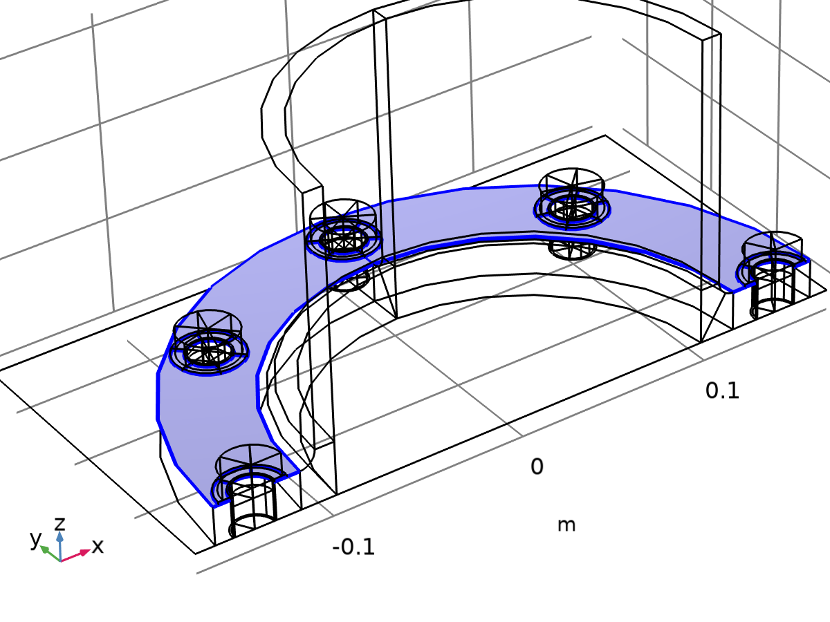

Contact 1a

Selection

|  |  |
| --- | --- |
| Geometric entity level | Boundary |
| Selection | Geometry geom1: Dimension 2: All boundaries |

Equations

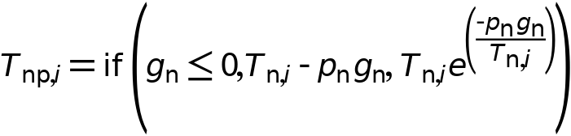

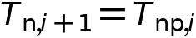

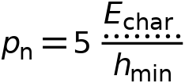

#### Contact Method

Settings

| **Description** | **Value** |
| --- | --- |
| Contact method | Augmented Lagrangian |
| Solution method | Segregated |

#### Contact Pressure Penalty Factor

Settings

| **Description** | **Value** |
| --- | --- |
| Penalty factor control | Preset |
| Tuned for | Speed |

#### Trigger Cutback

Settings

| **Description** | **Value** |
| --- | --- |
| Trigger cutback | Off |

#### Contact Surface Offset and Adjustment

Settings

| **Description** | **Value** | **Unit** |
| --- | --- | --- |
| Offset from destination surface | 0 | m |
| Offset from source surface | 0 | m |
| Force zero initial gap | Off |  |

#### Pair Selection

Settings

| **Description** | **Value** |
| --- | --- |
| Pairs | Contact Pair 3a (ap3) |

#### Variables

| **Name** | **Expression** | **Unit** | **Description** | **Selection** | **Details** |
| --- | --- | --- | --- | --- | --- |
| nsign_ap3 | 1 | m² | Contact normal orientation | Boundaries 5, 41 |  |
| nsign_ap3 | 1 | m² | Contact normal orientation | Boundaries 58, 62, 66, 72–73, 77, 83, 87, 91, 96–97, 101, 107, 111, 115, 120–121, 125, 131, 135, 139, 144, 148, 152 |  |
| ap3.offset | 0 | m | Offset from contact surface | Boundaries 5, 41 | + operation |
| ap3.offset | 0 | m | Offset from contact surface | Boundaries 58, 62, 66, 72–73, 77, 83, 87, 91, 96–97, 101, 107, 111, 115, 120–121, 125, 131, 135, 139, 144, 148, 152 | + operation |
| ap3.x | solid.x | m | Contact surface position, 1-component | Boundaries 5, 41 |  |
| ap3.y | solid.y | m | Contact surface position, 2-component | Boundaries 5, 41 |  |
| ap3.z | solid.z | m | Contact surface position, 3-component | Boundaries 5, 41 |  |
| ap3.x | solid.x | m | Contact surface position, 1-component | Boundaries 58, 62, 66, 72–73, 77, 83, 87, 91, 96–97, 101, 107, 111, 115, 120–121, 125, 131, 135, 139, 144, 148, 152 |  |
| ap3.y | solid.y | m | Contact surface position, 2-component | Boundaries 58, 62, 66, 72–73, 77, 83, 87, 91, 96–97, 101, 107, 111, 115, 120–121, 125, 131, 135, 139, 144, 148, 152 |  |
| ap3.z | solid.z | m | Contact surface position, 3-component | Boundaries 58, 62, 66, 72–73, 77, 83, 87, 91, 96–97, 101, 107, 111, 115, 120–121, 125, 131, 135, 139, 144, 148, 152 |  |
| ap3.X | solid.X | m | Contact surface initial position, 1-component | Boundaries 5, 41 |  |
| ap3.Y | solid.Y | m | Contact surface initial position, 2-component | Boundaries 5, 41 |  |
| ap3.Z | solid.Z | m | Contact surface initial position, 3-component | Boundaries 5, 41 |  |
| ap3.X | solid.X | m | Contact surface initial position, 1-component | Boundaries 58, 62, 66, 72–73, 77, 83, 87, 91, 96–97, 101, 107, 111, 115, 120–121, 125, 131, 135, 139, 144, 148, 152 |  |
| ap3.Y | solid.Y | m | Contact surface initial position, 2-component | Boundaries 58, 62, 66, 72–73, 77, 83, 87, 91, 96–97, 101, 107, 111, 115, 120–121, 125, 131, 135, 139, 144, 148, 152 |  |
| ap3.Z | solid.Z | m | Contact surface initial position, 3-component | Boundaries 58, 62, 66, 72–73, 77, 83, 87, 91, 96–97, 101, 107, 111, 115, 120–121, 125, 131, 135, 139, 144, 148, 152 |  |
| ap3.ux | solid.uf | m | Displacement, x-component | Boundaries 5, 41 |  |
| ap3.uy | solid.vf | m | Displacement, y-component | Boundaries 5, 41 |  |
| ap3.uz | solid.wf | m | Displacement, z-component | Boundaries 5, 41 |  |
| ap3.ux | solid.uf | m | Displacement, x-component | Boundaries 58, 62, 66, 72–73, 77, 83, 87, 91, 96–97, 101, 107, 111, 115, 120–121, 125, 131, 135, 139, 144, 148, 152 |  |
| ap3.uy | solid.vf | m | Displacement, y-component | Boundaries 58, 62, 66, 72–73, 77, 83, 87, 91, 96–97, 101, 107, 111, 115, 120–121, 125, 131, 135, 139, 144, 148, 152 |  |
| ap3.uz | solid.wf | m | Displacement, z-component | Boundaries 58, 62, 66, 72–73, 77, 83, 87, 91, 96–97, 101, 107, 111, 115, 120–121, 125, 131, 135, 139, 144, 148, 152 |  |
| incontact_ap3 | solid.gap_ap3<solid.cnt1.tolcontact | 1 | In contact control variable | Boundaries 5, 41 |  |
| incontact_ap3 | solid.gap_ap3<solid.cnt1.tolcontact | 1 | In contact control variable | Boundaries 58, 62, 66, 72–73, 77, 83, 87, 91, 96–97, 101, 107, 111, 115, 120–121, 125, 131, 135, 139, 144, 148, 152 |  |
| solid.incontact | solid.cnt1.incontact | 1 | In contact control variable | Points 6, 8, 10, 12, 14, 16, 19, 23, 28, 30, 32, 34, 42, 44, 46, 48, 50, 52, 54, 56, 61, 65, 68, 70, 72, 74, 76, 78–79, 81, 83, 85, 87, 89, 91, 93, 95, 97, 99, 101, 103, 105, 107, 109, 111, 113, 115, 117, 119, 121, 123, 125, 127, 129, 131, 133, 135, 137, 139, 141, 143, 145, 147, 149, 151, 153, 155, 157, 159, 161, 163, 165, 167, 169, 171, 173, 175, 177, 179, 181 | || operation |
| solid.incontact | solid.cnt1.incontact | 1 | In contact control variable | Edges 8–9, 12, 15, 18, 21, 26, 33–34, 42, 50, 55–56, 59, 78–79, 81, 84–85, 88, 91, 96–97, 100, 109, 116, 119, 122, 125, 128, 131–132, 136, 139–140, 144, 147–148, 152, 155, 159–161, 166–167, 171–172, 176, 179–180, 184, 187–188, 192, 195–196, 200, 203, 207–209, 214–215, 219–220, 224, 227–228, 232, 235–236, 240, 243–244, 248, 251, 255–257, 262–263, 267–268, 272, 275–276, 280, 283–284, 288, 291–292, 296, 299, 303–304, 308, 311–312, 316, 319–320, 324, 327 | || operation |
| solid.incontact | solid.cnt1.incontact | 1 | In contact control variable | Boundaries 5, 41, 58, 62, 66, 72–73, 77, 83, 87, 91, 96–97, 101, 107, 111, 115, 120–121, 125, 131, 135, 139, 144, 148, 152 | || operation |
| solid.Wh_tot | solid.cnt1.int(if(isdefined(solid.cnt1.Wcnt_ap3),solid.cnt1.gsa_ap3*solid.cnt1.Wcnt_ap3,0)) | J | Total stored energy | Global | + operation |
| solid.gap_I | if(isinf(solid.gap_ap3),0,solid.gap_ap3) | m | Intermediate gap variable | Boundaries 5, 41 | + operation |
| solid.gap | if(solid.nCont==solid.nInfCont,Inf,solid.gap_I) | m | Gap distance including offsets | Boundaries 5, 41 |  |
| solid.hmin_dst | solid.cnt1.min_dst(h) | m | Minimum mesh size on destination | Boundaries 5, 41 |  |
| solid.Tnx | if(isdefined(solid.cnt1.Tnx_ap3),solid.cnt1.Tnx_ap3,0) | N/m² | Contact pressure, x-component | Boundaries 5, 41 | + operation |
| solid.Tny | if(isdefined(solid.cnt1.Tny_ap3),solid.cnt1.Tny_ap3,0) | N/m² | Contact pressure, y-component | Boundaries 5, 41 | + operation |
| solid.Tnz | if(isdefined(solid.cnt1.Tnz_ap3),solid.cnt1.Tnz_ap3,0) | N/m² | Contact pressure, z-component | Boundaries 5, 41 | + operation |
| solid.Tn_totx | solid.cnt1.Tn_totx_ap3 | N | Total contact force, pressure contribution, x-component | Global | + operation |
| solid.Tn_toty | solid.cnt1.Tn_toty_ap3 | N | Total contact force, pressure contribution, y-component | Global | + operation |
| solid.Tn_totz | solid.cnt1.Tn_totz_ap3 | N | Total contact force, pressure contribution, z-component | Global | + operation |
| solid.T_totx | solid.cnt1.T_totx_ap3 | N | Total contact force, x-component | Global | + operation |
| solid.T_toty | solid.cnt1.T_toty_ap3 | N | Total contact force, y-component | Global | + operation |
| solid.T_totz | solid.cnt1.T_totz_ap3 | N | Total contact force, z-component | Global | + operation |
| solid.Wcnt | if(isdefined(solid.cnt1.Wcnt_ap3),solid.cnt1.Wcnt_ap3,0) | J/m² | Contact energy density | Boundaries 5, 41 | + operation |
| solid.Wcnt_tot | solid.cnt1.int(if(isdefined(solid.cnt1.Wcnt_ap3),solid.cnt1.gsa_ap3*solid.cnt1.Wcnt_ap3,0)) | J | Total contact energy | Global | + operation |
| solid.Tn | if(isdefined(solid.Tn_ap3),solid.Tn_ap3,0) | N/m² | Contact pressure | Boundaries 5, 41 | + operation |
| solid.cnt1.incontact | incontact_ap3 | 1 | In contact control variable | Boundaries 58, 62, 66, 72–73, 77, 83, 87, 91, 96–97, 101, 107, 111, 115, 120–121, 125, 131, 135, 139, 144, 148, 152 | || operation |
| solid.cnt1.incontact | incontact_ap3 | 1 | In contact control variable | Boundaries 5, 41 | || operation |
| solid.cnt1.E_char | solid.Eequ | Pa | Characteristic stiffness | Boundaries 5, 41, 58, 62, 66, 72–73, 77, 83, 87, 91, 96–97, 101, 107, 111, 115, 120–121, 125, 131, 135, 139, 144, 148, 152 |  |
| solid.cnt1.nx_ap3 | solid.nx | 1 | Contact surface normal direction, contact pair ap3, x component | Boundaries 5, 41 |  |
| solid.cnt1.ny_ap3 | solid.ny | 1 | Contact surface normal direction, contact pair ap3, y component | Boundaries 5, 41 |  |
| solid.cnt1.nz_ap3 | solid.nz | 1 | Contact surface normal direction, contact pair ap3, z component | Boundaries 5, 41 |  |
| solid.cnt1.nx_ap3 | solid.nx | 1 | Contact surface normal direction, contact pair ap3, x component | Boundaries 58, 62, 66, 72–73, 77, 83, 87, 91, 96–97, 101, 107, 111, 115, 120–121, 125, 131, 135, 139, 144, 148, 152 |  |
| solid.cnt1.ny_ap3 | solid.ny | 1 | Contact surface normal direction, contact pair ap3, y component | Boundaries 58, 62, 66, 72–73, 77, 83, 87, 91, 96–97, 101, 107, 111, 115, 120–121, 125, 131, 135, 139, 144, 148, 152 |  |
| solid.cnt1.nz_ap3 | solid.nz | 1 | Contact surface normal direction, contact pair ap3, z component | Boundaries 58, 62, 66, 72–73, 77, 83, 87, 91, 96–97, 101, 107, 111, 115, 120–121, 125, 131, 135, 139, 144, 148, 152 |  |
| solid.cnt1.np_ap3 | if(src2dst_ap3,nojac(ap3.nx*src2dst_ap3(ap3.nx)+ap3.ny*src2dst_ap3(ap3.ny)+ap3.nz*src2dst_ap3(ap3.nz)),-1) | 1 | Source to destination normal correction factor, spatial frame | Boundaries 5, 41 |  |
| solid.cnt1.np_ap3 | if(dst2src_ap3,nojac(ap3.nx*dst2src_ap3(ap3.nx)+ap3.ny*dst2src_ap3(ap3.ny)+ap3.nz*dst2src_ap3(ap3.nz)),-1) | 1 | Source to destination normal correction factor, spatial frame | Boundaries 58, 62, 66, 72–73, 77, 83, 87, 91, 96–97, 101, 107, 111, 115, 120–121, 125, 131, 135, 139, 144, 148, 152 |  |
| solid.cnt1.offset_ap3 | ap3.offset+if(src2dst_ap3&&ap3.hasSrcOffset,-src2dst_ap3(ap3.offset)/solid.cnt1.np_ap3,0) | m | Total offset | Boundaries 5, 41 | + operation |
| solid.cnt1.offset_ap3 | ap3.offset+if(dst2src_ap3,-dst2src_ap3(ap3.offset)/solid.cnt1.np_ap3,0) | m | Total offset | Boundaries 58, 62, 66, 72–73, 77, 83, 87, 91, 96–97, 101, 107, 111, 115, 120–121, 125, 131, 135, 139, 144, 148, 152 | + operation |
| solid.gap_ap3 | geomgap_dst_ap3-solid.cnt1.offset_ap3 | m | Gap distance including offsets, contact pair ap3 | Boundaries 5, 41 |  |
| solid.gap_ap3 | geomgap_src_ap3-solid.cnt1.offset_ap3 | m | Gap distance including offsets, contact pair ap3 | Boundaries 58, 62, 66, 72–73, 77, 83, 87, 91, 96–97, 101, 107, 111, 115, 120–121, 125, 131, 135, 139, 144, 148, 152 |  |
| solid.cnt1.tolcontact | 1.0E-4*solid.cnt1.geomsize | m | Multiphysics contact tolerance | Boundaries 5, 41, 58, 62, 66, 72–73, 77, 83, 87, 91, 96–97, 101, 107, 111, 115, 120–121, 125, 131, 135, 139, 144, 148, 152 |  |
| solid.cnt1.geomsize | 0.41386960782310445 | m | Bounding box | Global |  |
| solid.cnt1.gap_I | if(isinf(solid.gap_ap3),0,solid.gap_ap3) | m | Intermediate gap variable | Boundaries 5, 41 | + operation |
| solid.cnt1.gap | if(solid.cnt1.nCont==solid.cnt1.nInfCont,Inf,solid.cnt1.gap_I) | m | Gap distance including offsets | Boundaries 5, 41 |  |
| solid.gapmin_ap3 | solid.cnt1.min(if(isdefined(solid.gap_ap3),solid.gap_ap3,Inf)) | m | Minimum gap distance, contact pair ap3 | Global |  |
| solid.cnt1.pn | solid.cnt1.fp*solid.cnt1.E_char/solid.hmin_dst | N/m³ | Contact pressure penalty factor | Boundaries 5, 41 |  |
| solid.cnt1.fp | 5 | 1 | Penalty factor multiplier | Boundaries 5, 41 |  |
| solid.cnt1.Tnp_ap3 | max(if(solid.gap_ap3<=0,solid.Tn_ap3-solid.cnt1.pn*solid.gap_ap3,solid.Tn_ap3*exp(-solid.cnt1.pn*solid.gap_ap3/max(solid.Tn_ap3,eps))),0) | N/m² | Penalized contact pressure, contact pair ap3 | Boundaries 5, 41 |  |
| solid.cnt1.Tx_ap3 | -solid.cnt1.Tnp_ap3*ap3.nX | N/m² | Contact force, contact pair ap3, x component | Boundaries 5, 41 | + operation |
| solid.cnt1.Ty_ap3 | -solid.cnt1.Tnp_ap3*ap3.nY | N/m² | Contact force, contact pair ap3, y component | Boundaries 5, 41 | + operation |
| solid.cnt1.Tz_ap3 | -solid.cnt1.Tnp_ap3*ap3.nZ | N/m² | Contact force, contact pair ap3, z component | Boundaries 5, 41 | + operation |
| solid.cnt1.Tnx_ap3 | -ap3.nx*solid.Tn_ap3 | N/m² | Contact pressure, contact pair ap3, x component | Boundaries 5, 41 |  |
| solid.cnt1.Tny_ap3 | -ap3.ny*solid.Tn_ap3 | N/m² | Contact pressure, contact pair ap3, y component | Boundaries 5, 41 |  |
| solid.cnt1.Tnz_ap3 | -ap3.nz*solid.Tn_ap3 | N/m² | Contact pressure, contact pair ap3, z component | Boundaries 5, 41 |  |
| solid.cnt1.Tn_totx_ap3 | solid.cnt1.int(if(isdefined(solid.Tn_ap3),solid.cnt1.gsa_ap3*solid.cnt1.Tnx_ap3,0)) | N | Total contact force, pressure contribution, contact pair ap3, x component | Global |  |
| solid.cnt1.Tn_toty_ap3 | solid.cnt1.int(if(isdefined(solid.Tn_ap3),solid.cnt1.gsa_ap3*solid.cnt1.Tny_ap3,0)) | N | Total contact force, pressure contribution, contact pair ap3, y component | Global |  |
| solid.cnt1.Tn_totz_ap3 | solid.cnt1.int(if(isdefined(solid.Tn_ap3),solid.cnt1.gsa_ap3*solid.cnt1.Tnz_ap3,0)) | N | Total contact force, pressure contribution, contact pair ap3, z component | Global |  |
| solid.cnt1.T_totx_ap3 | solid.cnt1.Tn_totx_ap3 | N | Total contact force, contact pair ap3, x component | Global | + operation |
| solid.cnt1.T_toty_ap3 | solid.cnt1.Tn_toty_ap3 | N | Total contact force, contact pair ap3, y component | Global | + operation |
| solid.cnt1.T_totz_ap3 | solid.cnt1.Tn_totz_ap3 | N | Total contact force, contact pair ap3, z component | Global | + operation |
| solid.cnt1.Tn | if(isdefined(solid.Tn_ap3),solid.Tn_ap3,0) | N/m² | Contact pressure | Boundaries 5, 41 | + operation |
| solid.cnt1.Tnx | if(isdefined(solid.cnt1.Tnx_ap3),solid.cnt1.Tnx_ap3,0) | N/m² | Contact pressure, x-component | Boundaries 5, 41 | + operation |
| solid.cnt1.Tny | if(isdefined(solid.cnt1.Tny_ap3),solid.cnt1.Tny_ap3,0) | N/m² | Contact pressure, y-component | Boundaries 5, 41 | + operation |
| solid.cnt1.Tnz | if(isdefined(solid.cnt1.Tnz_ap3),solid.cnt1.Tnz_ap3,0) | N/m² | Contact pressure, z-component | Boundaries 5, 41 | + operation |
| solid.cnt1.Tn_totx | solid.cnt1.Tn_totx_ap3 | N | Total contact force, pressure contribution, x-component | Global | + operation |
| solid.cnt1.Tn_toty | solid.cnt1.Tn_toty_ap3 | N | Total contact force, pressure contribution, y-component | Global | + operation |
| solid.cnt1.Tn_totz | solid.cnt1.Tn_totz_ap3 | N | Total contact force, pressure contribution, z-component | Global | + operation |
| solid.cnt1.T_totx | solid.cnt1.T_totx_ap3 | N | Total contact force, x-component | Global | + operation |
| solid.cnt1.T_toty | solid.cnt1.T_toty_ap3 | N | Total contact force, y-component | Global | + operation |
| solid.cnt1.T_totz | solid.cnt1.T_totz_ap3 | N | Total contact force, z-component | Global | + operation |
| solid.Tnmax_ap3 | solid.cnt1.max(if(isdefined(solid.gap_ap3),solid.Tn_ap3,0)) | N/m² | Maximum contact pressure, contact pair ap3 | Global |  |
| solid.cnt1.Wcnt_ap3 | 0.5*solid.Tn_ap3*if(isinf(solid.gap_ap3),0,sign(solid.gap_ap3)*solid.gap_ap3) | J/m² | Contact energy density, contact pair ap3 | Boundaries 5, 41 |  |
| solid.cnt1.Wcnt | if(isdefined(solid.cnt1.Wcnt_ap3),solid.cnt1.Wcnt_ap3,0) | J/m² | Contact energy density | Boundaries 5, 41 | + operation |
| solid.cnt1.isContact_ap3 | incontact_ap3 | 1 | Contact variable, contact pair ap3 | Boundaries 5, 41 |  |
| ap3.hasSrcOffset | 0 | 1 | Has source offset | Global | || operation |
| solid.cnt1.dsign | 1 | 1 | Contact direction sign | Boundaries 5, 41, 58, 62, 66, 72–73, 77, 83, 87, 91, 96–97, 101, 107, 111, 115, 120–121, 125, 131, 135, 139, 144, 148, 152 |  |
| solid.cnt1.src2dstFtxX_ap3 | nojac(src2dst_ap3(dtang(x_ap3,X_ap3))) | 1 | Deformation gradient projected on the tangent plane, xX-component | Boundaries 5, 41 |  |
| solid.cnt1.src2dstFtyX_ap3 | nojac(src2dst_ap3(dtang(y_ap3,X_ap3))) | 1 | Deformation gradient projected on the tangent plane, yX-component | Boundaries 5, 41 |  |
| solid.cnt1.src2dstFtzX_ap3 | nojac(src2dst_ap3(dtang(z_ap3,X_ap3))) | 1 | Deformation gradient projected on the tangent plane, zX-component | Boundaries 5, 41 |  |
| solid.cnt1.src2dstFtxY_ap3 | nojac(src2dst_ap3(dtang(x_ap3,Y_ap3))) | 1 | Deformation gradient projected on the tangent plane, xY-component | Boundaries 5, 41 |  |
| solid.cnt1.src2dstFtyY_ap3 | nojac(src2dst_ap3(dtang(y_ap3,Y_ap3))) | 1 | Deformation gradient projected on the tangent plane, yY-component | Boundaries 5, 41 |  |
| solid.cnt1.src2dstFtzY_ap3 | nojac(src2dst_ap3(dtang(z_ap3,Y_ap3))) | 1 | Deformation gradient projected on the tangent plane, zY-component | Boundaries 5, 41 |  |
| solid.cnt1.src2dstFtxZ_ap3 | nojac(src2dst_ap3(dtang(x_ap3,Z_ap3))) | 1 | Deformation gradient projected on the tangent plane, xZ-component | Boundaries 5, 41 |  |
| solid.cnt1.src2dstFtyZ_ap3 | nojac(src2dst_ap3(dtang(y_ap3,Z_ap3))) | 1 | Deformation gradient projected on the tangent plane, yZ-component | Boundaries 5, 41 |  |
| solid.cnt1.src2dstFtzZ_ap3 | nojac(src2dst_ap3(dtang(z_ap3,Z_ap3))) | 1 | Deformation gradient projected on the tangent plane, zZ-component | Boundaries 5, 41 |  |
| solid.cnt1.src2dstinvFtXx_ap3 | nojac(src2dst_ap3(dtang(X_ap3,x_ap3))) | 1 | Inverse deformation gradient projected on the tangent plane, Xx-component | Boundaries 5, 41 |  |
| solid.cnt1.src2dstinvFtYx_ap3 | nojac(src2dst_ap3(dtang(Y_ap3,x_ap3))) | 1 | Inverse deformation gradient projected on the tangent plane, Yx-component | Boundaries 5, 41 |  |
| solid.cnt1.src2dstinvFtZx_ap3 | nojac(src2dst_ap3(dtang(Z_ap3,x_ap3))) | 1 | Inverse deformation gradient projected on the tangent plane, Zx-component | Boundaries 5, 41 |  |
| solid.cnt1.src2dstinvFtXy_ap3 | nojac(src2dst_ap3(dtang(X_ap3,y_ap3))) | 1 | Inverse deformation gradient projected on the tangent plane, Xy-component | Boundaries 5, 41 |  |
| solid.cnt1.src2dstinvFtYy_ap3 | nojac(src2dst_ap3(dtang(Y_ap3,y_ap3))) | 1 | Inverse deformation gradient projected on the tangent plane, Yy-component | Boundaries 5, 41 |  |
| solid.cnt1.src2dstinvFtZy_ap3 | nojac(src2dst_ap3(dtang(Z_ap3,y_ap3))) | 1 | Inverse deformation gradient projected on the tangent plane, Zy-component | Boundaries 5, 41 |  |
| solid.cnt1.src2dstinvFtXz_ap3 | nojac(src2dst_ap3(dtang(X_ap3,z_ap3))) | 1 | Inverse deformation gradient projected on the tangent plane, Xz-component | Boundaries 5, 41 |  |
| solid.cnt1.src2dstinvFtYz_ap3 | nojac(src2dst_ap3(dtang(Y_ap3,z_ap3))) | 1 | Inverse deformation gradient projected on the tangent plane, Yz-component | Boundaries 5, 41 |  |
| solid.cnt1.src2dstinvFtZz_ap3 | nojac(src2dst_ap3(dtang(Z_ap3,z_ap3))) | 1 | Inverse deformation gradient projected on the tangent plane, Zz-component | Boundaries 5, 41 |  |
| solid.cnt1.gsa_ap3 | dvol_material_ap3/dvol | 1 | Geometry scale factor (area) | Boundaries 5, 41 |  |
| solid.Tn_ap3TXt | d(solid.Tn_ap3TX,TIME) | W/m⁴ | Tangential gradient of Tn_ap3, X component, first time derivative | Boundaries 5, 41 |  |
| solid.Tn_ap3TYt | d(solid.Tn_ap3TY,TIME) | W/m⁴ | Tangential gradient of Tn_ap3, Y component, first time derivative | Boundaries 5, 41 |  |
| solid.Tn_ap3TZt | d(solid.Tn_ap3TZ,TIME) | W/m⁴ | Tangential gradient of Tn_ap3, Z component, first time derivative | Boundaries 5, 41 |  |
| solid.Tn_ap3TXtt | d(d(solid.Tn_ap3TX,TIME),TIME) | kg/(m²·s⁴) | Tangential gradient of Tn_ap3, X component, second time derivative | Boundaries 5, 41 |  |
| solid.Tn_ap3TYtt | d(d(solid.Tn_ap3TY,TIME),TIME) | kg/(m²·s⁴) | Tangential gradient of Tn_ap3, Y component, second time derivative | Boundaries 5, 41 |  |
| solid.Tn_ap3TZtt | d(d(solid.Tn_ap3TZ,TIME),TIME) | kg/(m²·s⁴) | Tangential gradient of Tn_ap3, Z component, second time derivative | Boundaries 5, 41 |  |
| solid.Tn_ap3t | d(solid.Tn_ap3,TIME) | W/m³ | Contact pressure, contact pair ap3, first time derivative | Boundaries 5, 41 |  |
| solid.Tn_ap3tt | d(d(solid.Tn_ap3,TIME),TIME) | Pa/s² | Contact pressure, contact pair ap3, second time derivative | Boundaries 5, 41 |  |

#### Shape functions

| **Name** | **Shape function** | **Unit** | **Description** | **Shape frame** | **Selection** |
| --- | --- | --- | --- | --- | --- |
| solid.Tn_ap3 | Lagrange (Linear) | N/m² | Contact pressure, contact pair ap3 | Material | Boundaries 5, 41 |

#### Weak Expressions

| **Weak expression** | **Integration order** | **Integration frame** | **Selection** |
| --- | --- | --- | --- |
| (nojac(solid.cnt1.Tnp_ap3)-solid.Tn_ap3)*test(solid.Tn_ap3)*solid.cnt1.gsa_ap3 | 4 | Material | Boundaries 5, 41 |
| if(solid.cnt1.Tnp_ap3>0,solid.cnt1.Tnp_ap3*test(solid.gap_ap3)*solid.cnt1.gsa_ap3,0) | 4 | Material | Boundaries 5, 41 |

#### Friction 1



Friction 1

Selection

|  |  |
| --- | --- |
| Geometric entity level | Boundary |
| Selection | Geometry geom1: Dimension 2: All boundaries |

Equations

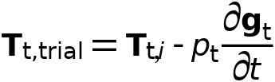

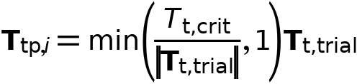

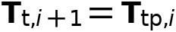



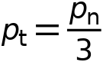

##### Friction Parameters

Settings

| **Description** | **Value** | **Unit** |
| --- | --- | --- |
| Friction model | Coulomb |  |
| Friction coefficient | 0.15 | 1 |
| Cohesion sliding resistance | 0 | N/m² |
| Maximum tangential traction | Inf | N/m² |

##### Friction Force Penalty Factor

Settings

| **Description** | **Value** |
| --- | --- |
| Penalty factor control | From parent |

##### Coordinate System Selection

Settings

| **Description** | **Value** |
| --- | --- |
| Coordinate system | Boundary System 1 (sys1) |

Used products

|  |
| --- |
| COMSOL Multiphysics |

##### Variables

| **Name** | **Expression** | **Unit** | **Description** | **Selection** | **Details** |
| --- | --- | --- | --- | --- | --- |
| solid.cnt1.u1_dst_ap3 | if(src2dst_ap3,ap3.ux,0) | m | Contact surface displacement on destination, contact pair ap3, 1 component | Boundaries 5, 41 |  |
| solid.cnt1.u2_dst_ap3 | if(src2dst_ap3,ap3.uy,0) | m | Contact surface displacement on destination, contact pair ap3, 2 component | Boundaries 5, 41 |  |
| solid.cnt1.u3_dst_ap3 | if(src2dst_ap3,ap3.uz,0) | m | Contact surface displacement on destination, contact pair ap3, 3 component | Boundaries 5, 41 |  |
| solid.cnt1.u1_src_ap3 | src2dst_ap3_nmj(ap3.ux) | m | Contact surface displacement on source, contact pair ap3, 1 component | Boundaries 5, 41 |  |
| solid.cnt1.u2_src_ap3 | src2dst_ap3_nmj(ap3.uy) | m | Contact surface displacement on source, contact pair ap3, 2 component | Boundaries 5, 41 |  |
| solid.cnt1.u3_src_ap3 | src2dst_ap3_nmj(ap3.uz) | m | Contact surface displacement on source, contact pair ap3, 3 component | Boundaries 5, 41 |  |
| solid.cnt1.Tx_ap3 | solid.cnt1.Ttpx_ap3 | N/m² | Contact force, contact pair ap3, x component | Boundaries 5, 41 | + operation |
| solid.cnt1.Ty_ap3 | solid.cnt1.Ttpy_ap3 | N/m² | Contact force, contact pair ap3, y component | Boundaries 5, 41 | + operation |
| solid.cnt1.Tz_ap3 | solid.cnt1.Ttpz_ap3 | N/m² | Contact force, contact pair ap3, z component | Boundaries 5, 41 | + operation |
| solid.cnt1.T_totx_ap3 | if(isdefined(solid.cnt1.Tt_totx_ap3),solid.cnt1.Tt_totx_ap3,0) | N | Total contact force, contact pair ap3, x component | Global | + operation |
| solid.cnt1.T_toty_ap3 | if(isdefined(solid.cnt1.Tt_toty_ap3),solid.cnt1.Tt_toty_ap3,0) | N | Total contact force, contact pair ap3, y component | Global | + operation |
| solid.cnt1.T_totz_ap3 | if(isdefined(solid.cnt1.Tt_totz_ap3),solid.cnt1.Tt_totz_ap3,0) | N | Total contact force, contact pair ap3, z component | Global | + operation |
| solid.cnt1.Ttx | if(isdefined(solid.cnt1.Ttx_ap3),solid.cnt1.Ttx_ap3,0) | N/m² | Friction force, x-component | Boundaries 5, 41 | + operation |
| solid.cnt1.Tty | if(isdefined(solid.cnt1.Tty_ap3),solid.cnt1.Tty_ap3,0) | N/m² | Friction force, y-component | Boundaries 5, 41 | + operation |
| solid.cnt1.Ttz | if(isdefined(solid.cnt1.Ttz_ap3),solid.cnt1.Ttz_ap3,0) | N/m² | Friction force, z-component | Boundaries 5, 41 | + operation |
| solid.cnt1.fric1.t1x_ap3 | nojac((sys1.Tdef11-(nx_ap3*sys1.Tdef11+ny_ap3*sys1.Tdef12+nz_ap3*sys1.Tdef13)*nx_ap3)/sqrt((sys1.Tdef11-(nx_ap3*sys1.Tdef11+ny_ap3*sys1.Tdef12+nz_ap3*sys1.Tdef13)*nx_ap3)^2+(sys1.Tdef12-(nx_ap3*sys1.Tdef11+ny_ap3*sys1.Tdef12+nz_ap3*sys1.Tdef13)*ny_ap3)^2+(sys1.Tdef13-(nx_ap3*sys1.Tdef11+ny_ap3*sys1.Tdef12+nz_ap3*sys1.Tdef13)*nz_ap3)^2)) | 1 | Tangent 1, x-component | Boundaries 5, 41, 58, 62, 66, 72–73, 77, 83, 87, 91, 96–97, 101, 107, 111, 115, 120–121, 125, 131, 135, 139, 144, 148, 152 |  |
| solid.cnt1.fric1.t1y_ap3 | nojac((sys1.Tdef12-(nx_ap3*sys1.Tdef11+ny_ap3*sys1.Tdef12+nz_ap3*sys1.Tdef13)*ny_ap3)/sqrt((sys1.Tdef11-(nx_ap3*sys1.Tdef11+ny_ap3*sys1.Tdef12+nz_ap3*sys1.Tdef13)*nx_ap3)^2+(sys1.Tdef12-(nx_ap3*sys1.Tdef11+ny_ap3*sys1.Tdef12+nz_ap3*sys1.Tdef13)*ny_ap3)^2+(sys1.Tdef13-(nx_ap3*sys1.Tdef11+ny_ap3*sys1.Tdef12+nz_ap3*sys1.Tdef13)*nz_ap3)^2)) | 1 | Tangent 1, y-component | Boundaries 5, 41, 58, 62, 66, 72–73, 77, 83, 87, 91, 96–97, 101, 107, 111, 115, 120–121, 125, 131, 135, 139, 144, 148, 152 |  |
| solid.cnt1.fric1.t1z_ap3 | nojac((sys1.Tdef13-(nx_ap3*sys1.Tdef11+ny_ap3*sys1.Tdef12+nz_ap3*sys1.Tdef13)*nz_ap3)/sqrt((sys1.Tdef11-(nx_ap3*sys1.Tdef11+ny_ap3*sys1.Tdef12+nz_ap3*sys1.Tdef13)*nx_ap3)^2+(sys1.Tdef12-(nx_ap3*sys1.Tdef11+ny_ap3*sys1.Tdef12+nz_ap3*sys1.Tdef13)*ny_ap3)^2+(sys1.Tdef13-(nx_ap3*sys1.Tdef11+ny_ap3*sys1.Tdef12+nz_ap3*sys1.Tdef13)*nz_ap3)^2)) | 1 | Tangent 1, z-component | Boundaries 5, 41, 58, 62, 66, 72–73, 77, 83, 87, 91, 96–97, 101, 107, 111, 115, 120–121, 125, 131, 135, 139, 144, 148, 152 |  |
| solid.cnt1.fric1.t2x_ap3 | -nojac(nsign_ap3*(nz_ap3*solid.cnt1.fric1.t1y_ap3-ny_ap3*solid.cnt1.fric1.t1z_ap3)/sqrt(nsign_ap3^2*((nz_ap3*solid.cnt1.fric1.t1y_ap3-ny_ap3*solid.cnt1.fric1.t1z_ap3)^2+(-nz_ap3*solid.cnt1.fric1.t1x_ap3+nx_ap3*solid.cnt1.fric1.t1z_ap3)^2+(ny_ap3*solid.cnt1.fric1.t1x_ap3-nx_ap3*solid.cnt1.fric1.t1y_ap3)^2))) | 1 | Tangent 2, x-component | Boundaries 5, 41, 58, 62, 66, 72–73, 77, 83, 87, 91, 96–97, 101, 107, 111, 115, 120–121, 125, 131, 135, 139, 144, 148, 152 |  |
| solid.cnt1.fric1.t2y_ap3 | -nojac(nsign_ap3*(-nz_ap3*solid.cnt1.fric1.t1x_ap3+nx_ap3*solid.cnt1.fric1.t1z_ap3)/sqrt(nsign_ap3^2*((nz_ap3*solid.cnt1.fric1.t1y_ap3-ny_ap3*solid.cnt1.fric1.t1z_ap3)^2+(-nz_ap3*solid.cnt1.fric1.t1x_ap3+nx_ap3*solid.cnt1.fric1.t1z_ap3)^2+(ny_ap3*solid.cnt1.fric1.t1x_ap3-nx_ap3*solid.cnt1.fric1.t1y_ap3)^2))) | 1 | Tangent 2, y-component | Boundaries 5, 41, 58, 62, 66, 72–73, 77, 83, 87, 91, 96–97, 101, 107, 111, 115, 120–121, 125, 131, 135, 139, 144, 148, 152 |  |
| solid.cnt1.fric1.t2z_ap3 | -nojac(nsign_ap3*(ny_ap3*solid.cnt1.fric1.t1x_ap3-nx_ap3*solid.cnt1.fric1.t1y_ap3)/sqrt(nsign_ap3^2*((nz_ap3*solid.cnt1.fric1.t1y_ap3-ny_ap3*solid.cnt1.fric1.t1z_ap3)^2+(-nz_ap3*solid.cnt1.fric1.t1x_ap3+nx_ap3*solid.cnt1.fric1.t1z_ap3)^2+(ny_ap3*solid.cnt1.fric1.t1x_ap3-nx_ap3*solid.cnt1.fric1.t1y_ap3)^2))) | 1 | Tangent 2, z-component | Boundaries 5, 41, 58, 62, 66, 72–73, 77, 83, 87, 91, 96–97, 101, 107, 111, 115, 120–121, 125, 131, 135, 139, 144, 148, 152 |  |
| solid.cnt1.fric1.t1X_ap3 | nojac((sys1.Tdef11-(nX_ap3*sys1.Tdef11+nY_ap3*sys1.Tdef12+nZ_ap3*sys1.Tdef13)*nX_ap3)/sqrt((sys1.Tdef11-(nX_ap3*sys1.Tdef11+nY_ap3*sys1.Tdef12+nZ_ap3*sys1.Tdef13)*nX_ap3)^2+(sys1.Tdef12-(nX_ap3*sys1.Tdef11+nY_ap3*sys1.Tdef12+nZ_ap3*sys1.Tdef13)*nY_ap3)^2+(sys1.Tdef13-(nX_ap3*sys1.Tdef11+nY_ap3*sys1.Tdef12+nZ_ap3*sys1.Tdef13)*nZ_ap3)^2)) | 1 | Tangent 1, X-component | Boundaries 5, 41, 58, 62, 66, 72–73, 77, 83, 87, 91, 96–97, 101, 107, 111, 115, 120–121, 125, 131, 135, 139, 144, 148, 152 |  |
| solid.cnt1.fric1.t1Y_ap3 | nojac((sys1.Tdef12-(nX_ap3*sys1.Tdef11+nY_ap3*sys1.Tdef12+nZ_ap3*sys1.Tdef13)*nY_ap3)/sqrt((sys1.Tdef11-(nX_ap3*sys1.Tdef11+nY_ap3*sys1.Tdef12+nZ_ap3*sys1.Tdef13)*nX_ap3)^2+(sys1.Tdef12-(nX_ap3*sys1.Tdef11+nY_ap3*sys1.Tdef12+nZ_ap3*sys1.Tdef13)*nY_ap3)^2+(sys1.Tdef13-(nX_ap3*sys1.Tdef11+nY_ap3*sys1.Tdef12+nZ_ap3*sys1.Tdef13)*nZ_ap3)^2)) | 1 | Tangent 1, Y-component | Boundaries 5, 41, 58, 62, 66, 72–73, 77, 83, 87, 91, 96–97, 101, 107, 111, 115, 120–121, 125, 131, 135, 139, 144, 148, 152 |  |
| solid.cnt1.fric1.t1Z_ap3 | nojac((sys1.Tdef13-(nX_ap3*sys1.Tdef11+nY_ap3*sys1.Tdef12+nZ_ap3*sys1.Tdef13)*nZ_ap3)/sqrt((sys1.Tdef11-(nX_ap3*sys1.Tdef11+nY_ap3*sys1.Tdef12+nZ_ap3*sys1.Tdef13)*nX_ap3)^2+(sys1.Tdef12-(nX_ap3*sys1.Tdef11+nY_ap3*sys1.Tdef12+nZ_ap3*sys1.Tdef13)*nY_ap3)^2+(sys1.Tdef13-(nX_ap3*sys1.Tdef11+nY_ap3*sys1.Tdef12+nZ_ap3*sys1.Tdef13)*nZ_ap3)^2)) | 1 | Tangent 1, Z-component | Boundaries 5, 41, 58, 62, 66, 72–73, 77, 83, 87, 91, 96–97, 101, 107, 111, 115, 120–121, 125, 131, 135, 139, 144, 148, 152 |  |
| solid.cnt1.fric1.t2X_ap3 | -nojac(nsign_ap3*(nZ_ap3*solid.cnt1.fric1.t1Y_ap3-nY_ap3*solid.cnt1.fric1.t1Z_ap3)/sqrt(nsign_ap3^2*((nZ_ap3*solid.cnt1.fric1.t1Y_ap3-nY_ap3*solid.cnt1.fric1.t1Z_ap3)^2+(-nZ_ap3*solid.cnt1.fric1.t1X_ap3+nX_ap3*solid.cnt1.fric1.t1Z_ap3)^2+(nY_ap3*solid.cnt1.fric1.t1X_ap3-nX_ap3*solid.cnt1.fric1.t1Y_ap3)^2))) | 1 | Tangent 2, X-component | Boundaries 5, 41, 58, 62, 66, 72–73, 77, 83, 87, 91, 96–97, 101, 107, 111, 115, 120–121, 125, 131, 135, 139, 144, 148, 152 |  |
| solid.cnt1.fric1.t2Y_ap3 | -nojac(nsign_ap3*(-nZ_ap3*solid.cnt1.fric1.t1X_ap3+nX_ap3*solid.cnt1.fric1.t1Z_ap3)/sqrt(nsign_ap3^2*((nZ_ap3*solid.cnt1.fric1.t1Y_ap3-nY_ap3*solid.cnt1.fric1.t1Z_ap3)^2+(-nZ_ap3*solid.cnt1.fric1.t1X_ap3+nX_ap3*solid.cnt1.fric1.t1Z_ap3)^2+(nY_ap3*solid.cnt1.fric1.t1X_ap3-nX_ap3*solid.cnt1.fric1.t1Y_ap3)^2))) | 1 | Tangent 2, Y-component | Boundaries 5, 41, 58, 62, 66, 72–73, 77, 83, 87, 91, 96–97, 101, 107, 111, 115, 120–121, 125, 131, 135, 139, 144, 148, 152 |  |
| solid.cnt1.fric1.t2Z_ap3 | -nojac(nsign_ap3*(nY_ap3*solid.cnt1.fric1.t1X_ap3-nX_ap3*solid.cnt1.fric1.t1Y_ap3)/sqrt(nsign_ap3^2*((nZ_ap3*solid.cnt1.fric1.t1Y_ap3-nY_ap3*solid.cnt1.fric1.t1Z_ap3)^2+(-nZ_ap3*solid.cnt1.fric1.t1X_ap3+nX_ap3*solid.cnt1.fric1.t1Z_ap3)^2+(nY_ap3*solid.cnt1.fric1.t1X_ap3-nX_ap3*solid.cnt1.fric1.t1Y_ap3)^2))) | 1 | Tangent 2, Z-component | Boundaries 5, 41, 58, 62, 66, 72–73, 77, 83, 87, 91, 96–97, 101, 107, 111, 115, 120–121, 125, 131, 135, 139, 144, 148, 152 |  |
| solid.cnt1.fric1.sysT11_ap3 | solid.cnt1.fric1.t1x_ap3 | 1 | Transform to global system, 11-component | Boundaries 5, 41, 58, 62, 66, 72–73, 77, 83, 87, 91, 96–97, 101, 107, 111, 115, 120–121, 125, 131, 135, 139, 144, 148, 152 |  |
| solid.cnt1.fric1.sysT21_ap3 | solid.cnt1.fric1.t2x_ap3 | 1 | Transform to global system, 21-component | Boundaries 5, 41, 58, 62, 66, 72–73, 77, 83, 87, 91, 96–97, 101, 107, 111, 115, 120–121, 125, 131, 135, 139, 144, 148, 152 |  |
| solid.cnt1.fric1.sysT31_ap3 | nsign_ap3*nx_ap3 | 1 | Transform to global system, 31-component | Boundaries 5, 41, 58, 62, 66, 72–73, 77, 83, 87, 91, 96–97, 101, 107, 111, 115, 120–121, 125, 131, 135, 139, 144, 148, 152 |  |
| solid.cnt1.fric1.sysT12_ap3 | solid.cnt1.fric1.t1y_ap3 | 1 | Transform to global system, 12-component | Boundaries 5, 41, 58, 62, 66, 72–73, 77, 83, 87, 91, 96–97, 101, 107, 111, 115, 120–121, 125, 131, 135, 139, 144, 148, 152 |  |
| solid.cnt1.fric1.sysT22_ap3 | solid.cnt1.fric1.t2y_ap3 | 1 | Transform to global system, 22-component | Boundaries 5, 41, 58, 62, 66, 72–73, 77, 83, 87, 91, 96–97, 101, 107, 111, 115, 120–121, 125, 131, 135, 139, 144, 148, 152 |  |
| solid.cnt1.fric1.sysT32_ap3 | nsign_ap3*ny_ap3 | 1 | Transform to global system, 32-component | Boundaries 5, 41, 58, 62, 66, 72–73, 77, 83, 87, 91, 96–97, 101, 107, 111, 115, 120–121, 125, 131, 135, 139, 144, 148, 152 |  |
| solid.cnt1.fric1.sysT13_ap3 | solid.cnt1.fric1.t1z_ap3 | 1 | Transform to global system, 13-component | Boundaries 5, 41, 58, 62, 66, 72–73, 77, 83, 87, 91, 96–97, 101, 107, 111, 115, 120–121, 125, 131, 135, 139, 144, 148, 152 |  |
| solid.cnt1.fric1.sysT23_ap3 | solid.cnt1.fric1.t2z_ap3 | 1 | Transform to global system, 23-component | Boundaries 5, 41, 58, 62, 66, 72–73, 77, 83, 87, 91, 96–97, 101, 107, 111, 115, 120–121, 125, 131, 135, 139, 144, 148, 152 |  |
| solid.cnt1.fric1.sysT33_ap3 | nsign_ap3*nz_ap3 | 1 | Transform to global system, 33-component | Boundaries 5, 41, 58, 62, 66, 72–73, 77, 83, 87, 91, 96–97, 101, 107, 111, 115, 120–121, 125, 131, 135, 139, 144, 148, 152 |  |
| solid.cnt1.pt | solid.cnt1.pn/3 | N/m³ | Friction force penalty factor | Boundaries 5, 41 |  |
| solid.cnt1.cmX_ap3 | ((solid.cnt1.u1_dst_ap3-solid.cnt1.u1_src_ap3)*t1X_ap3+(solid.cnt1.u2_dst_ap3-solid.cnt1.u2_src_ap3)*t1Y_ap3+(solid.cnt1.u3_dst_ap3-solid.cnt1.u3_src_ap3)*t1Z_ap3)*t1X_ap3+((solid.cnt1.u1_dst_ap3-solid.cnt1.u1_src_ap3)*t2X_ap3+(solid.cnt1.u2_dst_ap3-solid.cnt1.u2_src_ap3)*t2Y_ap3+(solid.cnt1.u3_dst_ap3-solid.cnt1.u3_src_ap3)*t2Z_ap3)*t2X_ap3 | m | Mapped source coordinates, contact pair ap3, X component | Boundaries 5, 41 |  |
| solid.cnt1.cmY_ap3 | ((solid.cnt1.u1_dst_ap3-solid.cnt1.u1_src_ap3)*t1X_ap3+(solid.cnt1.u2_dst_ap3-solid.cnt1.u2_src_ap3)*t1Y_ap3+(solid.cnt1.u3_dst_ap3-solid.cnt1.u3_src_ap3)*t1Z_ap3)*t1Y_ap3+((solid.cnt1.u1_dst_ap3-solid.cnt1.u1_src_ap3)*t2X_ap3+(solid.cnt1.u2_dst_ap3-solid.cnt1.u2_src_ap3)*t2Y_ap3+(solid.cnt1.u3_dst_ap3-solid.cnt1.u3_src_ap3)*t2Z_ap3)*t2Y_ap3 | m | Mapped source coordinates, contact pair ap3, Y component | Boundaries 5, 41 |  |
| solid.cnt1.cmZ_ap3 | ((solid.cnt1.u1_dst_ap3-solid.cnt1.u1_src_ap3)*t1X_ap3+(solid.cnt1.u2_dst_ap3-solid.cnt1.u2_src_ap3)*t1Y_ap3+(solid.cnt1.u3_dst_ap3-solid.cnt1.u3_src_ap3)*t1Z_ap3)*t1Z_ap3+((solid.cnt1.u1_dst_ap3-solid.cnt1.u1_src_ap3)*t2X_ap3+(solid.cnt1.u2_dst_ap3-solid.cnt1.u2_src_ap3)*t2Y_ap3+(solid.cnt1.u3_dst_ap3-solid.cnt1.u3_src_ap3)*t2Z_ap3)*t2Z_ap3 | m | Mapped source coordinates, contact pair ap3, Z component | Boundaries 5, 41 |  |
| solid.cnt1.slipX_ap3 | if(solid.cnt1.friction_ap3,solid.cnt1.cmX_ap3-solid.cmX_ap3_old,0) | m | Slip vector material frame, contact pair ap3, X component | Boundaries 5, 41 |  |
| solid.cnt1.slipY_ap3 | if(solid.cnt1.friction_ap3,solid.cnt1.cmY_ap3-solid.cmY_ap3_old,0) | m | Slip vector material frame, contact pair ap3, Y component | Boundaries 5, 41 |  |
| solid.cnt1.slipZ_ap3 | if(solid.cnt1.friction_ap3,solid.cnt1.cmZ_ap3-solid.cmZ_ap3_old,0) | m | Slip vector material frame, contact pair ap3, Z component | Boundaries 5, 41 |  |
| solid.cnt1.slipx_ap3 | solid.cnt1.src2dstFtxX_ap3*solid.cnt1.slipX_ap3+solid.cnt1.src2dstFtxY_ap3*solid.cnt1.slipY_ap3+solid.cnt1.src2dstFtxZ_ap3*solid.cnt1.slipZ_ap3 | m | Slip vector spatial frame, contact pair ap3, x component | Boundaries 5, 41 |  |
| solid.cnt1.slipy_ap3 | solid.cnt1.src2dstFtyX_ap3*solid.cnt1.slipX_ap3+solid.cnt1.src2dstFtyY_ap3*solid.cnt1.slipY_ap3+solid.cnt1.src2dstFtyZ_ap3*solid.cnt1.slipZ_ap3 | m | Slip vector spatial frame, contact pair ap3, y component | Boundaries 5, 41 |  |
| solid.cnt1.slipz_ap3 | solid.cnt1.src2dstFtzX_ap3*solid.cnt1.slipX_ap3+solid.cnt1.src2dstFtzY_ap3*solid.cnt1.slipY_ap3+solid.cnt1.src2dstFtzZ_ap3*solid.cnt1.slipZ_ap3 | m | Slip vector spatial frame, contact pair ap3, z component | Boundaries 5, 41 |  |
| solid.cnt1.slipt1_ap3 | solid.cnt1.fric1.sysT11_ap3*solid.cnt1.slipx_ap3+solid.cnt1.fric1.sysT12_ap3*solid.cnt1.slipy_ap3+solid.cnt1.fric1.sysT13_ap3*solid.cnt1.slipz_ap3 | m | Slip vector spatial frame, contact pair ap3, t1 component | Boundaries 5, 41 |  |
| solid.cnt1.slipt2_ap3 | solid.cnt1.fric1.sysT21_ap3*solid.cnt1.slipx_ap3+solid.cnt1.fric1.sysT22_ap3*solid.cnt1.slipy_ap3+solid.cnt1.fric1.sysT23_ap3*solid.cnt1.slipz_ap3 | m | Slip vector spatial frame, contact pair ap3, t2 component | Boundaries 5, 41 |  |
| solid.cnt1.slipn_ap3 | 0 | m | Slip vector spatial frame, contact pair ap3, n component | Boundaries 5, 41 |  |
| solid.cnt1.friction_ap3 | solid.contact_ap3_old | 1 | Enabling friction variable, contact pair ap3 | Boundaries 5, 41 | && operation |
| solid.cnt1.contact_ap3 | solid.gap_ap3<solid.cnt1.tolfriction | 1 | Contact variable, contact pair ap3 | Boundaries 5, 41 |  |
| solid.cnt1.tolfriction | 0.2*h | m | Friction detection tolerance | Boundaries 5, 41 |  |
| solid.cnt1.Tttrialt1_ap3 | solid.Ttt1_ap3-solid.cnt1.pt*solid.cnt1.slipt1_ap3 | N/m² | Trial friction force, contact pair ap3, t1 component | Boundaries 5, 41 |  |
| solid.cnt1.Tttrialt2_ap3 | solid.Ttt2_ap3-solid.cnt1.pt*solid.cnt1.slipt2_ap3 | N/m² | Trial friction force, contact pair ap3, t2 component | Boundaries 5, 41 |  |
| solid.cnt1.Tttrialn_ap3 | 0 | N/m² | Trial friction force, contact pair ap3, n component | Boundaries 5, 41 |  |
| solid.cnt1.Ttpt1_ap3 | min(solid.cnt1.Ttcrit_ap3/solid.cnt1.Tttrialnorm_ap3,1)*solid.cnt1.Tttrialt1_ap3 | N/m² | Penalized friction force, contact pair ap3, t1 component | Boundaries 5, 41 |  |
| solid.cnt1.Ttpt2_ap3 | min(solid.cnt1.Ttcrit_ap3/solid.cnt1.Tttrialnorm_ap3,1)*solid.cnt1.Tttrialt2_ap3 | N/m² | Penalized friction force, contact pair ap3, t2 component | Boundaries 5, 41 |  |
| solid.cnt1.Ttpn_ap3 | 0 | N/m² | Penalized friction force, contact pair ap3, n component | Boundaries 5, 41 |  |
| solid.cnt1.Ttpx_ap3 | solid.cnt1.fric1.sysT11_ap3*solid.cnt1.Ttpt1_ap3+solid.cnt1.fric1.sysT21_ap3*solid.cnt1.Ttpt2_ap3+solid.cnt1.fric1.sysT31_ap3*solid.cnt1.Ttpn_ap3 | N/m² | Penalized friction force, contact pair ap3, x component | Boundaries 5, 41 |  |
| solid.cnt1.Ttpy_ap3 | solid.cnt1.fric1.sysT12_ap3*solid.cnt1.Ttpt1_ap3+solid.cnt1.fric1.sysT22_ap3*solid.cnt1.Ttpt2_ap3+solid.cnt1.fric1.sysT32_ap3*solid.cnt1.Ttpn_ap3 | N/m² | Penalized friction force, contact pair ap3, y component | Boundaries 5, 41 |  |
| solid.cnt1.Ttpz_ap3 | solid.cnt1.fric1.sysT13_ap3*solid.cnt1.Ttpt1_ap3+solid.cnt1.fric1.sysT23_ap3*solid.cnt1.Ttpt2_ap3+solid.cnt1.fric1.sysT33_ap3*solid.cnt1.Ttpn_ap3 | N/m² | Penalized friction force, contact pair ap3, z component | Boundaries 5, 41 |  |
| solid.cnt1.Tttrialnorm_ap3 | sqrt(solid.cnt1.Tttrialt1_ap3^2+solid.cnt1.Tttrialt2_ap3^2+solid.cnt1.Tttrialn_ap3^2+eps) | N/m² | Trial friction force norm, contact pair ap3 | Boundaries 5, 41 |  |
| solid.cnt1.Ttx_ap3 | solid.cnt1.fric1.sysT11_ap3*solid.Ttt1_ap3+solid.cnt1.fric1.sysT21_ap3*solid.Ttt2_ap3 | N/m² | Friction force, contact pair ap3, x component | Boundaries 5, 41 |  |
| solid.cnt1.Tty_ap3 | solid.cnt1.fric1.sysT12_ap3*solid.Ttt1_ap3+solid.cnt1.fric1.sysT22_ap3*solid.Ttt2_ap3 | N/m² | Friction force, contact pair ap3, y component | Boundaries 5, 41 |  |
| solid.cnt1.Ttz_ap3 | solid.cnt1.fric1.sysT13_ap3*solid.Ttt1_ap3+solid.cnt1.fric1.sysT23_ap3*solid.Ttt2_ap3 | N/m² | Friction force, contact pair ap3, z component | Boundaries 5, 41 |  |
| solid.cnt1.mu_fric | 0.15 | 1 | Friction coefficient | Boundaries 5, 41 |  |
| solid.cnt1.cohe | 0 | N/m² | Cohesion sliding resistance | Boundaries 5, 41 |  |
| solid.cnt1.Ttmax | Inf | N/m² | Maximum tangential traction | Boundaries 5, 41 |  |
| solid.cnt1.Ttcrit_ap3 | min(solid.cnt1.mu_fric*solid.cnt1.Tnp_ap3+solid.cnt1.cohe,solid.cnt1.Ttmax) | N/m² | Critical friction force, contact pair ap3 | Boundaries 5, 41 |  |
| solid.cnt1.Tt_initt1 | 0 | N/m² | Friction force, t1-component | Boundaries 5, 41 |  |
| solid.cnt1.Tt_initt2 | 0 | N/m² | Friction force, t2-component | Boundaries 5, 41 |  |
| solid.cnt1.Tt_initn | 0 | N/m² | Friction force, n-component | Boundaries 5, 41 |  |
| solid.cnt1.isSliding_ap3 | if(solid.cnt1.isContact_ap3,solid.cnt1.Ttnorm_ap3/(min(solid.cnt1.mu_fric*solid.Tn_ap3+solid.cnt1.cohe,solid.cnt1.Ttmax)+eps)>=0.999,0) | 1 | Sliding friction status variable, contact pair ap3 | Boundaries 5, 41 |  |
| solid.cnt1.Ttnorm_ap3 | sqrt(solid.Ttt1_ap3^2+solid.Ttt2_ap3^2+eps) | N/m² | Friction force norm, contact pair ap3 | Boundaries 5, 41 |  |
| solid.cnt1.Tt_totx_ap3 | solid.cnt1.int(if(isdefined(solid.cnt1.Ttx_ap3),solid.cnt1.Ttx_ap3,0)) | N | Total contact force, friction contribution, contact pair ap3, x component | Global |  |
| solid.cnt1.Tt_toty_ap3 | solid.cnt1.int(if(isdefined(solid.cnt1.Tty_ap3),solid.cnt1.Tty_ap3,0)) | N | Total contact force, friction contribution, contact pair ap3, y component | Global |  |
| solid.cnt1.Tt_totz_ap3 | solid.cnt1.int(if(isdefined(solid.cnt1.Ttz_ap3),solid.cnt1.Ttz_ap3,0)) | N | Total contact force, friction contribution, contact pair ap3, z component | Global |  |
| solid.cnt1.Ttt1 | if(isdefined(solid.Ttt1_ap3),solid.Ttt1_ap3,0) | N/m² | Friction force, boundary system, t1-component | Boundaries 5, 41, 58, 62, 66, 72–73, 77, 83, 87, 91, 96–97, 101, 107, 111, 115, 120–121, 125, 131, 135, 139, 144, 148, 152 | + operation |
| solid.cnt1.Ttt2 | if(isdefined(solid.Ttt2_ap3),solid.Ttt2_ap3,0) | N/m² | Friction force, boundary system, t2-component | Boundaries 5, 41, 58, 62, 66, 72–73, 77, 83, 87, 91, 96–97, 101, 107, 111, 115, 120–121, 125, 131, 135, 139, 144, 148, 152 | + operation |
| solid.cnt1.Ttn | 0 | N/m² | Friction force, boundary system, n-component | Boundaries 5, 41, 58, 62, 66, 72–73, 77, 83, 87, 91, 96–97, 101, 107, 111, 115, 120–121, 125, 131, 135, 139, 144, 148, 152 | + operation |
| solid.cnt1.Ttnorm | if(isdefined(solid.cnt1.Ttnorm_ap3),solid.cnt1.Ttnorm_ap3,0) | N/m² | Friction force norm | Boundaries 5, 41 | + operation |
| solid.cnt1.Tt_totx | if(isdefined(solid.cnt1.Tt_totx_ap3),solid.cnt1.Tt_totx_ap3,0) | N | Total contact force, friction contribution, x-component | Global | + operation |
| solid.cnt1.Tt_toty | if(isdefined(solid.cnt1.Tt_toty_ap3),solid.cnt1.Tt_toty_ap3,0) | N | Total contact force, friction contribution, y-component | Global | + operation |
| solid.cnt1.Tt_totz | if(isdefined(solid.cnt1.Tt_totz_ap3),solid.cnt1.Tt_totz_ap3,0) | N | Total contact force, friction contribution, z-component | Global | + operation |
| solid.Tt_totx | if(isdefined(solid.cnt1.Tt_totx_ap3),solid.cnt1.Tt_totx_ap3,0) | N | Total contact force, friction contribution, x-component | Global | + operation |
| solid.Tt_toty | if(isdefined(solid.cnt1.Tt_toty_ap3),solid.cnt1.Tt_toty_ap3,0) | N | Total contact force, friction contribution, y-component | Global | + operation |
| solid.Tt_totz | if(isdefined(solid.cnt1.Tt_totz_ap3),solid.cnt1.Tt_totz_ap3,0) | N | Total contact force, friction contribution, z-component | Global | + operation |
| solid.Ttt1 | if(isdefined(solid.Ttt1_ap3),solid.Ttt1_ap3,0) | N/m² | Friction force, boundary system, t1-component | Boundaries 5, 41, 58, 62, 66, 72–73, 77, 83, 87, 91, 96–97, 101, 107, 111, 115, 120–121, 125, 131, 135, 139, 144, 148, 152 | + operation |
| solid.Ttt2 | if(isdefined(solid.Ttt2_ap3),solid.Ttt2_ap3,0) | N/m² | Friction force, boundary system, t2-component | Boundaries 5, 41, 58, 62, 66, 72–73, 77, 83, 87, 91, 96–97, 101, 107, 111, 115, 120–121, 125, 131, 135, 139, 144, 148, 152 | + operation |
| solid.Ttn | 0 | N/m² | Friction force, boundary system, n-component | Boundaries 5, 41, 58, 62, 66, 72–73, 77, 83, 87, 91, 96–97, 101, 107, 111, 115, 120–121, 125, 131, 135, 139, 144, 148, 152 | + operation |
| solid.Ttx | if(isdefined(solid.cnt1.Ttx_ap3),solid.cnt1.Ttx_ap3,0) | N/m² | Friction force, x-component | Boundaries 5, 41 | + operation |
| solid.Tty | if(isdefined(solid.cnt1.Tty_ap3),solid.cnt1.Tty_ap3,0) | N/m² | Friction force, y-component | Boundaries 5, 41 | + operation |
| solid.Ttz | if(isdefined(solid.cnt1.Ttz_ap3),solid.cnt1.Ttz_ap3,0) | N/m² | Friction force, z-component | Boundaries 5, 41 | + operation |
| solid.Ttnorm | if(isdefined(solid.cnt1.Ttnorm_ap3),solid.cnt1.Ttnorm_ap3,0) | N/m² | Friction force norm | Boundaries 5, 41 | + operation |

##### Shape functions

| **Name** | **Shape function** | **Unit** | **Description** | **Shape frame** | **Selection** |
| --- | --- | --- | --- | --- | --- |
| solid.Ttt1_ap3 | Lagrange (Linear) | N/m² | Friction force, contact pair ap3, t1 component | Spatial | Boundaries 5, 41 |
| solid.Ttt2_ap3 | Lagrange (Linear) | N/m² | Friction force, contact pair ap3, t2 component | Spatial | Boundaries 5, 41 |

##### Weak Expressions

| **Weak expression** | **Integration order** | **Integration frame** | **Selection** |
| --- | --- | --- | --- |
| ((nojac(solid.cnt1.friction_ap3*solid.cnt1.Ttpt1_ap3)-solid.Ttt1_ap3)*test(solid.Ttt1_ap3)+(nojac(solid.cnt1.friction_ap3*solid.cnt1.Ttpt2_ap3)-solid.Ttt2_ap3)*test(solid.Ttt2_ap3))*solid.cnt1.gsa_ap3 | 4 | Material | Boundaries 5, 41 |
| if(solid.cnt1.Tnp_ap3>0,((solid.cnt1.src2dstFtxX_ap3*solid.cnt1.Ttpx_ap3+solid.cnt1.src2dstFtyX_ap3*solid.cnt1.Ttpy_ap3+solid.cnt1.src2dstFtzX_ap3*solid.cnt1.Ttpz_ap3)*test(solid.cnt1.cmX_ap3)+(solid.cnt1.src2dstFtxY_ap3*solid.cnt1.Ttpx_ap3+solid.cnt1.src2dstFtyY_ap3*solid.cnt1.Ttpy_ap3+solid.cnt1.src2dstFtzY_ap3*solid.cnt1.Ttpz_ap3)*test(solid.cnt1.cmY_ap3)+(solid.cnt1.src2dstFtxZ_ap3*solid.cnt1.Ttpx_ap3+solid.cnt1.src2dstFtyZ_ap3*solid.cnt1.Ttpy_ap3+solid.cnt1.src2dstFtzZ_ap3*solid.cnt1.Ttpz_ap3)*test(solid.cnt1.cmZ_ap3))*solid.cnt1.gsa_ap3,0) | 4 | Material | Boundaries 5, 41 |

#### Stabilization 1



Stabilization 1

Selection

|  |  |
| --- | --- |
| Geometric entity level | Boundary |
| Selection | Geometry geom1: Dimension 2: All boundaries |

Equations

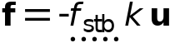

##### Quasistatic Stabilization

Settings

| **Description** | **Value** |
| --- | --- |
| Apply to | Adjacent domains |
| Stiffness multiplier | 1 |
| Method | Manual |
| Active for | First iteration |

Used products

|  |
| --- |
| COMSOL Multiphysics |

##### Variables

| **Name** | **Expression** | **Unit** | **Description** | **Selection** | **Details** |
| --- | --- | --- | --- | --- | --- |
| solid.cnt1.Wstb | solid.cnt1.stb1.int(0.5*(solid.cnt1.stb1.fsx*u+solid.cnt1.stb1.fsy*v+solid.cnt1.stb1.fsz*w)) | J | Total contact stabilization energy | Global | + operation |
| solid.cnt1.stb1.cond | solid.stepnumber==1&&niterCMP==1 | 1 | Stabilization condition | Global | && operation |
| solid.cnt1.stb1.factor | 1 | 1 | Relaxation factor | Global | * operation |
| solid.cnt1.stb1.ks | 1.0E-5*solid.cnt1.stb1.cond*solid.cnt1.stb1.factor*solid.Eequ*h/meshvol | kg/(m³·s²) | Spring constant | Domains 1, 5–9 |  |
| solid.cnt1.stb1.fsx | solid.cnt1.stb1.ks*u | N/m³ | Spring force, x-component | Domains 1, 5–9 |  |
| solid.cnt1.stb1.fsy | solid.cnt1.stb1.ks*v | N/m³ | Spring force, y-component | Domains 1, 5–9 |  |
| solid.cnt1.stb1.fsz | solid.cnt1.stb1.ks*w | N/m³ | Spring force, z-component | Domains 1, 5–9 |  |

##### Weak Expressions

| **Weak expression** | **Integration order** | **Integration frame** | **Selection** |
| --- | --- | --- | --- |
| if(solid.cnt1.stb1.cond,-solid.cnt1.stb1.fsx*test(u)-solid.cnt1.stb1.fsy*test(v)-solid.cnt1.stb1.fsz*test(w),0) | 4 | Material | Domains 1, 5–9 |

### Symmetry 1

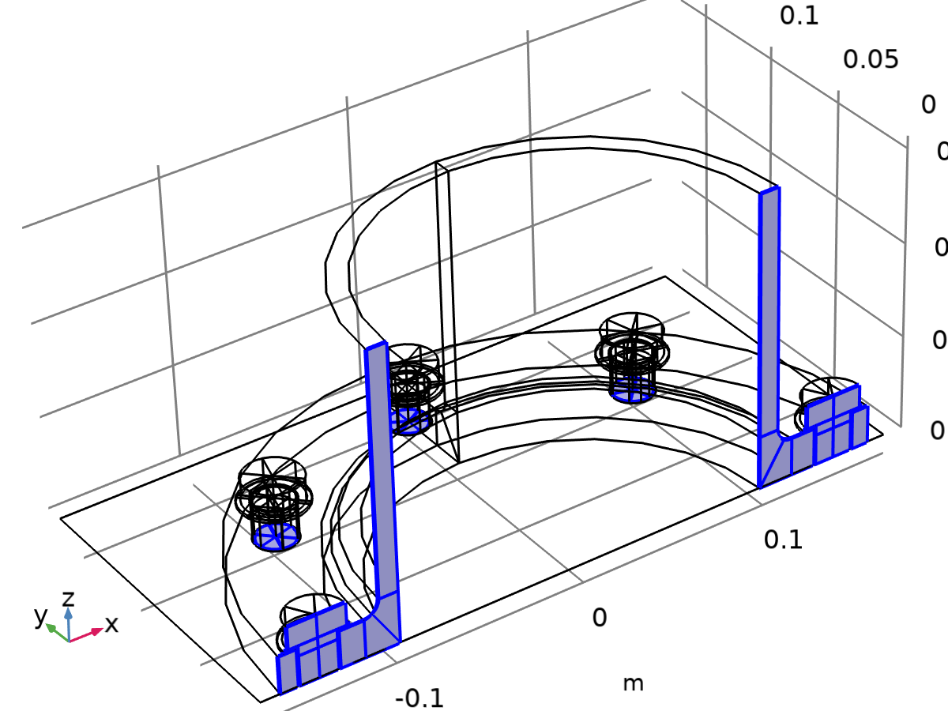

Symmetry 1

Selection

|  |  |
| --- | --- |
| Geometric entity level | Boundary |
| Name | Symmetry |
| Selection | Named uni1: Geometry geom1: Dimension 2: Boundaries 2, 9–10, 14, 19, 47–49, 51, 55–56, 69, 142, 155–156, 161–162, 164, 173, 179–180, 182, 185, 206–207, 217, 228, 236–237, 272–273, 283, 294, 302–303, 338–339, 349, 360, 368–369, 390, 395–396, 398, 407, 413–414, 416, 419 |

Equations

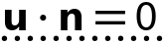

#### Normal Direction Condition

Settings

| **Description** | **Value** |
| --- | --- |
|  | No displacement |

Used products

|  |
| --- |
| COMSOL Multiphysics |

#### Variables

| **Name** | **Expression** | **Unit** | **Description** | **Selection** |
| --- | --- | --- | --- | --- |
| solid.sym1.nsymX | if(abs(-1+solid.sym1.avg(solid.nX)*solid.nX+solid.sym1.avg(solid.nY)*solid.nY+solid.sym1.avg(solid.nZ)*solid.nZ)<0.001,solid.sym1.avg(solid.nX),solid.nX) | 1 | Normal vector, X-component | Boundaries 2, 9–10, 14, 19, 47–49, 51, 55–56, 69, 142, 155–156, 161–162, 164, 173, 179–180, 182, 185, 206–207, 217, 228, 236–237, 272–273, 283, 294, 302–303, 338–339, 349, 360, 368–369, 390, 395–396, 398, 407, 413–414, 416, 419 |
| solid.sym1.nsymY | if(abs(-1+solid.sym1.avg(solid.nX)*solid.nX+solid.sym1.avg(solid.nY)*solid.nY+solid.sym1.avg(solid.nZ)*solid.nZ)<0.001,solid.sym1.avg(solid.nY),solid.nY) | 1 | Normal vector, Y-component | Boundaries 2, 9–10, 14, 19, 47–49, 51, 55–56, 69, 142, 155–156, 161–162, 164, 173, 179–180, 182, 185, 206–207, 217, 228, 236–237, 272–273, 283, 294, 302–303, 338–339, 349, 360, 368–369, 390, 395–396, 398, 407, 413–414, 416, 419 |
| solid.sym1.nsymZ | if(abs(-1+solid.sym1.avg(solid.nX)*solid.nX+solid.sym1.avg(solid.nY)*solid.nY+solid.sym1.avg(solid.nZ)*solid.nZ)<0.001,solid.sym1.avg(solid.nZ),solid.nZ) | 1 | Normal vector, Z-component | Boundaries 2, 9–10, 14, 19, 47–49, 51, 55–56, 69, 142, 155–156, 161–162, 164, 173, 179–180, 182, 185, 206–207, 217, 228, 236–237, 272–273, 283, 294, 302–303, 338–339, 349, 360, 368–369, 390, 395–396, 398, 407, 413–414, 416, 419 |

#### Constraints

| **Constraint** | **Constraint force** | **Shape function** | **Selection** | **Details** |
| --- | --- | --- | --- | --- |
| -solid.sym1.nsymX*u-solid.sym1.nsymY*v-solid.sym1.nsymZ*w | test(-solid.sym1.nsymX*u-solid.sym1.nsymY*v-solid.sym1.nsymZ*w) | Nodal serendipity (Quadratic) | Boundaries 2, 9–10, 14, 19, 47–49, 51, 55–56, 69, 142, 155–156, 161–162, 164, 173, 179–180, 182, 185, 206–207, 217, 228, 236–237, 272–273, 283, 294, 302–303, 338–339, 349, 360, 368–369, 390, 395–396, 398, 407, 413–414, 416, 419 | Elemental |

### Prescribed Displacement 1

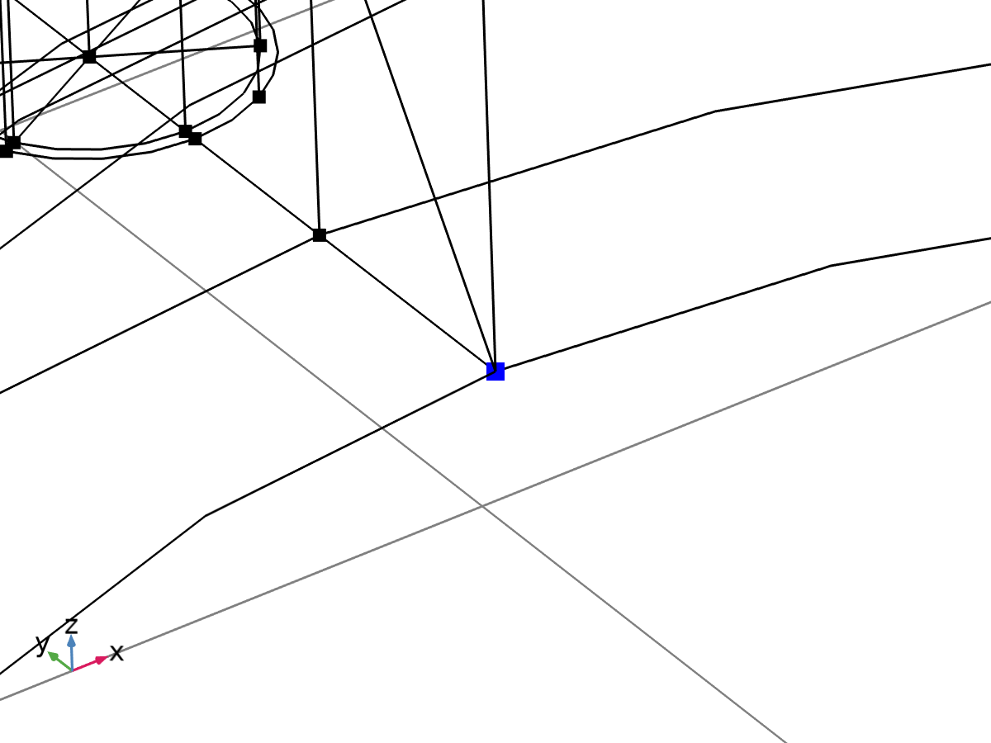

Prescribed Displacement 1

Selection

|  |  |
| --- | --- |
| Geometric entity level | Point |
| Selection | Geometry geom1: Dimension 0: Point 35 |

Equations

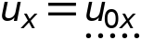

#### Prescribed Displacement

Settings

| **Description** | **Value** | **Unit** |
| --- | --- | --- |
| Displacement in x direction | Prescribed | 1 |
| Displacement in y direction | Free | 1 |
| Displacement in z direction | Free | 1 |
| Displacement constraint, x-component | 0 | m |
| Displacement constraint, y-component | 0 | m |
| Displacement constraint, z-component | 0 | m |
| Displacement in x direction | Prescribed | 1 |
| Displacement in y direction | Free | 1 |
| Displacement in z direction | Free | 1 |
| Displacement constraint, x-component | 0 | m |
| Displacement constraint, y-component | 0 | m |
| Displacement constraint, z-component | 0 | m |
| Displacement in x direction | Prescribed | 1 |
| Displacement in y direction | Free | 1 |
| Displacement in z direction | Free | 1 |
| Displacement constraint, x-component | 0 | m |
| Displacement constraint, y-component | 0 | m |
| Displacement constraint, z-component | 0 | m |

#### Coordinate System Selection

Settings

| **Description** | **Value** |
| --- | --- |
| Coordinate system | Global coordinate system |

Used products

|  |
| --- |
| COMSOL Multiphysics |

#### Variables

| **Name** | **Expression** | **Unit** | **Description** | **Selection** | **Details** |
| --- | --- | --- | --- | --- | --- |
| solid.disp1.U01 | 0 | m | Displacement constraint, 1-component | Point 35 |  |
| solid.disp1.U02 | 0 | m | Displacement constraint, 2-component | Point 35 |  |
| solid.disp1.U03 | 0 | m | Displacement constraint, 3-component | Point 35 |  |
| solid.disp1.usx | u | m | Displacement, spatial coordinate system, x-component | Point 35 | + operation |
| solid.disp1.usy | v | m | Displacement, spatial coordinate system, y-component | Point 35 | + operation |
| solid.disp1.usz | w | m | Displacement, spatial coordinate system, z-component | Point 35 | + operation |
| solid.disp1.ux | solid.disp1.usx | m | Displacement, local coordinate system, x-component | Point 35 |  |
| solid.disp1.uy | solid.disp1.usy | m | Displacement, local coordinate system, y-component | Point 35 |  |
| solid.disp1.uz | solid.disp1.usz | m | Displacement, local coordinate system, z-component | Point 35 |  |

#### Constraints

| **Constraint** | **Constraint force** | **Shape function** | **Selection** | **Details** |
| --- | --- | --- | --- | --- |
| -solid.disp1.ux+solid.disp1.U01 | test(-solid.disp1.ux+solid.disp1.U01) | Nodal serendipity (Quadratic) | Point 35 | Elemental |
| 0 | 0 | Nodal serendipity (Quadratic) | Point 35 | Elemental |
| 0 | 0 | Nodal serendipity (Quadratic) | Point 35 | Elemental |

### Stress Linearization 1

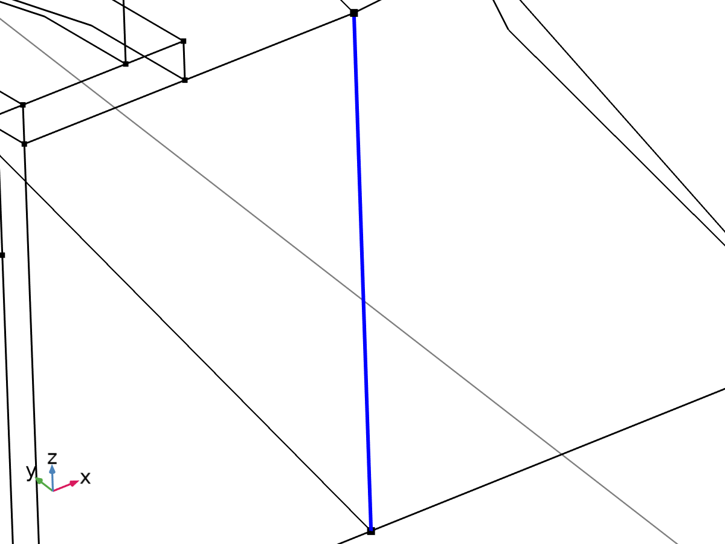

Linearization line, edge

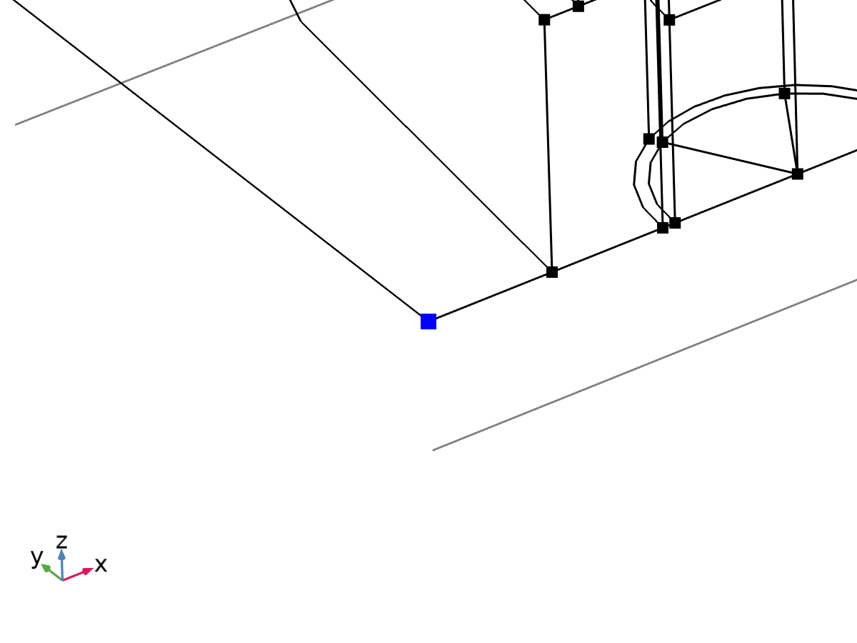

Second axis orientation reference point

Selection

|  |  |
| --- | --- |
| Geometric entity level | Entire model |

Equations

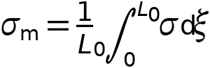

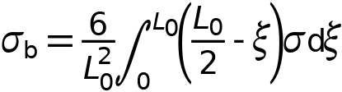

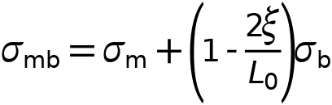

#### Linearization

Settings

| **Description** | **Value** |
| --- | --- |
| Type | Line |
| Defined by | Edge |

#### Second Axis Orientation

Settings

| **Description** | **Value** |
| --- | --- |
|  | Reference point |
| Defined by | Point |

#### Variables

| **Name** | **Expression** | **Unit** | **Description** | **Selection** | **Details** |
| --- | --- | --- | --- | --- | --- |
| solid.Sm11 | solid.sl1.Sm11 | N/m² | Membrane stress, 11-component | Edge 22 | + operation |
| solid.Sm12 | solid.sl1.Sm12 | N/m² | Membrane stress, 12-component | Edge 22 | + operation |
| solid.Sm13 | solid.sl1.Sm13 | N/m² | Membrane stress, 13-component | Edge 22 | + operation |
| solid.Sm22 | solid.sl1.Sm22 | N/m² | Membrane stress, 22-component | Edge 22 | + operation |
| solid.Sm23 | solid.sl1.Sm23 | N/m² | Membrane stress, 23-component | Edge 22 | + operation |
| solid.Sm33 | solid.sl1.Sm33 | N/m² | Membrane stress, 33-component | Edge 22 | + operation |
| solid.Smb11 | solid.sl1.Smb11 | N/m² | Membrane plus bending stress, 11-component | Edge 22 | + operation |
| solid.Smb12 | solid.sl1.Smb12 | N/m² | Membrane plus bending stress, 12-component | Edge 22 | + operation |
| solid.Smb13 | solid.sl1.Smb13 | N/m² | Membrane plus bending stress, 13-component | Edge 22 | + operation |
| solid.Smb22 | solid.sl1.Smb22 | N/m² | Membrane plus bending stress, 22-component | Edge 22 | + operation |
| solid.Smb23 | solid.sl1.Smb23 | N/m² | Membrane plus bending stress, 23-component | Edge 22 | + operation |
| solid.Smb33 | solid.sl1.Smb33 | N/m² | Membrane plus bending stress, 33-component | Edge 22 | + operation |
| solid.Sb11 | solid.sl1.Sb11 | N/m² | Bending stress, 11-component | Edge 22 | + operation |
| solid.Sb12 | solid.sl1.Sb12 | N/m² | Bending stress, 12-component | Edge 22 | + operation |
| solid.Sb13 | solid.sl1.Sb13 | N/m² | Bending stress, 13-component | Edge 22 | + operation |
| solid.Sb22 | solid.sl1.Sb22 | N/m² | Bending stress, 22-component | Edge 22 | + operation |
| solid.Sb23 | solid.sl1.Sb23 | N/m² | Bending stress, 23-component | Edge 22 | + operation |
| solid.Sb33 | solid.sl1.Sb33 | N/m² | Bending stress, 33-component | Edge 22 | + operation |
| solid.Slls11 | solid.sl1.Slls11 | N/m² | Stress tensor, linearization line system, 11-component | Edge 22 | + operation |
| solid.Slls12 | solid.sl1.Slls12 | N/m² | Stress tensor, linearization line system, 12-component | Edge 22 | + operation |
| solid.Slls13 | solid.sl1.Slls13 | N/m² | Stress tensor, linearization line system, 13-component | Edge 22 | + operation |
| solid.Slls22 | solid.sl1.Slls22 | N/m² | Stress tensor, linearization line system, 22-component | Edge 22 | + operation |
| solid.Slls23 | solid.sl1.Slls23 | N/m² | Stress tensor, linearization line system, 23-component | Edge 22 | + operation |
| solid.Slls33 | solid.sl1.Slls33 | N/m² | Stress tensor, linearization line system, 33-component | Edge 22 | + operation |
| solid.SIm | solid.sl1.SIm | N/m² | Stress intensity, membrane | Edge 22 | + operation |
| solid.SImb | solid.sl1.SImb | N/m² | Stress intensity, membrane plus bending | Edge 22 | + operation |
| solid.mises_m | solid.sl1.mises_m | N/m² | von Mises stress (membrane) | Edge 22 | + operation |
| solid.mises_b | solid.sl1.mises_b | N/m² | von Mises stress (bending) | Edge 22 | + operation |
| solid.mises_mb | solid.sl1.mises_mb | N/m² | von Mises stress (membrane plus bending) | Edge 22 | + operation |
| solid.tresca_m | solid.sl1.tresca_m | N/m² | Tresca stress (membrane) | Edge 22 | + operation |
| solid.tresca_b | solid.sl1.tresca_b | N/m² | Tresca stress (bending) | Edge 22 | + operation |
| solid.tresca_mb | solid.sl1.tresca_mb | N/m² | Tresca stress (membrane plus bending) | Edge 22 | + operation |
| solid.sl1.dX | solid.sl1.pt1X-solid.sl1.pt0X | m | Stress linearization line direction, X-component | Edge 22 |  |
| solid.sl1.dY | solid.sl1.pt1Y-solid.sl1.pt0Y | m | Stress linearization line direction, Y-component | Edge 22 |  |
| solid.sl1.dZ | solid.sl1.pt1Z-solid.sl1.pt0Z | m | Stress linearization line direction, Z-component | Edge 22 |  |
| solid.sl1.nl1X | solid.sl1.dX/sqrt(solid.sl1.dX^2+solid.sl1.dY^2+solid.sl1.dZ^2) | 1 | First axis direction, X-component | Edge 22 |  |
| solid.sl1.nl1Y | solid.sl1.dY/sqrt(solid.sl1.dX^2+solid.sl1.dY^2+solid.sl1.dZ^2) | 1 | First axis direction, Y-component | Edge 22 |  |
| solid.sl1.nl1Z | solid.sl1.dZ/sqrt(solid.sl1.dX^2+solid.sl1.dY^2+solid.sl1.dZ^2) | 1 | First axis direction, Z-component | Edge 22 |  |
| solid.sl1.nl2X | (solid.sl1.pointrefX-solid.sl1.pt0X-((solid.sl1.pointrefX-solid.sl1.pt0X)*solid.sl1.nl1X+(solid.sl1.pointrefY-solid.sl1.pt0Y)*solid.sl1.nl1Y+(solid.sl1.pointrefZ-solid.sl1.pt0Z)*solid.sl1.nl1Z)*solid.sl1.nl1X)/sqrt((solid.sl1.pointrefX-solid.sl1.pt0X-((solid.sl1.pointrefX-solid.sl1.pt0X)*solid.sl1.nl1X+(solid.sl1.pointrefY-solid.sl1.pt0Y)*solid.sl1.nl1Y+(solid.sl1.pointrefZ-solid.sl1.pt0Z)*solid.sl1.nl1Z)*solid.sl1.nl1X)^2+(solid.sl1.pointrefY-solid.sl1.pt0Y-((solid.sl1.pointrefX-solid.sl1.pt0X)*solid.sl1.nl1X+(solid.sl1.pointrefY-solid.sl1.pt0Y)*solid.sl1.nl1Y+(solid.sl1.pointrefZ-solid.sl1.pt0Z)*solid.sl1.nl1Z)*solid.sl1.nl1Y)^2+(solid.sl1.pointrefZ-solid.sl1.pt0Z-((solid.sl1.pointrefX-solid.sl1.pt0X)*solid.sl1.nl1X+(solid.sl1.pointrefY-solid.sl1.pt0Y)*solid.sl1.nl1Y+(solid.sl1.pointrefZ-solid.sl1.pt0Z)*solid.sl1.nl1Z)*solid.sl1.nl1Z)^2+eps) | 1 | Second axis direction, X-component | Global |  |
| solid.sl1.nl2Y | (solid.sl1.pointrefY-solid.sl1.pt0Y-((solid.sl1.pointrefX-solid.sl1.pt0X)*solid.sl1.nl1X+(solid.sl1.pointrefY-solid.sl1.pt0Y)*solid.sl1.nl1Y+(solid.sl1.pointrefZ-solid.sl1.pt0Z)*solid.sl1.nl1Z)*solid.sl1.nl1Y)/sqrt((solid.sl1.pointrefX-solid.sl1.pt0X-((solid.sl1.pointrefX-solid.sl1.pt0X)*solid.sl1.nl1X+(solid.sl1.pointrefY-solid.sl1.pt0Y)*solid.sl1.nl1Y+(solid.sl1.pointrefZ-solid.sl1.pt0Z)*solid.sl1.nl1Z)*solid.sl1.nl1X)^2+(solid.sl1.pointrefY-solid.sl1.pt0Y-((solid.sl1.pointrefX-solid.sl1.pt0X)*solid.sl1.nl1X+(solid.sl1.pointrefY-solid.sl1.pt0Y)*solid.sl1.nl1Y+(solid.sl1.pointrefZ-solid.sl1.pt0Z)*solid.sl1.nl1Z)*solid.sl1.nl1Y)^2+(solid.sl1.pointrefZ-solid.sl1.pt0Z-((solid.sl1.pointrefX-solid.sl1.pt0X)*solid.sl1.nl1X+(solid.sl1.pointrefY-solid.sl1.pt0Y)*solid.sl1.nl1Y+(solid.sl1.pointrefZ-solid.sl1.pt0Z)*solid.sl1.nl1Z)*solid.sl1.nl1Z)^2+eps) | 1 | Second axis direction, Y-component | Global |  |
| solid.sl1.nl2Z | (solid.sl1.pointrefZ-solid.sl1.pt0Z-((solid.sl1.pointrefX-solid.sl1.pt0X)*solid.sl1.nl1X+(solid.sl1.pointrefY-solid.sl1.pt0Y)*solid.sl1.nl1Y+(solid.sl1.pointrefZ-solid.sl1.pt0Z)*solid.sl1.nl1Z)*solid.sl1.nl1Z)/sqrt((solid.sl1.pointrefX-solid.sl1.pt0X-((solid.sl1.pointrefX-solid.sl1.pt0X)*solid.sl1.nl1X+(solid.sl1.pointrefY-solid.sl1.pt0Y)*solid.sl1.nl1Y+(solid.sl1.pointrefZ-solid.sl1.pt0Z)*solid.sl1.nl1Z)*solid.sl1.nl1X)^2+(solid.sl1.pointrefY-solid.sl1.pt0Y-((solid.sl1.pointrefX-solid.sl1.pt0X)*solid.sl1.nl1X+(solid.sl1.pointrefY-solid.sl1.pt0Y)*solid.sl1.nl1Y+(solid.sl1.pointrefZ-solid.sl1.pt0Z)*solid.sl1.nl1Z)*solid.sl1.nl1Y)^2+(solid.sl1.pointrefZ-solid.sl1.pt0Z-((solid.sl1.pointrefX-solid.sl1.pt0X)*solid.sl1.nl1X+(solid.sl1.pointrefY-solid.sl1.pt0Y)*solid.sl1.nl1Y+(solid.sl1.pointrefZ-solid.sl1.pt0Z)*solid.sl1.nl1Z)*solid.sl1.nl1Z)^2+eps) | 1 | Second axis direction, Z-component | Global |  |
| solid.sl1.nl3X | (solid.sl1.nl2Z*solid.sl1.nl1Y-solid.sl1.nl2Y*solid.sl1.nl1Z)/sqrt((solid.sl1.nl2Z*solid.sl1.nl1Y-solid.sl1.nl2Y*solid.sl1.nl1Z)^2+(-solid.sl1.nl2Z*solid.sl1.nl1X+solid.sl1.nl2X*solid.sl1.nl1Z)^2+(solid.sl1.nl2Y*solid.sl1.nl1X-solid.sl1.nl2X*solid.sl1.nl1Y)^2) | 1 | Third axis direction, X-component | Edge 22 |  |
| solid.sl1.nl3Y | (-solid.sl1.nl2Z*solid.sl1.nl1X+solid.sl1.nl2X*solid.sl1.nl1Z)/sqrt((solid.sl1.nl2Z*solid.sl1.nl1Y-solid.sl1.nl2Y*solid.sl1.nl1Z)^2+(-solid.sl1.nl2Z*solid.sl1.nl1X+solid.sl1.nl2X*solid.sl1.nl1Z)^2+(solid.sl1.nl2Y*solid.sl1.nl1X-solid.sl1.nl2X*solid.sl1.nl1Y)^2) | 1 | Third axis direction, Y-component | Edge 22 |  |
| solid.sl1.nl3Z | (solid.sl1.nl2Y*solid.sl1.nl1X-solid.sl1.nl2X*solid.sl1.nl1Y)/sqrt((solid.sl1.nl2Z*solid.sl1.nl1Y-solid.sl1.nl2Y*solid.sl1.nl1Z)^2+(-solid.sl1.nl2Z*solid.sl1.nl1X+solid.sl1.nl2X*solid.sl1.nl1Z)^2+(solid.sl1.nl2Y*solid.sl1.nl1X-solid.sl1.nl2X*solid.sl1.nl1Y)^2) | 1 | Third axis direction, Z-component | Edge 22 |  |
| solid.sl1.Sm11 | solid.sl1.int(solid.sl1.Slls11)/solid.sl1.lengthtot | N/m² | Membrane stress, 11-component | Global |  |
| solid.sl1.Sm12 | solid.sl1.int(solid.sl1.Slls12)/solid.sl1.lengthtot | N/m² | Membrane stress, 12-component | Global |  |
| solid.sl1.Sm13 | solid.sl1.int(solid.sl1.Slls13)/solid.sl1.lengthtot | N/m² | Membrane stress, 13-component | Global |  |
| solid.sl1.Sm22 | solid.sl1.int(solid.sl1.Slls22)/solid.sl1.lengthtot | N/m² | Membrane stress, 22-component | Global |  |
| solid.sl1.Sm23 | solid.sl1.int(solid.sl1.Slls23)/solid.sl1.lengthtot | N/m² | Membrane stress, 23-component | Global |  |
| solid.sl1.Sm33 | solid.sl1.int(solid.sl1.Slls33)/solid.sl1.lengthtot | N/m² | Membrane stress, 33-component | Global |  |
| solid.sl1.Sbmax11 | 6*solid.sl1.int((0.5*solid.sl1.lengthtot-solid.sl1.arclength)*solid.sl1.Slls11)/solid.sl1.lengthtot^2 | N/m² | Maximum bending stress, 11-component | Global |  |
| solid.sl1.Sbmax12 | 6*solid.sl1.int((0.5*solid.sl1.lengthtot-solid.sl1.arclength)*solid.sl1.Slls12)/solid.sl1.lengthtot^2 | N/m² | Maximum bending stress, 12-component | Global |  |
| solid.sl1.Sbmax13 | 6*solid.sl1.int((0.5*solid.sl1.lengthtot-solid.sl1.arclength)*solid.sl1.Slls13)/solid.sl1.lengthtot^2 | N/m² | Maximum bending stress, 13-component | Global |  |
| solid.sl1.Sbmax22 | 6*solid.sl1.int((0.5*solid.sl1.lengthtot-solid.sl1.arclength)*solid.sl1.Slls22)/solid.sl1.lengthtot^2 | N/m² | Maximum bending stress, 22-component | Global |  |
| solid.sl1.Sbmax23 | 6*solid.sl1.int((0.5*solid.sl1.lengthtot-solid.sl1.arclength)*solid.sl1.Slls23)/solid.sl1.lengthtot^2 | N/m² | Maximum bending stress, 23-component | Global |  |
| solid.sl1.Sbmax33 | 6*solid.sl1.int((0.5*solid.sl1.lengthtot-solid.sl1.arclength)*solid.sl1.Slls33)/solid.sl1.lengthtot^2 | N/m² | Maximum bending stress, 33-component | Global |  |
| solid.sl1.Sb11 | 2*(0.5-solid.sl1.arclength/solid.sl1.lengthtot)*solid.sl1.Sbmax11 | N/m² | Bending stress, 11-component | Edge 22 |  |
| solid.sl1.Sb12 | 2*(0.5-solid.sl1.arclength/solid.sl1.lengthtot)*solid.sl1.Sbmax12 | N/m² | Bending stress, 12-component | Edge 22 |  |
| solid.sl1.Sb13 | 2*(0.5-solid.sl1.arclength/solid.sl1.lengthtot)*solid.sl1.Sbmax13 | N/m² | Bending stress, 13-component | Edge 22 |  |
| solid.sl1.Sb22 | 2*(0.5-solid.sl1.arclength/solid.sl1.lengthtot)*solid.sl1.Sbmax22 | N/m² | Bending stress, 22-component | Edge 22 |  |
| solid.sl1.Sb23 | 2*(0.5-solid.sl1.arclength/solid.sl1.lengthtot)*solid.sl1.Sbmax23 | N/m² | Bending stress, 23-component | Edge 22 |  |
| solid.sl1.Sb33 | 2*(0.5-solid.sl1.arclength/solid.sl1.lengthtot)*solid.sl1.Sbmax33 | N/m² | Bending stress, 33-component | Edge 22 |  |
| solid.sl1.Smb11 | solid.sl1.Sm11+solid.sl1.Sb11 | N/m² | Membrane plus bending stress, 11-component | Edge 22 |  |
| solid.sl1.Smb12 | solid.sl1.Sm12+solid.sl1.Sb12 | N/m² | Membrane plus bending stress, 12-component | Edge 22 |  |
| solid.sl1.Smb13 | solid.sl1.Sm13+solid.sl1.Sb13 | N/m² | Membrane plus bending stress, 13-component | Edge 22 |  |
| solid.sl1.Smb22 | solid.sl1.Sm22+solid.sl1.Sb22 | N/m² | Membrane plus bending stress, 22-component | Edge 22 |  |
| solid.sl1.Smb23 | solid.sl1.Sm23+solid.sl1.Sb23 | N/m² | Membrane plus bending stress, 23-component | Edge 22 |  |
| solid.sl1.Smb33 | solid.sl1.Sm33+solid.sl1.Sb33 | N/m² | Membrane plus bending stress, 33-component | Edge 22 |  |
| solid.sl1.Sps11 | solid.sl1.startpoint(solid.sl1.Slls11-solid.sl1.Smb11) | N/m² | Peak stress, starting point, 11-component | Global |  |
| solid.sl1.Sps12 | solid.sl1.startpoint(solid.sl1.Slls12-solid.sl1.Smb12) | N/m² | Peak stress, starting point, 12-component | Global |  |
| solid.sl1.Sps13 | solid.sl1.startpoint(solid.sl1.Slls13-solid.sl1.Smb13) | N/m² | Peak stress, starting point, 13-component | Global |  |
| solid.sl1.Sps22 | solid.sl1.startpoint(solid.sl1.Slls22-solid.sl1.Smb22) | N/m² | Peak stress, starting point, 22-component | Global |  |
| solid.sl1.Sps23 | solid.sl1.startpoint(solid.sl1.Slls23-solid.sl1.Smb23) | N/m² | Peak stress, starting point, 23-component | Global |  |
| solid.sl1.Sps33 | solid.sl1.startpoint(solid.sl1.Slls33-solid.sl1.Smb33) | N/m² | Peak stress, starting point, 33-component | Global |  |
| solid.sl1.Spe11 | solid.sl1.endpoint(solid.sl1.Slls11-solid.sl1.Smb11) | N/m² | Peak stress, endpoint, 11-component | Global |  |
| solid.sl1.Spe12 | solid.sl1.endpoint(solid.sl1.Slls12-solid.sl1.Smb12) | N/m² | Peak stress, endpoint, 12-component | Global |  |
| solid.sl1.Spe13 | solid.sl1.endpoint(solid.sl1.Slls13-solid.sl1.Smb13) | N/m² | Peak stress, endpoint, 13-component | Global |  |
| solid.sl1.Spe22 | solid.sl1.endpoint(solid.sl1.Slls22-solid.sl1.Smb22) | N/m² | Peak stress, endpoint, 22-component | Global |  |
| solid.sl1.Spe23 | solid.sl1.endpoint(solid.sl1.Slls23-solid.sl1.Smb23) | N/m² | Peak stress, endpoint, 23-component | Global |  |
| solid.sl1.Spe33 | solid.sl1.endpoint(solid.sl1.Slls33-solid.sl1.Smb33) | N/m² | Peak stress, endpoint, 33-component | Global |  |
| solid.sl1.Slls11 | (solid.sl1.nl1X*solid.SXX+solid.sl1.nl1Y*solid.SXY+solid.sl1.nl1Z*solid.SXZ)*solid.sl1.nl1X+(solid.sl1.nl1X*solid.SXY+solid.sl1.nl1Y*solid.SYY+solid.sl1.nl1Z*solid.SYZ)*solid.sl1.nl1Y+(solid.sl1.nl1X*solid.SXZ+solid.sl1.nl1Y*solid.SYZ+solid.sl1.nl1Z*solid.SZZ)*solid.sl1.nl1Z | N/m² | Stress tensor, linearization line system, 11-component | Edge 22 |  |
| solid.sl1.Slls12 | (solid.sl1.nl1X*solid.SXX+solid.sl1.nl1Y*solid.SXY+solid.sl1.nl1Z*solid.SXZ)*solid.sl1.nl2X+(solid.sl1.nl1X*solid.SXY+solid.sl1.nl1Y*solid.SYY+solid.sl1.nl1Z*solid.SYZ)*solid.sl1.nl2Y+(solid.sl1.nl1X*solid.SXZ+solid.sl1.nl1Y*solid.SYZ+solid.sl1.nl1Z*solid.SZZ)*solid.sl1.nl2Z | N/m² | Stress tensor, linearization line system, 12-component | Edge 22 |  |
| solid.sl1.Slls13 | (solid.sl1.nl1X*solid.SXX+solid.sl1.nl1Y*solid.SXY+solid.sl1.nl1Z*solid.SXZ)*solid.sl1.nl3X+(solid.sl1.nl1X*solid.SXY+solid.sl1.nl1Y*solid.SYY+solid.sl1.nl1Z*solid.SYZ)*solid.sl1.nl3Y+(solid.sl1.nl1X*solid.SXZ+solid.sl1.nl1Y*solid.SYZ+solid.sl1.nl1Z*solid.SZZ)*solid.sl1.nl3Z | N/m² | Stress tensor, linearization line system, 13-component | Edge 22 |  |
| solid.sl1.Slls22 | (solid.sl1.nl2X*solid.SXX+solid.sl1.nl2Y*solid.SXY+solid.sl1.nl2Z*solid.SXZ)*solid.sl1.nl2X+(solid.sl1.nl2X*solid.SXY+solid.sl1.nl2Y*solid.SYY+solid.sl1.nl2Z*solid.SYZ)*solid.sl1.nl2Y+(solid.sl1.nl2X*solid.SXZ+solid.sl1.nl2Y*solid.SYZ+solid.sl1.nl2Z*solid.SZZ)*solid.sl1.nl2Z | N/m² | Stress tensor, linearization line system, 22-component | Edge 22 |  |
| solid.sl1.Slls23 | (solid.sl1.nl2X*solid.SXX+solid.sl1.nl2Y*solid.SXY+solid.sl1.nl2Z*solid.SXZ)*solid.sl1.nl3X+(solid.sl1.nl2X*solid.SXY+solid.sl1.nl2Y*solid.SYY+solid.sl1.nl2Z*solid.SYZ)*solid.sl1.nl3Y+(solid.sl1.nl2X*solid.SXZ+solid.sl1.nl2Y*solid.SYZ+solid.sl1.nl2Z*solid.SZZ)*solid.sl1.nl3Z | N/m² | Stress tensor, linearization line system, 23-component | Edge 22 |  |
| solid.sl1.Slls33 | (solid.sl1.nl3X*solid.SXX+solid.sl1.nl3Y*solid.SXY+solid.sl1.nl3Z*solid.SXZ)*solid.sl1.nl3X+(solid.sl1.nl3X*solid.SXY+solid.sl1.nl3Y*solid.SYY+solid.sl1.nl3Z*solid.SYZ)*solid.sl1.nl3Y+(solid.sl1.nl3X*solid.SXZ+solid.sl1.nl3Y*solid.SYZ+solid.sl1.nl3Z*solid.SZZ)*solid.sl1.nl3Z | N/m² | Stress tensor, linearization line system, 33-component | Edge 22 |  |
| solid.sl1.pointrefX | solid.sl1.pointref(X) | m | Reference point defining local 2 direction, X-component | Global |  |
| solid.sl1.pointrefY | solid.sl1.pointref(Y) | m | Reference point defining local 2 direction, Y-component | Global |  |
| solid.sl1.pointrefZ | solid.sl1.pointref(Z) | m | Reference point defining local 2 direction, Z-component | Global |  |
| solid.sl1.lengthtot | solid.sl1.int(1) | m | Edge length total | Global |  |
| solid.sl1.arclength | (s1-solid.sl1.s1s)*solid.sl1.length/(solid.sl1.s1e-solid.sl1.s1s)+solid.sl1.arclength_offset | m | Arc length | Edge 22 |  |
| solid.sl1.N22 | solid.sl1.lengthtot*solid.sl1.Sm22 | N/m | Local in plane force, 22 component | Global |  |
| solid.sl1.N33 | solid.sl1.lengthtot*solid.sl1.Sm33 | N/m | Local in plane force, 33 component | Global |  |
| solid.sl1.N23 | solid.sl1.lengthtot*solid.sl1.Sm23 | N/m | Local in plane force, 23 component | Global |  |
| solid.sl1.M22 | solid.sl1.lengthtot^2*solid.sl1.Sbmax22/6 | N | Local bending moment, 22 component | Global |  |
| solid.sl1.M33 | solid.sl1.lengthtot^2*solid.sl1.Sbmax33/6 | N | Local bending moment, 33 component | Global |  |
| solid.sl1.M23 | solid.sl1.lengthtot^2*solid.sl1.Sbmax23/6 | N | Local bending moment, 23 component | Global |  |
| solid.sl1.Q2 | solid.sl1.lengthtot*solid.sl1.Sm12 | N/m | Local out-of-plane shear force, 2 component | Global |  |
| solid.sl1.Q3 | solid.sl1.lengthtot*solid.sl1.Sm13 | N/m | Local out-of-plane shear force, 3 component | Global |  |
| solid.sl1.pt0X | solid.sl1.startpoint(solid.X) | m | Starting point, X-component | Global |  |
| solid.sl1.pt0Y | solid.sl1.startpoint(solid.Y) | m | Starting point, Y-component | Global |  |
| solid.sl1.pt0Z | solid.sl1.startpoint(solid.Z) | m | Starting point, Z-component | Global |  |
| solid.sl1.pt1X | solid.sl1.endpoint(solid.X) | m | Endpoint, X-component | Global |  |
| solid.sl1.pt1Y | solid.sl1.endpoint(solid.Y) | m | Endpoint, Y-component | Global |  |
| solid.sl1.pt1Z | solid.sl1.endpoint(solid.Z) | m | Endpoint, Z-component | Global |  |
| solid.sl1.mises_m | sqrt(0.5*((solid.sl1.Sm11-solid.sl1.Sm22)^2+(solid.sl1.Sm22-solid.sl1.Sm33)^2+(solid.sl1.Sm33-solid.sl1.Sm11)^2+6*(solid.sl1.Sm12^2+solid.sl1.Sm23^2+solid.sl1.Sm13^2))) | N/m² | von Mises stress (membrane) | Global |  |
| solid.sl1.mises_b | sqrt(0.5*((solid.sl1.Sb11-solid.sl1.Sb22)^2+(solid.sl1.Sb22-solid.sl1.Sb33)^2+(solid.sl1.Sb33-solid.sl1.Sb11)^2+6*(solid.sl1.Sb12^2+solid.sl1.Sb23^2+solid.sl1.Sb13^2))) | N/m² | von Mises stress (bending) | Edge 22 |  |
| solid.sl1.mises_mb | sqrt(0.5*((solid.sl1.Smb11-solid.sl1.Smb22)^2+(solid.sl1.Smb22-solid.sl1.Smb33)^2+(solid.sl1.Smb33-solid.sl1.Smb11)^2+6*(solid.sl1.Smb12^2+solid.sl1.Smb23^2+solid.sl1.Smb13^2))) | N/m² | von Mises stress (membrane plus bending) | Edge 22 |  |
| solid.sl1.tresca_m | max(max(abs(solid.sl1.Smp1-solid.sl1.Smp2),abs(solid.sl1.Smp1-solid.sl1.Smp3)),abs(solid.sl1.Smp2-solid.sl1.Smp3)) | N/m² | Tresca stress (membrane) | Global |  |
| solid.sl1.tresca_b | max(max(abs(solid.sl1.Sbp1-solid.sl1.Sbp2),abs(solid.sl1.Sbp1-solid.sl1.Sbp3)),abs(solid.sl1.Sbp2-solid.sl1.Sbp3)) | N/m² | Tresca stress (bending) | Edge 22 |  |
| solid.sl1.tresca_mb | max(max(abs(solid.sl1.Smbp1-solid.sl1.Smbp2),abs(solid.sl1.Smbp1-solid.sl1.Smbp3)),abs(solid.sl1.Smbp2-solid.sl1.Smbp3)) | N/m² | Tresca stress (membrane plus bending) | Edge 22 |  |
| solid.sl1.Smbs11 | solid.sl1.Sm11+solid.sl1.Sbmax11 | N/m² | Membrane plus bending stress, starting point, 11-component | Global |  |
| solid.sl1.Smbs12 | solid.sl1.Sm12+solid.sl1.Sbmax12 | N/m² | Membrane plus bending stress, starting point, 12-component | Global |  |
| solid.sl1.Smbs13 | solid.sl1.Sm13+solid.sl1.Sbmax13 | N/m² | Membrane plus bending stress, starting point, 13-component | Global |  |
| solid.sl1.Smbs22 | solid.sl1.Sm22+solid.sl1.Sbmax22 | N/m² | Membrane plus bending stress, starting point, 22-component | Global |  |
| solid.sl1.Smbs23 | solid.sl1.Sm23+solid.sl1.Sbmax23 | N/m² | Membrane plus bending stress, starting point, 23-component | Global |  |
| solid.sl1.Smbs33 | solid.sl1.Sm33+solid.sl1.Sbmax33 | N/m² | Membrane plus bending stress, starting point, 33-component | Global |  |
| solid.sl1.Smbe11 | solid.sl1.Sm11-solid.sl1.Sbmax11 | N/m² | Membrane plus bending stress, endpoint, 11-component | Global |  |
| solid.sl1.Smbe12 | solid.sl1.Sm12-solid.sl1.Sbmax12 | N/m² | Membrane plus bending stress, endpoint, 12-component | Global |  |
| solid.sl1.Smbe13 | solid.sl1.Sm13-solid.sl1.Sbmax13 | N/m² | Membrane plus bending stress, endpoint, 13-component | Global |  |
| solid.sl1.Smbe22 | solid.sl1.Sm22-solid.sl1.Sbmax22 | N/m² | Membrane plus bending stress, endpoint, 22-component | Global |  |
| solid.sl1.Smbe23 | solid.sl1.Sm23-solid.sl1.Sbmax23 | N/m² | Membrane plus bending stress, endpoint, 23-component | Global |  |
| solid.sl1.Smbe33 | solid.sl1.Sm33-solid.sl1.Sbmax33 | N/m² | Membrane plus bending stress, endpoint, 33-component | Global |  |
| solid.sl1.ySmbs11 | solid.sl1.Smbs11 | N/m² | Membrane plus bending stress, starting point, 11-component | Global |  |
| solid.sl1.ySmbs12 | solid.sl1.Smbs12 | N/m² | Membrane plus bending stress, starting point, 12-component | Global |  |
| solid.sl1.ySmbs13 | solid.sl1.Smbs13 | N/m² | Membrane plus bending stress, starting point, 13-component | Global |  |
| solid.sl1.ySmbs22 | solid.sl1.Smbs22 | N/m² | Membrane plus bending stress, starting point, 22-component | Global |  |
| solid.sl1.ySmbs23 | solid.sl1.Smbs23 | N/m² | Membrane plus bending stress, starting point, 23-component | Global |  |
| solid.sl1.ySmbs33 | solid.sl1.Smbs33 | N/m² | Membrane plus bending stress, starting point, 33-component | Global |  |
| solid.sl1.ySmbe11 | solid.sl1.Smbe11 | N/m² | Membrane plus bending stress, endpoint, 11-component | Global |  |
| solid.sl1.ySmbe12 | solid.sl1.Smbe12 | N/m² | Membrane plus bending stress, endpoint, 12-component | Global |  |
| solid.sl1.ySmbe13 | solid.sl1.Smbe13 | N/m² | Membrane plus bending stress, endpoint, 13-component | Global |  |
| solid.sl1.ySmbe22 | solid.sl1.Smbe22 | N/m² | Membrane plus bending stress, endpoint, 22-component | Global |  |
| solid.sl1.ySmbe23 | solid.sl1.Smbe23 | N/m² | Membrane plus bending stress, endpoint, 23-component | Global |  |
| solid.sl1.ySmbe33 | solid.sl1.Smbe33 | N/m² | Membrane plus bending stress, endpoint, 33-component | Global |  |
| solid.sl1.ySm11 | solid.sl1.Sm11 | N/m² | Membrane stress, 11-component | Global |  |
| solid.sl1.ySm12 | solid.sl1.Sm12 | N/m² | Membrane stress, 12-component | Global |  |
| solid.sl1.ySm13 | solid.sl1.Sm13 | N/m² | Membrane stress, 13-component | Global |  |
| solid.sl1.ySm22 | solid.sl1.Sm22 | N/m² | Membrane stress, 22-component | Global |  |
| solid.sl1.ySm23 | solid.sl1.Sm23 | N/m² | Membrane stress, 23-component | Global |  |
| solid.sl1.ySm33 | solid.sl1.Sm33 | N/m² | Membrane stress, 33-component | Global |  |
| solid.sl1.xs | 0 | m | Arc length, starting point | Global |  |
| solid.sl1.xe | solid.sl1.lengthtot | m | Arc length, endpoint | Global |  |
| solid.sl1.SIm | max(max(abs(solid.sl1.Smp1-solid.sl1.Smp2),abs(solid.sl1.Smp1-solid.sl1.Smp3)),abs(solid.sl1.Smp2-solid.sl1.Smp3)) | N/m² | Stress intensity, membrane | Global |  |
| solid.sl1.SImbe | max(max(abs(solid.sl1.Smbpe1-solid.sl1.Smbpe2),abs(solid.sl1.Smbpe1-solid.sl1.Smbpe3)),abs(solid.sl1.Smbpe2-solid.sl1.Smbpe3)) | N/m² | Stress intensity, membrane plus bending, endpoint | Global |  |
| solid.sl1.SImbs | max(max(abs(solid.sl1.Smbps1-solid.sl1.Smbps2),abs(solid.sl1.Smbps1-solid.sl1.Smbps3)),abs(solid.sl1.Smbps2-solid.sl1.Smbps3)) | N/m² | Stress intensity, membrane plus bending, starting point | Global |  |
| solid.sl1.SImb | max(solid.sl1.SImbs,solid.sl1.SImbe) | N/m² | Stress intensity, membrane plus bending | Global |  |
| solid.sl1.length | solid.sl1.intline22(1) | m | Length | Edge 22 |  |
| solid.sl1.s1s | 0 | m | Local parameter, start | Edge 22 |  |
| solid.sl1.s1e | 0.02 | m | Local parameter, end | Edge 22 |  |
| solid.sl1.arclength_offset | 0 | m | Arc length offset | Edge 22 |  |

### Stress Linearization 2

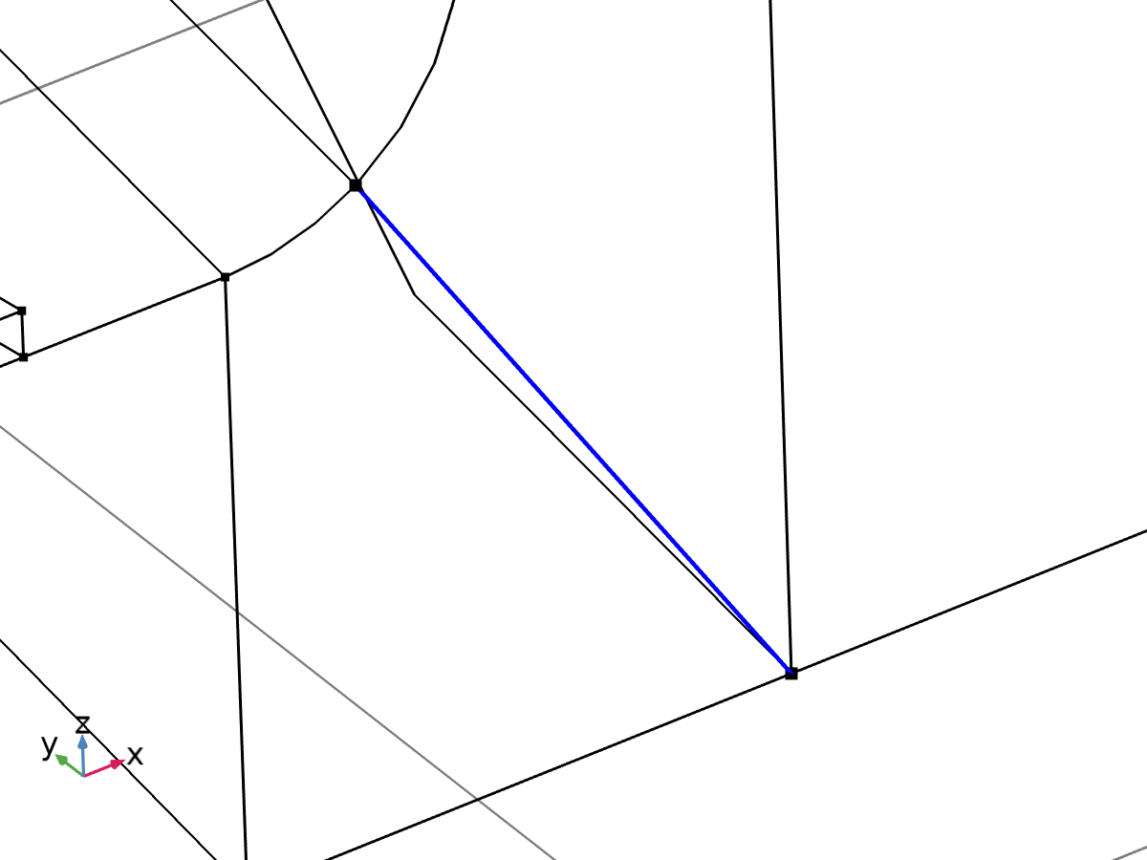

Linearization line, edge



Second axis orientation reference point

Selection

|  |  |
| --- | --- |
| Geometric entity level | Entire model |

Equations







#### Linearization

Settings

| **Description** | **Value** |
| --- | --- |
| Type | Line |
| Defined by | Edge |

#### Second Axis Orientation

Settings

| **Description** | **Value** |
| --- | --- |
|  | Reference point |
| Defined by | Point |

#### Variables

| **Name** | **Expression** | **Unit** | **Description** | **Selection** | **Details** |
| --- | --- | --- | --- | --- | --- |
| solid.Sm11 | solid.sl2.Sm11 | N/m² | Membrane stress, 11-component | Edge 28 | + operation |
| solid.Sm12 | solid.sl2.Sm12 | N/m² | Membrane stress, 12-component | Edge 28 | + operation |
| solid.Sm13 | solid.sl2.Sm13 | N/m² | Membrane stress, 13-component | Edge 28 | + operation |
| solid.Sm22 | solid.sl2.Sm22 | N/m² | Membrane stress, 22-component | Edge 28 | + operation |
| solid.Sm23 | solid.sl2.Sm23 | N/m² | Membrane stress, 23-component | Edge 28 | + operation |
| solid.Sm33 | solid.sl2.Sm33 | N/m² | Membrane stress, 33-component | Edge 28 | + operation |
| solid.Smb11 | solid.sl2.Smb11 | N/m² | Membrane plus bending stress, 11-component | Edge 28 | + operation |
| solid.Smb12 | solid.sl2.Smb12 | N/m² | Membrane plus bending stress, 12-component | Edge 28 | + operation |
| solid.Smb13 | solid.sl2.Smb13 | N/m² | Membrane plus bending stress, 13-component | Edge 28 | + operation |
| solid.Smb22 | solid.sl2.Smb22 | N/m² | Membrane plus bending stress, 22-component | Edge 28 | + operation |
| solid.Smb23 | solid.sl2.Smb23 | N/m² | Membrane plus bending stress, 23-component | Edge 28 | + operation |
| solid.Smb33 | solid.sl2.Smb33 | N/m² | Membrane plus bending stress, 33-component | Edge 28 | + operation |
| solid.Sb11 | solid.sl2.Sb11 | N/m² | Bending stress, 11-component | Edge 28 | + operation |
| solid.Sb12 | solid.sl2.Sb12 | N/m² | Bending stress, 12-component | Edge 28 | + operation |
| solid.Sb13 | solid.sl2.Sb13 | N/m² | Bending stress, 13-component | Edge 28 | + operation |
| solid.Sb22 | solid.sl2.Sb22 | N/m² | Bending stress, 22-component | Edge 28 | + operation |
| solid.Sb23 | solid.sl2.Sb23 | N/m² | Bending stress, 23-component | Edge 28 | + operation |
| solid.Sb33 | solid.sl2.Sb33 | N/m² | Bending stress, 33-component | Edge 28 | + operation |
| solid.Slls11 | solid.sl2.Slls11 | N/m² | Stress tensor, linearization line system, 11-component | Edge 28 | + operation |
| solid.Slls12 | solid.sl2.Slls12 | N/m² | Stress tensor, linearization line system, 12-component | Edge 28 | + operation |
| solid.Slls13 | solid.sl2.Slls13 | N/m² | Stress tensor, linearization line system, 13-component | Edge 28 | + operation |
| solid.Slls22 | solid.sl2.Slls22 | N/m² | Stress tensor, linearization line system, 22-component | Edge 28 | + operation |
| solid.Slls23 | solid.sl2.Slls23 | N/m² | Stress tensor, linearization line system, 23-component | Edge 28 | + operation |
| solid.Slls33 | solid.sl2.Slls33 | N/m² | Stress tensor, linearization line system, 33-component | Edge 28 | + operation |
| solid.SIm | solid.sl2.SIm | N/m² | Stress intensity, membrane | Edge 28 | + operation |
| solid.SImb | solid.sl2.SImb | N/m² | Stress intensity, membrane plus bending | Edge 28 | + operation |
| solid.mises_m | solid.sl2.mises_m | N/m² | von Mises stress (membrane) | Edge 28 | + operation |
| solid.mises_b | solid.sl2.mises_b | N/m² | von Mises stress (bending) | Edge 28 | + operation |
| solid.mises_mb | solid.sl2.mises_mb | N/m² | von Mises stress (membrane plus bending) | Edge 28 | + operation |
| solid.tresca_m | solid.sl2.tresca_m | N/m² | Tresca stress (membrane) | Edge 28 | + operation |
| solid.tresca_b | solid.sl2.tresca_b | N/m² | Tresca stress (bending) | Edge 28 | + operation |
| solid.tresca_mb | solid.sl2.tresca_mb | N/m² | Tresca stress (membrane plus bending) | Edge 28 | + operation |
| solid.sl2.dX | solid.sl2.pt1X-solid.sl2.pt0X | m | Stress linearization line direction, X-component | Edge 28 |  |
| solid.sl2.dY | solid.sl2.pt1Y-solid.sl2.pt0Y | m | Stress linearization line direction, Y-component | Edge 28 |  |
| solid.sl2.dZ | solid.sl2.pt1Z-solid.sl2.pt0Z | m | Stress linearization line direction, Z-component | Edge 28 |  |
| solid.sl2.nl1X | solid.sl2.dX/sqrt(solid.sl2.dX^2+solid.sl2.dY^2+solid.sl2.dZ^2) | 1 | First axis direction, X-component | Edge 28 |  |
| solid.sl2.nl1Y | solid.sl2.dY/sqrt(solid.sl2.dX^2+solid.sl2.dY^2+solid.sl2.dZ^2) | 1 | First axis direction, Y-component | Edge 28 |  |
| solid.sl2.nl1Z | solid.sl2.dZ/sqrt(solid.sl2.dX^2+solid.sl2.dY^2+solid.sl2.dZ^2) | 1 | First axis direction, Z-component | Edge 28 |  |
| solid.sl2.nl2X | (solid.sl2.pointrefX-solid.sl2.pt0X-((solid.sl2.pointrefX-solid.sl2.pt0X)*solid.sl2.nl1X+(solid.sl2.pointrefY-solid.sl2.pt0Y)*solid.sl2.nl1Y+(solid.sl2.pointrefZ-solid.sl2.pt0Z)*solid.sl2.nl1Z)*solid.sl2.nl1X)/sqrt((solid.sl2.pointrefX-solid.sl2.pt0X-((solid.sl2.pointrefX-solid.sl2.pt0X)*solid.sl2.nl1X+(solid.sl2.pointrefY-solid.sl2.pt0Y)*solid.sl2.nl1Y+(solid.sl2.pointrefZ-solid.sl2.pt0Z)*solid.sl2.nl1Z)*solid.sl2.nl1X)^2+(solid.sl2.pointrefY-solid.sl2.pt0Y-((solid.sl2.pointrefX-solid.sl2.pt0X)*solid.sl2.nl1X+(solid.sl2.pointrefY-solid.sl2.pt0Y)*solid.sl2.nl1Y+(solid.sl2.pointrefZ-solid.sl2.pt0Z)*solid.sl2.nl1Z)*solid.sl2.nl1Y)^2+(solid.sl2.pointrefZ-solid.sl2.pt0Z-((solid.sl2.pointrefX-solid.sl2.pt0X)*solid.sl2.nl1X+(solid.sl2.pointrefY-solid.sl2.pt0Y)*solid.sl2.nl1Y+(solid.sl2.pointrefZ-solid.sl2.pt0Z)*solid.sl2.nl1Z)*solid.sl2.nl1Z)^2+eps) | 1 | Second axis direction, X-component | Global |  |
| solid.sl2.nl2Y | (solid.sl2.pointrefY-solid.sl2.pt0Y-((solid.sl2.pointrefX-solid.sl2.pt0X)*solid.sl2.nl1X+(solid.sl2.pointrefY-solid.sl2.pt0Y)*solid.sl2.nl1Y+(solid.sl2.pointrefZ-solid.sl2.pt0Z)*solid.sl2.nl1Z)*solid.sl2.nl1Y)/sqrt((solid.sl2.pointrefX-solid.sl2.pt0X-((solid.sl2.pointrefX-solid.sl2.pt0X)*solid.sl2.nl1X+(solid.sl2.pointrefY-solid.sl2.pt0Y)*solid.sl2.nl1Y+(solid.sl2.pointrefZ-solid.sl2.pt0Z)*solid.sl2.nl1Z)*solid.sl2.nl1X)^2+(solid.sl2.pointrefY-solid.sl2.pt0Y-((solid.sl2.pointrefX-solid.sl2.pt0X)*solid.sl2.nl1X+(solid.sl2.pointrefY-solid.sl2.pt0Y)*solid.sl2.nl1Y+(solid.sl2.pointrefZ-solid.sl2.pt0Z)*solid.sl2.nl1Z)*solid.sl2.nl1Y)^2+(solid.sl2.pointrefZ-solid.sl2.pt0Z-((solid.sl2.pointrefX-solid.sl2.pt0X)*solid.sl2.nl1X+(solid.sl2.pointrefY-solid.sl2.pt0Y)*solid.sl2.nl1Y+(solid.sl2.pointrefZ-solid.sl2.pt0Z)*solid.sl2.nl1Z)*solid.sl2.nl1Z)^2+eps) | 1 | Second axis direction, Y-component | Global |  |
| solid.sl2.nl2Z | (solid.sl2.pointrefZ-solid.sl2.pt0Z-((solid.sl2.pointrefX-solid.sl2.pt0X)*solid.sl2.nl1X+(solid.sl2.pointrefY-solid.sl2.pt0Y)*solid.sl2.nl1Y+(solid.sl2.pointrefZ-solid.sl2.pt0Z)*solid.sl2.nl1Z)*solid.sl2.nl1Z)/sqrt((solid.sl2.pointrefX-solid.sl2.pt0X-((solid.sl2.pointrefX-solid.sl2.pt0X)*solid.sl2.nl1X+(solid.sl2.pointrefY-solid.sl2.pt0Y)*solid.sl2.nl1Y+(solid.sl2.pointrefZ-solid.sl2.pt0Z)*solid.sl2.nl1Z)*solid.sl2.nl1X)^2+(solid.sl2.pointrefY-solid.sl2.pt0Y-((solid.sl2.pointrefX-solid.sl2.pt0X)*solid.sl2.nl1X+(solid.sl2.pointrefY-solid.sl2.pt0Y)*solid.sl2.nl1Y+(solid.sl2.pointrefZ-solid.sl2.pt0Z)*solid.sl2.nl1Z)*solid.sl2.nl1Y)^2+(solid.sl2.pointrefZ-solid.sl2.pt0Z-((solid.sl2.pointrefX-solid.sl2.pt0X)*solid.sl2.nl1X+(solid.sl2.pointrefY-solid.sl2.pt0Y)*solid.sl2.nl1Y+(solid.sl2.pointrefZ-solid.sl2.pt0Z)*solid.sl2.nl1Z)*solid.sl2.nl1Z)^2+eps) | 1 | Second axis direction, Z-component | Global |  |
| solid.sl2.nl3X | (solid.sl2.nl2Z*solid.sl2.nl1Y-solid.sl2.nl2Y*solid.sl2.nl1Z)/sqrt((solid.sl2.nl2Z*solid.sl2.nl1Y-solid.sl2.nl2Y*solid.sl2.nl1Z)^2+(-solid.sl2.nl2Z*solid.sl2.nl1X+solid.sl2.nl2X*solid.sl2.nl1Z)^2+(solid.sl2.nl2Y*solid.sl2.nl1X-solid.sl2.nl2X*solid.sl2.nl1Y)^2) | 1 | Third axis direction, X-component | Edge 28 |  |
| solid.sl2.nl3Y | (-solid.sl2.nl2Z*solid.sl2.nl1X+solid.sl2.nl2X*solid.sl2.nl1Z)/sqrt((solid.sl2.nl2Z*solid.sl2.nl1Y-solid.sl2.nl2Y*solid.sl2.nl1Z)^2+(-solid.sl2.nl2Z*solid.sl2.nl1X+solid.sl2.nl2X*solid.sl2.nl1Z)^2+(solid.sl2.nl2Y*solid.sl2.nl1X-solid.sl2.nl2X*solid.sl2.nl1Y)^2) | 1 | Third axis direction, Y-component | Edge 28 |  |
| solid.sl2.nl3Z | (solid.sl2.nl2Y*solid.sl2.nl1X-solid.sl2.nl2X*solid.sl2.nl1Y)/sqrt((solid.sl2.nl2Z*solid.sl2.nl1Y-solid.sl2.nl2Y*solid.sl2.nl1Z)^2+(-solid.sl2.nl2Z*solid.sl2.nl1X+solid.sl2.nl2X*solid.sl2.nl1Z)^2+(solid.sl2.nl2Y*solid.sl2.nl1X-solid.sl2.nl2X*solid.sl2.nl1Y)^2) | 1 | Third axis direction, Z-component | Edge 28 |  |
| solid.sl2.Sm11 | solid.sl2.int(solid.sl2.Slls11)/solid.sl2.lengthtot | N/m² | Membrane stress, 11-component | Global |  |
| solid.sl2.Sm12 | solid.sl2.int(solid.sl2.Slls12)/solid.sl2.lengthtot | N/m² | Membrane stress, 12-component | Global |  |
| solid.sl2.Sm13 | solid.sl2.int(solid.sl2.Slls13)/solid.sl2.lengthtot | N/m² | Membrane stress, 13-component | Global |  |
| solid.sl2.Sm22 | solid.sl2.int(solid.sl2.Slls22)/solid.sl2.lengthtot | N/m² | Membrane stress, 22-component | Global |  |
| solid.sl2.Sm23 | solid.sl2.int(solid.sl2.Slls23)/solid.sl2.lengthtot | N/m² | Membrane stress, 23-component | Global |  |
| solid.sl2.Sm33 | solid.sl2.int(solid.sl2.Slls33)/solid.sl2.lengthtot | N/m² | Membrane stress, 33-component | Global |  |
| solid.sl2.Sbmax11 | 6*solid.sl2.int((0.5*solid.sl2.lengthtot-solid.sl2.arclength)*solid.sl2.Slls11)/solid.sl2.lengthtot^2 | N/m² | Maximum bending stress, 11-component | Global |  |
| solid.sl2.Sbmax12 | 6*solid.sl2.int((0.5*solid.sl2.lengthtot-solid.sl2.arclength)*solid.sl2.Slls12)/solid.sl2.lengthtot^2 | N/m² | Maximum bending stress, 12-component | Global |  |
| solid.sl2.Sbmax13 | 6*solid.sl2.int((0.5*solid.sl2.lengthtot-solid.sl2.arclength)*solid.sl2.Slls13)/solid.sl2.lengthtot^2 | N/m² | Maximum bending stress, 13-component | Global |  |
| solid.sl2.Sbmax22 | 6*solid.sl2.int((0.5*solid.sl2.lengthtot-solid.sl2.arclength)*solid.sl2.Slls22)/solid.sl2.lengthtot^2 | N/m² | Maximum bending stress, 22-component | Global |  |
| solid.sl2.Sbmax23 | 6*solid.sl2.int((0.5*solid.sl2.lengthtot-solid.sl2.arclength)*solid.sl2.Slls23)/solid.sl2.lengthtot^2 | N/m² | Maximum bending stress, 23-component | Global |  |
| solid.sl2.Sbmax33 | 6*solid.sl2.int((0.5*solid.sl2.lengthtot-solid.sl2.arclength)*solid.sl2.Slls33)/solid.sl2.lengthtot^2 | N/m² | Maximum bending stress, 33-component | Global |  |
| solid.sl2.Sb11 | 2*(0.5-solid.sl2.arclength/solid.sl2.lengthtot)*solid.sl2.Sbmax11 | N/m² | Bending stress, 11-component | Edge 28 |  |
| solid.sl2.Sb12 | 2*(0.5-solid.sl2.arclength/solid.sl2.lengthtot)*solid.sl2.Sbmax12 | N/m² | Bending stress, 12-component | Edge 28 |  |
| solid.sl2.Sb13 | 2*(0.5-solid.sl2.arclength/solid.sl2.lengthtot)*solid.sl2.Sbmax13 | N/m² | Bending stress, 13-component | Edge 28 |  |
| solid.sl2.Sb22 | 2*(0.5-solid.sl2.arclength/solid.sl2.lengthtot)*solid.sl2.Sbmax22 | N/m² | Bending stress, 22-component | Edge 28 |  |
| solid.sl2.Sb23 | 2*(0.5-solid.sl2.arclength/solid.sl2.lengthtot)*solid.sl2.Sbmax23 | N/m² | Bending stress, 23-component | Edge 28 |  |
| solid.sl2.Sb33 | 2*(0.5-solid.sl2.arclength/solid.sl2.lengthtot)*solid.sl2.Sbmax33 | N/m² | Bending stress, 33-component | Edge 28 |  |
| solid.sl2.Smb11 | solid.sl2.Sm11+solid.sl2.Sb11 | N/m² | Membrane plus bending stress, 11-component | Edge 28 |  |
| solid.sl2.Smb12 | solid.sl2.Sm12+solid.sl2.Sb12 | N/m² | Membrane plus bending stress, 12-component | Edge 28 |  |
| solid.sl2.Smb13 | solid.sl2.Sm13+solid.sl2.Sb13 | N/m² | Membrane plus bending stress, 13-component | Edge 28 |  |
| solid.sl2.Smb22 | solid.sl2.Sm22+solid.sl2.Sb22 | N/m² | Membrane plus bending stress, 22-component | Edge 28 |  |
| solid.sl2.Smb23 | solid.sl2.Sm23+solid.sl2.Sb23 | N/m² | Membrane plus bending stress, 23-component | Edge 28 |  |
| solid.sl2.Smb33 | solid.sl2.Sm33+solid.sl2.Sb33 | N/m² | Membrane plus bending stress, 33-component | Edge 28 |  |
| solid.sl2.Sps11 | solid.sl2.startpoint(solid.sl2.Slls11-solid.sl2.Smb11) | N/m² | Peak stress, starting point, 11-component | Global |  |
| solid.sl2.Sps12 | solid.sl2.startpoint(solid.sl2.Slls12-solid.sl2.Smb12) | N/m² | Peak stress, starting point, 12-component | Global |  |
| solid.sl2.Sps13 | solid.sl2.startpoint(solid.sl2.Slls13-solid.sl2.Smb13) | N/m² | Peak stress, starting point, 13-component | Global |  |
| solid.sl2.Sps22 | solid.sl2.startpoint(solid.sl2.Slls22-solid.sl2.Smb22) | N/m² | Peak stress, starting point, 22-component | Global |  |
| solid.sl2.Sps23 | solid.sl2.startpoint(solid.sl2.Slls23-solid.sl2.Smb23) | N/m² | Peak stress, starting point, 23-component | Global |  |
| solid.sl2.Sps33 | solid.sl2.startpoint(solid.sl2.Slls33-solid.sl2.Smb33) | N/m² | Peak stress, starting point, 33-component | Global |  |
| solid.sl2.Spe11 | solid.sl2.endpoint(solid.sl2.Slls11-solid.sl2.Smb11) | N/m² | Peak stress, endpoint, 11-component | Global |  |
| solid.sl2.Spe12 | solid.sl2.endpoint(solid.sl2.Slls12-solid.sl2.Smb12) | N/m² | Peak stress, endpoint, 12-component | Global |  |
| solid.sl2.Spe13 | solid.sl2.endpoint(solid.sl2.Slls13-solid.sl2.Smb13) | N/m² | Peak stress, endpoint, 13-component | Global |  |
| solid.sl2.Spe22 | solid.sl2.endpoint(solid.sl2.Slls22-solid.sl2.Smb22) | N/m² | Peak stress, endpoint, 22-component | Global |  |
| solid.sl2.Spe23 | solid.sl2.endpoint(solid.sl2.Slls23-solid.sl2.Smb23) | N/m² | Peak stress, endpoint, 23-component | Global |  |
| solid.sl2.Spe33 | solid.sl2.endpoint(solid.sl2.Slls33-solid.sl2.Smb33) | N/m² | Peak stress, endpoint, 33-component | Global |  |
| solid.sl2.Slls11 | (solid.sl2.nl1X*solid.SXX+solid.sl2.nl1Y*solid.SXY+solid.sl2.nl1Z*solid.SXZ)*solid.sl2.nl1X+(solid.sl2.nl1X*solid.SXY+solid.sl2.nl1Y*solid.SYY+solid.sl2.nl1Z*solid.SYZ)*solid.sl2.nl1Y+(solid.sl2.nl1X*solid.SXZ+solid.sl2.nl1Y*solid.SYZ+solid.sl2.nl1Z*solid.SZZ)*solid.sl2.nl1Z | N/m² | Stress tensor, linearization line system, 11-component | Edge 28 |  |
| solid.sl2.Slls12 | (solid.sl2.nl1X*solid.SXX+solid.sl2.nl1Y*solid.SXY+solid.sl2.nl1Z*solid.SXZ)*solid.sl2.nl2X+(solid.sl2.nl1X*solid.SXY+solid.sl2.nl1Y*solid.SYY+solid.sl2.nl1Z*solid.SYZ)*solid.sl2.nl2Y+(solid.sl2.nl1X*solid.SXZ+solid.sl2.nl1Y*solid.SYZ+solid.sl2.nl1Z*solid.SZZ)*solid.sl2.nl2Z | N/m² | Stress tensor, linearization line system, 12-component | Edge 28 |  |
| solid.sl2.Slls13 | (solid.sl2.nl1X*solid.SXX+solid.sl2.nl1Y*solid.SXY+solid.sl2.nl1Z*solid.SXZ)*solid.sl2.nl3X+(solid.sl2.nl1X*solid.SXY+solid.sl2.nl1Y*solid.SYY+solid.sl2.nl1Z*solid.SYZ)*solid.sl2.nl3Y+(solid.sl2.nl1X*solid.SXZ+solid.sl2.nl1Y*solid.SYZ+solid.sl2.nl1Z*solid.SZZ)*solid.sl2.nl3Z | N/m² | Stress tensor, linearization line system, 13-component | Edge 28 |  |
| solid.sl2.Slls22 | (solid.sl2.nl2X*solid.SXX+solid.sl2.nl2Y*solid.SXY+solid.sl2.nl2Z*solid.SXZ)*solid.sl2.nl2X+(solid.sl2.nl2X*solid.SXY+solid.sl2.nl2Y*solid.SYY+solid.sl2.nl2Z*solid.SYZ)*solid.sl2.nl2Y+(solid.sl2.nl2X*solid.SXZ+solid.sl2.nl2Y*solid.SYZ+solid.sl2.nl2Z*solid.SZZ)*solid.sl2.nl2Z | N/m² | Stress tensor, linearization line system, 22-component | Edge 28 |  |
| solid.sl2.Slls23 | (solid.sl2.nl2X*solid.SXX+solid.sl2.nl2Y*solid.SXY+solid.sl2.nl2Z*solid.SXZ)*solid.sl2.nl3X+(solid.sl2.nl2X*solid.SXY+solid.sl2.nl2Y*solid.SYY+solid.sl2.nl2Z*solid.SYZ)*solid.sl2.nl3Y+(solid.sl2.nl2X*solid.SXZ+solid.sl2.nl2Y*solid.SYZ+solid.sl2.nl2Z*solid.SZZ)*solid.sl2.nl3Z | N/m² | Stress tensor, linearization line system, 23-component | Edge 28 |  |
| solid.sl2.Slls33 | (solid.sl2.nl3X*solid.SXX+solid.sl2.nl3Y*solid.SXY+solid.sl2.nl3Z*solid.SXZ)*solid.sl2.nl3X+(solid.sl2.nl3X*solid.SXY+solid.sl2.nl3Y*solid.SYY+solid.sl2.nl3Z*solid.SYZ)*solid.sl2.nl3Y+(solid.sl2.nl3X*solid.SXZ+solid.sl2.nl3Y*solid.SYZ+solid.sl2.nl3Z*solid.SZZ)*solid.sl2.nl3Z | N/m² | Stress tensor, linearization line system, 33-component | Edge 28 |  |
| solid.sl2.pointrefX | solid.sl2.pointref(X) | m | Reference point defining local 2 direction, X-component | Global |  |
| solid.sl2.pointrefY | solid.sl2.pointref(Y) | m | Reference point defining local 2 direction, Y-component | Global |  |
| solid.sl2.pointrefZ | solid.sl2.pointref(Z) | m | Reference point defining local 2 direction, Z-component | Global |  |
| solid.sl2.lengthtot | solid.sl2.int(1) | m | Edge length total | Global |  |
| solid.sl2.arclength | (s1-solid.sl2.s1s)*solid.sl2.length/(solid.sl2.s1e-solid.sl2.s1s)+solid.sl2.arclength_offset | m | Arc length | Edge 28 |  |
| solid.sl2.N22 | solid.sl2.lengthtot*solid.sl2.Sm22 | N/m | Local in plane force, 22 component | Global |  |
| solid.sl2.N33 | solid.sl2.lengthtot*solid.sl2.Sm33 | N/m | Local in plane force, 33 component | Global |  |
| solid.sl2.N23 | solid.sl2.lengthtot*solid.sl2.Sm23 | N/m | Local in plane force, 23 component | Global |  |
| solid.sl2.M22 | solid.sl2.lengthtot^2*solid.sl2.Sbmax22/6 | N | Local bending moment, 22 component | Global |  |
| solid.sl2.M33 | solid.sl2.lengthtot^2*solid.sl2.Sbmax33/6 | N | Local bending moment, 33 component | Global |  |
| solid.sl2.M23 | solid.sl2.lengthtot^2*solid.sl2.Sbmax23/6 | N | Local bending moment, 23 component | Global |  |
| solid.sl2.Q2 | solid.sl2.lengthtot*solid.sl2.Sm12 | N/m | Local out-of-plane shear force, 2 component | Global |  |
| solid.sl2.Q3 | solid.sl2.lengthtot*solid.sl2.Sm13 | N/m | Local out-of-plane shear force, 3 component | Global |  |
| solid.sl2.pt0X | solid.sl2.startpoint(solid.X) | m | Starting point, X-component | Global |  |
| solid.sl2.pt0Y | solid.sl2.startpoint(solid.Y) | m | Starting point, Y-component | Global |  |
| solid.sl2.pt0Z | solid.sl2.startpoint(solid.Z) | m | Starting point, Z-component | Global |  |
| solid.sl2.pt1X | solid.sl2.endpoint(solid.X) | m | Endpoint, X-component | Global |  |
| solid.sl2.pt1Y | solid.sl2.endpoint(solid.Y) | m | Endpoint, Y-component | Global |  |
| solid.sl2.pt1Z | solid.sl2.endpoint(solid.Z) | m | Endpoint, Z-component | Global |  |
| solid.sl2.mises_m | sqrt(0.5*((solid.sl2.Sm11-solid.sl2.Sm22)^2+(solid.sl2.Sm22-solid.sl2.Sm33)^2+(solid.sl2.Sm33-solid.sl2.Sm11)^2+6*(solid.sl2.Sm12^2+solid.sl2.Sm23^2+solid.sl2.Sm13^2))) | N/m² | von Mises stress (membrane) | Global |  |
| solid.sl2.mises_b | sqrt(0.5*((solid.sl2.Sb11-solid.sl2.Sb22)^2+(solid.sl2.Sb22-solid.sl2.Sb33)^2+(solid.sl2.Sb33-solid.sl2.Sb11)^2+6*(solid.sl2.Sb12^2+solid.sl2.Sb23^2+solid.sl2.Sb13^2))) | N/m² | von Mises stress (bending) | Edge 28 |  |
| solid.sl2.mises_mb | sqrt(0.5*((solid.sl2.Smb11-solid.sl2.Smb22)^2+(solid.sl2.Smb22-solid.sl2.Smb33)^2+(solid.sl2.Smb33-solid.sl2.Smb11)^2+6*(solid.sl2.Smb12^2+solid.sl2.Smb23^2+solid.sl2.Smb13^2))) | N/m² | von Mises stress (membrane plus bending) | Edge 28 |  |
| solid.sl2.tresca_m | max(max(abs(solid.sl2.Smp1-solid.sl2.Smp2),abs(solid.sl2.Smp1-solid.sl2.Smp3)),abs(solid.sl2.Smp2-solid.sl2.Smp3)) | N/m² | Tresca stress (membrane) | Global |  |
| solid.sl2.tresca_b | max(max(abs(solid.sl2.Sbp1-solid.sl2.Sbp2),abs(solid.sl2.Sbp1-solid.sl2.Sbp3)),abs(solid.sl2.Sbp2-solid.sl2.Sbp3)) | N/m² | Tresca stress (bending) | Edge 28 |  |
| solid.sl2.tresca_mb | max(max(abs(solid.sl2.Smbp1-solid.sl2.Smbp2),abs(solid.sl2.Smbp1-solid.sl2.Smbp3)),abs(solid.sl2.Smbp2-solid.sl2.Smbp3)) | N/m² | Tresca stress (membrane plus bending) | Edge 28 |  |
| solid.sl2.Smbs11 | solid.sl2.Sm11+solid.sl2.Sbmax11 | N/m² | Membrane plus bending stress, starting point, 11-component | Global |  |
| solid.sl2.Smbs12 | solid.sl2.Sm12+solid.sl2.Sbmax12 | N/m² | Membrane plus bending stress, starting point, 12-component | Global |  |
| solid.sl2.Smbs13 | solid.sl2.Sm13+solid.sl2.Sbmax13 | N/m² | Membrane plus bending stress, starting point, 13-component | Global |  |
| solid.sl2.Smbs22 | solid.sl2.Sm22+solid.sl2.Sbmax22 | N/m² | Membrane plus bending stress, starting point, 22-component | Global |  |
| solid.sl2.Smbs23 | solid.sl2.Sm23+solid.sl2.Sbmax23 | N/m² | Membrane plus bending stress, starting point, 23-component | Global |  |
| solid.sl2.Smbs33 | solid.sl2.Sm33+solid.sl2.Sbmax33 | N/m² | Membrane plus bending stress, starting point, 33-component | Global |  |
| solid.sl2.Smbe11 | solid.sl2.Sm11-solid.sl2.Sbmax11 | N/m² | Membrane plus bending stress, endpoint, 11-component | Global |  |
| solid.sl2.Smbe12 | solid.sl2.Sm12-solid.sl2.Sbmax12 | N/m² | Membrane plus bending stress, endpoint, 12-component | Global |  |
| solid.sl2.Smbe13 | solid.sl2.Sm13-solid.sl2.Sbmax13 | N/m² | Membrane plus bending stress, endpoint, 13-component | Global |  |
| solid.sl2.Smbe22 | solid.sl2.Sm22-solid.sl2.Sbmax22 | N/m² | Membrane plus bending stress, endpoint, 22-component | Global |  |
| solid.sl2.Smbe23 | solid.sl2.Sm23-solid.sl2.Sbmax23 | N/m² | Membrane plus bending stress, endpoint, 23-component | Global |  |
| solid.sl2.Smbe33 | solid.sl2.Sm33-solid.sl2.Sbmax33 | N/m² | Membrane plus bending stress, endpoint, 33-component | Global |  |
| solid.sl2.ySmbs11 | solid.sl2.Smbs11 | N/m² | Membrane plus bending stress, starting point, 11-component | Global |  |
| solid.sl2.ySmbs12 | solid.sl2.Smbs12 | N/m² | Membrane plus bending stress, starting point, 12-component | Global |  |
| solid.sl2.ySmbs13 | solid.sl2.Smbs13 | N/m² | Membrane plus bending stress, starting point, 13-component | Global |  |
| solid.sl2.ySmbs22 | solid.sl2.Smbs22 | N/m² | Membrane plus bending stress, starting point, 22-component | Global |  |
| solid.sl2.ySmbs23 | solid.sl2.Smbs23 | N/m² | Membrane plus bending stress, starting point, 23-component | Global |  |
| solid.sl2.ySmbs33 | solid.sl2.Smbs33 | N/m² | Membrane plus bending stress, starting point, 33-component | Global |  |
| solid.sl2.ySmbe11 | solid.sl2.Smbe11 | N/m² | Membrane plus bending stress, endpoint, 11-component | Global |  |
| solid.sl2.ySmbe12 | solid.sl2.Smbe12 | N/m² | Membrane plus bending stress, endpoint, 12-component | Global |  |
| solid.sl2.ySmbe13 | solid.sl2.Smbe13 | N/m² | Membrane plus bending stress, endpoint, 13-component | Global |  |
| solid.sl2.ySmbe22 | solid.sl2.Smbe22 | N/m² | Membrane plus bending stress, endpoint, 22-component | Global |  |
| solid.sl2.ySmbe23 | solid.sl2.Smbe23 | N/m² | Membrane plus bending stress, endpoint, 23-component | Global |  |
| solid.sl2.ySmbe33 | solid.sl2.Smbe33 | N/m² | Membrane plus bending stress, endpoint, 33-component | Global |  |
| solid.sl2.ySm11 | solid.sl2.Sm11 | N/m² | Membrane stress, 11-component | Global |  |
| solid.sl2.ySm12 | solid.sl2.Sm12 | N/m² | Membrane stress, 12-component | Global |  |
| solid.sl2.ySm13 | solid.sl2.Sm13 | N/m² | Membrane stress, 13-component | Global |  |
| solid.sl2.ySm22 | solid.sl2.Sm22 | N/m² | Membrane stress, 22-component | Global |  |
| solid.sl2.ySm23 | solid.sl2.Sm23 | N/m² | Membrane stress, 23-component | Global |  |
| solid.sl2.ySm33 | solid.sl2.Sm33 | N/m² | Membrane stress, 33-component | Global |  |
| solid.sl2.xs | 0 | m | Arc length, starting point | Global |  |
| solid.sl2.xe | solid.sl2.lengthtot | m | Arc length, endpoint | Global |  |
| solid.sl2.SIm | max(max(abs(solid.sl2.Smp1-solid.sl2.Smp2),abs(solid.sl2.Smp1-solid.sl2.Smp3)),abs(solid.sl2.Smp2-solid.sl2.Smp3)) | N/m² | Stress intensity, membrane | Global |  |
| solid.sl2.SImbe | max(max(abs(solid.sl2.Smbpe1-solid.sl2.Smbpe2),abs(solid.sl2.Smbpe1-solid.sl2.Smbpe3)),abs(solid.sl2.Smbpe2-solid.sl2.Smbpe3)) | N/m² | Stress intensity, membrane plus bending, endpoint | Global |  |
| solid.sl2.SImbs | max(max(abs(solid.sl2.Smbps1-solid.sl2.Smbps2),abs(solid.sl2.Smbps1-solid.sl2.Smbps3)),abs(solid.sl2.Smbps2-solid.sl2.Smbps3)) | N/m² | Stress intensity, membrane plus bending, starting point | Global |  |
| solid.sl2.SImb | max(solid.sl2.SImbs,solid.sl2.SImbe) | N/m² | Stress intensity, membrane plus bending | Global |  |
| solid.sl2.length | solid.sl2.intline28(1) | m | Length | Edge 28 |  |
| solid.sl2.s1s | 0 | m | Local parameter, start | Edge 28 |  |
| solid.sl2.s1e | 0.025286633954186476 | m | Local parameter, end | Edge 28 |  |
| solid.sl2.arclength_offset | 0 | m | Arc length offset | Edge 28 |  |

### Stress Linearization 3

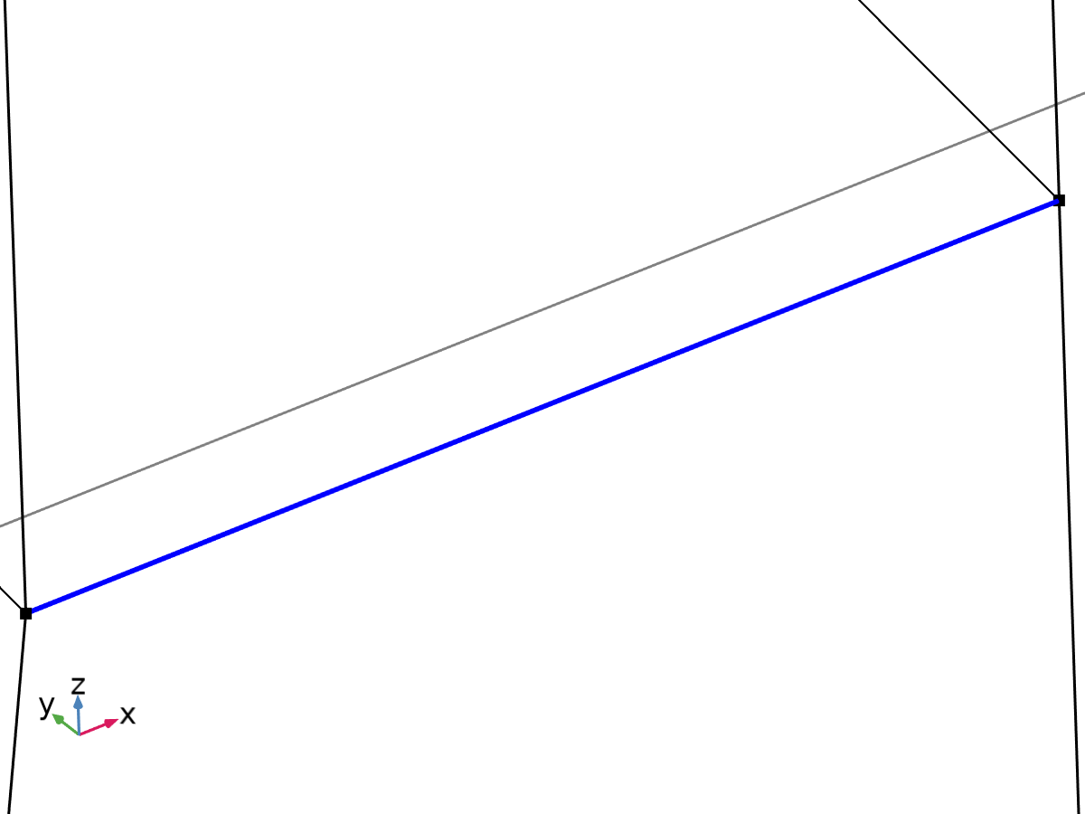

Linearization line, edge



Second axis orientation reference point

Selection

|  |  |
| --- | --- |
| Geometric entity level | Entire model |

Equations







#### Linearization

Settings

| **Description** | **Value** |
| --- | --- |
| Type | Line |
| Defined by | Edge |

#### Second Axis Orientation

Settings

| **Description** | **Value** |
| --- | --- |
|  | Reference point |
| Defined by | Point |

#### Variables

| **Name** | **Expression** | **Unit** | **Description** | **Selection** | **Details** |
| --- | --- | --- | --- | --- | --- |
| solid.Sm11 | solid.sl3.Sm11 | N/m² | Membrane stress, 11-component | Edge 36 | + operation |
| solid.Sm12 | solid.sl3.Sm12 | N/m² | Membrane stress, 12-component | Edge 36 | + operation |
| solid.Sm13 | solid.sl3.Sm13 | N/m² | Membrane stress, 13-component | Edge 36 | + operation |
| solid.Sm22 | solid.sl3.Sm22 | N/m² | Membrane stress, 22-component | Edge 36 | + operation |
| solid.Sm23 | solid.sl3.Sm23 | N/m² | Membrane stress, 23-component | Edge 36 | + operation |
| solid.Sm33 | solid.sl3.Sm33 | N/m² | Membrane stress, 33-component | Edge 36 | + operation |
| solid.Smb11 | solid.sl3.Smb11 | N/m² | Membrane plus bending stress, 11-component | Edge 36 | + operation |
| solid.Smb12 | solid.sl3.Smb12 | N/m² | Membrane plus bending stress, 12-component | Edge 36 | + operation |
| solid.Smb13 | solid.sl3.Smb13 | N/m² | Membrane plus bending stress, 13-component | Edge 36 | + operation |
| solid.Smb22 | solid.sl3.Smb22 | N/m² | Membrane plus bending stress, 22-component | Edge 36 | + operation |
| solid.Smb23 | solid.sl3.Smb23 | N/m² | Membrane plus bending stress, 23-component | Edge 36 | + operation |
| solid.Smb33 | solid.sl3.Smb33 | N/m² | Membrane plus bending stress, 33-component | Edge 36 | + operation |
| solid.Sb11 | solid.sl3.Sb11 | N/m² | Bending stress, 11-component | Edge 36 | + operation |
| solid.Sb12 | solid.sl3.Sb12 | N/m² | Bending stress, 12-component | Edge 36 | + operation |
| solid.Sb13 | solid.sl3.Sb13 | N/m² | Bending stress, 13-component | Edge 36 | + operation |
| solid.Sb22 | solid.sl3.Sb22 | N/m² | Bending stress, 22-component | Edge 36 | + operation |
| solid.Sb23 | solid.sl3.Sb23 | N/m² | Bending stress, 23-component | Edge 36 | + operation |
| solid.Sb33 | solid.sl3.Sb33 | N/m² | Bending stress, 33-component | Edge 36 | + operation |
| solid.Slls11 | solid.sl3.Slls11 | N/m² | Stress tensor, linearization line system, 11-component | Edge 36 | + operation |
| solid.Slls12 | solid.sl3.Slls12 | N/m² | Stress tensor, linearization line system, 12-component | Edge 36 | + operation |
| solid.Slls13 | solid.sl3.Slls13 | N/m² | Stress tensor, linearization line system, 13-component | Edge 36 | + operation |
| solid.Slls22 | solid.sl3.Slls22 | N/m² | Stress tensor, linearization line system, 22-component | Edge 36 | + operation |
| solid.Slls23 | solid.sl3.Slls23 | N/m² | Stress tensor, linearization line system, 23-component | Edge 36 | + operation |
| solid.Slls33 | solid.sl3.Slls33 | N/m² | Stress tensor, linearization line system, 33-component | Edge 36 | + operation |
| solid.SIm | solid.sl3.SIm | N/m² | Stress intensity, membrane | Edge 36 | + operation |
| solid.SImb | solid.sl3.SImb | N/m² | Stress intensity, membrane plus bending | Edge 36 | + operation |
| solid.mises_m | solid.sl3.mises_m | N/m² | von Mises stress (membrane) | Edge 36 | + operation |
| solid.mises_b | solid.sl3.mises_b | N/m² | von Mises stress (bending) | Edge 36 | + operation |
| solid.mises_mb | solid.sl3.mises_mb | N/m² | von Mises stress (membrane plus bending) | Edge 36 | + operation |
| solid.tresca_m | solid.sl3.tresca_m | N/m² | Tresca stress (membrane) | Edge 36 | + operation |
| solid.tresca_b | solid.sl3.tresca_b | N/m² | Tresca stress (bending) | Edge 36 | + operation |
| solid.tresca_mb | solid.sl3.tresca_mb | N/m² | Tresca stress (membrane plus bending) | Edge 36 | + operation |
| solid.sl3.dX | solid.sl3.pt1X-solid.sl3.pt0X | m | Stress linearization line direction, X-component | Edge 36 |  |
| solid.sl3.dY | solid.sl3.pt1Y-solid.sl3.pt0Y | m | Stress linearization line direction, Y-component | Edge 36 |  |
| solid.sl3.dZ | solid.sl3.pt1Z-solid.sl3.pt0Z | m | Stress linearization line direction, Z-component | Edge 36 |  |
| solid.sl3.nl1X | solid.sl3.dX/sqrt(solid.sl3.dX^2+solid.sl3.dY^2+solid.sl3.dZ^2) | 1 | First axis direction, X-component | Edge 36 |  |
| solid.sl3.nl1Y | solid.sl3.dY/sqrt(solid.sl3.dX^2+solid.sl3.dY^2+solid.sl3.dZ^2) | 1 | First axis direction, Y-component | Edge 36 |  |
| solid.sl3.nl1Z | solid.sl3.dZ/sqrt(solid.sl3.dX^2+solid.sl3.dY^2+solid.sl3.dZ^2) | 1 | First axis direction, Z-component | Edge 36 |  |
| solid.sl3.nl2X | (solid.sl3.pointrefX-solid.sl3.pt0X-((solid.sl3.pointrefX-solid.sl3.pt0X)*solid.sl3.nl1X+(solid.sl3.pointrefY-solid.sl3.pt0Y)*solid.sl3.nl1Y+(solid.sl3.pointrefZ-solid.sl3.pt0Z)*solid.sl3.nl1Z)*solid.sl3.nl1X)/sqrt((solid.sl3.pointrefX-solid.sl3.pt0X-((solid.sl3.pointrefX-solid.sl3.pt0X)*solid.sl3.nl1X+(solid.sl3.pointrefY-solid.sl3.pt0Y)*solid.sl3.nl1Y+(solid.sl3.pointrefZ-solid.sl3.pt0Z)*solid.sl3.nl1Z)*solid.sl3.nl1X)^2+(solid.sl3.pointrefY-solid.sl3.pt0Y-((solid.sl3.pointrefX-solid.sl3.pt0X)*solid.sl3.nl1X+(solid.sl3.pointrefY-solid.sl3.pt0Y)*solid.sl3.nl1Y+(solid.sl3.pointrefZ-solid.sl3.pt0Z)*solid.sl3.nl1Z)*solid.sl3.nl1Y)^2+(solid.sl3.pointrefZ-solid.sl3.pt0Z-((solid.sl3.pointrefX-solid.sl3.pt0X)*solid.sl3.nl1X+(solid.sl3.pointrefY-solid.sl3.pt0Y)*solid.sl3.nl1Y+(solid.sl3.pointrefZ-solid.sl3.pt0Z)*solid.sl3.nl1Z)*solid.sl3.nl1Z)^2+eps) | 1 | Second axis direction, X-component | Global |  |
| solid.sl3.nl2Y | (solid.sl3.pointrefY-solid.sl3.pt0Y-((solid.sl3.pointrefX-solid.sl3.pt0X)*solid.sl3.nl1X+(solid.sl3.pointrefY-solid.sl3.pt0Y)*solid.sl3.nl1Y+(solid.sl3.pointrefZ-solid.sl3.pt0Z)*solid.sl3.nl1Z)*solid.sl3.nl1Y)/sqrt((solid.sl3.pointrefX-solid.sl3.pt0X-((solid.sl3.pointrefX-solid.sl3.pt0X)*solid.sl3.nl1X+(solid.sl3.pointrefY-solid.sl3.pt0Y)*solid.sl3.nl1Y+(solid.sl3.pointrefZ-solid.sl3.pt0Z)*solid.sl3.nl1Z)*solid.sl3.nl1X)^2+(solid.sl3.pointrefY-solid.sl3.pt0Y-((solid.sl3.pointrefX-solid.sl3.pt0X)*solid.sl3.nl1X+(solid.sl3.pointrefY-solid.sl3.pt0Y)*solid.sl3.nl1Y+(solid.sl3.pointrefZ-solid.sl3.pt0Z)*solid.sl3.nl1Z)*solid.sl3.nl1Y)^2+(solid.sl3.pointrefZ-solid.sl3.pt0Z-((solid.sl3.pointrefX-solid.sl3.pt0X)*solid.sl3.nl1X+(solid.sl3.pointrefY-solid.sl3.pt0Y)*solid.sl3.nl1Y+(solid.sl3.pointrefZ-solid.sl3.pt0Z)*solid.sl3.nl1Z)*solid.sl3.nl1Z)^2+eps) | 1 | Second axis direction, Y-component | Global |  |
| solid.sl3.nl2Z | (solid.sl3.pointrefZ-solid.sl3.pt0Z-((solid.sl3.pointrefX-solid.sl3.pt0X)*solid.sl3.nl1X+(solid.sl3.pointrefY-solid.sl3.pt0Y)*solid.sl3.nl1Y+(solid.sl3.pointrefZ-solid.sl3.pt0Z)*solid.sl3.nl1Z)*solid.sl3.nl1Z)/sqrt((solid.sl3.pointrefX-solid.sl3.pt0X-((solid.sl3.pointrefX-solid.sl3.pt0X)*solid.sl3.nl1X+(solid.sl3.pointrefY-solid.sl3.pt0Y)*solid.sl3.nl1Y+(solid.sl3.pointrefZ-solid.sl3.pt0Z)*solid.sl3.nl1Z)*solid.sl3.nl1X)^2+(solid.sl3.pointrefY-solid.sl3.pt0Y-((solid.sl3.pointrefX-solid.sl3.pt0X)*solid.sl3.nl1X+(solid.sl3.pointrefY-solid.sl3.pt0Y)*solid.sl3.nl1Y+(solid.sl3.pointrefZ-solid.sl3.pt0Z)*solid.sl3.nl1Z)*solid.sl3.nl1Y)^2+(solid.sl3.pointrefZ-solid.sl3.pt0Z-((solid.sl3.pointrefX-solid.sl3.pt0X)*solid.sl3.nl1X+(solid.sl3.pointrefY-solid.sl3.pt0Y)*solid.sl3.nl1Y+(solid.sl3.pointrefZ-solid.sl3.pt0Z)*solid.sl3.nl1Z)*solid.sl3.nl1Z)^2+eps) | 1 | Second axis direction, Z-component | Global |  |
| solid.sl3.nl3X | (solid.sl3.nl2Z*solid.sl3.nl1Y-solid.sl3.nl2Y*solid.sl3.nl1Z)/sqrt((solid.sl3.nl2Z*solid.sl3.nl1Y-solid.sl3.nl2Y*solid.sl3.nl1Z)^2+(-solid.sl3.nl2Z*solid.sl3.nl1X+solid.sl3.nl2X*solid.sl3.nl1Z)^2+(solid.sl3.nl2Y*solid.sl3.nl1X-solid.sl3.nl2X*solid.sl3.nl1Y)^2) | 1 | Third axis direction, X-component | Edge 36 |  |
| solid.sl3.nl3Y | (-solid.sl3.nl2Z*solid.sl3.nl1X+solid.sl3.nl2X*solid.sl3.nl1Z)/sqrt((solid.sl3.nl2Z*solid.sl3.nl1Y-solid.sl3.nl2Y*solid.sl3.nl1Z)^2+(-solid.sl3.nl2Z*solid.sl3.nl1X+solid.sl3.nl2X*solid.sl3.nl1Z)^2+(solid.sl3.nl2Y*solid.sl3.nl1X-solid.sl3.nl2X*solid.sl3.nl1Y)^2) | 1 | Third axis direction, Y-component | Edge 36 |  |
| solid.sl3.nl3Z | (solid.sl3.nl2Y*solid.sl3.nl1X-solid.sl3.nl2X*solid.sl3.nl1Y)/sqrt((solid.sl3.nl2Z*solid.sl3.nl1Y-solid.sl3.nl2Y*solid.sl3.nl1Z)^2+(-solid.sl3.nl2Z*solid.sl3.nl1X+solid.sl3.nl2X*solid.sl3.nl1Z)^2+(solid.sl3.nl2Y*solid.sl3.nl1X-solid.sl3.nl2X*solid.sl3.nl1Y)^2) | 1 | Third axis direction, Z-component | Edge 36 |  |
| solid.sl3.Sm11 | solid.sl3.int(solid.sl3.Slls11)/solid.sl3.lengthtot | N/m² | Membrane stress, 11-component | Global |  |
| solid.sl3.Sm12 | solid.sl3.int(solid.sl3.Slls12)/solid.sl3.lengthtot | N/m² | Membrane stress, 12-component | Global |  |
| solid.sl3.Sm13 | solid.sl3.int(solid.sl3.Slls13)/solid.sl3.lengthtot | N/m² | Membrane stress, 13-component | Global |  |
| solid.sl3.Sm22 | solid.sl3.int(solid.sl3.Slls22)/solid.sl3.lengthtot | N/m² | Membrane stress, 22-component | Global |  |
| solid.sl3.Sm23 | solid.sl3.int(solid.sl3.Slls23)/solid.sl3.lengthtot | N/m² | Membrane stress, 23-component | Global |  |
| solid.sl3.Sm33 | solid.sl3.int(solid.sl3.Slls33)/solid.sl3.lengthtot | N/m² | Membrane stress, 33-component | Global |  |
| solid.sl3.Sbmax11 | 6*solid.sl3.int((0.5*solid.sl3.lengthtot-solid.sl3.arclength)*solid.sl3.Slls11)/solid.sl3.lengthtot^2 | N/m² | Maximum bending stress, 11-component | Global |  |
| solid.sl3.Sbmax12 | 6*solid.sl3.int((0.5*solid.sl3.lengthtot-solid.sl3.arclength)*solid.sl3.Slls12)/solid.sl3.lengthtot^2 | N/m² | Maximum bending stress, 12-component | Global |  |
| solid.sl3.Sbmax13 | 6*solid.sl3.int((0.5*solid.sl3.lengthtot-solid.sl3.arclength)*solid.sl3.Slls13)/solid.sl3.lengthtot^2 | N/m² | Maximum bending stress, 13-component | Global |  |
| solid.sl3.Sbmax22 | 6*solid.sl3.int((0.5*solid.sl3.lengthtot-solid.sl3.arclength)*solid.sl3.Slls22)/solid.sl3.lengthtot^2 | N/m² | Maximum bending stress, 22-component | Global |  |
| solid.sl3.Sbmax23 | 6*solid.sl3.int((0.5*solid.sl3.lengthtot-solid.sl3.arclength)*solid.sl3.Slls23)/solid.sl3.lengthtot^2 | N/m² | Maximum bending stress, 23-component | Global |  |
| solid.sl3.Sbmax33 | 6*solid.sl3.int((0.5*solid.sl3.lengthtot-solid.sl3.arclength)*solid.sl3.Slls33)/solid.sl3.lengthtot^2 | N/m² | Maximum bending stress, 33-component | Global |  |
| solid.sl3.Sb11 | 2*(0.5-solid.sl3.arclength/solid.sl3.lengthtot)*solid.sl3.Sbmax11 | N/m² | Bending stress, 11-component | Edge 36 |  |
| solid.sl3.Sb12 | 2*(0.5-solid.sl3.arclength/solid.sl3.lengthtot)*solid.sl3.Sbmax12 | N/m² | Bending stress, 12-component | Edge 36 |  |
| solid.sl3.Sb13 | 2*(0.5-solid.sl3.arclength/solid.sl3.lengthtot)*solid.sl3.Sbmax13 | N/m² | Bending stress, 13-component | Edge 36 |  |
| solid.sl3.Sb22 | 2*(0.5-solid.sl3.arclength/solid.sl3.lengthtot)*solid.sl3.Sbmax22 | N/m² | Bending stress, 22-component | Edge 36 |  |
| solid.sl3.Sb23 | 2*(0.5-solid.sl3.arclength/solid.sl3.lengthtot)*solid.sl3.Sbmax23 | N/m² | Bending stress, 23-component | Edge 36 |  |
| solid.sl3.Sb33 | 2*(0.5-solid.sl3.arclength/solid.sl3.lengthtot)*solid.sl3.Sbmax33 | N/m² | Bending stress, 33-component | Edge 36 |  |
| solid.sl3.Smb11 | solid.sl3.Sm11+solid.sl3.Sb11 | N/m² | Membrane plus bending stress, 11-component | Edge 36 |  |
| solid.sl3.Smb12 | solid.sl3.Sm12+solid.sl3.Sb12 | N/m² | Membrane plus bending stress, 12-component | Edge 36 |  |
| solid.sl3.Smb13 | solid.sl3.Sm13+solid.sl3.Sb13 | N/m² | Membrane plus bending stress, 13-component | Edge 36 |  |
| solid.sl3.Smb22 | solid.sl3.Sm22+solid.sl3.Sb22 | N/m² | Membrane plus bending stress, 22-component | Edge 36 |  |
| solid.sl3.Smb23 | solid.sl3.Sm23+solid.sl3.Sb23 | N/m² | Membrane plus bending stress, 23-component | Edge 36 |  |
| solid.sl3.Smb33 | solid.sl3.Sm33+solid.sl3.Sb33 | N/m² | Membrane plus bending stress, 33-component | Edge 36 |  |
| solid.sl3.Sps11 | solid.sl3.startpoint(solid.sl3.Slls11-solid.sl3.Smb11) | N/m² | Peak stress, starting point, 11-component | Global |  |
| solid.sl3.Sps12 | solid.sl3.startpoint(solid.sl3.Slls12-solid.sl3.Smb12) | N/m² | Peak stress, starting point, 12-component | Global |  |
| solid.sl3.Sps13 | solid.sl3.startpoint(solid.sl3.Slls13-solid.sl3.Smb13) | N/m² | Peak stress, starting point, 13-component | Global |  |
| solid.sl3.Sps22 | solid.sl3.startpoint(solid.sl3.Slls22-solid.sl3.Smb22) | N/m² | Peak stress, starting point, 22-component | Global |  |
| solid.sl3.Sps23 | solid.sl3.startpoint(solid.sl3.Slls23-solid.sl3.Smb23) | N/m² | Peak stress, starting point, 23-component | Global |  |
| solid.sl3.Sps33 | solid.sl3.startpoint(solid.sl3.Slls33-solid.sl3.Smb33) | N/m² | Peak stress, starting point, 33-component | Global |  |
| solid.sl3.Spe11 | solid.sl3.endpoint(solid.sl3.Slls11-solid.sl3.Smb11) | N/m² | Peak stress, endpoint, 11-component | Global |  |
| solid.sl3.Spe12 | solid.sl3.endpoint(solid.sl3.Slls12-solid.sl3.Smb12) | N/m² | Peak stress, endpoint, 12-component | Global |  |
| solid.sl3.Spe13 | solid.sl3.endpoint(solid.sl3.Slls13-solid.sl3.Smb13) | N/m² | Peak stress, endpoint, 13-component | Global |  |
| solid.sl3.Spe22 | solid.sl3.endpoint(solid.sl3.Slls22-solid.sl3.Smb22) | N/m² | Peak stress, endpoint, 22-component | Global |  |
| solid.sl3.Spe23 | solid.sl3.endpoint(solid.sl3.Slls23-solid.sl3.Smb23) | N/m² | Peak stress, endpoint, 23-component | Global |  |
| solid.sl3.Spe33 | solid.sl3.endpoint(solid.sl3.Slls33-solid.sl3.Smb33) | N/m² | Peak stress, endpoint, 33-component | Global |  |
| solid.sl3.Slls11 | (solid.sl3.nl1X*solid.SXX+solid.sl3.nl1Y*solid.SXY+solid.sl3.nl1Z*solid.SXZ)*solid.sl3.nl1X+(solid.sl3.nl1X*solid.SXY+solid.sl3.nl1Y*solid.SYY+solid.sl3.nl1Z*solid.SYZ)*solid.sl3.nl1Y+(solid.sl3.nl1X*solid.SXZ+solid.sl3.nl1Y*solid.SYZ+solid.sl3.nl1Z*solid.SZZ)*solid.sl3.nl1Z | N/m² | Stress tensor, linearization line system, 11-component | Edge 36 |  |
| solid.sl3.Slls12 | (solid.sl3.nl1X*solid.SXX+solid.sl3.nl1Y*solid.SXY+solid.sl3.nl1Z*solid.SXZ)*solid.sl3.nl2X+(solid.sl3.nl1X*solid.SXY+solid.sl3.nl1Y*solid.SYY+solid.sl3.nl1Z*solid.SYZ)*solid.sl3.nl2Y+(solid.sl3.nl1X*solid.SXZ+solid.sl3.nl1Y*solid.SYZ+solid.sl3.nl1Z*solid.SZZ)*solid.sl3.nl2Z | N/m² | Stress tensor, linearization line system, 12-component | Edge 36 |  |
| solid.sl3.Slls13 | (solid.sl3.nl1X*solid.SXX+solid.sl3.nl1Y*solid.SXY+solid.sl3.nl1Z*solid.SXZ)*solid.sl3.nl3X+(solid.sl3.nl1X*solid.SXY+solid.sl3.nl1Y*solid.SYY+solid.sl3.nl1Z*solid.SYZ)*solid.sl3.nl3Y+(solid.sl3.nl1X*solid.SXZ+solid.sl3.nl1Y*solid.SYZ+solid.sl3.nl1Z*solid.SZZ)*solid.sl3.nl3Z | N/m² | Stress tensor, linearization line system, 13-component | Edge 36 |  |
| solid.sl3.Slls22 | (solid.sl3.nl2X*solid.SXX+solid.sl3.nl2Y*solid.SXY+solid.sl3.nl2Z*solid.SXZ)*solid.sl3.nl2X+(solid.sl3.nl2X*solid.SXY+solid.sl3.nl2Y*solid.SYY+solid.sl3.nl2Z*solid.SYZ)*solid.sl3.nl2Y+(solid.sl3.nl2X*solid.SXZ+solid.sl3.nl2Y*solid.SYZ+solid.sl3.nl2Z*solid.SZZ)*solid.sl3.nl2Z | N/m² | Stress tensor, linearization line system, 22-component | Edge 36 |  |
| solid.sl3.Slls23 | (solid.sl3.nl2X*solid.SXX+solid.sl3.nl2Y*solid.SXY+solid.sl3.nl2Z*solid.SXZ)*solid.sl3.nl3X+(solid.sl3.nl2X*solid.SXY+solid.sl3.nl2Y*solid.SYY+solid.sl3.nl2Z*solid.SYZ)*solid.sl3.nl3Y+(solid.sl3.nl2X*solid.SXZ+solid.sl3.nl2Y*solid.SYZ+solid.sl3.nl2Z*solid.SZZ)*solid.sl3.nl3Z | N/m² | Stress tensor, linearization line system, 23-component | Edge 36 |  |
| solid.sl3.Slls33 | (solid.sl3.nl3X*solid.SXX+solid.sl3.nl3Y*solid.SXY+solid.sl3.nl3Z*solid.SXZ)*solid.sl3.nl3X+(solid.sl3.nl3X*solid.SXY+solid.sl3.nl3Y*solid.SYY+solid.sl3.nl3Z*solid.SYZ)*solid.sl3.nl3Y+(solid.sl3.nl3X*solid.SXZ+solid.sl3.nl3Y*solid.SYZ+solid.sl3.nl3Z*solid.SZZ)*solid.sl3.nl3Z | N/m² | Stress tensor, linearization line system, 33-component | Edge 36 |  |
| solid.sl3.pointrefX | solid.sl3.pointref(X) | m | Reference point defining local 2 direction, X-component | Global |  |
| solid.sl3.pointrefY | solid.sl3.pointref(Y) | m | Reference point defining local 2 direction, Y-component | Global |  |
| solid.sl3.pointrefZ | solid.sl3.pointref(Z) | m | Reference point defining local 2 direction, Z-component | Global |  |
| solid.sl3.lengthtot | solid.sl3.int(1) | m | Edge length total | Global |  |
| solid.sl3.arclength | (s1-solid.sl3.s1s)*solid.sl3.length/(solid.sl3.s1e-solid.sl3.s1s)+solid.sl3.arclength_offset | m | Arc length | Edge 36 |  |
| solid.sl3.N22 | solid.sl3.lengthtot*solid.sl3.Sm22 | N/m | Local in plane force, 22 component | Global |  |
| solid.sl3.N33 | solid.sl3.lengthtot*solid.sl3.Sm33 | N/m | Local in plane force, 33 component | Global |  |
| solid.sl3.N23 | solid.sl3.lengthtot*solid.sl3.Sm23 | N/m | Local in plane force, 23 component | Global |  |
| solid.sl3.M22 | solid.sl3.lengthtot^2*solid.sl3.Sbmax22/6 | N | Local bending moment, 22 component | Global |  |
| solid.sl3.M33 | solid.sl3.lengthtot^2*solid.sl3.Sbmax33/6 | N | Local bending moment, 33 component | Global |  |
| solid.sl3.M23 | solid.sl3.lengthtot^2*solid.sl3.Sbmax23/6 | N | Local bending moment, 23 component | Global |  |
| solid.sl3.Q2 | solid.sl3.lengthtot*solid.sl3.Sm12 | N/m | Local out-of-plane shear force, 2 component | Global |  |
| solid.sl3.Q3 | solid.sl3.lengthtot*solid.sl3.Sm13 | N/m | Local out-of-plane shear force, 3 component | Global |  |
| solid.sl3.pt0X | solid.sl3.startpoint(solid.X) | m | Starting point, X-component | Global |  |
| solid.sl3.pt0Y | solid.sl3.startpoint(solid.Y) | m | Starting point, Y-component | Global |  |
| solid.sl3.pt0Z | solid.sl3.startpoint(solid.Z) | m | Starting point, Z-component | Global |  |
| solid.sl3.pt1X | solid.sl3.endpoint(solid.X) | m | Endpoint, X-component | Global |  |
| solid.sl3.pt1Y | solid.sl3.endpoint(solid.Y) | m | Endpoint, Y-component | Global |  |
| solid.sl3.pt1Z | solid.sl3.endpoint(solid.Z) | m | Endpoint, Z-component | Global |  |
| solid.sl3.mises_m | sqrt(0.5*((solid.sl3.Sm11-solid.sl3.Sm22)^2+(solid.sl3.Sm22-solid.sl3.Sm33)^2+(solid.sl3.Sm33-solid.sl3.Sm11)^2+6*(solid.sl3.Sm12^2+solid.sl3.Sm23^2+solid.sl3.Sm13^2))) | N/m² | von Mises stress (membrane) | Global |  |
| solid.sl3.mises_b | sqrt(0.5*((solid.sl3.Sb11-solid.sl3.Sb22)^2+(solid.sl3.Sb22-solid.sl3.Sb33)^2+(solid.sl3.Sb33-solid.sl3.Sb11)^2+6*(solid.sl3.Sb12^2+solid.sl3.Sb23^2+solid.sl3.Sb13^2))) | N/m² | von Mises stress (bending) | Edge 36 |  |
| solid.sl3.mises_mb | sqrt(0.5*((solid.sl3.Smb11-solid.sl3.Smb22)^2+(solid.sl3.Smb22-solid.sl3.Smb33)^2+(solid.sl3.Smb33-solid.sl3.Smb11)^2+6*(solid.sl3.Smb12^2+solid.sl3.Smb23^2+solid.sl3.Smb13^2))) | N/m² | von Mises stress (membrane plus bending) | Edge 36 |  |
| solid.sl3.tresca_m | max(max(abs(solid.sl3.Smp1-solid.sl3.Smp2),abs(solid.sl3.Smp1-solid.sl3.Smp3)),abs(solid.sl3.Smp2-solid.sl3.Smp3)) | N/m² | Tresca stress (membrane) | Global |  |
| solid.sl3.tresca_b | max(max(abs(solid.sl3.Sbp1-solid.sl3.Sbp2),abs(solid.sl3.Sbp1-solid.sl3.Sbp3)),abs(solid.sl3.Sbp2-solid.sl3.Sbp3)) | N/m² | Tresca stress (bending) | Edge 36 |  |
| solid.sl3.tresca_mb | max(max(abs(solid.sl3.Smbp1-solid.sl3.Smbp2),abs(solid.sl3.Smbp1-solid.sl3.Smbp3)),abs(solid.sl3.Smbp2-solid.sl3.Smbp3)) | N/m² | Tresca stress (membrane plus bending) | Edge 36 |  |
| solid.sl3.Smbs11 | solid.sl3.Sm11+solid.sl3.Sbmax11 | N/m² | Membrane plus bending stress, starting point, 11-component | Global |  |
| solid.sl3.Smbs12 | solid.sl3.Sm12+solid.sl3.Sbmax12 | N/m² | Membrane plus bending stress, starting point, 12-component | Global |  |
| solid.sl3.Smbs13 | solid.sl3.Sm13+solid.sl3.Sbmax13 | N/m² | Membrane plus bending stress, starting point, 13-component | Global |  |
| solid.sl3.Smbs22 | solid.sl3.Sm22+solid.sl3.Sbmax22 | N/m² | Membrane plus bending stress, starting point, 22-component | Global |  |
| solid.sl3.Smbs23 | solid.sl3.Sm23+solid.sl3.Sbmax23 | N/m² | Membrane plus bending stress, starting point, 23-component | Global |  |
| solid.sl3.Smbs33 | solid.sl3.Sm33+solid.sl3.Sbmax33 | N/m² | Membrane plus bending stress, starting point, 33-component | Global |  |
| solid.sl3.Smbe11 | solid.sl3.Sm11-solid.sl3.Sbmax11 | N/m² | Membrane plus bending stress, endpoint, 11-component | Global |  |
| solid.sl3.Smbe12 | solid.sl3.Sm12-solid.sl3.Sbmax12 | N/m² | Membrane plus bending stress, endpoint, 12-component | Global |  |
| solid.sl3.Smbe13 | solid.sl3.Sm13-solid.sl3.Sbmax13 | N/m² | Membrane plus bending stress, endpoint, 13-component | Global |  |
| solid.sl3.Smbe22 | solid.sl3.Sm22-solid.sl3.Sbmax22 | N/m² | Membrane plus bending stress, endpoint, 22-component | Global |  |
| solid.sl3.Smbe23 | solid.sl3.Sm23-solid.sl3.Sbmax23 | N/m² | Membrane plus bending stress, endpoint, 23-component | Global |  |
| solid.sl3.Smbe33 | solid.sl3.Sm33-solid.sl3.Sbmax33 | N/m² | Membrane plus bending stress, endpoint, 33-component | Global |  |
| solid.sl3.ySmbs11 | solid.sl3.Smbs11 | N/m² | Membrane plus bending stress, starting point, 11-component | Global |  |
| solid.sl3.ySmbs12 | solid.sl3.Smbs12 | N/m² | Membrane plus bending stress, starting point, 12-component | Global |  |
| solid.sl3.ySmbs13 | solid.sl3.Smbs13 | N/m² | Membrane plus bending stress, starting point, 13-component | Global |  |
| solid.sl3.ySmbs22 | solid.sl3.Smbs22 | N/m² | Membrane plus bending stress, starting point, 22-component | Global |  |
| solid.sl3.ySmbs23 | solid.sl3.Smbs23 | N/m² | Membrane plus bending stress, starting point, 23-component | Global |  |
| solid.sl3.ySmbs33 | solid.sl3.Smbs33 | N/m² | Membrane plus bending stress, starting point, 33-component | Global |  |
| solid.sl3.ySmbe11 | solid.sl3.Smbe11 | N/m² | Membrane plus bending stress, endpoint, 11-component | Global |  |
| solid.sl3.ySmbe12 | solid.sl3.Smbe12 | N/m² | Membrane plus bending stress, endpoint, 12-component | Global |  |
| solid.sl3.ySmbe13 | solid.sl3.Smbe13 | N/m² | Membrane plus bending stress, endpoint, 13-component | Global |  |
| solid.sl3.ySmbe22 | solid.sl3.Smbe22 | N/m² | Membrane plus bending stress, endpoint, 22-component | Global |  |
| solid.sl3.ySmbe23 | solid.sl3.Smbe23 | N/m² | Membrane plus bending stress, endpoint, 23-component | Global |  |
| solid.sl3.ySmbe33 | solid.sl3.Smbe33 | N/m² | Membrane plus bending stress, endpoint, 33-component | Global |  |
| solid.sl3.ySm11 | solid.sl3.Sm11 | N/m² | Membrane stress, 11-component | Global |  |
| solid.sl3.ySm12 | solid.sl3.Sm12 | N/m² | Membrane stress, 12-component | Global |  |
| solid.sl3.ySm13 | solid.sl3.Sm13 | N/m² | Membrane stress, 13-component | Global |  |
| solid.sl3.ySm22 | solid.sl3.Sm22 | N/m² | Membrane stress, 22-component | Global |  |
| solid.sl3.ySm23 | solid.sl3.Sm23 | N/m² | Membrane stress, 23-component | Global |  |
| solid.sl3.ySm33 | solid.sl3.Sm33 | N/m² | Membrane stress, 33-component | Global |  |
| solid.sl3.xs | 0 | m | Arc length, starting point | Global |  |
| solid.sl3.xe | solid.sl3.lengthtot | m | Arc length, endpoint | Global |  |
| solid.sl3.SIm | max(max(abs(solid.sl3.Smp1-solid.sl3.Smp2),abs(solid.sl3.Smp1-solid.sl3.Smp3)),abs(solid.sl3.Smp2-solid.sl3.Smp3)) | N/m² | Stress intensity, membrane | Global |  |
| solid.sl3.SImbe | max(max(abs(solid.sl3.Smbpe1-solid.sl3.Smbpe2),abs(solid.sl3.Smbpe1-solid.sl3.Smbpe3)),abs(solid.sl3.Smbpe2-solid.sl3.Smbpe3)) | N/m² | Stress intensity, membrane plus bending, endpoint | Global |  |
| solid.sl3.SImbs | max(max(abs(solid.sl3.Smbps1-solid.sl3.Smbps2),abs(solid.sl3.Smbps1-solid.sl3.Smbps3)),abs(solid.sl3.Smbps2-solid.sl3.Smbps3)) | N/m² | Stress intensity, membrane plus bending, starting point | Global |  |
| solid.sl3.SImb | max(solid.sl3.SImbs,solid.sl3.SImbe) | N/m² | Stress intensity, membrane plus bending | Global |  |
| solid.sl3.length | solid.sl3.intline36(1) | m | Length | Edge 36 |  |
| solid.sl3.s1s | 0 | m | Local parameter, start | Edge 36 |  |
| solid.sl3.s1e | 0.009999999999999995 | m | Local parameter, end | Edge 36 |  |
| solid.sl3.arclength_offset | 0 | m | Arc length offset | Edge 36 |  |

### Stress Linearization 4

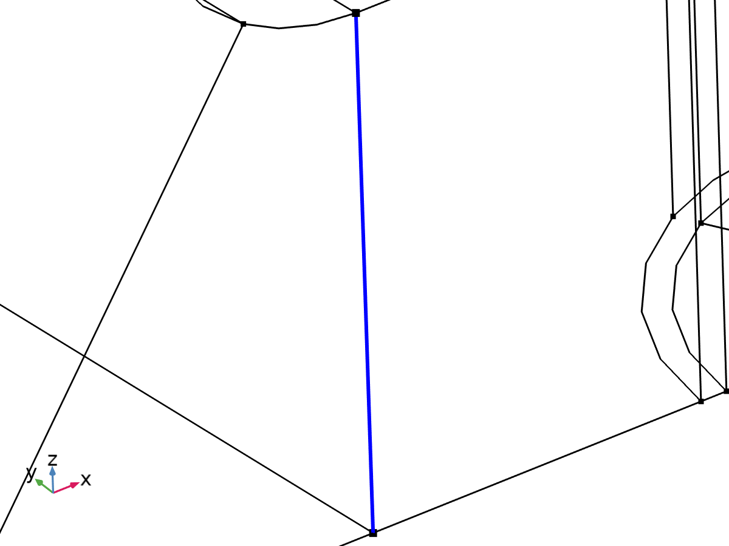

Linearization line, edge



Second axis orientation reference point

Selection

|  |  |
| --- | --- |
| Geometric entity level | Entire model |

Equations







#### Linearization

Settings

| **Description** | **Value** |
| --- | --- |
| Type | Line |
| Defined by | Edge |

#### Second Axis Orientation

Settings

| **Description** | **Value** |
| --- | --- |
|  | Reference point |
| Defined by | Point |

#### Variables

| **Name** | **Expression** | **Unit** | **Description** | **Selection** | **Details** |
| --- | --- | --- | --- | --- | --- |
| solid.Sm11 | solid.sl4.Sm11 | N/m² | Membrane stress, 11-component | Edge 114 | + operation |
| solid.Sm12 | solid.sl4.Sm12 | N/m² | Membrane stress, 12-component | Edge 114 | + operation |
| solid.Sm13 | solid.sl4.Sm13 | N/m² | Membrane stress, 13-component | Edge 114 | + operation |
| solid.Sm22 | solid.sl4.Sm22 | N/m² | Membrane stress, 22-component | Edge 114 | + operation |
| solid.Sm23 | solid.sl4.Sm23 | N/m² | Membrane stress, 23-component | Edge 114 | + operation |
| solid.Sm33 | solid.sl4.Sm33 | N/m² | Membrane stress, 33-component | Edge 114 | + operation |
| solid.Smb11 | solid.sl4.Smb11 | N/m² | Membrane plus bending stress, 11-component | Edge 114 | + operation |
| solid.Smb12 | solid.sl4.Smb12 | N/m² | Membrane plus bending stress, 12-component | Edge 114 | + operation |
| solid.Smb13 | solid.sl4.Smb13 | N/m² | Membrane plus bending stress, 13-component | Edge 114 | + operation |
| solid.Smb22 | solid.sl4.Smb22 | N/m² | Membrane plus bending stress, 22-component | Edge 114 | + operation |
| solid.Smb23 | solid.sl4.Smb23 | N/m² | Membrane plus bending stress, 23-component | Edge 114 | + operation |
| solid.Smb33 | solid.sl4.Smb33 | N/m² | Membrane plus bending stress, 33-component | Edge 114 | + operation |
| solid.Sb11 | solid.sl4.Sb11 | N/m² | Bending stress, 11-component | Edge 114 | + operation |
| solid.Sb12 | solid.sl4.Sb12 | N/m² | Bending stress, 12-component | Edge 114 | + operation |
| solid.Sb13 | solid.sl4.Sb13 | N/m² | Bending stress, 13-component | Edge 114 | + operation |
| solid.Sb22 | solid.sl4.Sb22 | N/m² | Bending stress, 22-component | Edge 114 | + operation |
| solid.Sb23 | solid.sl4.Sb23 | N/m² | Bending stress, 23-component | Edge 114 | + operation |
| solid.Sb33 | solid.sl4.Sb33 | N/m² | Bending stress, 33-component | Edge 114 | + operation |
| solid.Slls11 | solid.sl4.Slls11 | N/m² | Stress tensor, linearization line system, 11-component | Edge 114 | + operation |
| solid.Slls12 | solid.sl4.Slls12 | N/m² | Stress tensor, linearization line system, 12-component | Edge 114 | + operation |
| solid.Slls13 | solid.sl4.Slls13 | N/m² | Stress tensor, linearization line system, 13-component | Edge 114 | + operation |
| solid.Slls22 | solid.sl4.Slls22 | N/m² | Stress tensor, linearization line system, 22-component | Edge 114 | + operation |
| solid.Slls23 | solid.sl4.Slls23 | N/m² | Stress tensor, linearization line system, 23-component | Edge 114 | + operation |
| solid.Slls33 | solid.sl4.Slls33 | N/m² | Stress tensor, linearization line system, 33-component | Edge 114 | + operation |
| solid.SIm | solid.sl4.SIm | N/m² | Stress intensity, membrane | Edge 114 | + operation |
| solid.SImb | solid.sl4.SImb | N/m² | Stress intensity, membrane plus bending | Edge 114 | + operation |
| solid.mises_m | solid.sl4.mises_m | N/m² | von Mises stress (membrane) | Edge 114 | + operation |
| solid.mises_b | solid.sl4.mises_b | N/m² | von Mises stress (bending) | Edge 114 | + operation |
| solid.mises_mb | solid.sl4.mises_mb | N/m² | von Mises stress (membrane plus bending) | Edge 114 | + operation |
| solid.tresca_m | solid.sl4.tresca_m | N/m² | Tresca stress (membrane) | Edge 114 | + operation |
| solid.tresca_b | solid.sl4.tresca_b | N/m² | Tresca stress (bending) | Edge 114 | + operation |
| solid.tresca_mb | solid.sl4.tresca_mb | N/m² | Tresca stress (membrane plus bending) | Edge 114 | + operation |
| solid.sl4.dX | solid.sl4.pt1X-solid.sl4.pt0X | m | Stress linearization line direction, X-component | Edge 114 |  |
| solid.sl4.dY | solid.sl4.pt1Y-solid.sl4.pt0Y | m | Stress linearization line direction, Y-component | Edge 114 |  |
| solid.sl4.dZ | solid.sl4.pt1Z-solid.sl4.pt0Z | m | Stress linearization line direction, Z-component | Edge 114 |  |
| solid.sl4.nl1X | solid.sl4.dX/sqrt(solid.sl4.dX^2+solid.sl4.dY^2+solid.sl4.dZ^2) | 1 | First axis direction, X-component | Edge 114 |  |
| solid.sl4.nl1Y | solid.sl4.dY/sqrt(solid.sl4.dX^2+solid.sl4.dY^2+solid.sl4.dZ^2) | 1 | First axis direction, Y-component | Edge 114 |  |
| solid.sl4.nl1Z | solid.sl4.dZ/sqrt(solid.sl4.dX^2+solid.sl4.dY^2+solid.sl4.dZ^2) | 1 | First axis direction, Z-component | Edge 114 |  |
| solid.sl4.nl2X | (solid.sl4.pointrefX-solid.sl4.pt0X-((solid.sl4.pointrefX-solid.sl4.pt0X)*solid.sl4.nl1X+(solid.sl4.pointrefY-solid.sl4.pt0Y)*solid.sl4.nl1Y+(solid.sl4.pointrefZ-solid.sl4.pt0Z)*solid.sl4.nl1Z)*solid.sl4.nl1X)/sqrt((solid.sl4.pointrefX-solid.sl4.pt0X-((solid.sl4.pointrefX-solid.sl4.pt0X)*solid.sl4.nl1X+(solid.sl4.pointrefY-solid.sl4.pt0Y)*solid.sl4.nl1Y+(solid.sl4.pointrefZ-solid.sl4.pt0Z)*solid.sl4.nl1Z)*solid.sl4.nl1X)^2+(solid.sl4.pointrefY-solid.sl4.pt0Y-((solid.sl4.pointrefX-solid.sl4.pt0X)*solid.sl4.nl1X+(solid.sl4.pointrefY-solid.sl4.pt0Y)*solid.sl4.nl1Y+(solid.sl4.pointrefZ-solid.sl4.pt0Z)*solid.sl4.nl1Z)*solid.sl4.nl1Y)^2+(solid.sl4.pointrefZ-solid.sl4.pt0Z-((solid.sl4.pointrefX-solid.sl4.pt0X)*solid.sl4.nl1X+(solid.sl4.pointrefY-solid.sl4.pt0Y)*solid.sl4.nl1Y+(solid.sl4.pointrefZ-solid.sl4.pt0Z)*solid.sl4.nl1Z)*solid.sl4.nl1Z)^2+eps) | 1 | Second axis direction, X-component | Global |  |
| solid.sl4.nl2Y | (solid.sl4.pointrefY-solid.sl4.pt0Y-((solid.sl4.pointrefX-solid.sl4.pt0X)*solid.sl4.nl1X+(solid.sl4.pointrefY-solid.sl4.pt0Y)*solid.sl4.nl1Y+(solid.sl4.pointrefZ-solid.sl4.pt0Z)*solid.sl4.nl1Z)*solid.sl4.nl1Y)/sqrt((solid.sl4.pointrefX-solid.sl4.pt0X-((solid.sl4.pointrefX-solid.sl4.pt0X)*solid.sl4.nl1X+(solid.sl4.pointrefY-solid.sl4.pt0Y)*solid.sl4.nl1Y+(solid.sl4.pointrefZ-solid.sl4.pt0Z)*solid.sl4.nl1Z)*solid.sl4.nl1X)^2+(solid.sl4.pointrefY-solid.sl4.pt0Y-((solid.sl4.pointrefX-solid.sl4.pt0X)*solid.sl4.nl1X+(solid.sl4.pointrefY-solid.sl4.pt0Y)*solid.sl4.nl1Y+(solid.sl4.pointrefZ-solid.sl4.pt0Z)*solid.sl4.nl1Z)*solid.sl4.nl1Y)^2+(solid.sl4.pointrefZ-solid.sl4.pt0Z-((solid.sl4.pointrefX-solid.sl4.pt0X)*solid.sl4.nl1X+(solid.sl4.pointrefY-solid.sl4.pt0Y)*solid.sl4.nl1Y+(solid.sl4.pointrefZ-solid.sl4.pt0Z)*solid.sl4.nl1Z)*solid.sl4.nl1Z)^2+eps) | 1 | Second axis direction, Y-component | Global |  |
| solid.sl4.nl2Z | (solid.sl4.pointrefZ-solid.sl4.pt0Z-((solid.sl4.pointrefX-solid.sl4.pt0X)*solid.sl4.nl1X+(solid.sl4.pointrefY-solid.sl4.pt0Y)*solid.sl4.nl1Y+(solid.sl4.pointrefZ-solid.sl4.pt0Z)*solid.sl4.nl1Z)*solid.sl4.nl1Z)/sqrt((solid.sl4.pointrefX-solid.sl4.pt0X-((solid.sl4.pointrefX-solid.sl4.pt0X)*solid.sl4.nl1X+(solid.sl4.pointrefY-solid.sl4.pt0Y)*solid.sl4.nl1Y+(solid.sl4.pointrefZ-solid.sl4.pt0Z)*solid.sl4.nl1Z)*solid.sl4.nl1X)^2+(solid.sl4.pointrefY-solid.sl4.pt0Y-((solid.sl4.pointrefX-solid.sl4.pt0X)*solid.sl4.nl1X+(solid.sl4.pointrefY-solid.sl4.pt0Y)*solid.sl4.nl1Y+(solid.sl4.pointrefZ-solid.sl4.pt0Z)*solid.sl4.nl1Z)*solid.sl4.nl1Y)^2+(solid.sl4.pointrefZ-solid.sl4.pt0Z-((solid.sl4.pointrefX-solid.sl4.pt0X)*solid.sl4.nl1X+(solid.sl4.pointrefY-solid.sl4.pt0Y)*solid.sl4.nl1Y+(solid.sl4.pointrefZ-solid.sl4.pt0Z)*solid.sl4.nl1Z)*solid.sl4.nl1Z)^2+eps) | 1 | Second axis direction, Z-component | Global |  |
| solid.sl4.nl3X | (solid.sl4.nl2Z*solid.sl4.nl1Y-solid.sl4.nl2Y*solid.sl4.nl1Z)/sqrt((solid.sl4.nl2Z*solid.sl4.nl1Y-solid.sl4.nl2Y*solid.sl4.nl1Z)^2+(-solid.sl4.nl2Z*solid.sl4.nl1X+solid.sl4.nl2X*solid.sl4.nl1Z)^2+(solid.sl4.nl2Y*solid.sl4.nl1X-solid.sl4.nl2X*solid.sl4.nl1Y)^2) | 1 | Third axis direction, X-component | Edge 114 |  |
| solid.sl4.nl3Y | (-solid.sl4.nl2Z*solid.sl4.nl1X+solid.sl4.nl2X*solid.sl4.nl1Z)/sqrt((solid.sl4.nl2Z*solid.sl4.nl1Y-solid.sl4.nl2Y*solid.sl4.nl1Z)^2+(-solid.sl4.nl2Z*solid.sl4.nl1X+solid.sl4.nl2X*solid.sl4.nl1Z)^2+(solid.sl4.nl2Y*solid.sl4.nl1X-solid.sl4.nl2X*solid.sl4.nl1Y)^2) | 1 | Third axis direction, Y-component | Edge 114 |  |
| solid.sl4.nl3Z | (solid.sl4.nl2Y*solid.sl4.nl1X-solid.sl4.nl2X*solid.sl4.nl1Y)/sqrt((solid.sl4.nl2Z*solid.sl4.nl1Y-solid.sl4.nl2Y*solid.sl4.nl1Z)^2+(-solid.sl4.nl2Z*solid.sl4.nl1X+solid.sl4.nl2X*solid.sl4.nl1Z)^2+(solid.sl4.nl2Y*solid.sl4.nl1X-solid.sl4.nl2X*solid.sl4.nl1Y)^2) | 1 | Third axis direction, Z-component | Edge 114 |  |
| solid.sl4.Sm11 | solid.sl4.int(solid.sl4.Slls11)/solid.sl4.lengthtot | N/m² | Membrane stress, 11-component | Global |  |
| solid.sl4.Sm12 | solid.sl4.int(solid.sl4.Slls12)/solid.sl4.lengthtot | N/m² | Membrane stress, 12-component | Global |  |
| solid.sl4.Sm13 | solid.sl4.int(solid.sl4.Slls13)/solid.sl4.lengthtot | N/m² | Membrane stress, 13-component | Global |  |
| solid.sl4.Sm22 | solid.sl4.int(solid.sl4.Slls22)/solid.sl4.lengthtot | N/m² | Membrane stress, 22-component | Global |  |
| solid.sl4.Sm23 | solid.sl4.int(solid.sl4.Slls23)/solid.sl4.lengthtot | N/m² | Membrane stress, 23-component | Global |  |
| solid.sl4.Sm33 | solid.sl4.int(solid.sl4.Slls33)/solid.sl4.lengthtot | N/m² | Membrane stress, 33-component | Global |  |
| solid.sl4.Sbmax11 | 6*solid.sl4.int((0.5*solid.sl4.lengthtot-solid.sl4.arclength)*solid.sl4.Slls11)/solid.sl4.lengthtot^2 | N/m² | Maximum bending stress, 11-component | Global |  |
| solid.sl4.Sbmax12 | 6*solid.sl4.int((0.5*solid.sl4.lengthtot-solid.sl4.arclength)*solid.sl4.Slls12)/solid.sl4.lengthtot^2 | N/m² | Maximum bending stress, 12-component | Global |  |
| solid.sl4.Sbmax13 | 6*solid.sl4.int((0.5*solid.sl4.lengthtot-solid.sl4.arclength)*solid.sl4.Slls13)/solid.sl4.lengthtot^2 | N/m² | Maximum bending stress, 13-component | Global |  |
| solid.sl4.Sbmax22 | 6*solid.sl4.int((0.5*solid.sl4.lengthtot-solid.sl4.arclength)*solid.sl4.Slls22)/solid.sl4.lengthtot^2 | N/m² | Maximum bending stress, 22-component | Global |  |
| solid.sl4.Sbmax23 | 6*solid.sl4.int((0.5*solid.sl4.lengthtot-solid.sl4.arclength)*solid.sl4.Slls23)/solid.sl4.lengthtot^2 | N/m² | Maximum bending stress, 23-component | Global |  |
| solid.sl4.Sbmax33 | 6*solid.sl4.int((0.5*solid.sl4.lengthtot-solid.sl4.arclength)*solid.sl4.Slls33)/solid.sl4.lengthtot^2 | N/m² | Maximum bending stress, 33-component | Global |  |
| solid.sl4.Sb11 | 2*(0.5-solid.sl4.arclength/solid.sl4.lengthtot)*solid.sl4.Sbmax11 | N/m² | Bending stress, 11-component | Edge 114 |  |
| solid.sl4.Sb12 | 2*(0.5-solid.sl4.arclength/solid.sl4.lengthtot)*solid.sl4.Sbmax12 | N/m² | Bending stress, 12-component | Edge 114 |  |
| solid.sl4.Sb13 | 2*(0.5-solid.sl4.arclength/solid.sl4.lengthtot)*solid.sl4.Sbmax13 | N/m² | Bending stress, 13-component | Edge 114 |  |
| solid.sl4.Sb22 | 2*(0.5-solid.sl4.arclength/solid.sl4.lengthtot)*solid.sl4.Sbmax22 | N/m² | Bending stress, 22-component | Edge 114 |  |
| solid.sl4.Sb23 | 2*(0.5-solid.sl4.arclength/solid.sl4.lengthtot)*solid.sl4.Sbmax23 | N/m² | Bending stress, 23-component | Edge 114 |  |
| solid.sl4.Sb33 | 2*(0.5-solid.sl4.arclength/solid.sl4.lengthtot)*solid.sl4.Sbmax33 | N/m² | Bending stress, 33-component | Edge 114 |  |
| solid.sl4.Smb11 | solid.sl4.Sm11+solid.sl4.Sb11 | N/m² | Membrane plus bending stress, 11-component | Edge 114 |  |
| solid.sl4.Smb12 | solid.sl4.Sm12+solid.sl4.Sb12 | N/m² | Membrane plus bending stress, 12-component | Edge 114 |  |
| solid.sl4.Smb13 | solid.sl4.Sm13+solid.sl4.Sb13 | N/m² | Membrane plus bending stress, 13-component | Edge 114 |  |
| solid.sl4.Smb22 | solid.sl4.Sm22+solid.sl4.Sb22 | N/m² | Membrane plus bending stress, 22-component | Edge 114 |  |
| solid.sl4.Smb23 | solid.sl4.Sm23+solid.sl4.Sb23 | N/m² | Membrane plus bending stress, 23-component | Edge 114 |  |
| solid.sl4.Smb33 | solid.sl4.Sm33+solid.sl4.Sb33 | N/m² | Membrane plus bending stress, 33-component | Edge 114 |  |
| solid.sl4.Sps11 | solid.sl4.startpoint(solid.sl4.Slls11-solid.sl4.Smb11) | N/m² | Peak stress, starting point, 11-component | Global |  |
| solid.sl4.Sps12 | solid.sl4.startpoint(solid.sl4.Slls12-solid.sl4.Smb12) | N/m² | Peak stress, starting point, 12-component | Global |  |
| solid.sl4.Sps13 | solid.sl4.startpoint(solid.sl4.Slls13-solid.sl4.Smb13) | N/m² | Peak stress, starting point, 13-component | Global |  |
| solid.sl4.Sps22 | solid.sl4.startpoint(solid.sl4.Slls22-solid.sl4.Smb22) | N/m² | Peak stress, starting point, 22-component | Global |  |
| solid.sl4.Sps23 | solid.sl4.startpoint(solid.sl4.Slls23-solid.sl4.Smb23) | N/m² | Peak stress, starting point, 23-component | Global |  |
| solid.sl4.Sps33 | solid.sl4.startpoint(solid.sl4.Slls33-solid.sl4.Smb33) | N/m² | Peak stress, starting point, 33-component | Global |  |
| solid.sl4.Spe11 | solid.sl4.endpoint(solid.sl4.Slls11-solid.sl4.Smb11) | N/m² | Peak stress, endpoint, 11-component | Global |  |
| solid.sl4.Spe12 | solid.sl4.endpoint(solid.sl4.Slls12-solid.sl4.Smb12) | N/m² | Peak stress, endpoint, 12-component | Global |  |
| solid.sl4.Spe13 | solid.sl4.endpoint(solid.sl4.Slls13-solid.sl4.Smb13) | N/m² | Peak stress, endpoint, 13-component | Global |  |
| solid.sl4.Spe22 | solid.sl4.endpoint(solid.sl4.Slls22-solid.sl4.Smb22) | N/m² | Peak stress, endpoint, 22-component | Global |  |
| solid.sl4.Spe23 | solid.sl4.endpoint(solid.sl4.Slls23-solid.sl4.Smb23) | N/m² | Peak stress, endpoint, 23-component | Global |  |
| solid.sl4.Spe33 | solid.sl4.endpoint(solid.sl4.Slls33-solid.sl4.Smb33) | N/m² | Peak stress, endpoint, 33-component | Global |  |
| solid.sl4.Slls11 | (solid.sl4.nl1X*solid.SXX+solid.sl4.nl1Y*solid.SXY+solid.sl4.nl1Z*solid.SXZ)*solid.sl4.nl1X+(solid.sl4.nl1X*solid.SXY+solid.sl4.nl1Y*solid.SYY+solid.sl4.nl1Z*solid.SYZ)*solid.sl4.nl1Y+(solid.sl4.nl1X*solid.SXZ+solid.sl4.nl1Y*solid.SYZ+solid.sl4.nl1Z*solid.SZZ)*solid.sl4.nl1Z | N/m² | Stress tensor, linearization line system, 11-component | Edge 114 |  |
| solid.sl4.Slls12 | (solid.sl4.nl1X*solid.SXX+solid.sl4.nl1Y*solid.SXY+solid.sl4.nl1Z*solid.SXZ)*solid.sl4.nl2X+(solid.sl4.nl1X*solid.SXY+solid.sl4.nl1Y*solid.SYY+solid.sl4.nl1Z*solid.SYZ)*solid.sl4.nl2Y+(solid.sl4.nl1X*solid.SXZ+solid.sl4.nl1Y*solid.SYZ+solid.sl4.nl1Z*solid.SZZ)*solid.sl4.nl2Z | N/m² | Stress tensor, linearization line system, 12-component | Edge 114 |  |
| solid.sl4.Slls13 | (solid.sl4.nl1X*solid.SXX+solid.sl4.nl1Y*solid.SXY+solid.sl4.nl1Z*solid.SXZ)*solid.sl4.nl3X+(solid.sl4.nl1X*solid.SXY+solid.sl4.nl1Y*solid.SYY+solid.sl4.nl1Z*solid.SYZ)*solid.sl4.nl3Y+(solid.sl4.nl1X*solid.SXZ+solid.sl4.nl1Y*solid.SYZ+solid.sl4.nl1Z*solid.SZZ)*solid.sl4.nl3Z | N/m² | Stress tensor, linearization line system, 13-component | Edge 114 |  |
| solid.sl4.Slls22 | (solid.sl4.nl2X*solid.SXX+solid.sl4.nl2Y*solid.SXY+solid.sl4.nl2Z*solid.SXZ)*solid.sl4.nl2X+(solid.sl4.nl2X*solid.SXY+solid.sl4.nl2Y*solid.SYY+solid.sl4.nl2Z*solid.SYZ)*solid.sl4.nl2Y+(solid.sl4.nl2X*solid.SXZ+solid.sl4.nl2Y*solid.SYZ+solid.sl4.nl2Z*solid.SZZ)*solid.sl4.nl2Z | N/m² | Stress tensor, linearization line system, 22-component | Edge 114 |  |
| solid.sl4.Slls23 | (solid.sl4.nl2X*solid.SXX+solid.sl4.nl2Y*solid.SXY+solid.sl4.nl2Z*solid.SXZ)*solid.sl4.nl3X+(solid.sl4.nl2X*solid.SXY+solid.sl4.nl2Y*solid.SYY+solid.sl4.nl2Z*solid.SYZ)*solid.sl4.nl3Y+(solid.sl4.nl2X*solid.SXZ+solid.sl4.nl2Y*solid.SYZ+solid.sl4.nl2Z*solid.SZZ)*solid.sl4.nl3Z | N/m² | Stress tensor, linearization line system, 23-component | Edge 114 |  |
| solid.sl4.Slls33 | (solid.sl4.nl3X*solid.SXX+solid.sl4.nl3Y*solid.SXY+solid.sl4.nl3Z*solid.SXZ)*solid.sl4.nl3X+(solid.sl4.nl3X*solid.SXY+solid.sl4.nl3Y*solid.SYY+solid.sl4.nl3Z*solid.SYZ)*solid.sl4.nl3Y+(solid.sl4.nl3X*solid.SXZ+solid.sl4.nl3Y*solid.SYZ+solid.sl4.nl3Z*solid.SZZ)*solid.sl4.nl3Z | N/m² | Stress tensor, linearization line system, 33-component | Edge 114 |  |
| solid.sl4.pointrefX | solid.sl4.pointref(X) | m | Reference point defining local 2 direction, X-component | Global |  |
| solid.sl4.pointrefY | solid.sl4.pointref(Y) | m | Reference point defining local 2 direction, Y-component | Global |  |
| solid.sl4.pointrefZ | solid.sl4.pointref(Z) | m | Reference point defining local 2 direction, Z-component | Global |  |
| solid.sl4.lengthtot | solid.sl4.int(1) | m | Edge length total | Global |  |
| solid.sl4.arclength | (s1-solid.sl4.s1s)*solid.sl4.length/(solid.sl4.s1e-solid.sl4.s1s)+solid.sl4.arclength_offset | m | Arc length | Edge 114 |  |
| solid.sl4.N22 | solid.sl4.lengthtot*solid.sl4.Sm22 | N/m | Local in plane force, 22 component | Global |  |
| solid.sl4.N33 | solid.sl4.lengthtot*solid.sl4.Sm33 | N/m | Local in plane force, 33 component | Global |  |
| solid.sl4.N23 | solid.sl4.lengthtot*solid.sl4.Sm23 | N/m | Local in plane force, 23 component | Global |  |
| solid.sl4.M22 | solid.sl4.lengthtot^2*solid.sl4.Sbmax22/6 | N | Local bending moment, 22 component | Global |  |
| solid.sl4.M33 | solid.sl4.lengthtot^2*solid.sl4.Sbmax33/6 | N | Local bending moment, 33 component | Global |  |
| solid.sl4.M23 | solid.sl4.lengthtot^2*solid.sl4.Sbmax23/6 | N | Local bending moment, 23 component | Global |  |
| solid.sl4.Q2 | solid.sl4.lengthtot*solid.sl4.Sm12 | N/m | Local out-of-plane shear force, 2 component | Global |  |
| solid.sl4.Q3 | solid.sl4.lengthtot*solid.sl4.Sm13 | N/m | Local out-of-plane shear force, 3 component | Global |  |
| solid.sl4.pt0X | solid.sl4.startpoint(solid.X) | m | Starting point, X-component | Global |  |
| solid.sl4.pt0Y | solid.sl4.startpoint(solid.Y) | m | Starting point, Y-component | Global |  |
| solid.sl4.pt0Z | solid.sl4.startpoint(solid.Z) | m | Starting point, Z-component | Global |  |
| solid.sl4.pt1X | solid.sl4.endpoint(solid.X) | m | Endpoint, X-component | Global |  |
| solid.sl4.pt1Y | solid.sl4.endpoint(solid.Y) | m | Endpoint, Y-component | Global |  |
| solid.sl4.pt1Z | solid.sl4.endpoint(solid.Z) | m | Endpoint, Z-component | Global |  |
| solid.sl4.mises_m | sqrt(0.5*((solid.sl4.Sm11-solid.sl4.Sm22)^2+(solid.sl4.Sm22-solid.sl4.Sm33)^2+(solid.sl4.Sm33-solid.sl4.Sm11)^2+6*(solid.sl4.Sm12^2+solid.sl4.Sm23^2+solid.sl4.Sm13^2))) | N/m² | von Mises stress (membrane) | Global |  |
| solid.sl4.mises_b | sqrt(0.5*((solid.sl4.Sb11-solid.sl4.Sb22)^2+(solid.sl4.Sb22-solid.sl4.Sb33)^2+(solid.sl4.Sb33-solid.sl4.Sb11)^2+6*(solid.sl4.Sb12^2+solid.sl4.Sb23^2+solid.sl4.Sb13^2))) | N/m² | von Mises stress (bending) | Edge 114 |  |
| solid.sl4.mises_mb | sqrt(0.5*((solid.sl4.Smb11-solid.sl4.Smb22)^2+(solid.sl4.Smb22-solid.sl4.Smb33)^2+(solid.sl4.Smb33-solid.sl4.Smb11)^2+6*(solid.sl4.Smb12^2+solid.sl4.Smb23^2+solid.sl4.Smb13^2))) | N/m² | von Mises stress (membrane plus bending) | Edge 114 |  |
| solid.sl4.tresca_m | max(max(abs(solid.sl4.Smp1-solid.sl4.Smp2),abs(solid.sl4.Smp1-solid.sl4.Smp3)),abs(solid.sl4.Smp2-solid.sl4.Smp3)) | N/m² | Tresca stress (membrane) | Global |  |
| solid.sl4.tresca_b | max(max(abs(solid.sl4.Sbp1-solid.sl4.Sbp2),abs(solid.sl4.Sbp1-solid.sl4.Sbp3)),abs(solid.sl4.Sbp2-solid.sl4.Sbp3)) | N/m² | Tresca stress (bending) | Edge 114 |  |
| solid.sl4.tresca_mb | max(max(abs(solid.sl4.Smbp1-solid.sl4.Smbp2),abs(solid.sl4.Smbp1-solid.sl4.Smbp3)),abs(solid.sl4.Smbp2-solid.sl4.Smbp3)) | N/m² | Tresca stress (membrane plus bending) | Edge 114 |  |
| solid.sl4.Smbs11 | solid.sl4.Sm11+solid.sl4.Sbmax11 | N/m² | Membrane plus bending stress, starting point, 11-component | Global |  |
| solid.sl4.Smbs12 | solid.sl4.Sm12+solid.sl4.Sbmax12 | N/m² | Membrane plus bending stress, starting point, 12-component | Global |  |
| solid.sl4.Smbs13 | solid.sl4.Sm13+solid.sl4.Sbmax13 | N/m² | Membrane plus bending stress, starting point, 13-component | Global |  |
| solid.sl4.Smbs22 | solid.sl4.Sm22+solid.sl4.Sbmax22 | N/m² | Membrane plus bending stress, starting point, 22-component | Global |  |
| solid.sl4.Smbs23 | solid.sl4.Sm23+solid.sl4.Sbmax23 | N/m² | Membrane plus bending stress, starting point, 23-component | Global |  |
| solid.sl4.Smbs33 | solid.sl4.Sm33+solid.sl4.Sbmax33 | N/m² | Membrane plus bending stress, starting point, 33-component | Global |  |
| solid.sl4.Smbe11 | solid.sl4.Sm11-solid.sl4.Sbmax11 | N/m² | Membrane plus bending stress, endpoint, 11-component | Global |  |
| solid.sl4.Smbe12 | solid.sl4.Sm12-solid.sl4.Sbmax12 | N/m² | Membrane plus bending stress, endpoint, 12-component | Global |  |
| solid.sl4.Smbe13 | solid.sl4.Sm13-solid.sl4.Sbmax13 | N/m² | Membrane plus bending stress, endpoint, 13-component | Global |  |
| solid.sl4.Smbe22 | solid.sl4.Sm22-solid.sl4.Sbmax22 | N/m² | Membrane plus bending stress, endpoint, 22-component | Global |  |
| solid.sl4.Smbe23 | solid.sl4.Sm23-solid.sl4.Sbmax23 | N/m² | Membrane plus bending stress, endpoint, 23-component | Global |  |
| solid.sl4.Smbe33 | solid.sl4.Sm33-solid.sl4.Sbmax33 | N/m² | Membrane plus bending stress, endpoint, 33-component | Global |  |
| solid.sl4.ySmbs11 | solid.sl4.Smbs11 | N/m² | Membrane plus bending stress, starting point, 11-component | Global |  |
| solid.sl4.ySmbs12 | solid.sl4.Smbs12 | N/m² | Membrane plus bending stress, starting point, 12-component | Global |  |
| solid.sl4.ySmbs13 | solid.sl4.Smbs13 | N/m² | Membrane plus bending stress, starting point, 13-component | Global |  |
| solid.sl4.ySmbs22 | solid.sl4.Smbs22 | N/m² | Membrane plus bending stress, starting point, 22-component | Global |  |
| solid.sl4.ySmbs23 | solid.sl4.Smbs23 | N/m² | Membrane plus bending stress, starting point, 23-component | Global |  |
| solid.sl4.ySmbs33 | solid.sl4.Smbs33 | N/m² | Membrane plus bending stress, starting point, 33-component | Global |  |
| solid.sl4.ySmbe11 | solid.sl4.Smbe11 | N/m² | Membrane plus bending stress, endpoint, 11-component | Global |  |
| solid.sl4.ySmbe12 | solid.sl4.Smbe12 | N/m² | Membrane plus bending stress, endpoint, 12-component | Global |  |
| solid.sl4.ySmbe13 | solid.sl4.Smbe13 | N/m² | Membrane plus bending stress, endpoint, 13-component | Global |  |
| solid.sl4.ySmbe22 | solid.sl4.Smbe22 | N/m² | Membrane plus bending stress, endpoint, 22-component | Global |  |
| solid.sl4.ySmbe23 | solid.sl4.Smbe23 | N/m² | Membrane plus bending stress, endpoint, 23-component | Global |  |
| solid.sl4.ySmbe33 | solid.sl4.Smbe33 | N/m² | Membrane plus bending stress, endpoint, 33-component | Global |  |
| solid.sl4.ySm11 | solid.sl4.Sm11 | N/m² | Membrane stress, 11-component | Global |  |
| solid.sl4.ySm12 | solid.sl4.Sm12 | N/m² | Membrane stress, 12-component | Global |  |
| solid.sl4.ySm13 | solid.sl4.Sm13 | N/m² | Membrane stress, 13-component | Global |  |
| solid.sl4.ySm22 | solid.sl4.Sm22 | N/m² | Membrane stress, 22-component | Global |  |
| solid.sl4.ySm23 | solid.sl4.Sm23 | N/m² | Membrane stress, 23-component | Global |  |
| solid.sl4.ySm33 | solid.sl4.Sm33 | N/m² | Membrane stress, 33-component | Global |  |
| solid.sl4.xs | 0 | m | Arc length, starting point | Global |  |
| solid.sl4.xe | solid.sl4.lengthtot | m | Arc length, endpoint | Global |  |
| solid.sl4.SIm | max(max(abs(solid.sl4.Smp1-solid.sl4.Smp2),abs(solid.sl4.Smp1-solid.sl4.Smp3)),abs(solid.sl4.Smp2-solid.sl4.Smp3)) | N/m² | Stress intensity, membrane | Global |  |
| solid.sl4.SImbe | max(max(abs(solid.sl4.Smbpe1-solid.sl4.Smbpe2),abs(solid.sl4.Smbpe1-solid.sl4.Smbpe3)),abs(solid.sl4.Smbpe2-solid.sl4.Smbpe3)) | N/m² | Stress intensity, membrane plus bending, endpoint | Global |  |
| solid.sl4.SImbs | max(max(abs(solid.sl4.Smbps1-solid.sl4.Smbps2),abs(solid.sl4.Smbps1-solid.sl4.Smbps3)),abs(solid.sl4.Smbps2-solid.sl4.Smbps3)) | N/m² | Stress intensity, membrane plus bending, starting point | Global |  |
| solid.sl4.SImb | max(solid.sl4.SImbs,solid.sl4.SImbe) | N/m² | Stress intensity, membrane plus bending | Global |  |
| solid.sl4.length | solid.sl4.intline114(1) | m | Length | Edge 114 |  |
| solid.sl4.s1s | 0 | m | Local parameter, start | Edge 114 |  |
| solid.sl4.s1e | 0.02 | m | Local parameter, end | Edge 114 |  |
| solid.sl4.arclength_offset | 0 | m | Arc length offset | Edge 114 |  |

### Stress Linearization 5

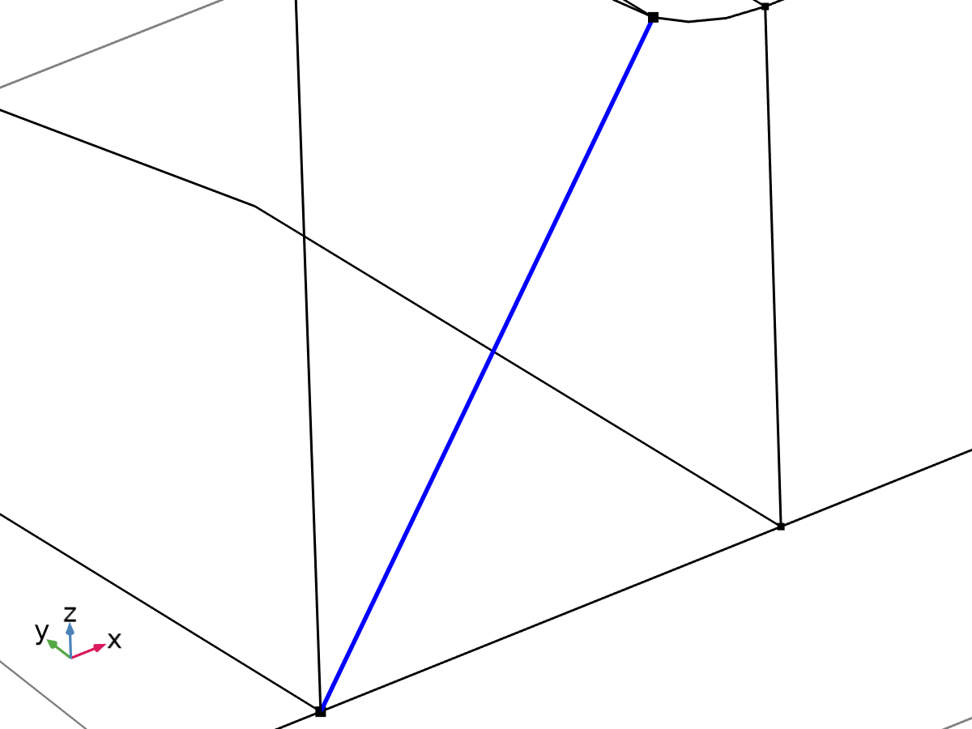

Linearization line, edge



Second axis orientation reference point

Selection

|  |  |
| --- | --- |
| Geometric entity level | Entire model |

Equations







#### Linearization

Settings

| **Description** | **Value** |
| --- | --- |
| Type | Line |
| Defined by | Edge |

#### Second Axis Orientation

Settings

| **Description** | **Value** |
| --- | --- |
|  | Reference point |
| Defined by | Point |

#### Variables

| **Name** | **Expression** | **Unit** | **Description** | **Selection** | **Details** |
| --- | --- | --- | --- | --- | --- |
| solid.Sm11 | solid.sl5.Sm11 | N/m² | Membrane stress, 11-component | Edge 102 | + operation |
| solid.Sm12 | solid.sl5.Sm12 | N/m² | Membrane stress, 12-component | Edge 102 | + operation |
| solid.Sm13 | solid.sl5.Sm13 | N/m² | Membrane stress, 13-component | Edge 102 | + operation |
| solid.Sm22 | solid.sl5.Sm22 | N/m² | Membrane stress, 22-component | Edge 102 | + operation |
| solid.Sm23 | solid.sl5.Sm23 | N/m² | Membrane stress, 23-component | Edge 102 | + operation |
| solid.Sm33 | solid.sl5.Sm33 | N/m² | Membrane stress, 33-component | Edge 102 | + operation |
| solid.Smb11 | solid.sl5.Smb11 | N/m² | Membrane plus bending stress, 11-component | Edge 102 | + operation |
| solid.Smb12 | solid.sl5.Smb12 | N/m² | Membrane plus bending stress, 12-component | Edge 102 | + operation |
| solid.Smb13 | solid.sl5.Smb13 | N/m² | Membrane plus bending stress, 13-component | Edge 102 | + operation |
| solid.Smb22 | solid.sl5.Smb22 | N/m² | Membrane plus bending stress, 22-component | Edge 102 | + operation |
| solid.Smb23 | solid.sl5.Smb23 | N/m² | Membrane plus bending stress, 23-component | Edge 102 | + operation |
| solid.Smb33 | solid.sl5.Smb33 | N/m² | Membrane plus bending stress, 33-component | Edge 102 | + operation |
| solid.Sb11 | solid.sl5.Sb11 | N/m² | Bending stress, 11-component | Edge 102 | + operation |
| solid.Sb12 | solid.sl5.Sb12 | N/m² | Bending stress, 12-component | Edge 102 | + operation |
| solid.Sb13 | solid.sl5.Sb13 | N/m² | Bending stress, 13-component | Edge 102 | + operation |
| solid.Sb22 | solid.sl5.Sb22 | N/m² | Bending stress, 22-component | Edge 102 | + operation |
| solid.Sb23 | solid.sl5.Sb23 | N/m² | Bending stress, 23-component | Edge 102 | + operation |
| solid.Sb33 | solid.sl5.Sb33 | N/m² | Bending stress, 33-component | Edge 102 | + operation |
| solid.Slls11 | solid.sl5.Slls11 | N/m² | Stress tensor, linearization line system, 11-component | Edge 102 | + operation |
| solid.Slls12 | solid.sl5.Slls12 | N/m² | Stress tensor, linearization line system, 12-component | Edge 102 | + operation |
| solid.Slls13 | solid.sl5.Slls13 | N/m² | Stress tensor, linearization line system, 13-component | Edge 102 | + operation |
| solid.Slls22 | solid.sl5.Slls22 | N/m² | Stress tensor, linearization line system, 22-component | Edge 102 | + operation |
| solid.Slls23 | solid.sl5.Slls23 | N/m² | Stress tensor, linearization line system, 23-component | Edge 102 | + operation |
| solid.Slls33 | solid.sl5.Slls33 | N/m² | Stress tensor, linearization line system, 33-component | Edge 102 | + operation |
| solid.SIm | solid.sl5.SIm | N/m² | Stress intensity, membrane | Edge 102 | + operation |
| solid.SImb | solid.sl5.SImb | N/m² | Stress intensity, membrane plus bending | Edge 102 | + operation |
| solid.mises_m | solid.sl5.mises_m | N/m² | von Mises stress (membrane) | Edge 102 | + operation |
| solid.mises_b | solid.sl5.mises_b | N/m² | von Mises stress (bending) | Edge 102 | + operation |
| solid.mises_mb | solid.sl5.mises_mb | N/m² | von Mises stress (membrane plus bending) | Edge 102 | + operation |
| solid.tresca_m | solid.sl5.tresca_m | N/m² | Tresca stress (membrane) | Edge 102 | + operation |
| solid.tresca_b | solid.sl5.tresca_b | N/m² | Tresca stress (bending) | Edge 102 | + operation |
| solid.tresca_mb | solid.sl5.tresca_mb | N/m² | Tresca stress (membrane plus bending) | Edge 102 | + operation |
| solid.sl5.dX | solid.sl5.pt1X-solid.sl5.pt0X | m | Stress linearization line direction, X-component | Edge 102 |  |
| solid.sl5.dY | solid.sl5.pt1Y-solid.sl5.pt0Y | m | Stress linearization line direction, Y-component | Edge 102 |  |
| solid.sl5.dZ | solid.sl5.pt1Z-solid.sl5.pt0Z | m | Stress linearization line direction, Z-component | Edge 102 |  |
| solid.sl5.nl1X | solid.sl5.dX/sqrt(solid.sl5.dX^2+solid.sl5.dY^2+solid.sl5.dZ^2) | 1 | First axis direction, X-component | Edge 102 |  |
| solid.sl5.nl1Y | solid.sl5.dY/sqrt(solid.sl5.dX^2+solid.sl5.dY^2+solid.sl5.dZ^2) | 1 | First axis direction, Y-component | Edge 102 |  |
| solid.sl5.nl1Z | solid.sl5.dZ/sqrt(solid.sl5.dX^2+solid.sl5.dY^2+solid.sl5.dZ^2) | 1 | First axis direction, Z-component | Edge 102 |  |
| solid.sl5.nl2X | (solid.sl5.pointrefX-solid.sl5.pt0X-((solid.sl5.pointrefX-solid.sl5.pt0X)*solid.sl5.nl1X+(solid.sl5.pointrefY-solid.sl5.pt0Y)*solid.sl5.nl1Y+(solid.sl5.pointrefZ-solid.sl5.pt0Z)*solid.sl5.nl1Z)*solid.sl5.nl1X)/sqrt((solid.sl5.pointrefX-solid.sl5.pt0X-((solid.sl5.pointrefX-solid.sl5.pt0X)*solid.sl5.nl1X+(solid.sl5.pointrefY-solid.sl5.pt0Y)*solid.sl5.nl1Y+(solid.sl5.pointrefZ-solid.sl5.pt0Z)*solid.sl5.nl1Z)*solid.sl5.nl1X)^2+(solid.sl5.pointrefY-solid.sl5.pt0Y-((solid.sl5.pointrefX-solid.sl5.pt0X)*solid.sl5.nl1X+(solid.sl5.pointrefY-solid.sl5.pt0Y)*solid.sl5.nl1Y+(solid.sl5.pointrefZ-solid.sl5.pt0Z)*solid.sl5.nl1Z)*solid.sl5.nl1Y)^2+(solid.sl5.pointrefZ-solid.sl5.pt0Z-((solid.sl5.pointrefX-solid.sl5.pt0X)*solid.sl5.nl1X+(solid.sl5.pointrefY-solid.sl5.pt0Y)*solid.sl5.nl1Y+(solid.sl5.pointrefZ-solid.sl5.pt0Z)*solid.sl5.nl1Z)*solid.sl5.nl1Z)^2+eps) | 1 | Second axis direction, X-component | Global |  |
| solid.sl5.nl2Y | (solid.sl5.pointrefY-solid.sl5.pt0Y-((solid.sl5.pointrefX-solid.sl5.pt0X)*solid.sl5.nl1X+(solid.sl5.pointrefY-solid.sl5.pt0Y)*solid.sl5.nl1Y+(solid.sl5.pointrefZ-solid.sl5.pt0Z)*solid.sl5.nl1Z)*solid.sl5.nl1Y)/sqrt((solid.sl5.pointrefX-solid.sl5.pt0X-((solid.sl5.pointrefX-solid.sl5.pt0X)*solid.sl5.nl1X+(solid.sl5.pointrefY-solid.sl5.pt0Y)*solid.sl5.nl1Y+(solid.sl5.pointrefZ-solid.sl5.pt0Z)*solid.sl5.nl1Z)*solid.sl5.nl1X)^2+(solid.sl5.pointrefY-solid.sl5.pt0Y-((solid.sl5.pointrefX-solid.sl5.pt0X)*solid.sl5.nl1X+(solid.sl5.pointrefY-solid.sl5.pt0Y)*solid.sl5.nl1Y+(solid.sl5.pointrefZ-solid.sl5.pt0Z)*solid.sl5.nl1Z)*solid.sl5.nl1Y)^2+(solid.sl5.pointrefZ-solid.sl5.pt0Z-((solid.sl5.pointrefX-solid.sl5.pt0X)*solid.sl5.nl1X+(solid.sl5.pointrefY-solid.sl5.pt0Y)*solid.sl5.nl1Y+(solid.sl5.pointrefZ-solid.sl5.pt0Z)*solid.sl5.nl1Z)*solid.sl5.nl1Z)^2+eps) | 1 | Second axis direction, Y-component | Global |  |
| solid.sl5.nl2Z | (solid.sl5.pointrefZ-solid.sl5.pt0Z-((solid.sl5.pointrefX-solid.sl5.pt0X)*solid.sl5.nl1X+(solid.sl5.pointrefY-solid.sl5.pt0Y)*solid.sl5.nl1Y+(solid.sl5.pointrefZ-solid.sl5.pt0Z)*solid.sl5.nl1Z)*solid.sl5.nl1Z)/sqrt((solid.sl5.pointrefX-solid.sl5.pt0X-((solid.sl5.pointrefX-solid.sl5.pt0X)*solid.sl5.nl1X+(solid.sl5.pointrefY-solid.sl5.pt0Y)*solid.sl5.nl1Y+(solid.sl5.pointrefZ-solid.sl5.pt0Z)*solid.sl5.nl1Z)*solid.sl5.nl1X)^2+(solid.sl5.pointrefY-solid.sl5.pt0Y-((solid.sl5.pointrefX-solid.sl5.pt0X)*solid.sl5.nl1X+(solid.sl5.pointrefY-solid.sl5.pt0Y)*solid.sl5.nl1Y+(solid.sl5.pointrefZ-solid.sl5.pt0Z)*solid.sl5.nl1Z)*solid.sl5.nl1Y)^2+(solid.sl5.pointrefZ-solid.sl5.pt0Z-((solid.sl5.pointrefX-solid.sl5.pt0X)*solid.sl5.nl1X+(solid.sl5.pointrefY-solid.sl5.pt0Y)*solid.sl5.nl1Y+(solid.sl5.pointrefZ-solid.sl5.pt0Z)*solid.sl5.nl1Z)*solid.sl5.nl1Z)^2+eps) | 1 | Second axis direction, Z-component | Global |  |
| solid.sl5.nl3X | (solid.sl5.nl2Z*solid.sl5.nl1Y-solid.sl5.nl2Y*solid.sl5.nl1Z)/sqrt((solid.sl5.nl2Z*solid.sl5.nl1Y-solid.sl5.nl2Y*solid.sl5.nl1Z)^2+(-solid.sl5.nl2Z*solid.sl5.nl1X+solid.sl5.nl2X*solid.sl5.nl1Z)^2+(solid.sl5.nl2Y*solid.sl5.nl1X-solid.sl5.nl2X*solid.sl5.nl1Y)^2) | 1 | Third axis direction, X-component | Edge 102 |  |
| solid.sl5.nl3Y | (-solid.sl5.nl2Z*solid.sl5.nl1X+solid.sl5.nl2X*solid.sl5.nl1Z)/sqrt((solid.sl5.nl2Z*solid.sl5.nl1Y-solid.sl5.nl2Y*solid.sl5.nl1Z)^2+(-solid.sl5.nl2Z*solid.sl5.nl1X+solid.sl5.nl2X*solid.sl5.nl1Z)^2+(solid.sl5.nl2Y*solid.sl5.nl1X-solid.sl5.nl2X*solid.sl5.nl1Y)^2) | 1 | Third axis direction, Y-component | Edge 102 |  |
| solid.sl5.nl3Z | (solid.sl5.nl2Y*solid.sl5.nl1X-solid.sl5.nl2X*solid.sl5.nl1Y)/sqrt((solid.sl5.nl2Z*solid.sl5.nl1Y-solid.sl5.nl2Y*solid.sl5.nl1Z)^2+(-solid.sl5.nl2Z*solid.sl5.nl1X+solid.sl5.nl2X*solid.sl5.nl1Z)^2+(solid.sl5.nl2Y*solid.sl5.nl1X-solid.sl5.nl2X*solid.sl5.nl1Y)^2) | 1 | Third axis direction, Z-component | Edge 102 |  |
| solid.sl5.Sm11 | solid.sl5.int(solid.sl5.Slls11)/solid.sl5.lengthtot | N/m² | Membrane stress, 11-component | Global |  |
| solid.sl5.Sm12 | solid.sl5.int(solid.sl5.Slls12)/solid.sl5.lengthtot | N/m² | Membrane stress, 12-component | Global |  |
| solid.sl5.Sm13 | solid.sl5.int(solid.sl5.Slls13)/solid.sl5.lengthtot | N/m² | Membrane stress, 13-component | Global |  |
| solid.sl5.Sm22 | solid.sl5.int(solid.sl5.Slls22)/solid.sl5.lengthtot | N/m² | Membrane stress, 22-component | Global |  |
| solid.sl5.Sm23 | solid.sl5.int(solid.sl5.Slls23)/solid.sl5.lengthtot | N/m² | Membrane stress, 23-component | Global |  |
| solid.sl5.Sm33 | solid.sl5.int(solid.sl5.Slls33)/solid.sl5.lengthtot | N/m² | Membrane stress, 33-component | Global |  |
| solid.sl5.Sbmax11 | 6*solid.sl5.int((0.5*solid.sl5.lengthtot-solid.sl5.arclength)*solid.sl5.Slls11)/solid.sl5.lengthtot^2 | N/m² | Maximum bending stress, 11-component | Global |  |
| solid.sl5.Sbmax12 | 6*solid.sl5.int((0.5*solid.sl5.lengthtot-solid.sl5.arclength)*solid.sl5.Slls12)/solid.sl5.lengthtot^2 | N/m² | Maximum bending stress, 12-component | Global |  |
| solid.sl5.Sbmax13 | 6*solid.sl5.int((0.5*solid.sl5.lengthtot-solid.sl5.arclength)*solid.sl5.Slls13)/solid.sl5.lengthtot^2 | N/m² | Maximum bending stress, 13-component | Global |  |
| solid.sl5.Sbmax22 | 6*solid.sl5.int((0.5*solid.sl5.lengthtot-solid.sl5.arclength)*solid.sl5.Slls22)/solid.sl5.lengthtot^2 | N/m² | Maximum bending stress, 22-component | Global |  |
| solid.sl5.Sbmax23 | 6*solid.sl5.int((0.5*solid.sl5.lengthtot-solid.sl5.arclength)*solid.sl5.Slls23)/solid.sl5.lengthtot^2 | N/m² | Maximum bending stress, 23-component | Global |  |
| solid.sl5.Sbmax33 | 6*solid.sl5.int((0.5*solid.sl5.lengthtot-solid.sl5.arclength)*solid.sl5.Slls33)/solid.sl5.lengthtot^2 | N/m² | Maximum bending stress, 33-component | Global |  |
| solid.sl5.Sb11 | 2*(0.5-solid.sl5.arclength/solid.sl5.lengthtot)*solid.sl5.Sbmax11 | N/m² | Bending stress, 11-component | Edge 102 |  |
| solid.sl5.Sb12 | 2*(0.5-solid.sl5.arclength/solid.sl5.lengthtot)*solid.sl5.Sbmax12 | N/m² | Bending stress, 12-component | Edge 102 |  |
| solid.sl5.Sb13 | 2*(0.5-solid.sl5.arclength/solid.sl5.lengthtot)*solid.sl5.Sbmax13 | N/m² | Bending stress, 13-component | Edge 102 |  |
| solid.sl5.Sb22 | 2*(0.5-solid.sl5.arclength/solid.sl5.lengthtot)*solid.sl5.Sbmax22 | N/m² | Bending stress, 22-component | Edge 102 |  |
| solid.sl5.Sb23 | 2*(0.5-solid.sl5.arclength/solid.sl5.lengthtot)*solid.sl5.Sbmax23 | N/m² | Bending stress, 23-component | Edge 102 |  |
| solid.sl5.Sb33 | 2*(0.5-solid.sl5.arclength/solid.sl5.lengthtot)*solid.sl5.Sbmax33 | N/m² | Bending stress, 33-component | Edge 102 |  |
| solid.sl5.Smb11 | solid.sl5.Sm11+solid.sl5.Sb11 | N/m² | Membrane plus bending stress, 11-component | Edge 102 |  |
| solid.sl5.Smb12 | solid.sl5.Sm12+solid.sl5.Sb12 | N/m² | Membrane plus bending stress, 12-component | Edge 102 |  |
| solid.sl5.Smb13 | solid.sl5.Sm13+solid.sl5.Sb13 | N/m² | Membrane plus bending stress, 13-component | Edge 102 |  |
| solid.sl5.Smb22 | solid.sl5.Sm22+solid.sl5.Sb22 | N/m² | Membrane plus bending stress, 22-component | Edge 102 |  |
| solid.sl5.Smb23 | solid.sl5.Sm23+solid.sl5.Sb23 | N/m² | Membrane plus bending stress, 23-component | Edge 102 |  |
| solid.sl5.Smb33 | solid.sl5.Sm33+solid.sl5.Sb33 | N/m² | Membrane plus bending stress, 33-component | Edge 102 |  |
| solid.sl5.Sps11 | solid.sl5.startpoint(solid.sl5.Slls11-solid.sl5.Smb11) | N/m² | Peak stress, starting point, 11-component | Global |  |
| solid.sl5.Sps12 | solid.sl5.startpoint(solid.sl5.Slls12-solid.sl5.Smb12) | N/m² | Peak stress, starting point, 12-component | Global |  |
| solid.sl5.Sps13 | solid.sl5.startpoint(solid.sl5.Slls13-solid.sl5.Smb13) | N/m² | Peak stress, starting point, 13-component | Global |  |
| solid.sl5.Sps22 | solid.sl5.startpoint(solid.sl5.Slls22-solid.sl5.Smb22) | N/m² | Peak stress, starting point, 22-component | Global |  |
| solid.sl5.Sps23 | solid.sl5.startpoint(solid.sl5.Slls23-solid.sl5.Smb23) | N/m² | Peak stress, starting point, 23-component | Global |  |
| solid.sl5.Sps33 | solid.sl5.startpoint(solid.sl5.Slls33-solid.sl5.Smb33) | N/m² | Peak stress, starting point, 33-component | Global |  |
| solid.sl5.Spe11 | solid.sl5.endpoint(solid.sl5.Slls11-solid.sl5.Smb11) | N/m² | Peak stress, endpoint, 11-component | Global |  |
| solid.sl5.Spe12 | solid.sl5.endpoint(solid.sl5.Slls12-solid.sl5.Smb12) | N/m² | Peak stress, endpoint, 12-component | Global |  |
| solid.sl5.Spe13 | solid.sl5.endpoint(solid.sl5.Slls13-solid.sl5.Smb13) | N/m² | Peak stress, endpoint, 13-component | Global |  |
| solid.sl5.Spe22 | solid.sl5.endpoint(solid.sl5.Slls22-solid.sl5.Smb22) | N/m² | Peak stress, endpoint, 22-component | Global |  |
| solid.sl5.Spe23 | solid.sl5.endpoint(solid.sl5.Slls23-solid.sl5.Smb23) | N/m² | Peak stress, endpoint, 23-component | Global |  |
| solid.sl5.Spe33 | solid.sl5.endpoint(solid.sl5.Slls33-solid.sl5.Smb33) | N/m² | Peak stress, endpoint, 33-component | Global |  |
| solid.sl5.Slls11 | (solid.sl5.nl1X*solid.SXX+solid.sl5.nl1Y*solid.SXY+solid.sl5.nl1Z*solid.SXZ)*solid.sl5.nl1X+(solid.sl5.nl1X*solid.SXY+solid.sl5.nl1Y*solid.SYY+solid.sl5.nl1Z*solid.SYZ)*solid.sl5.nl1Y+(solid.sl5.nl1X*solid.SXZ+solid.sl5.nl1Y*solid.SYZ+solid.sl5.nl1Z*solid.SZZ)*solid.sl5.nl1Z | N/m² | Stress tensor, linearization line system, 11-component | Edge 102 |  |
| solid.sl5.Slls12 | (solid.sl5.nl1X*solid.SXX+solid.sl5.nl1Y*solid.SXY+solid.sl5.nl1Z*solid.SXZ)*solid.sl5.nl2X+(solid.sl5.nl1X*solid.SXY+solid.sl5.nl1Y*solid.SYY+solid.sl5.nl1Z*solid.SYZ)*solid.sl5.nl2Y+(solid.sl5.nl1X*solid.SXZ+solid.sl5.nl1Y*solid.SYZ+solid.sl5.nl1Z*solid.SZZ)*solid.sl5.nl2Z | N/m² | Stress tensor, linearization line system, 12-component | Edge 102 |  |
| solid.sl5.Slls13 | (solid.sl5.nl1X*solid.SXX+solid.sl5.nl1Y*solid.SXY+solid.sl5.nl1Z*solid.SXZ)*solid.sl5.nl3X+(solid.sl5.nl1X*solid.SXY+solid.sl5.nl1Y*solid.SYY+solid.sl5.nl1Z*solid.SYZ)*solid.sl5.nl3Y+(solid.sl5.nl1X*solid.SXZ+solid.sl5.nl1Y*solid.SYZ+solid.sl5.nl1Z*solid.SZZ)*solid.sl5.nl3Z | N/m² | Stress tensor, linearization line system, 13-component | Edge 102 |  |
| solid.sl5.Slls22 | (solid.sl5.nl2X*solid.SXX+solid.sl5.nl2Y*solid.SXY+solid.sl5.nl2Z*solid.SXZ)*solid.sl5.nl2X+(solid.sl5.nl2X*solid.SXY+solid.sl5.nl2Y*solid.SYY+solid.sl5.nl2Z*solid.SYZ)*solid.sl5.nl2Y+(solid.sl5.nl2X*solid.SXZ+solid.sl5.nl2Y*solid.SYZ+solid.sl5.nl2Z*solid.SZZ)*solid.sl5.nl2Z | N/m² | Stress tensor, linearization line system, 22-component | Edge 102 |  |
| solid.sl5.Slls23 | (solid.sl5.nl2X*solid.SXX+solid.sl5.nl2Y*solid.SXY+solid.sl5.nl2Z*solid.SXZ)*solid.sl5.nl3X+(solid.sl5.nl2X*solid.SXY+solid.sl5.nl2Y*solid.SYY+solid.sl5.nl2Z*solid.SYZ)*solid.sl5.nl3Y+(solid.sl5.nl2X*solid.SXZ+solid.sl5.nl2Y*solid.SYZ+solid.sl5.nl2Z*solid.SZZ)*solid.sl5.nl3Z | N/m² | Stress tensor, linearization line system, 23-component | Edge 102 |  |
| solid.sl5.Slls33 | (solid.sl5.nl3X*solid.SXX+solid.sl5.nl3Y*solid.SXY+solid.sl5.nl3Z*solid.SXZ)*solid.sl5.nl3X+(solid.sl5.nl3X*solid.SXY+solid.sl5.nl3Y*solid.SYY+solid.sl5.nl3Z*solid.SYZ)*solid.sl5.nl3Y+(solid.sl5.nl3X*solid.SXZ+solid.sl5.nl3Y*solid.SYZ+solid.sl5.nl3Z*solid.SZZ)*solid.sl5.nl3Z | N/m² | Stress tensor, linearization line system, 33-component | Edge 102 |  |
| solid.sl5.pointrefX | solid.sl5.pointref(X) | m | Reference point defining local 2 direction, X-component | Global |  |
| solid.sl5.pointrefY | solid.sl5.pointref(Y) | m | Reference point defining local 2 direction, Y-component | Global |  |
| solid.sl5.pointrefZ | solid.sl5.pointref(Z) | m | Reference point defining local 2 direction, Z-component | Global |  |
| solid.sl5.lengthtot | solid.sl5.int(1) | m | Edge length total | Global |  |
| solid.sl5.arclength | (s1-solid.sl5.s1s)*solid.sl5.length/(solid.sl5.s1e-solid.sl5.s1s)+solid.sl5.arclength_offset | m | Arc length | Edge 102 |  |
| solid.sl5.N22 | solid.sl5.lengthtot*solid.sl5.Sm22 | N/m | Local in plane force, 22 component | Global |  |
| solid.sl5.N33 | solid.sl5.lengthtot*solid.sl5.Sm33 | N/m | Local in plane force, 33 component | Global |  |
| solid.sl5.N23 | solid.sl5.lengthtot*solid.sl5.Sm23 | N/m | Local in plane force, 23 component | Global |  |
| solid.sl5.M22 | solid.sl5.lengthtot^2*solid.sl5.Sbmax22/6 | N | Local bending moment, 22 component | Global |  |
| solid.sl5.M33 | solid.sl5.lengthtot^2*solid.sl5.Sbmax33/6 | N | Local bending moment, 33 component | Global |  |
| solid.sl5.M23 | solid.sl5.lengthtot^2*solid.sl5.Sbmax23/6 | N | Local bending moment, 23 component | Global |  |
| solid.sl5.Q2 | solid.sl5.lengthtot*solid.sl5.Sm12 | N/m | Local out-of-plane shear force, 2 component | Global |  |
| solid.sl5.Q3 | solid.sl5.lengthtot*solid.sl5.Sm13 | N/m | Local out-of-plane shear force, 3 component | Global |  |
| solid.sl5.pt0X | solid.sl5.startpoint(solid.X) | m | Starting point, X-component | Global |  |
| solid.sl5.pt0Y | solid.sl5.startpoint(solid.Y) | m | Starting point, Y-component | Global |  |
| solid.sl5.pt0Z | solid.sl5.startpoint(solid.Z) | m | Starting point, Z-component | Global |  |
| solid.sl5.pt1X | solid.sl5.endpoint(solid.X) | m | Endpoint, X-component | Global |  |
| solid.sl5.pt1Y | solid.sl5.endpoint(solid.Y) | m | Endpoint, Y-component | Global |  |
| solid.sl5.pt1Z | solid.sl5.endpoint(solid.Z) | m | Endpoint, Z-component | Global |  |
| solid.sl5.mises_m | sqrt(0.5*((solid.sl5.Sm11-solid.sl5.Sm22)^2+(solid.sl5.Sm22-solid.sl5.Sm33)^2+(solid.sl5.Sm33-solid.sl5.Sm11)^2+6*(solid.sl5.Sm12^2+solid.sl5.Sm23^2+solid.sl5.Sm13^2))) | N/m² | von Mises stress (membrane) | Global |  |
| solid.sl5.mises_b | sqrt(0.5*((solid.sl5.Sb11-solid.sl5.Sb22)^2+(solid.sl5.Sb22-solid.sl5.Sb33)^2+(solid.sl5.Sb33-solid.sl5.Sb11)^2+6*(solid.sl5.Sb12^2+solid.sl5.Sb23^2+solid.sl5.Sb13^2))) | N/m² | von Mises stress (bending) | Edge 102 |  |
| solid.sl5.mises_mb | sqrt(0.5*((solid.sl5.Smb11-solid.sl5.Smb22)^2+(solid.sl5.Smb22-solid.sl5.Smb33)^2+(solid.sl5.Smb33-solid.sl5.Smb11)^2+6*(solid.sl5.Smb12^2+solid.sl5.Smb23^2+solid.sl5.Smb13^2))) | N/m² | von Mises stress (membrane plus bending) | Edge 102 |  |
| solid.sl5.tresca_m | max(max(abs(solid.sl5.Smp1-solid.sl5.Smp2),abs(solid.sl5.Smp1-solid.sl5.Smp3)),abs(solid.sl5.Smp2-solid.sl5.Smp3)) | N/m² | Tresca stress (membrane) | Global |  |
| solid.sl5.tresca_b | max(max(abs(solid.sl5.Sbp1-solid.sl5.Sbp2),abs(solid.sl5.Sbp1-solid.sl5.Sbp3)),abs(solid.sl5.Sbp2-solid.sl5.Sbp3)) | N/m² | Tresca stress (bending) | Edge 102 |  |
| solid.sl5.tresca_mb | max(max(abs(solid.sl5.Smbp1-solid.sl5.Smbp2),abs(solid.sl5.Smbp1-solid.sl5.Smbp3)),abs(solid.sl5.Smbp2-solid.sl5.Smbp3)) | N/m² | Tresca stress (membrane plus bending) | Edge 102 |  |
| solid.sl5.Smbs11 | solid.sl5.Sm11+solid.sl5.Sbmax11 | N/m² | Membrane plus bending stress, starting point, 11-component | Global |  |
| solid.sl5.Smbs12 | solid.sl5.Sm12+solid.sl5.Sbmax12 | N/m² | Membrane plus bending stress, starting point, 12-component | Global |  |
| solid.sl5.Smbs13 | solid.sl5.Sm13+solid.sl5.Sbmax13 | N/m² | Membrane plus bending stress, starting point, 13-component | Global |  |
| solid.sl5.Smbs22 | solid.sl5.Sm22+solid.sl5.Sbmax22 | N/m² | Membrane plus bending stress, starting point, 22-component | Global |  |
| solid.sl5.Smbs23 | solid.sl5.Sm23+solid.sl5.Sbmax23 | N/m² | Membrane plus bending stress, starting point, 23-component | Global |  |
| solid.sl5.Smbs33 | solid.sl5.Sm33+solid.sl5.Sbmax33 | N/m² | Membrane plus bending stress, starting point, 33-component | Global |  |
| solid.sl5.Smbe11 | solid.sl5.Sm11-solid.sl5.Sbmax11 | N/m² | Membrane plus bending stress, endpoint, 11-component | Global |  |
| solid.sl5.Smbe12 | solid.sl5.Sm12-solid.sl5.Sbmax12 | N/m² | Membrane plus bending stress, endpoint, 12-component | Global |  |
| solid.sl5.Smbe13 | solid.sl5.Sm13-solid.sl5.Sbmax13 | N/m² | Membrane plus bending stress, endpoint, 13-component | Global |  |
| solid.sl5.Smbe22 | solid.sl5.Sm22-solid.sl5.Sbmax22 | N/m² | Membrane plus bending stress, endpoint, 22-component | Global |  |
| solid.sl5.Smbe23 | solid.sl5.Sm23-solid.sl5.Sbmax23 | N/m² | Membrane plus bending stress, endpoint, 23-component | Global |  |
| solid.sl5.Smbe33 | solid.sl5.Sm33-solid.sl5.Sbmax33 | N/m² | Membrane plus bending stress, endpoint, 33-component | Global |  |
| solid.sl5.ySmbs11 | solid.sl5.Smbs11 | N/m² | Membrane plus bending stress, starting point, 11-component | Global |  |
| solid.sl5.ySmbs12 | solid.sl5.Smbs12 | N/m² | Membrane plus bending stress, starting point, 12-component | Global |  |
| solid.sl5.ySmbs13 | solid.sl5.Smbs13 | N/m² | Membrane plus bending stress, starting point, 13-component | Global |  |
| solid.sl5.ySmbs22 | solid.sl5.Smbs22 | N/m² | Membrane plus bending stress, starting point, 22-component | Global |  |
| solid.sl5.ySmbs23 | solid.sl5.Smbs23 | N/m² | Membrane plus bending stress, starting point, 23-component | Global |  |
| solid.sl5.ySmbs33 | solid.sl5.Smbs33 | N/m² | Membrane plus bending stress, starting point, 33-component | Global |  |
| solid.sl5.ySmbe11 | solid.sl5.Smbe11 | N/m² | Membrane plus bending stress, endpoint, 11-component | Global |  |
| solid.sl5.ySmbe12 | solid.sl5.Smbe12 | N/m² | Membrane plus bending stress, endpoint, 12-component | Global |  |
| solid.sl5.ySmbe13 | solid.sl5.Smbe13 | N/m² | Membrane plus bending stress, endpoint, 13-component | Global |  |
| solid.sl5.ySmbe22 | solid.sl5.Smbe22 | N/m² | Membrane plus bending stress, endpoint, 22-component | Global |  |
| solid.sl5.ySmbe23 | solid.sl5.Smbe23 | N/m² | Membrane plus bending stress, endpoint, 23-component | Global |  |
| solid.sl5.ySmbe33 | solid.sl5.Smbe33 | N/m² | Membrane plus bending stress, endpoint, 33-component | Global |  |
| solid.sl5.ySm11 | solid.sl5.Sm11 | N/m² | Membrane stress, 11-component | Global |  |
| solid.sl5.ySm12 | solid.sl5.Sm12 | N/m² | Membrane stress, 12-component | Global |  |
| solid.sl5.ySm13 | solid.sl5.Sm13 | N/m² | Membrane stress, 13-component | Global |  |
| solid.sl5.ySm22 | solid.sl5.Sm22 | N/m² | Membrane stress, 22-component | Global |  |
| solid.sl5.ySm23 | solid.sl5.Sm23 | N/m² | Membrane stress, 23-component | Global |  |
| solid.sl5.ySm33 | solid.sl5.Sm33 | N/m² | Membrane stress, 33-component | Global |  |
| solid.sl5.xs | 0 | m | Arc length, starting point | Global |  |
| solid.sl5.xe | solid.sl5.lengthtot | m | Arc length, endpoint | Global |  |
| solid.sl5.SIm | max(max(abs(solid.sl5.Smp1-solid.sl5.Smp2),abs(solid.sl5.Smp1-solid.sl5.Smp3)),abs(solid.sl5.Smp2-solid.sl5.Smp3)) | N/m² | Stress intensity, membrane | Global |  |
| solid.sl5.SImbe | max(max(abs(solid.sl5.Smbpe1-solid.sl5.Smbpe2),abs(solid.sl5.Smbpe1-solid.sl5.Smbpe3)),abs(solid.sl5.Smbpe2-solid.sl5.Smbpe3)) | N/m² | Stress intensity, membrane plus bending, endpoint | Global |  |
| solid.sl5.SImbs | max(max(abs(solid.sl5.Smbps1-solid.sl5.Smbps2),abs(solid.sl5.Smbps1-solid.sl5.Smbps3)),abs(solid.sl5.Smbps2-solid.sl5.Smbps3)) | N/m² | Stress intensity, membrane plus bending, starting point | Global |  |
| solid.sl5.SImb | max(solid.sl5.SImbs,solid.sl5.SImbe) | N/m² | Stress intensity, membrane plus bending | Global |  |
| solid.sl5.length | solid.sl5.intline102(1) | m | Length | Edge 102 |  |
| solid.sl5.s1s | 0 | m | Local parameter, start | Edge 102 |  |
| solid.sl5.s1e | 0.025286633954186476 | m | Local parameter, end | Edge 102 |  |
| solid.sl5.arclength_offset | 0 | m | Arc length offset | Edge 102 |  |

### Stress Linearization 6

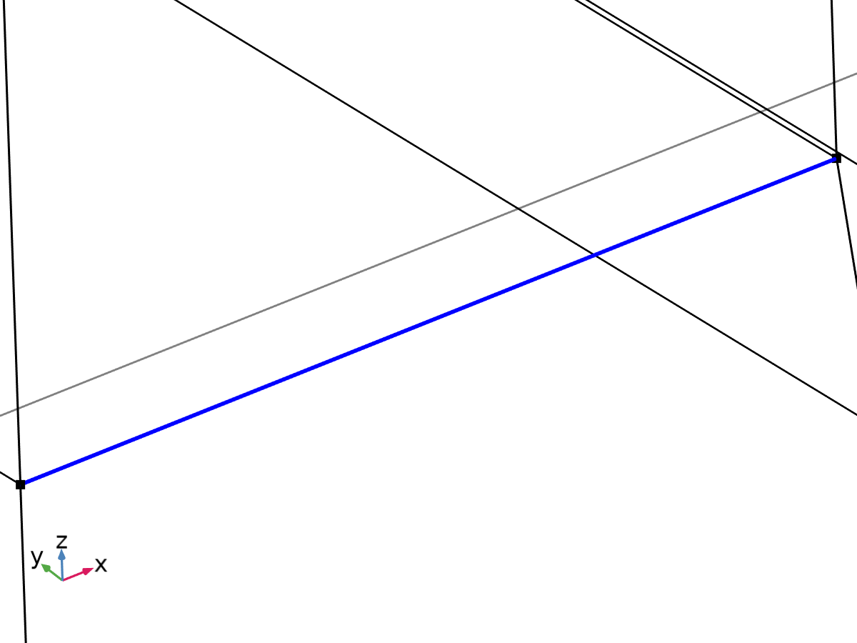

Linearization line, edge



Second axis orientation reference point

Selection

|  |  |
| --- | --- |
| Geometric entity level | Entire model |

Equations







#### Linearization

Settings

| **Description** | **Value** |
| --- | --- |
| Type | Line |
| Defined by | Edge |

#### Second Axis Orientation

Settings

| **Description** | **Value** |
| --- | --- |
|  | Reference point |
| Defined by | Point |

#### Variables

| **Name** | **Expression** | **Unit** | **Description** | **Selection** | **Details** |
| --- | --- | --- | --- | --- | --- |
| solid.Sm11 | solid.sl6.Sm11 | N/m² | Membrane stress, 11-component | Edge 105 | + operation |
| solid.Sm12 | solid.sl6.Sm12 | N/m² | Membrane stress, 12-component | Edge 105 | + operation |
| solid.Sm13 | solid.sl6.Sm13 | N/m² | Membrane stress, 13-component | Edge 105 | + operation |
| solid.Sm22 | solid.sl6.Sm22 | N/m² | Membrane stress, 22-component | Edge 105 | + operation |
| solid.Sm23 | solid.sl6.Sm23 | N/m² | Membrane stress, 23-component | Edge 105 | + operation |
| solid.Sm33 | solid.sl6.Sm33 | N/m² | Membrane stress, 33-component | Edge 105 | + operation |
| solid.Smb11 | solid.sl6.Smb11 | N/m² | Membrane plus bending stress, 11-component | Edge 105 | + operation |
| solid.Smb12 | solid.sl6.Smb12 | N/m² | Membrane plus bending stress, 12-component | Edge 105 | + operation |
| solid.Smb13 | solid.sl6.Smb13 | N/m² | Membrane plus bending stress, 13-component | Edge 105 | + operation |
| solid.Smb22 | solid.sl6.Smb22 | N/m² | Membrane plus bending stress, 22-component | Edge 105 | + operation |
| solid.Smb23 | solid.sl6.Smb23 | N/m² | Membrane plus bending stress, 23-component | Edge 105 | + operation |
| solid.Smb33 | solid.sl6.Smb33 | N/m² | Membrane plus bending stress, 33-component | Edge 105 | + operation |
| solid.Sb11 | solid.sl6.Sb11 | N/m² | Bending stress, 11-component | Edge 105 | + operation |
| solid.Sb12 | solid.sl6.Sb12 | N/m² | Bending stress, 12-component | Edge 105 | + operation |
| solid.Sb13 | solid.sl6.Sb13 | N/m² | Bending stress, 13-component | Edge 105 | + operation |
| solid.Sb22 | solid.sl6.Sb22 | N/m² | Bending stress, 22-component | Edge 105 | + operation |
| solid.Sb23 | solid.sl6.Sb23 | N/m² | Bending stress, 23-component | Edge 105 | + operation |
| solid.Sb33 | solid.sl6.Sb33 | N/m² | Bending stress, 33-component | Edge 105 | + operation |
| solid.Slls11 | solid.sl6.Slls11 | N/m² | Stress tensor, linearization line system, 11-component | Edge 105 | + operation |
| solid.Slls12 | solid.sl6.Slls12 | N/m² | Stress tensor, linearization line system, 12-component | Edge 105 | + operation |
| solid.Slls13 | solid.sl6.Slls13 | N/m² | Stress tensor, linearization line system, 13-component | Edge 105 | + operation |
| solid.Slls22 | solid.sl6.Slls22 | N/m² | Stress tensor, linearization line system, 22-component | Edge 105 | + operation |
| solid.Slls23 | solid.sl6.Slls23 | N/m² | Stress tensor, linearization line system, 23-component | Edge 105 | + operation |
| solid.Slls33 | solid.sl6.Slls33 | N/m² | Stress tensor, linearization line system, 33-component | Edge 105 | + operation |
| solid.SIm | solid.sl6.SIm | N/m² | Stress intensity, membrane | Edge 105 | + operation |
| solid.SImb | solid.sl6.SImb | N/m² | Stress intensity, membrane plus bending | Edge 105 | + operation |
| solid.mises_m | solid.sl6.mises_m | N/m² | von Mises stress (membrane) | Edge 105 | + operation |
| solid.mises_b | solid.sl6.mises_b | N/m² | von Mises stress (bending) | Edge 105 | + operation |
| solid.mises_mb | solid.sl6.mises_mb | N/m² | von Mises stress (membrane plus bending) | Edge 105 | + operation |
| solid.tresca_m | solid.sl6.tresca_m | N/m² | Tresca stress (membrane) | Edge 105 | + operation |
| solid.tresca_b | solid.sl6.tresca_b | N/m² | Tresca stress (bending) | Edge 105 | + operation |
| solid.tresca_mb | solid.sl6.tresca_mb | N/m² | Tresca stress (membrane plus bending) | Edge 105 | + operation |
| solid.sl6.dX | solid.sl6.pt1X-solid.sl6.pt0X | m | Stress linearization line direction, X-component | Edge 105 |  |
| solid.sl6.dY | solid.sl6.pt1Y-solid.sl6.pt0Y | m | Stress linearization line direction, Y-component | Edge 105 |  |
| solid.sl6.dZ | solid.sl6.pt1Z-solid.sl6.pt0Z | m | Stress linearization line direction, Z-component | Edge 105 |  |
| solid.sl6.nl1X | solid.sl6.dX/sqrt(solid.sl6.dX^2+solid.sl6.dY^2+solid.sl6.dZ^2) | 1 | First axis direction, X-component | Edge 105 |  |
| solid.sl6.nl1Y | solid.sl6.dY/sqrt(solid.sl6.dX^2+solid.sl6.dY^2+solid.sl6.dZ^2) | 1 | First axis direction, Y-component | Edge 105 |  |
| solid.sl6.nl1Z | solid.sl6.dZ/sqrt(solid.sl6.dX^2+solid.sl6.dY^2+solid.sl6.dZ^2) | 1 | First axis direction, Z-component | Edge 105 |  |
| solid.sl6.nl2X | (solid.sl6.pointrefX-solid.sl6.pt0X-((solid.sl6.pointrefX-solid.sl6.pt0X)*solid.sl6.nl1X+(solid.sl6.pointrefY-solid.sl6.pt0Y)*solid.sl6.nl1Y+(solid.sl6.pointrefZ-solid.sl6.pt0Z)*solid.sl6.nl1Z)*solid.sl6.nl1X)/sqrt((solid.sl6.pointrefX-solid.sl6.pt0X-((solid.sl6.pointrefX-solid.sl6.pt0X)*solid.sl6.nl1X+(solid.sl6.pointrefY-solid.sl6.pt0Y)*solid.sl6.nl1Y+(solid.sl6.pointrefZ-solid.sl6.pt0Z)*solid.sl6.nl1Z)*solid.sl6.nl1X)^2+(solid.sl6.pointrefY-solid.sl6.pt0Y-((solid.sl6.pointrefX-solid.sl6.pt0X)*solid.sl6.nl1X+(solid.sl6.pointrefY-solid.sl6.pt0Y)*solid.sl6.nl1Y+(solid.sl6.pointrefZ-solid.sl6.pt0Z)*solid.sl6.nl1Z)*solid.sl6.nl1Y)^2+(solid.sl6.pointrefZ-solid.sl6.pt0Z-((solid.sl6.pointrefX-solid.sl6.pt0X)*solid.sl6.nl1X+(solid.sl6.pointrefY-solid.sl6.pt0Y)*solid.sl6.nl1Y+(solid.sl6.pointrefZ-solid.sl6.pt0Z)*solid.sl6.nl1Z)*solid.sl6.nl1Z)^2+eps) | 1 | Second axis direction, X-component | Global |  |
| solid.sl6.nl2Y | (solid.sl6.pointrefY-solid.sl6.pt0Y-((solid.sl6.pointrefX-solid.sl6.pt0X)*solid.sl6.nl1X+(solid.sl6.pointrefY-solid.sl6.pt0Y)*solid.sl6.nl1Y+(solid.sl6.pointrefZ-solid.sl6.pt0Z)*solid.sl6.nl1Z)*solid.sl6.nl1Y)/sqrt((solid.sl6.pointrefX-solid.sl6.pt0X-((solid.sl6.pointrefX-solid.sl6.pt0X)*solid.sl6.nl1X+(solid.sl6.pointrefY-solid.sl6.pt0Y)*solid.sl6.nl1Y+(solid.sl6.pointrefZ-solid.sl6.pt0Z)*solid.sl6.nl1Z)*solid.sl6.nl1X)^2+(solid.sl6.pointrefY-solid.sl6.pt0Y-((solid.sl6.pointrefX-solid.sl6.pt0X)*solid.sl6.nl1X+(solid.sl6.pointrefY-solid.sl6.pt0Y)*solid.sl6.nl1Y+(solid.sl6.pointrefZ-solid.sl6.pt0Z)*solid.sl6.nl1Z)*solid.sl6.nl1Y)^2+(solid.sl6.pointrefZ-solid.sl6.pt0Z-((solid.sl6.pointrefX-solid.sl6.pt0X)*solid.sl6.nl1X+(solid.sl6.pointrefY-solid.sl6.pt0Y)*solid.sl6.nl1Y+(solid.sl6.pointrefZ-solid.sl6.pt0Z)*solid.sl6.nl1Z)*solid.sl6.nl1Z)^2+eps) | 1 | Second axis direction, Y-component | Global |  |
| solid.sl6.nl2Z | (solid.sl6.pointrefZ-solid.sl6.pt0Z-((solid.sl6.pointrefX-solid.sl6.pt0X)*solid.sl6.nl1X+(solid.sl6.pointrefY-solid.sl6.pt0Y)*solid.sl6.nl1Y+(solid.sl6.pointrefZ-solid.sl6.pt0Z)*solid.sl6.nl1Z)*solid.sl6.nl1Z)/sqrt((solid.sl6.pointrefX-solid.sl6.pt0X-((solid.sl6.pointrefX-solid.sl6.pt0X)*solid.sl6.nl1X+(solid.sl6.pointrefY-solid.sl6.pt0Y)*solid.sl6.nl1Y+(solid.sl6.pointrefZ-solid.sl6.pt0Z)*solid.sl6.nl1Z)*solid.sl6.nl1X)^2+(solid.sl6.pointrefY-solid.sl6.pt0Y-((solid.sl6.pointrefX-solid.sl6.pt0X)*solid.sl6.nl1X+(solid.sl6.pointrefY-solid.sl6.pt0Y)*solid.sl6.nl1Y+(solid.sl6.pointrefZ-solid.sl6.pt0Z)*solid.sl6.nl1Z)*solid.sl6.nl1Y)^2+(solid.sl6.pointrefZ-solid.sl6.pt0Z-((solid.sl6.pointrefX-solid.sl6.pt0X)*solid.sl6.nl1X+(solid.sl6.pointrefY-solid.sl6.pt0Y)*solid.sl6.nl1Y+(solid.sl6.pointrefZ-solid.sl6.pt0Z)*solid.sl6.nl1Z)*solid.sl6.nl1Z)^2+eps) | 1 | Second axis direction, Z-component | Global |  |
| solid.sl6.nl3X | (solid.sl6.nl2Z*solid.sl6.nl1Y-solid.sl6.nl2Y*solid.sl6.nl1Z)/sqrt((solid.sl6.nl2Z*solid.sl6.nl1Y-solid.sl6.nl2Y*solid.sl6.nl1Z)^2+(-solid.sl6.nl2Z*solid.sl6.nl1X+solid.sl6.nl2X*solid.sl6.nl1Z)^2+(solid.sl6.nl2Y*solid.sl6.nl1X-solid.sl6.nl2X*solid.sl6.nl1Y)^2) | 1 | Third axis direction, X-component | Edge 105 |  |
| solid.sl6.nl3Y | (-solid.sl6.nl2Z*solid.sl6.nl1X+solid.sl6.nl2X*solid.sl6.nl1Z)/sqrt((solid.sl6.nl2Z*solid.sl6.nl1Y-solid.sl6.nl2Y*solid.sl6.nl1Z)^2+(-solid.sl6.nl2Z*solid.sl6.nl1X+solid.sl6.nl2X*solid.sl6.nl1Z)^2+(solid.sl6.nl2Y*solid.sl6.nl1X-solid.sl6.nl2X*solid.sl6.nl1Y)^2) | 1 | Third axis direction, Y-component | Edge 105 |  |
| solid.sl6.nl3Z | (solid.sl6.nl2Y*solid.sl6.nl1X-solid.sl6.nl2X*solid.sl6.nl1Y)/sqrt((solid.sl6.nl2Z*solid.sl6.nl1Y-solid.sl6.nl2Y*solid.sl6.nl1Z)^2+(-solid.sl6.nl2Z*solid.sl6.nl1X+solid.sl6.nl2X*solid.sl6.nl1Z)^2+(solid.sl6.nl2Y*solid.sl6.nl1X-solid.sl6.nl2X*solid.sl6.nl1Y)^2) | 1 | Third axis direction, Z-component | Edge 105 |  |
| solid.sl6.Sm11 | solid.sl6.int(solid.sl6.Slls11)/solid.sl6.lengthtot | N/m² | Membrane stress, 11-component | Global |  |
| solid.sl6.Sm12 | solid.sl6.int(solid.sl6.Slls12)/solid.sl6.lengthtot | N/m² | Membrane stress, 12-component | Global |  |
| solid.sl6.Sm13 | solid.sl6.int(solid.sl6.Slls13)/solid.sl6.lengthtot | N/m² | Membrane stress, 13-component | Global |  |
| solid.sl6.Sm22 | solid.sl6.int(solid.sl6.Slls22)/solid.sl6.lengthtot | N/m² | Membrane stress, 22-component | Global |  |
| solid.sl6.Sm23 | solid.sl6.int(solid.sl6.Slls23)/solid.sl6.lengthtot | N/m² | Membrane stress, 23-component | Global |  |
| solid.sl6.Sm33 | solid.sl6.int(solid.sl6.Slls33)/solid.sl6.lengthtot | N/m² | Membrane stress, 33-component | Global |  |
| solid.sl6.Sbmax11 | 6*solid.sl6.int((0.5*solid.sl6.lengthtot-solid.sl6.arclength)*solid.sl6.Slls11)/solid.sl6.lengthtot^2 | N/m² | Maximum bending stress, 11-component | Global |  |
| solid.sl6.Sbmax12 | 6*solid.sl6.int((0.5*solid.sl6.lengthtot-solid.sl6.arclength)*solid.sl6.Slls12)/solid.sl6.lengthtot^2 | N/m² | Maximum bending stress, 12-component | Global |  |
| solid.sl6.Sbmax13 | 6*solid.sl6.int((0.5*solid.sl6.lengthtot-solid.sl6.arclength)*solid.sl6.Slls13)/solid.sl6.lengthtot^2 | N/m² | Maximum bending stress, 13-component | Global |  |
| solid.sl6.Sbmax22 | 6*solid.sl6.int((0.5*solid.sl6.lengthtot-solid.sl6.arclength)*solid.sl6.Slls22)/solid.sl6.lengthtot^2 | N/m² | Maximum bending stress, 22-component | Global |  |
| solid.sl6.Sbmax23 | 6*solid.sl6.int((0.5*solid.sl6.lengthtot-solid.sl6.arclength)*solid.sl6.Slls23)/solid.sl6.lengthtot^2 | N/m² | Maximum bending stress, 23-component | Global |  |
| solid.sl6.Sbmax33 | 6*solid.sl6.int((0.5*solid.sl6.lengthtot-solid.sl6.arclength)*solid.sl6.Slls33)/solid.sl6.lengthtot^2 | N/m² | Maximum bending stress, 33-component | Global |  |
| solid.sl6.Sb11 | 2*(0.5-solid.sl6.arclength/solid.sl6.lengthtot)*solid.sl6.Sbmax11 | N/m² | Bending stress, 11-component | Edge 105 |  |
| solid.sl6.Sb12 | 2*(0.5-solid.sl6.arclength/solid.sl6.lengthtot)*solid.sl6.Sbmax12 | N/m² | Bending stress, 12-component | Edge 105 |  |
| solid.sl6.Sb13 | 2*(0.5-solid.sl6.arclength/solid.sl6.lengthtot)*solid.sl6.Sbmax13 | N/m² | Bending stress, 13-component | Edge 105 |  |
| solid.sl6.Sb22 | 2*(0.5-solid.sl6.arclength/solid.sl6.lengthtot)*solid.sl6.Sbmax22 | N/m² | Bending stress, 22-component | Edge 105 |  |
| solid.sl6.Sb23 | 2*(0.5-solid.sl6.arclength/solid.sl6.lengthtot)*solid.sl6.Sbmax23 | N/m² | Bending stress, 23-component | Edge 105 |  |
| solid.sl6.Sb33 | 2*(0.5-solid.sl6.arclength/solid.sl6.lengthtot)*solid.sl6.Sbmax33 | N/m² | Bending stress, 33-component | Edge 105 |  |
| solid.sl6.Smb11 | solid.sl6.Sm11+solid.sl6.Sb11 | N/m² | Membrane plus bending stress, 11-component | Edge 105 |  |
| solid.sl6.Smb12 | solid.sl6.Sm12+solid.sl6.Sb12 | N/m² | Membrane plus bending stress, 12-component | Edge 105 |  |
| solid.sl6.Smb13 | solid.sl6.Sm13+solid.sl6.Sb13 | N/m² | Membrane plus bending stress, 13-component | Edge 105 |  |
| solid.sl6.Smb22 | solid.sl6.Sm22+solid.sl6.Sb22 | N/m² | Membrane plus bending stress, 22-component | Edge 105 |  |
| solid.sl6.Smb23 | solid.sl6.Sm23+solid.sl6.Sb23 | N/m² | Membrane plus bending stress, 23-component | Edge 105 |  |
| solid.sl6.Smb33 | solid.sl6.Sm33+solid.sl6.Sb33 | N/m² | Membrane plus bending stress, 33-component | Edge 105 |  |
| solid.sl6.Sps11 | solid.sl6.startpoint(solid.sl6.Slls11-solid.sl6.Smb11) | N/m² | Peak stress, starting point, 11-component | Global |  |
| solid.sl6.Sps12 | solid.sl6.startpoint(solid.sl6.Slls12-solid.sl6.Smb12) | N/m² | Peak stress, starting point, 12-component | Global |  |
| solid.sl6.Sps13 | solid.sl6.startpoint(solid.sl6.Slls13-solid.sl6.Smb13) | N/m² | Peak stress, starting point, 13-component | Global |  |
| solid.sl6.Sps22 | solid.sl6.startpoint(solid.sl6.Slls22-solid.sl6.Smb22) | N/m² | Peak stress, starting point, 22-component | Global |  |
| solid.sl6.Sps23 | solid.sl6.startpoint(solid.sl6.Slls23-solid.sl6.Smb23) | N/m² | Peak stress, starting point, 23-component | Global |  |
| solid.sl6.Sps33 | solid.sl6.startpoint(solid.sl6.Slls33-solid.sl6.Smb33) | N/m² | Peak stress, starting point, 33-component | Global |  |
| solid.sl6.Spe11 | solid.sl6.endpoint(solid.sl6.Slls11-solid.sl6.Smb11) | N/m² | Peak stress, endpoint, 11-component | Global |  |
| solid.sl6.Spe12 | solid.sl6.endpoint(solid.sl6.Slls12-solid.sl6.Smb12) | N/m² | Peak stress, endpoint, 12-component | Global |  |
| solid.sl6.Spe13 | solid.sl6.endpoint(solid.sl6.Slls13-solid.sl6.Smb13) | N/m² | Peak stress, endpoint, 13-component | Global |  |
| solid.sl6.Spe22 | solid.sl6.endpoint(solid.sl6.Slls22-solid.sl6.Smb22) | N/m² | Peak stress, endpoint, 22-component | Global |  |
| solid.sl6.Spe23 | solid.sl6.endpoint(solid.sl6.Slls23-solid.sl6.Smb23) | N/m² | Peak stress, endpoint, 23-component | Global |  |
| solid.sl6.Spe33 | solid.sl6.endpoint(solid.sl6.Slls33-solid.sl6.Smb33) | N/m² | Peak stress, endpoint, 33-component | Global |  |
| solid.sl6.Slls11 | (solid.sl6.nl1X*solid.SXX+solid.sl6.nl1Y*solid.SXY+solid.sl6.nl1Z*solid.SXZ)*solid.sl6.nl1X+(solid.sl6.nl1X*solid.SXY+solid.sl6.nl1Y*solid.SYY+solid.sl6.nl1Z*solid.SYZ)*solid.sl6.nl1Y+(solid.sl6.nl1X*solid.SXZ+solid.sl6.nl1Y*solid.SYZ+solid.sl6.nl1Z*solid.SZZ)*solid.sl6.nl1Z | N/m² | Stress tensor, linearization line system, 11-component | Edge 105 |  |
| solid.sl6.Slls12 | (solid.sl6.nl1X*solid.SXX+solid.sl6.nl1Y*solid.SXY+solid.sl6.nl1Z*solid.SXZ)*solid.sl6.nl2X+(solid.sl6.nl1X*solid.SXY+solid.sl6.nl1Y*solid.SYY+solid.sl6.nl1Z*solid.SYZ)*solid.sl6.nl2Y+(solid.sl6.nl1X*solid.SXZ+solid.sl6.nl1Y*solid.SYZ+solid.sl6.nl1Z*solid.SZZ)*solid.sl6.nl2Z | N/m² | Stress tensor, linearization line system, 12-component | Edge 105 |  |
| solid.sl6.Slls13 | (solid.sl6.nl1X*solid.SXX+solid.sl6.nl1Y*solid.SXY+solid.sl6.nl1Z*solid.SXZ)*solid.sl6.nl3X+(solid.sl6.nl1X*solid.SXY+solid.sl6.nl1Y*solid.SYY+solid.sl6.nl1Z*solid.SYZ)*solid.sl6.nl3Y+(solid.sl6.nl1X*solid.SXZ+solid.sl6.nl1Y*solid.SYZ+solid.sl6.nl1Z*solid.SZZ)*solid.sl6.nl3Z | N/m² | Stress tensor, linearization line system, 13-component | Edge 105 |  |
| solid.sl6.Slls22 | (solid.sl6.nl2X*solid.SXX+solid.sl6.nl2Y*solid.SXY+solid.sl6.nl2Z*solid.SXZ)*solid.sl6.nl2X+(solid.sl6.nl2X*solid.SXY+solid.sl6.nl2Y*solid.SYY+solid.sl6.nl2Z*solid.SYZ)*solid.sl6.nl2Y+(solid.sl6.nl2X*solid.SXZ+solid.sl6.nl2Y*solid.SYZ+solid.sl6.nl2Z*solid.SZZ)*solid.sl6.nl2Z | N/m² | Stress tensor, linearization line system, 22-component | Edge 105 |  |
| solid.sl6.Slls23 | (solid.sl6.nl2X*solid.SXX+solid.sl6.nl2Y*solid.SXY+solid.sl6.nl2Z*solid.SXZ)*solid.sl6.nl3X+(solid.sl6.nl2X*solid.SXY+solid.sl6.nl2Y*solid.SYY+solid.sl6.nl2Z*solid.SYZ)*solid.sl6.nl3Y+(solid.sl6.nl2X*solid.SXZ+solid.sl6.nl2Y*solid.SYZ+solid.sl6.nl2Z*solid.SZZ)*solid.sl6.nl3Z | N/m² | Stress tensor, linearization line system, 23-component | Edge 105 |  |
| solid.sl6.Slls33 | (solid.sl6.nl3X*solid.SXX+solid.sl6.nl3Y*solid.SXY+solid.sl6.nl3Z*solid.SXZ)*solid.sl6.nl3X+(solid.sl6.nl3X*solid.SXY+solid.sl6.nl3Y*solid.SYY+solid.sl6.nl3Z*solid.SYZ)*solid.sl6.nl3Y+(solid.sl6.nl3X*solid.SXZ+solid.sl6.nl3Y*solid.SYZ+solid.sl6.nl3Z*solid.SZZ)*solid.sl6.nl3Z | N/m² | Stress tensor, linearization line system, 33-component | Edge 105 |  |
| solid.sl6.pointrefX | solid.sl6.pointref(X) | m | Reference point defining local 2 direction, X-component | Global |  |
| solid.sl6.pointrefY | solid.sl6.pointref(Y) | m | Reference point defining local 2 direction, Y-component | Global |  |
| solid.sl6.pointrefZ | solid.sl6.pointref(Z) | m | Reference point defining local 2 direction, Z-component | Global |  |
| solid.sl6.lengthtot | solid.sl6.int(1) | m | Edge length total | Global |  |
| solid.sl6.arclength | (s1-solid.sl6.s1s)*solid.sl6.length/(solid.sl6.s1e-solid.sl6.s1s)+solid.sl6.arclength_offset | m | Arc length | Edge 105 |  |
| solid.sl6.N22 | solid.sl6.lengthtot*solid.sl6.Sm22 | N/m | Local in plane force, 22 component | Global |  |
| solid.sl6.N33 | solid.sl6.lengthtot*solid.sl6.Sm33 | N/m | Local in plane force, 33 component | Global |  |
| solid.sl6.N23 | solid.sl6.lengthtot*solid.sl6.Sm23 | N/m | Local in plane force, 23 component | Global |  |
| solid.sl6.M22 | solid.sl6.lengthtot^2*solid.sl6.Sbmax22/6 | N | Local bending moment, 22 component | Global |  |
| solid.sl6.M33 | solid.sl6.lengthtot^2*solid.sl6.Sbmax33/6 | N | Local bending moment, 33 component | Global |  |
| solid.sl6.M23 | solid.sl6.lengthtot^2*solid.sl6.Sbmax23/6 | N | Local bending moment, 23 component | Global |  |
| solid.sl6.Q2 | solid.sl6.lengthtot*solid.sl6.Sm12 | N/m | Local out-of-plane shear force, 2 component | Global |  |
| solid.sl6.Q3 | solid.sl6.lengthtot*solid.sl6.Sm13 | N/m | Local out-of-plane shear force, 3 component | Global |  |
| solid.sl6.pt0X | solid.sl6.startpoint(solid.X) | m | Starting point, X-component | Global |  |
| solid.sl6.pt0Y | solid.sl6.startpoint(solid.Y) | m | Starting point, Y-component | Global |  |
| solid.sl6.pt0Z | solid.sl6.startpoint(solid.Z) | m | Starting point, Z-component | Global |  |
| solid.sl6.pt1X | solid.sl6.endpoint(solid.X) | m | Endpoint, X-component | Global |  |
| solid.sl6.pt1Y | solid.sl6.endpoint(solid.Y) | m | Endpoint, Y-component | Global |  |
| solid.sl6.pt1Z | solid.sl6.endpoint(solid.Z) | m | Endpoint, Z-component | Global |  |
| solid.sl6.mises_m | sqrt(0.5*((solid.sl6.Sm11-solid.sl6.Sm22)^2+(solid.sl6.Sm22-solid.sl6.Sm33)^2+(solid.sl6.Sm33-solid.sl6.Sm11)^2+6*(solid.sl6.Sm12^2+solid.sl6.Sm23^2+solid.sl6.Sm13^2))) | N/m² | von Mises stress (membrane) | Global |  |
| solid.sl6.mises_b | sqrt(0.5*((solid.sl6.Sb11-solid.sl6.Sb22)^2+(solid.sl6.Sb22-solid.sl6.Sb33)^2+(solid.sl6.Sb33-solid.sl6.Sb11)^2+6*(solid.sl6.Sb12^2+solid.sl6.Sb23^2+solid.sl6.Sb13^2))) | N/m² | von Mises stress (bending) | Edge 105 |  |
| solid.sl6.mises_mb | sqrt(0.5*((solid.sl6.Smb11-solid.sl6.Smb22)^2+(solid.sl6.Smb22-solid.sl6.Smb33)^2+(solid.sl6.Smb33-solid.sl6.Smb11)^2+6*(solid.sl6.Smb12^2+solid.sl6.Smb23^2+solid.sl6.Smb13^2))) | N/m² | von Mises stress (membrane plus bending) | Edge 105 |  |
| solid.sl6.tresca_m | max(max(abs(solid.sl6.Smp1-solid.sl6.Smp2),abs(solid.sl6.Smp1-solid.sl6.Smp3)),abs(solid.sl6.Smp2-solid.sl6.Smp3)) | N/m² | Tresca stress (membrane) | Global |  |
| solid.sl6.tresca_b | max(max(abs(solid.sl6.Sbp1-solid.sl6.Sbp2),abs(solid.sl6.Sbp1-solid.sl6.Sbp3)),abs(solid.sl6.Sbp2-solid.sl6.Sbp3)) | N/m² | Tresca stress (bending) | Edge 105 |  |
| solid.sl6.tresca_mb | max(max(abs(solid.sl6.Smbp1-solid.sl6.Smbp2),abs(solid.sl6.Smbp1-solid.sl6.Smbp3)),abs(solid.sl6.Smbp2-solid.sl6.Smbp3)) | N/m² | Tresca stress (membrane plus bending) | Edge 105 |  |
| solid.sl6.Smbs11 | solid.sl6.Sm11+solid.sl6.Sbmax11 | N/m² | Membrane plus bending stress, starting point, 11-component | Global |  |
| solid.sl6.Smbs12 | solid.sl6.Sm12+solid.sl6.Sbmax12 | N/m² | Membrane plus bending stress, starting point, 12-component | Global |  |
| solid.sl6.Smbs13 | solid.sl6.Sm13+solid.sl6.Sbmax13 | N/m² | Membrane plus bending stress, starting point, 13-component | Global |  |
| solid.sl6.Smbs22 | solid.sl6.Sm22+solid.sl6.Sbmax22 | N/m² | Membrane plus bending stress, starting point, 22-component | Global |  |
| solid.sl6.Smbs23 | solid.sl6.Sm23+solid.sl6.Sbmax23 | N/m² | Membrane plus bending stress, starting point, 23-component | Global |  |
| solid.sl6.Smbs33 | solid.sl6.Sm33+solid.sl6.Sbmax33 | N/m² | Membrane plus bending stress, starting point, 33-component | Global |  |
| solid.sl6.Smbe11 | solid.sl6.Sm11-solid.sl6.Sbmax11 | N/m² | Membrane plus bending stress, endpoint, 11-component | Global |  |
| solid.sl6.Smbe12 | solid.sl6.Sm12-solid.sl6.Sbmax12 | N/m² | Membrane plus bending stress, endpoint, 12-component | Global |  |
| solid.sl6.Smbe13 | solid.sl6.Sm13-solid.sl6.Sbmax13 | N/m² | Membrane plus bending stress, endpoint, 13-component | Global |  |
| solid.sl6.Smbe22 | solid.sl6.Sm22-solid.sl6.Sbmax22 | N/m² | Membrane plus bending stress, endpoint, 22-component | Global |  |
| solid.sl6.Smbe23 | solid.sl6.Sm23-solid.sl6.Sbmax23 | N/m² | Membrane plus bending stress, endpoint, 23-component | Global |  |
| solid.sl6.Smbe33 | solid.sl6.Sm33-solid.sl6.Sbmax33 | N/m² | Membrane plus bending stress, endpoint, 33-component | Global |  |
| solid.sl6.ySmbs11 | solid.sl6.Smbs11 | N/m² | Membrane plus bending stress, starting point, 11-component | Global |  |
| solid.sl6.ySmbs12 | solid.sl6.Smbs12 | N/m² | Membrane plus bending stress, starting point, 12-component | Global |  |
| solid.sl6.ySmbs13 | solid.sl6.Smbs13 | N/m² | Membrane plus bending stress, starting point, 13-component | Global |  |
| solid.sl6.ySmbs22 | solid.sl6.Smbs22 | N/m² | Membrane plus bending stress, starting point, 22-component | Global |  |
| solid.sl6.ySmbs23 | solid.sl6.Smbs23 | N/m² | Membrane plus bending stress, starting point, 23-component | Global |  |
| solid.sl6.ySmbs33 | solid.sl6.Smbs33 | N/m² | Membrane plus bending stress, starting point, 33-component | Global |  |
| solid.sl6.ySmbe11 | solid.sl6.Smbe11 | N/m² | Membrane plus bending stress, endpoint, 11-component | Global |  |
| solid.sl6.ySmbe12 | solid.sl6.Smbe12 | N/m² | Membrane plus bending stress, endpoint, 12-component | Global |  |
| solid.sl6.ySmbe13 | solid.sl6.Smbe13 | N/m² | Membrane plus bending stress, endpoint, 13-component | Global |  |
| solid.sl6.ySmbe22 | solid.sl6.Smbe22 | N/m² | Membrane plus bending stress, endpoint, 22-component | Global |  |
| solid.sl6.ySmbe23 | solid.sl6.Smbe23 | N/m² | Membrane plus bending stress, endpoint, 23-component | Global |  |
| solid.sl6.ySmbe33 | solid.sl6.Smbe33 | N/m² | Membrane plus bending stress, endpoint, 33-component | Global |  |
| solid.sl6.ySm11 | solid.sl6.Sm11 | N/m² | Membrane stress, 11-component | Global |  |
| solid.sl6.ySm12 | solid.sl6.Sm12 | N/m² | Membrane stress, 12-component | Global |  |
| solid.sl6.ySm13 | solid.sl6.Sm13 | N/m² | Membrane stress, 13-component | Global |  |
| solid.sl6.ySm22 | solid.sl6.Sm22 | N/m² | Membrane stress, 22-component | Global |  |
| solid.sl6.ySm23 | solid.sl6.Sm23 | N/m² | Membrane stress, 23-component | Global |  |
| solid.sl6.ySm33 | solid.sl6.Sm33 | N/m² | Membrane stress, 33-component | Global |  |
| solid.sl6.xs | 0 | m | Arc length, starting point | Global |  |
| solid.sl6.xe | solid.sl6.lengthtot | m | Arc length, endpoint | Global |  |
| solid.sl6.SIm | max(max(abs(solid.sl6.Smp1-solid.sl6.Smp2),abs(solid.sl6.Smp1-solid.sl6.Smp3)),abs(solid.sl6.Smp2-solid.sl6.Smp3)) | N/m² | Stress intensity, membrane | Global |  |
| solid.sl6.SImbe | max(max(abs(solid.sl6.Smbpe1-solid.sl6.Smbpe2),abs(solid.sl6.Smbpe1-solid.sl6.Smbpe3)),abs(solid.sl6.Smbpe2-solid.sl6.Smbpe3)) | N/m² | Stress intensity, membrane plus bending, endpoint | Global |  |
| solid.sl6.SImbs | max(max(abs(solid.sl6.Smbps1-solid.sl6.Smbps2),abs(solid.sl6.Smbps1-solid.sl6.Smbps3)),abs(solid.sl6.Smbps2-solid.sl6.Smbps3)) | N/m² | Stress intensity, membrane plus bending, starting point | Global |  |
| solid.sl6.SImb | max(solid.sl6.SImbs,solid.sl6.SImbe) | N/m² | Stress intensity, membrane plus bending | Global |  |
| solid.sl6.length | solid.sl6.intline105(1) | m | Length | Edge 105 |  |
| solid.sl6.s1s | 0 | m | Local parameter, start | Edge 105 |  |
| solid.sl6.s1e | 0.009999999999999995 | m | Local parameter, end | Edge 105 |  |
| solid.sl6.arclength_offset | 0 | m | Arc length offset | Edge 105 |  |

### Section Forces 1

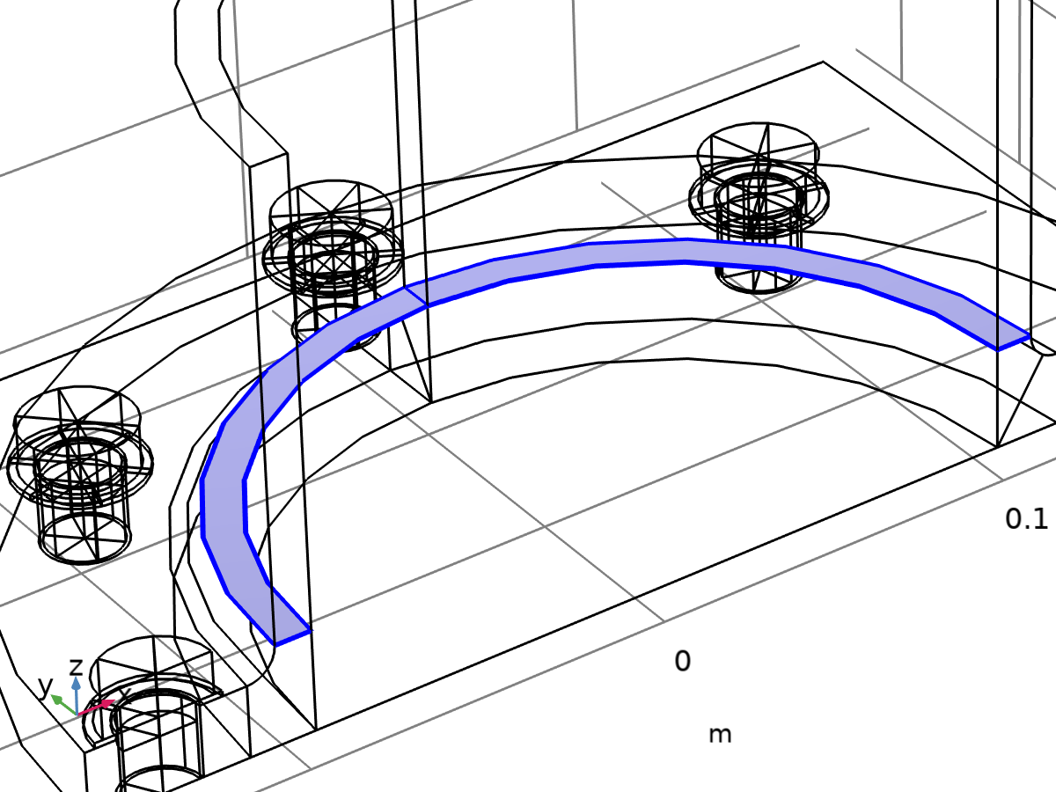

Cut plane selection

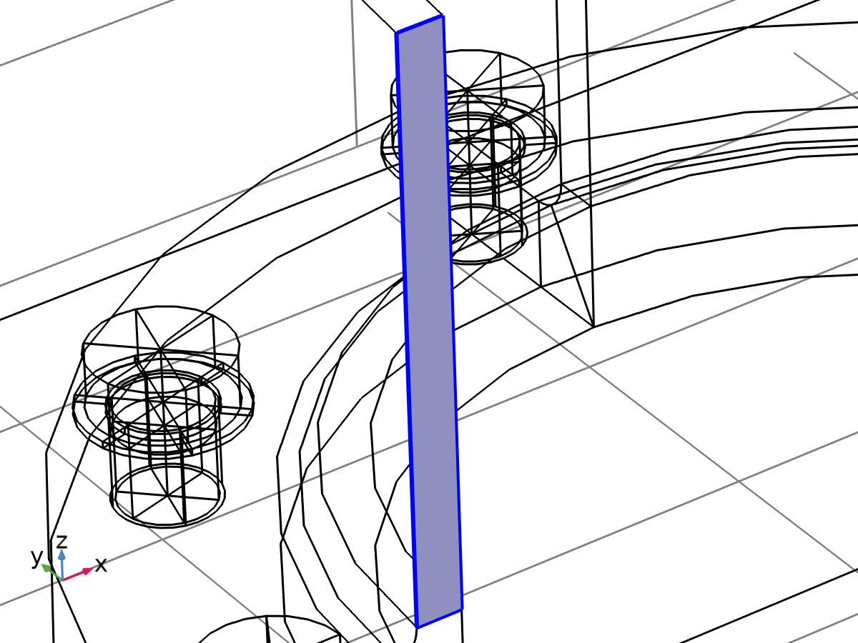

Symmetry plane selection

Selection

|  |  |
| --- | --- |
| Geometric entity level | Entire model |

Equations

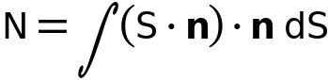

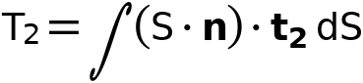

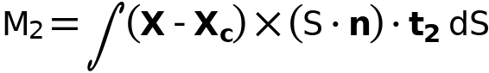

#### Coordinate System Selection

Settings

| **Description** | **Value** |
| --- | --- |
| Defined by | Boundary System 1 (sys1) |

#### Cut Plane

Settings

| **Description** | **Value** |
| --- | --- |
| Allow disconnected boundaries | Off |
| Symmetry plane | On |
| Symmetry type | Symmetry |

#### Variables

| **Name** | **Expression** | **Unit** | **Description** | **Selection** |
| --- | --- | --- | --- | --- |
| solid.secf1.N | 2*solid.secf1.intbnd((solid.SXX*solid.secf1.nX+solid.SXY*solid.secf1.nY+solid.SXZ*solid.secf1.nZ)*solid.secf1.nX+(solid.SXY*solid.secf1.nX+solid.SYY*solid.secf1.nY+solid.SYZ*solid.secf1.nZ)*solid.secf1.nY+(solid.SXZ*solid.secf1.nX+solid.SYZ*solid.secf1.nY+solid.SZZ*solid.secf1.nZ)*solid.secf1.nZ) | N | Axial force | Global |
| solid.secf1.T1 | 0 | N | Shear force along 1-axis | Global |
| solid.secf1.M2 | 0 | N·m | Bending moment around 2-axis | Global |
| solid.secf1.xcX | solid.secf1.xcsX-(solid.secf1.t1X*(solid.secf1.xcsX-solid.secf1.xsX)+solid.secf1.t1Y*(solid.secf1.xcsY-solid.secf1.xsY)+solid.secf1.t1Z*(solid.secf1.xcsZ-solid.secf1.xsZ))*solid.secf1.t1X | m | Centroid coordinates, X-component | Global |
| solid.secf1.xcY | solid.secf1.xcsY-(solid.secf1.t1X*(solid.secf1.xcsX-solid.secf1.xsX)+solid.secf1.t1Y*(solid.secf1.xcsY-solid.secf1.xsY)+solid.secf1.t1Z*(solid.secf1.xcsZ-solid.secf1.xsZ))*solid.secf1.t1Y | m | Centroid coordinates, Y-component | Global |
| solid.secf1.xcZ | solid.secf1.xcsZ-(solid.secf1.t1X*(solid.secf1.xcsX-solid.secf1.xsX)+solid.secf1.t1Y*(solid.secf1.xcsY-solid.secf1.xsY)+solid.secf1.t1Z*(solid.secf1.xcsZ-solid.secf1.xsZ))*solid.secf1.t1Z | m | Centroid coordinates, Z-component | Global |
| solid.secf1.nX | solid.secf1.intbnd(sys1.e_n1)/solid.secf1.A | 1 | Normal, X-component | Global |
| solid.secf1.nY | solid.secf1.intbnd(sys1.e_n2)/solid.secf1.A | 1 | Normal, Y-component | Global |
| solid.secf1.nZ | solid.secf1.intbnd(sys1.e_n3)/solid.secf1.A | 1 | Normal, Z-component | Global |
| solid.secf1.t1X | solid.secf1.intsym(sys1.e_n1)/solid.secf1.intsym(1) | 1 | Tangent direction, first axis, X-component | Global |
| solid.secf1.t1Y | solid.secf1.intsym(sys1.e_n2)/solid.secf1.intsym(1) | 1 | Tangent direction, first axis, Y-component | Global |
| solid.secf1.t1Z | solid.secf1.intsym(sys1.e_n3)/solid.secf1.intsym(1) | 1 | Tangent direction, first axis, Z-component | Global |
| solid.secf1.t2X | solid.secf1.t1Z*solid.secf1.nY-solid.secf1.t1Y*solid.secf1.nZ | 1 | Tangent direction, second axis, X-component | Global |
| solid.secf1.t2Y | -solid.secf1.t1Z*solid.secf1.nX+solid.secf1.t1X*solid.secf1.nZ | 1 | Tangent direction, second axis, Y-component | Global |
| solid.secf1.t2Z | solid.secf1.t1Y*solid.secf1.nX-solid.secf1.t1X*solid.secf1.nY | 1 | Tangent direction, second axis, Z-component | Global |
| solid.secf1.T2 | 2*solid.secf1.intbnd((solid.SXX*solid.secf1.nX+solid.SXY*solid.secf1.nY+solid.SXZ*solid.secf1.nZ)*solid.secf1.t2X+(solid.SXY*solid.secf1.nX+solid.SYY*solid.secf1.nY+solid.SYZ*solid.secf1.nZ)*solid.secf1.t2Y+(solid.SXZ*solid.secf1.nX+solid.SYZ*solid.secf1.nY+solid.SZZ*solid.secf1.nZ)*solid.secf1.t2Z) | N | Shear force along 2-axis | Global |
| solid.secf1.Mt | 0 | N·m | Twisting moment | Global |
| solid.secf1.M1 | 2*solid.secf1.intbnd(((solid.SXZ*solid.secf1.nX+solid.SYZ*solid.secf1.nY+solid.SZZ*solid.secf1.nZ)*(Y-solid.secf1.xcY)+(-solid.SXY*solid.secf1.nX-solid.SYY*solid.secf1.nY-solid.SYZ*solid.secf1.nZ)*(Z-solid.secf1.xcZ))*solid.secf1.t1X+((-solid.SXZ*solid.secf1.nX-solid.SYZ*solid.secf1.nY-solid.SZZ*solid.secf1.nZ)*(X-solid.secf1.xcX)+(solid.SXX*solid.secf1.nX+solid.SXY*solid.secf1.nY+solid.SXZ*solid.secf1.nZ)*(Z-solid.secf1.xcZ))*solid.secf1.t1Y+((solid.SXY*solid.secf1.nX+solid.SYY*solid.secf1.nY+solid.SYZ*solid.secf1.nZ)*(X-solid.secf1.xcX)+(-solid.SXX*solid.secf1.nX-solid.SXY*solid.secf1.nY-solid.SXZ*solid.secf1.nZ)*(Y-solid.secf1.xcY))*solid.secf1.t1Z) | N·m | Bending moment around 1-axis | Global |
| solid.secf1.A | solid.secf1.intbnd(1) | m² | Section area | Global |
| solid.secf1.xsX | solid.secf1.intsym(X)/solid.secf1.intsym(1) | m | Point on symmetry, X-component | Global |
| solid.secf1.xsY | solid.secf1.intsym(Y)/solid.secf1.intsym(1) | m | Point on symmetry, Y-component | Global |
| solid.secf1.xsZ | solid.secf1.intsym(Z)/solid.secf1.intsym(1) | m | Point on symmetry, Z-component | Global |
| solid.secf1.xcsX | solid.secf1.intbnd(X)/solid.secf1.A | m | Point on symmetry, X-component | Global |
| solid.secf1.xcsY | solid.secf1.intbnd(Y)/solid.secf1.A | m | Point on symmetry, Y-component | Global |
| solid.secf1.xcsZ | solid.secf1.intbnd(Z)/solid.secf1.A | m | Point on symmetry, Z-component | Global |

## Mesh 1

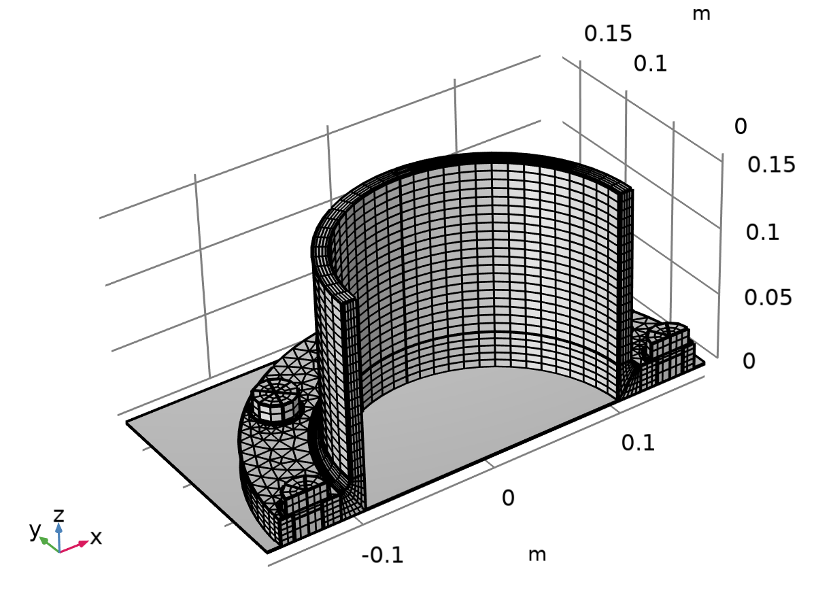

Mesh 1

Mesh statistics

| **Description** | **Value** |
| --- | --- |
| Status | Complete mesh |
| Mesh vertices | 10065 |
| Prisms | 4570 |
| Hexahedra | 5100 |
| Triangles | 1828 |
| Quads | 4829 |
| Edge elements | 2007 |
| Vertex elements | 332 |
| Number of elements | 9670 |
| Minimum element quality | 0.3633 |
| Average element quality | 0.8312 |
| Element volume ratio | 0.034117 |
| Mesh volume | 9.798E-4 m³ |

### Size (size)

Settings

| **Description** | **Value** |
| --- | --- |
| Maximum element size | 0.034 |
| Minimum element size | 0.00612 |
| Curvature factor | 0.6 |
| Resolution of narrow regions | 0.5 |
| Maximum element growth rate | 1.5 |

### Swept 1 (swe1)

Selection

|  |  |
| --- | --- |
| Geometric entity level | Domain |
| Name | Washers |
| Selection | Named geom1_rot3_dom: Geometry geom1: Dimension 3: Domains 5–9 |

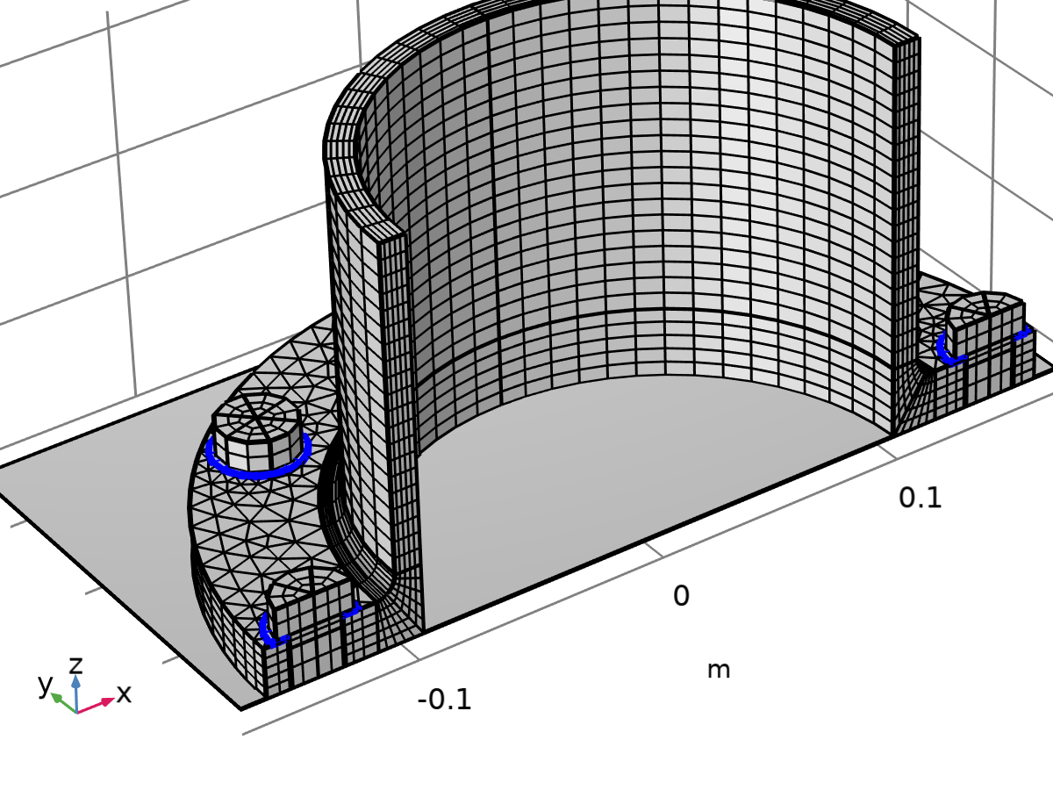

Swept 1

Information

| **Description** | **Value** |
| --- | --- |
| Last build time | < 1 second |
| Built with | COMSOL 6.2.0.339 (win64), Aug 20, 2025, 5:52:31 PM |

#### Size 1 (size1)

Selection

|  |  |
| --- | --- |
| Geometric entity level | Domain |
| Name | Washers |
| Selection | Named geom1_rot3_dom: Geometry geom1: Dimension 3: Domains 5–9 |



Size 1

Settings

| **Description** | **Value** |
| --- | --- |
| Maximum element size | 0.0187 |
| Minimum element size | 0.00136 |
| Curvature factor | 0.4 |
| Resolution of narrow regions | 0.7 |
| Maximum element growth rate | 1.4 |
| Predefined size | Finer |

### Swept 2 (swe2)

Selection

|  |  |
| --- | --- |
| Geometric entity level | Domain |
| Name | Bolts |
| Selection | Named geom1_rot2_dom: Geometry geom1: Dimension 3: Domains 10–81 |

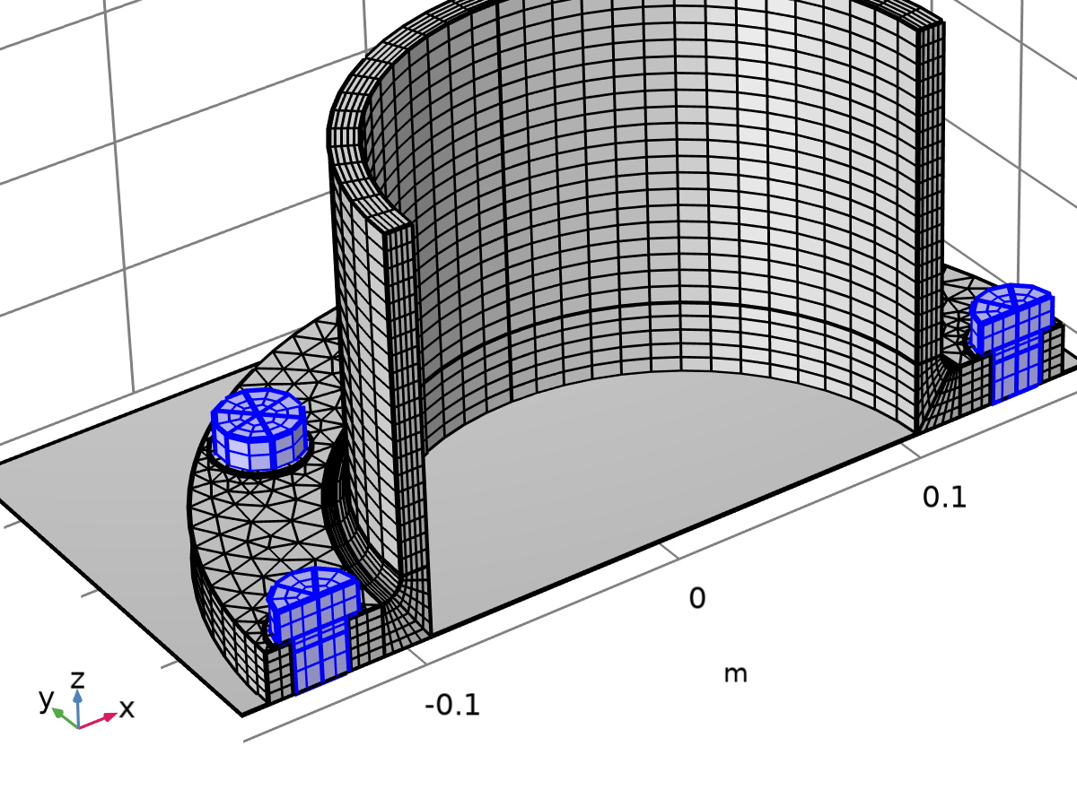

Swept 2

Information

| **Description** | **Value** |
| --- | --- |
| Last build time | < 1 second |
| Built with | COMSOL 6.2.0.339 (win64), Aug 20, 2025, 5:52:31 PM |

#### Size 1 (size1)

Selection

|  |  |
| --- | --- |
| Geometric entity level | Domain |
| Name | Bolts |
| Selection | Named geom1_rot2_dom: Geometry geom1: Dimension 3: Domains 10–81 |



Size 1

Settings

| **Description** | **Value** |
| --- | --- |
| Maximum element size | 0.0272 |
| Minimum element size | 0.0034 |
| Curvature factor | 0.5 |
| Resolution of narrow regions | 0.6 |
| Maximum element growth rate | 1.45 |
| Predefined size | Fine |

#### Distribution 1 (dis1)

Selection

|  |  |
| --- | --- |
| Geometric entity level | Domain |
| Selection | Geometry geom1: Dimension 3: Domains 10–81 |



Distribution 1

Settings

| **Description** | **Value** |
| --- | --- |
| Number of elements | 2 |

### Mapped 1 (map1)

Selection

|  |  |
| --- | --- |
| Geometric entity level | Boundary |
| Selection | Geometry geom1: Dimension 2: Boundaries 10, 14, 19 |

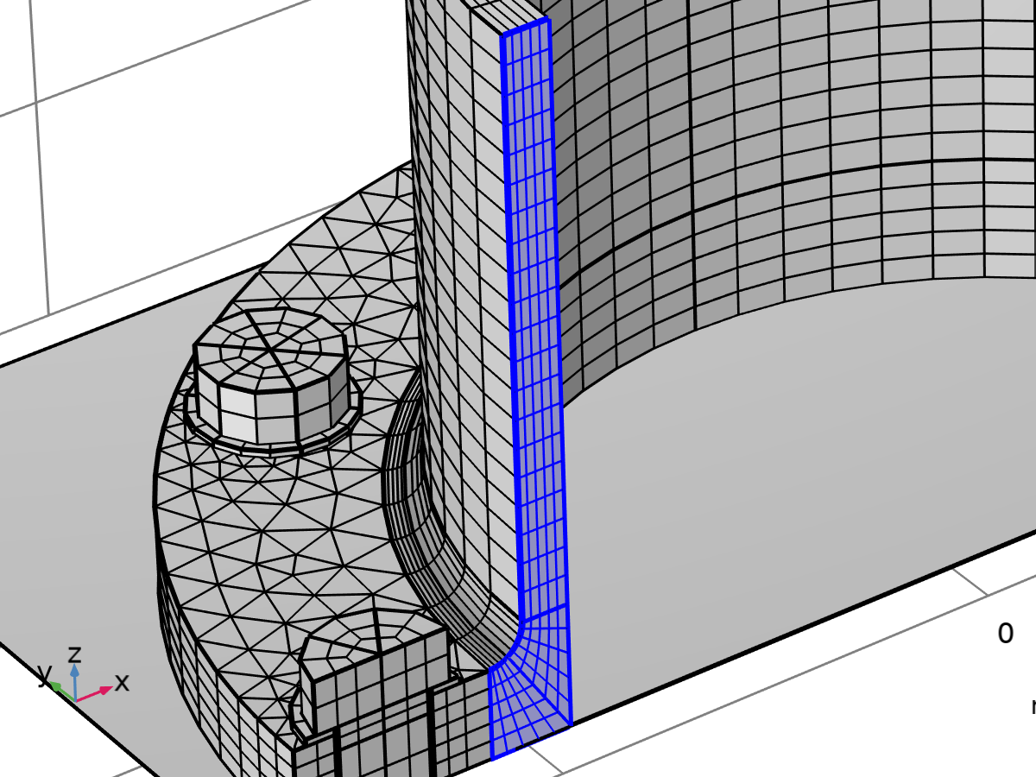

Mapped 1

Information

| **Description** | **Value** |
| --- | --- |
| Last build time | < 1 second |
| Built with | COMSOL 6.2.0.339 (win64), Aug 20, 2025, 5:52:31 PM |

#### Distribution 1 (dis1)

Selection

|  |  |
| --- | --- |
| Geometric entity level | Edge |
| Selection | Geometry geom1: Dimension 1: Edges 25, 27, 38 |

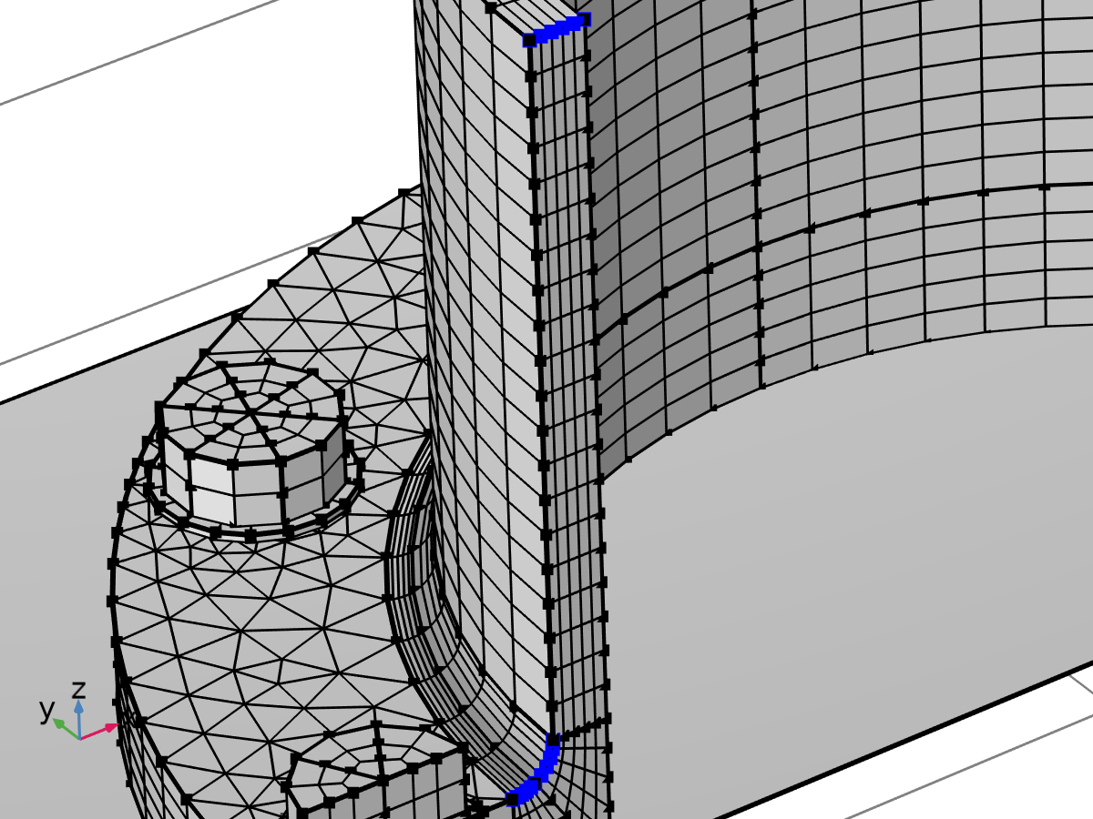

Distribution 1

#### Distribution 2 (dis2)

Selection

|  |  |
| --- | --- |
| Geometric entity level | Edge |
| Selection | Geometry geom1: Dimension 1: Edge 35 |

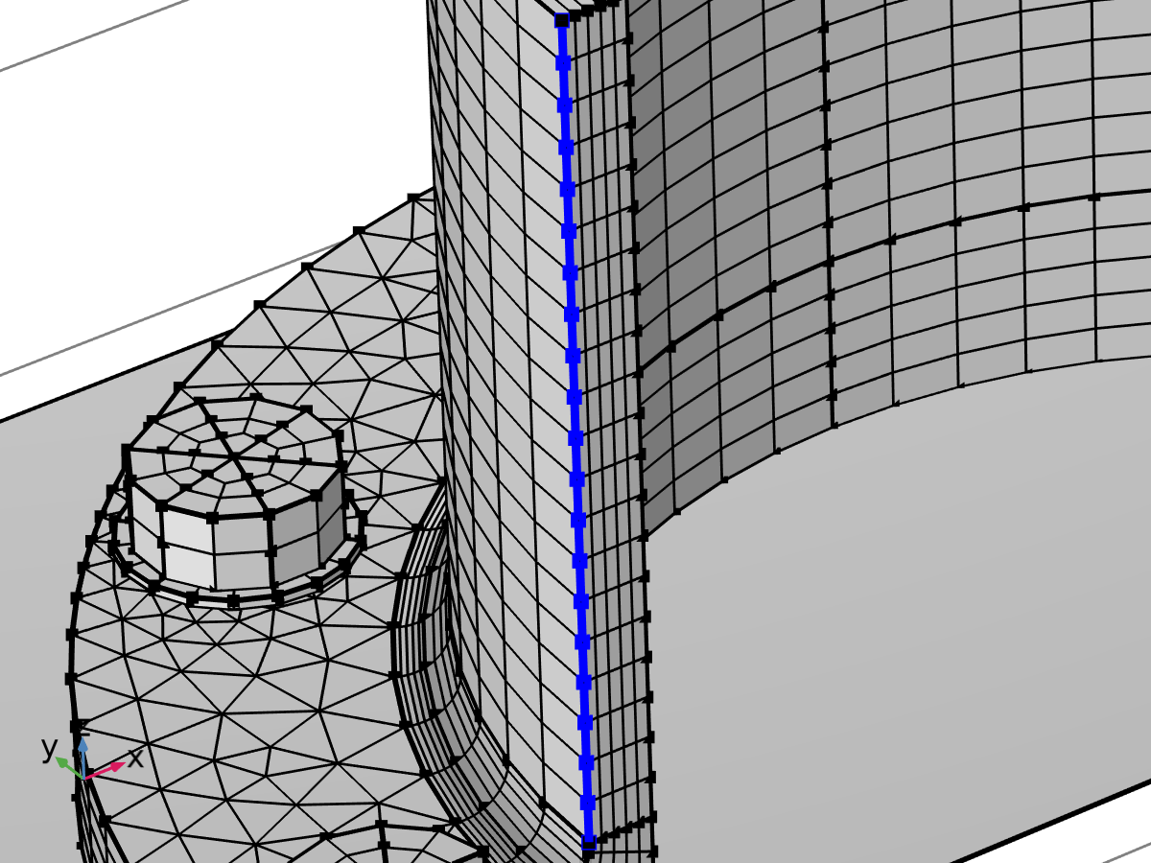

Distribution 2

Settings

| **Description** | **Value** |
| --- | --- |
| Number of elements | 20 |

### Swept 3 (swe3)

Selection

|  |  |
| --- | --- |
| Geometric entity level | Domain |
| Selection | Geometry geom1: Dimension 3: Domains 2–4 |

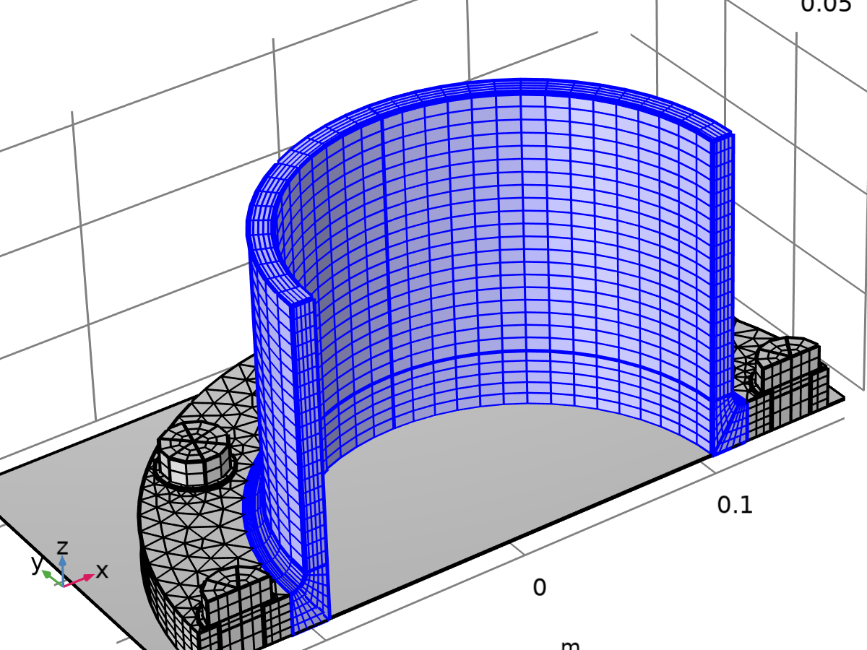

Swept 3

Information

| **Description** | **Value** |
| --- | --- |
| Last build time | < 1 second |
| Built with | COMSOL 6.2.0.339 (win64), Aug 20, 2025, 5:52:32 PM |

#### Distribution 1 (dis1)

Selection

|  |  |
| --- | --- |
| Geometric entity level | Domain |
| Selection | Geometry geom1: Dimension 3: Domains 2–4 |



Distribution 1

Settings

| **Description** | **Value** |
| --- | --- |
| Number of elements | 30 |

### Free Triangular 1 (ftri1)

Selection

|  |  |
| --- | --- |
| Geometric entity level | Boundary |
| Selection | Geometry geom1: Dimension 2: Boundaries 5, 41 |

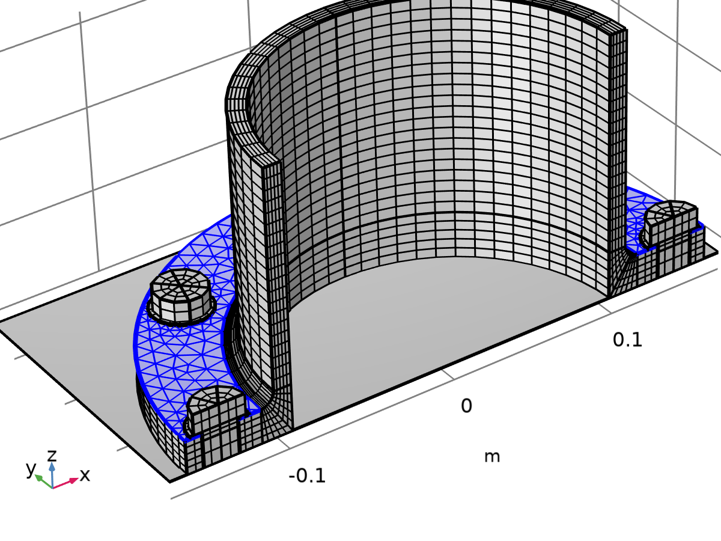

Free Triangular 1

Information

| **Description** | **Value** |
| --- | --- |
| Last build time | < 1 second |
| Built with | COMSOL 6.2.0.339 (win64), Aug 20, 2025, 5:52:32 PM |

#### Size 1 (size1)

Selection

|  |  |
| --- | --- |
| Geometric entity level | Boundary |
| Selection | Geometry geom1: Dimension 2: Boundaries 5, 41 |



Size 1

Settings

| **Description** | **Value** |
| --- | --- |
| Maximum element size | 0.0119 |
| Minimum element size | 5.1E-4 |
| Curvature factor | 0.3 |
| Resolution of narrow regions | 0.85 |
| Maximum element growth rate | 1.35 |
| Predefined size | Extra fine |

### Swept 4 (swe4)

Selection

|  |  |
| --- | --- |
| Geometric entity level | Domain |
| Selection | Remaining |

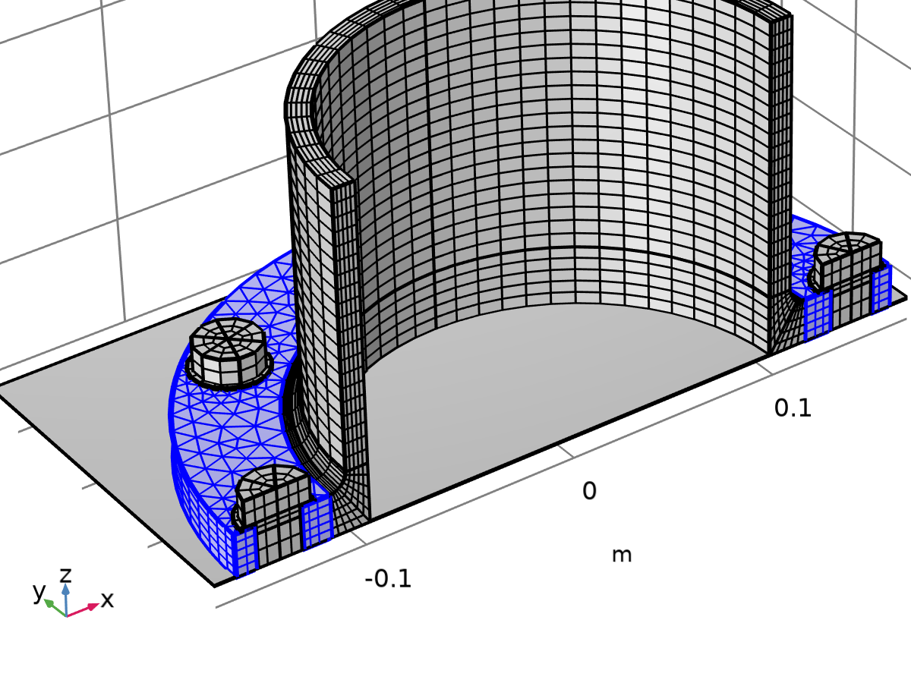

Swept 4

Information

| **Description** | **Value** |
| --- | --- |
| Last build time | < 1 second |
| Built with | COMSOL 6.2.0.339 (win64), Aug 20, 2025, 5:52:32 PM |

### Mapped 2 (map2)

Selection

|  |  |
| --- | --- |
| Geometric entity level | Boundary |
| Selection | Geometry geom1: Dimension 2: Boundary 1 |

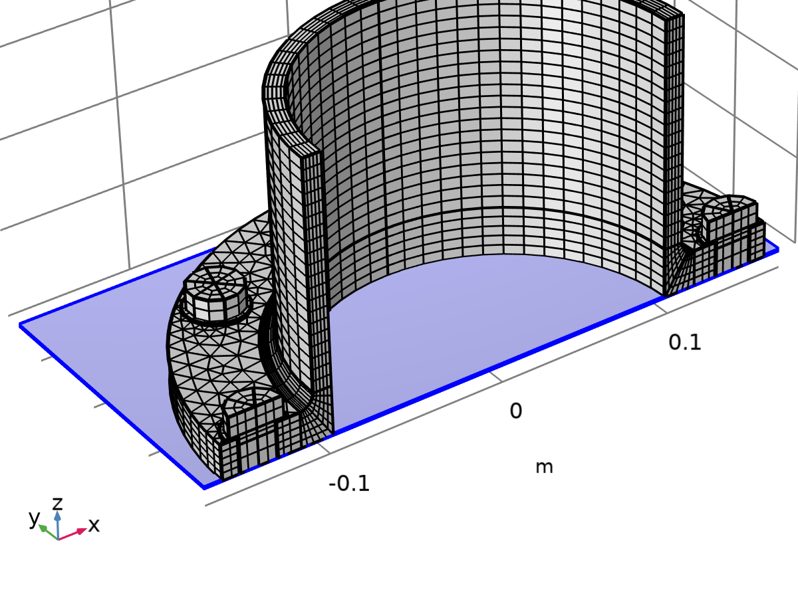

Mapped 2

Information

| **Description** | **Value** |
| --- | --- |
| Last build time | < 1 second |
| Built with | COMSOL 6.2.0.339 (win64), Aug 20, 2025, 5:52:32 PM |

#### Distribution 1 (dis1)

Selection

|  |  |
| --- | --- |
| Geometric entity level | Edge |
| Selection | Geometry geom1: Dimension 1: Edges 1–2 |

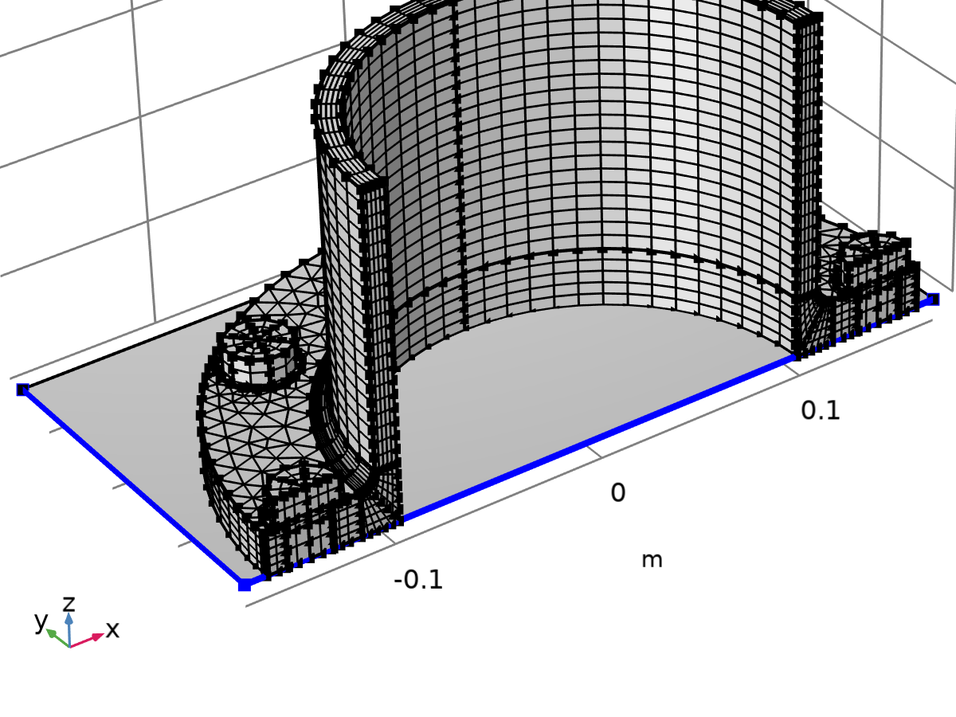

Distribution 1

Settings

| **Description** | **Value** |
| --- | --- |
| Number of elements | 1 |

# Study 1

Computation information

|  |  |
| --- | --- |
| Computation time | 11 min 39 s |

## Bolt Pretension

Study settings

| **Description** | **Value** |
| --- | --- |
| Include geometric nonlinearity | On |

Study settings

| **Description** | **Value** |
| --- | --- |
| Include geometric nonlinearity | On |

Physics and variables selection

| **Physics interface** | **Solve for** | **Equation form** |
| --- | --- | --- |
| Solid Mechanics (solid) | On | Automatic (Stationary) |

Store in output

| **Interface** | **Output** | **Selection** |
| --- | --- | --- |
| Solid Mechanics (solid) | Physics controlled |  |

Mesh selection

| **Component** | **Mesh** |
| --- | --- |
| Component 1 | Mesh 1 |

## Stationary

Study settings

| **Description** | **Value** |
| --- | --- |
| Include geometric nonlinearity | On |

Study settings

| **Description** | **Value** |
| --- | --- |
| Include geometric nonlinearity | On |

Physics and variables selection

| **Physics interface** | **Solve for** | **Equation form** |
| --- | --- | --- |
| Solid Mechanics (solid) | On | Automatic (Stationary) |

Store in output

| **Interface** | **Output** | **Selection** |
| --- | --- | --- |
| Solid Mechanics (solid) | Physics controlled |  |

Mesh selection

| **Component** | **Mesh** |
| --- | --- |
| Component 1 | Mesh 1 |

Study extensions

| **Description** | **Value** |
| --- | --- |
| Auxiliary sweep | On |
| Sweep type | Specified combinations |

Parameters

| **Parameter name** | **Parameter value list** | **Parameter unit** |
| --- | --- | --- |
| lp (Loading parameter) | range(0.2,0.2,1) |  |

### Study extensions

Study extensions

| **Description** | **Value** |
| --- | --- |
| Auxiliary sweep | On |
| Sweep type | Specified combinations |

Parameters

| **Parameter name** | **Parameter value list** | **Parameter unit** |
| --- | --- | --- |
| lp (Loading parameter) | range(0.2,0.2,1) |  |

## Solver Configurations

### Solution 1

#### Compile Equations: Bolt Pretension (st1)

Study and step

| **Description** | **Value** |
| --- | --- |
| Use study | Study 1 |
| Use study step | Bolt Pretension |

Log

<---- Compile Equations: Bolt Pretension in Study 1/Solution 1 (sol1) ----------

Started at Aug 21, 2025, 10:05:01 PM.

Geometry shape function: Quadratic serendipity

Running on Intel(R) Core(TM) i5-6500 CPU at 3.20 GHz.

Using 1 socket with 4 cores in total on DESKTOP-2025NZC.

Available memory: 16.33 GB.

Time: 9 s.

Physical memory: 1.58 GB

Virtual memory: 2.3 GB

Ended at Aug 21, 2025, 10:05:10 PM.

----- Compile Equations: Bolt Pretension in Study 1/Solution 1 (sol1) --------->

#### Dependent Variables 1 (v1)

General

| **Description** | **Value** |
| --- | --- |
| Defined by study step | Step 1: Bolt Pretension |

Log

<---- Dependent Variables 1 in Study 1/Solution 1 (sol1) -----------------------

Started at Aug 21, 2025, 10:05:10 PM.

Solution time: 0 s.

Physical memory: 1.59 GB

Virtual memory: 2.3 GB

Ended at Aug 21, 2025, 10:05:10 PM.

----- Dependent Variables 1 in Study 1/Solution 1 (sol1) ---------------------->

##### Contact Pressure (comp1.solid.Tn_ap3) (comp1_solid_Tn_ap3)

General

| **Description** | **Value** |
| --- | --- |
| Field components | comp1.solid.Tn_ap3 |

Scaling

| **Description** | **Value** |
| --- | --- |
| Method | Manual |
| Scale | 1E8 |

##### Friction Force (Spatial Frame) (comp1.solid.Tt_ap3) (comp1_solid_Tt_ap3)

General

| **Description** | **Value** |
| --- | --- |
| Field components | {comp1.solid.Ttt1_ap3, comp1.solid.Ttt2_ap3} |

Scaling

| **Description** | **Value** |
| --- | --- |
| Method | Manual |
| Scale | 1E7 |

##### Displacement Field (comp1.u) (comp1_u)

General

| **Description** | **Value** |
| --- | --- |
| Field components | {comp1.u, comp1.v, comp1.w} |
| Internal variables | {comp1.solid.contact_ap3_old, comp1.solid.cmX_ap3_old, comp1.solid.cmY_ap3_old, comp1.solid.cmZ_ap3_old, comp1.solid.stepnumber} |

Scaling

| **Description** | **Value** |
| --- | --- |
| Method | Manual |
| Scale | 1E-4 |

##### Predeformation (comp1.solid.pblt1.sblt1.d_pre) (comp1_solid_pblt1_sblt1_d_pre)

General

| **Description** | **Value** |
| --- | --- |
| State components | comp1.solid.pblt1.sblt1.d_pre |

Scaling

| **Description** | **Value** |
| --- | --- |
| Method | Manual |
| Scale | 1E-4 |

##### Predeformation (comp1.solid.pblt1.sblt2.d_pre) (comp1_solid_pblt1_sblt2_d_pre)

General

| **Description** | **Value** |
| --- | --- |
| State components | comp1.solid.pblt1.sblt2.d_pre |

Scaling

| **Description** | **Value** |
| --- | --- |
| Method | Manual |
| Scale | 1E-4 |

##### Predeformation (comp1.solid.pblt1.sblt3.d_pre) (comp1_solid_pblt1_sblt3_d_pre)

General

| **Description** | **Value** |
| --- | --- |
| State components | comp1.solid.pblt1.sblt3.d_pre |

Scaling

| **Description** | **Value** |
| --- | --- |
| Method | Manual |
| Scale | 1E-4 |

##### Predeformation (comp1.solid.pblt1.sblt4.d_pre) (comp1_solid_pblt1_sblt4_d_pre)

General

| **Description** | **Value** |
| --- | --- |
| State components | comp1.solid.pblt1.sblt4.d_pre |

Scaling

| **Description** | **Value** |
| --- | --- |
| Method | Manual |
| Scale | 1E-4 |

##### Predeformation (comp1.solid.pblt1.sblt5.d_pre) (comp1_solid_pblt1_sblt5_d_pre)

General

| **Description** | **Value** |
| --- | --- |
| State components | comp1.solid.pblt1.sblt5.d_pre |

Scaling

| **Description** | **Value** |
| --- | --- |
| Method | Manual |
| Scale | 1E-4 |

#### Stationary Solver 1 (s1)

General

| **Description** | **Value** |
| --- | --- |
| Defined by study step | Step 1: Bolt Pretension |

Log

<---- Stationary Solver 1 in Study 1/Solution 1 (sol1) -------------------------

Started at Aug 21, 2025, 10:05:11 PM.

Segregated solver

Number of degrees of freedom solved for: 122633 (plus 21937 internal DOFs).

Segregated solver iteration 1.

Solid Mechanics

Symmetric matrices found.

Scales for dependent variables:

Displacement Field (comp1.u): 0.0001

Predeformation (comp1.solid.pblt1.sblt1.d_pre): 0.0001

Predeformation (comp1.solid.pblt1.sblt2.d_pre): 0.0001

Predeformation (comp1.solid.pblt1.sblt3.d_pre): 0.0001

Predeformation (comp1.solid.pblt1.sblt4.d_pre): 0.0001

Predeformation (comp1.solid.pblt1.sblt5.d_pre): 0.0001

Explicit-Orthonormal null-space function used.

Iter      ResEst      Newton      Cauchy    Stepsize #Res #Jac #Sol   LinErr   LinRes

   1     2.7e+16   1.0000000   0.0000000          39    3    1    1  7.9e-12  5.9e-11

Nonsymmetric matrix found.

   2     0.00027   1.0000000   0.0000000          39    4    2    2  1.3e-13  2.7e-15

Lumped Step 1

Scales for dependent variables:

Contact Pressure (comp1.solid.Tn_ap3): 1e+08

Friction Force (Spatial Frame) (comp1.solid.Tt_ap3): 1e+07

Orthonormal null-space function used.

Iter      SolEst     Damping    Stepsize #Res #Jac #Sol

   1           0   1.0000000          15    1    1    1

Solution error estimates for segregated groups

7.1, 15

Residual error estimates for segregated groups

1.6e+04, 0

Segregated solver iteration 2.

Solid Mechanics

Iter      ResEst      Newton      Cauchy    Stepsize #Res #Jac #Sol   LinErr   LinRes

   1        0.38   1.0000000   0.0000000      0.0035    7    3    3  4.4e-13  2.7e-15

   2        0.12   1.0000000   0.0000000       0.002    8    4    4  7.7e-13  1.1e-14

   3       0.033   1.0000000   0.0000000     0.00076    9    5    5  1.3e-13  1.7e-14

   4      0.0016   1.0000000   0.0000000     0.00014   10    6    6  3.2e-13  1.2e-14

   5     5.2e-09   1.0000000   0.0000000     3.2e-06   11    7    7  9.3e-13  5.4e-15

Lumped Step 1

Iter      SolEst     Damping    Stepsize #Res #Jac #Sol

   1           0   1.0000000         2.9    2    1    2

Solution error estimates for segregated groups

0.057, 2.9

Residual error estimates for segregated groups

97, 0

Segregated solver iteration 3.

Solid Mechanics

Iter      ResEst      Newton      Cauchy    Stepsize #Res #Jac #Sol   LinErr   LinRes

   1      0.0029   1.0000000   0.0000000     4.6e-05   14    8    8  3.2e-13  1.5e-15

   2     4.1e-05   1.0000000   0.0000000     1.7e-06   15    9    9  3.7e-13  1.6e-15

Lumped Step 1

Iter      SolEst     Damping    Stepsize #Res #Jac #Sol

   1           0   1.0000000       0.072    3    1    3

Solution error estimates for segregated groups

0.00043, 0.072

Residual error estimates for segregated groups

3.6, 0

Segregated solver iteration 4.

Solid Mechanics

Iter      ResEst      Newton      Cauchy    Stepsize #Res #Jac #Sol   LinErr   LinRes

   1     1.8e-06   1.0000000   0.0000000     1.2e-06   18   10   10  1.6e-13  1.2e-15

Lumped Step 1

Iter      SolEst     Damping    Stepsize #Res #Jac #Sol

   1           0   1.0000000      0.0038    4    1    4

Solution error estimates for segregated groups

4.5e-05, 0.0038

Residual error estimates for segregated groups

0.19, 0

Segregated solver iteration 5.

Solid Mechanics

Iter      ResEst      Newton      Cauchy    Stepsize #Res #Jac #Sol   LinErr   LinRes

   1       9e-09   1.0000000   0.0000000     6.3e-08   21   11   11    3e-13  1.2e-15

Lumped Step 1

Iter      SolEst     Damping    Stepsize #Res #Jac #Sol

   1           0   1.0000000     0.00026    5    1    5

Solution error estimates for segregated groups

2.2e-06, 0.00026

Residual error estimates for segregated groups

0.013, 0

Solution time: 117 s. (1 minute, 57 seconds)

Physical memory: 5.15 GB

Virtual memory: 6.25 GB

Ended at Aug 21, 2025, 10:07:07 PM.

----- Stationary Solver 1 in Study 1/Solution 1 (sol1) ------------------------>

##### Advanced (aDef)

Assembly settings

| **Description** | **Value** |
| --- | --- |
| Reuse sparsity pattern | On |

##### Segregated 1 (se1)

General

| **Description** | **Value** |
| --- | --- |
| Maximum number of iterations | 15 |

###### Solid Mechanics (ss1)

General

| **Description** | **Value** |
| --- | --- |
| Variables | {Displacement Field (comp1.u), Predeformation (comp1.solid.pblt1.sblt1.d_pre), Predeformation (comp1.solid.pblt1.sblt2.d_pre), Predeformation (comp1.solid.pblt1.sblt3.d_pre), Predeformation (comp1.solid.pblt1.sblt4.d_pre), Predeformation (comp1.solid.pblt1.sblt5.d_pre)} |
| Linear solver | Suggested Direct Solver (solid) |

Method and termination

| **Description** | **Value** |
| --- | --- |
| Nonlinear method | Double dogleg |
| Termination technique | Iterations or tolerance |
| Number of iterations | 7 |
| Tolerance factor | 1 |

###### Lumped Step 1 (ls1)

General

| **Description** | **Value** |
| --- | --- |
| Variables | {Contact Pressure (comp1.solid.Tn_ap3), Friction Force (Spatial Frame) (comp1.solid.Tt_ap3)} |

##### Suggested Direct Solver (solid) (d1)

General

| **Description** | **Value** |
| --- | --- |
| Solver | PARDISO |
| Pivoting perturbation | 1E-9 |

Error

| **Description** | **Value** |
| --- | --- |
| Use in nonlinear solver | On |

#### Solution Store 1 (su1)

General

| **Description** | **Value** |
| --- | --- |
| Solution | Solution Store 1 (sol2) |

#### Compile Equations: Stationary (st2)

Study and step

| **Description** | **Value** |
| --- | --- |
| Use study | Study 1 |
| Use study step | Stationary |

Log

<---- Compile Equations: Stationary in Study 1/Solution 1 (sol1) ---------------

Started at Aug 21, 2025, 10:07:07 PM.

Geometry shape function: Quadratic serendipity

Time: 6 s.

Physical memory: 1.77 GB

Virtual memory: 2.49 GB

Ended at Aug 21, 2025, 10:07:13 PM.

----- Compile Equations: Stationary in Study 1/Solution 1 (sol1) -------------->

#### Dependent Variables 2 (v2)

General

| **Description** | **Value** |
| --- | --- |
| Defined by study step | Step 2: Stationary |

Initial values of variables solved for

| **Description** | **Value** |
| --- | --- |
| Method | Solution |
| Solution | Solution 1 (sol1) |

Values of variables not solved for

| **Description** | **Value** |
| --- | --- |
| Method | Solution |
| Solution | Solution 1 (sol1) |

Initial value calculation constants

| **Constant name** | **Initial value source** |
| --- | --- |
| lp | range(0.2,0.2,1) |

Log

<---- Dependent Variables 2 in Study 1/Solution 1 (sol1) -----------------------

Started at Aug 21, 2025, 10:07:14 PM.

Initial values of variables solved for: Solution 1 (sol1), Solution Store 1 (sol2).

Values of variables not solved for: Solution 1 (sol1).

Solution time: 0 s.

Physical memory: 1.76 GB

Virtual memory: 2.48 GB

Ended at Aug 21, 2025, 10:07:14 PM.

----- Dependent Variables 2 in Study 1/Solution 1 (sol1) ---------------------->

##### Contact Pressure (comp1.solid.Tn_ap3) (comp1_solid_Tn_ap3)

General

| **Description** | **Value** |
| --- | --- |
| Field components | comp1.solid.Tn_ap3 |

Scaling

| **Description** | **Value** |
| --- | --- |
| Method | Manual |
| Scale | 1E8 |

##### Friction Force (Spatial Frame) (comp1.solid.Tt_ap3) (comp1_solid_Tt_ap3)

General

| **Description** | **Value** |
| --- | --- |
| Field components | {comp1.solid.Ttt1_ap3, comp1.solid.Ttt2_ap3} |

Scaling

| **Description** | **Value** |
| --- | --- |
| Method | Manual |
| Scale | 1E7 |

##### Displacement Field (comp1.u) (comp1_u)

General

| **Description** | **Value** |
| --- | --- |
| Field components | {comp1.u, comp1.v, comp1.w} |
| Internal variables | {comp1.solid.contact_ap3_old, comp1.solid.cmX_ap3_old, comp1.solid.cmY_ap3_old, comp1.solid.cmZ_ap3_old, comp1.solid.stepnumber} |

Scaling

| **Description** | **Value** |
| --- | --- |
| Method | Manual |
| Scale | 1E-4 |

##### Predeformation (comp1.solid.pblt1.sblt1.d_pre) (comp1_solid_pblt1_sblt1_d_pre)

General

| **Description** | **Value** |
| --- | --- |
| State components | comp1.solid.pblt1.sblt1.d_pre |
| Solve for this state | Off |

Scaling

| **Description** | **Value** |
| --- | --- |
| Method | Manual |
| Scale | 1E-4 |

##### Predeformation (comp1.solid.pblt1.sblt2.d_pre) (comp1_solid_pblt1_sblt2_d_pre)

General

| **Description** | **Value** |
| --- | --- |
| State components | comp1.solid.pblt1.sblt2.d_pre |
| Solve for this state | Off |

Scaling

| **Description** | **Value** |
| --- | --- |
| Method | Manual |
| Scale | 1E-4 |

##### Predeformation (comp1.solid.pblt1.sblt3.d_pre) (comp1_solid_pblt1_sblt3_d_pre)

General

| **Description** | **Value** |
| --- | --- |
| State components | comp1.solid.pblt1.sblt3.d_pre |
| Solve for this state | Off |

Scaling

| **Description** | **Value** |
| --- | --- |
| Method | Manual |
| Scale | 1E-4 |

##### Predeformation (comp1.solid.pblt1.sblt4.d_pre) (comp1_solid_pblt1_sblt4_d_pre)

General

| **Description** | **Value** |
| --- | --- |
| State components | comp1.solid.pblt1.sblt4.d_pre |
| Solve for this state | Off |

Scaling

| **Description** | **Value** |
| --- | --- |
| Method | Manual |
| Scale | 1E-4 |

##### Predeformation (comp1.solid.pblt1.sblt5.d_pre) (comp1_solid_pblt1_sblt5_d_pre)

General

| **Description** | **Value** |
| --- | --- |
| State components | comp1.solid.pblt1.sblt5.d_pre |
| Solve for this state | Off |

Scaling

| **Description** | **Value** |
| --- | --- |
| Method | Manual |
| Scale | 1E-4 |

#### Stationary Solver 2 (s2)

General

| **Description** | **Value** |
| --- | --- |
| Defined by study step | Step 2: Stationary |

Results while solving

| **Description** | **Value** |
| --- | --- |
| Probes | None |

Log

<---- Stationary Solver 2 in Study 1/Solution 1 (sol1) -------------------------

Started at Aug 21, 2025, 10:07:14 PM.

Continuation solver

Segregated solver

Number of degrees of freedom solved for: 122628 (plus 21937 internal DOFs).

Continuation parameter lp = 0.2.

Continuation parameter stepsize CMPpcontstep = 0.

Segregated solver iteration 1.

Solid Mechanics

Nonsymmetric matrix found.

Scales for dependent variables:

Displacement Field (comp1.u): 0.0001

Explicit-Orthonormal null-space function used.

Iter      ResEst      Newton      Cauchy    Stepsize #Res #Jac #Sol   LinErr   LinRes

   1           4   1.0000000   0.0000000        0.22    3    1    1  9.1e-13  3.4e-13

   2         1.8   1.0000000   0.0000000        0.15    4    2    2  4.8e-13  7.3e-14

   3         1.1   1.0000000   0.0000000        0.14    5    3    3    8e-13  7.6e-14

   4         0.7   1.0000000   0.0000000        0.11    6    4    4  8.5e-13  7.1e-14

   5        0.44   1.0000000   0.0000000        0.11    7    5    5  9.5e-13  9.4e-14

   6        0.15   1.0000000   0.0000000       0.035    8    6    6    8e-13  5.4e-14

   7       0.027   1.0000000   0.0000000      0.0058    9    7    7  6.6e-13  2.9e-14

Lumped Step 1

Scales for dependent variables:

Contact Pressure (comp1.solid.Tn_ap3): 1e+08

Friction Force (Spatial Frame) (comp1.solid.Tt_ap3): 1e+07

Orthonormal null-space function used.

Iter      SolEst     Damping    Stepsize #Res #Jac #Sol

   1           0   1.0000000         5.1    1    1    1

Solution error estimates for segregated groups

7.4, 5.1

Residual error estimates for segregated groups

1.5e+03, 0

Segregated solver iteration 2.

Solid Mechanics

Iter      ResEst      Newton      Cauchy    Stepsize #Res #Jac #Sol   LinErr   LinRes

   1       0.024   1.0000000   0.0000000      0.0098   12    8    8  1.1e-12  2.2e-14

   2     0.00048   1.0000000   0.0000000     5.5e-05   13    9    9  1.7e-12  2.6e-15

Lumped Step 1

Iter      SolEst     Damping    Stepsize #Res #Jac #Sol

   1           0   1.0000000        0.14    2    1    2

Solution error estimates for segregated groups

0.098, 0.14

Residual error estimates for segregated groups

21, 0

Segregated solver iteration 3.

Solid Mechanics

Iter      ResEst      Newton      Cauchy    Stepsize #Res #Jac #Sol   LinErr   LinRes

   1     3.3e-05   1.0000000   0.0000000     3.2e-05   16   10   10  1.1e-12    3e-15

Lumped Step 1

Iter      SolEst     Damping    Stepsize #Res #Jac #Sol

   1           0   1.0000000      0.0048    3    1    3

Solution error estimates for segregated groups

0.00031, 0.0048

Residual error estimates for segregated groups

0.29, 0

Segregated solver iteration 4.

Solid Mechanics

Iter      ResEst      Newton      Cauchy    Stepsize #Res #Jac #Sol   LinErr   LinRes

   1     6.5e-08   1.0000000   0.0000000     2.3e-07   19   11   11  2.2e-12  1.3e-15

Lumped Step 1

Iter      SolEst     Damping    Stepsize #Res #Jac #Sol

   1           0   1.0000000     0.00046    4    1    4

Solution error estimates for segregated groups

2.2e-06, 0.00046

Residual error estimates for segregated groups

0.029, 0

Continuation parameter lp = 0.4.

Continuation parameter stepsize CMPpcontstep = 0.2.

Segregated solver iteration 1.

Solid Mechanics

Iter      ResEst      Newton      Cauchy    Stepsize #Res #Jac #Sol   LinErr   LinRes

   1        0.73   1.0000000   0.0000000        0.24   23   12   12  1.2e-12  1.1e-12

   2       0.095   1.0000000   0.0000000      0.0087   24   13   13  3.1e-12  6.3e-15

   3       0.023   1.0000000   0.0000000      0.0054   25   14   14  3.1e-12  3.6e-14

   4      0.0032   1.0000000   0.0000000      0.0011   26   15   15  2.7e-12    3e-14

   5     1.7e-05   1.0000000   0.0000000     8.9e-05   27   16   16  1.5e-12  1.7e-14

Lumped Step 1

Iter      SolEst     Damping    Stepsize #Res #Jac #Sol

   1           0   1.0000000         2.8    5    1    5

Solution error estimates for segregated groups

2.3, 2.8

Residual error estimates for segregated groups

3.1e+02, 0

Segregated solver iteration 2.

Solid Mechanics

Iter      ResEst      Newton      Cauchy    Stepsize #Res #Jac #Sol   LinErr   LinRes

   1      0.0064   1.0000000   0.0000000     0.00048   30   17   17  2.8e-12  2.9e-15

   2     0.00027   1.0000000   0.0000000     9.5e-06   31   18   18  1.5e-12  1.8e-15

Lumped Step 1

Iter      SolEst     Damping    Stepsize #Res #Jac #Sol

   1           0   1.0000000        0.12    6    1    6

Solution error estimates for segregated groups

0.0047, 0.12

Residual error estimates for segregated groups

3.1, 0

Segregated solver iteration 3.

Solid Mechanics

Iter      ResEst      Newton      Cauchy    Stepsize #Res #Jac #Sol   LinErr   LinRes

   1     3.7e-05   1.0000000   0.0000000     7.5e-06   34   19   19    5e-12  3.1e-15

Lumped Step 1

Iter      SolEst     Damping    Stepsize #Res #Jac #Sol

   1           0   1.0000000        0.02    7    1    7

Solution error estimates for segregated groups

7.5e-05, 0.02

Residual error estimates for segregated groups

0.16, 0

Segregated solver iteration 4.

Solid Mechanics

Iter      ResEst      Newton      Cauchy    Stepsize #Res #Jac #Sol   LinErr   LinRes

   1     4.1e-08   1.0000000   0.0000000     2.4e-07   37   20   20  6.4e-12  1.8e-15

Lumped Step 1

Iter      SolEst     Damping    Stepsize #Res #Jac #Sol

   1           0   1.0000000      0.0059    8    1    8

Solution error estimates for segregated groups

2.4e-06, 0.0059

Residual error estimates for segregated groups

0.038, 0

Segregated solver iteration 5.

Solid Mechanics

Iter      ResEst      Newton      Cauchy    Stepsize #Res #Jac #Sol   LinErr   LinRes

   1     4.6e-09   1.0000000   0.0000000     2.5e-08   40   21   21  7.6e-13  7.7e-16

Lumped Step 1

Iter      SolEst     Damping    Stepsize #Res #Jac #Sol

   1           0   1.0000000      0.0021    9    1    9

Solution error estimates for segregated groups

2.4e-07, 0.0021

Residual error estimates for segregated groups

0.014, 0

Segregated solver iteration 6.

Solid Mechanics

Iter      ResEst      Newton      Cauchy    Stepsize #Res #Jac #Sol   LinErr   LinRes

   1     7.6e-10   1.0000000   0.0000000     7.7e-09   43   22   22  1.7e-12  6.4e-16

Lumped Step 1

Iter      SolEst     Damping    Stepsize #Res #Jac #Sol

   1           0   1.0000000     0.00075   10    1   10

Solution error estimates for segregated groups

7.2e-08, 0.00075

Residual error estimates for segregated groups

0.0053, 0

Continuation parameter lp = 0.6.

Continuation parameter stepsize CMPpcontstep = 0.2.

Segregated solver iteration 1.

Solid Mechanics

Iter      ResEst      Newton      Cauchy    Stepsize #Res #Jac #Sol   LinErr   LinRes

   1        0.86   1.0000000   0.0000000        0.22   47   23   23  2.5e-12  1.1e-12

Reassembling sparsity pattern.

   2         0.1   1.0000000   0.0000000      0.0079   48   24   24  2.8e-12  5.6e-15

   3       0.033   1.0000000   0.0000000      0.0054   49   25   25  9.4e-13  3.8e-14

   4      0.0053   1.0000000   0.0000000      0.0013   50   26   26  1.1e-12  2.5e-14

   5     0.00023   1.0000000   0.0000000     0.00014   51   27   27  2.2e-12  1.6e-14

Lumped Step 1

Iter      SolEst     Damping    Stepsize #Res #Jac #Sol

   1           0   1.0000000         2.7   11    1   11

Solution error estimates for segregated groups

2.1, 2.7

Residual error estimates for segregated groups

3e+02, 0

Segregated solver iteration 2.

Solid Mechanics

Iter      ResEst      Newton      Cauchy    Stepsize #Res #Jac #Sol   LinErr   LinRes

   1      0.0089   1.0000000   0.0000000     0.00045   54   28   28  1.3e-12  3.1e-15

   2     0.00015   1.0000000   0.0000000     1.9e-05   55   29   29  6.8e-13  2.4e-15

Lumped Step 1

Iter      SolEst     Damping    Stepsize #Res #Jac #Sol

   1           0   1.0000000        0.13   12    1   12

Solution error estimates for segregated groups

0.0044, 0.13

Residual error estimates for segregated groups

3.3, 0

Segregated solver iteration 3.

Solid Mechanics

Iter      ResEst      Newton      Cauchy    Stepsize #Res #Jac #Sol   LinErr   LinRes

   1     2.1e-05   1.0000000   0.0000000     7.1e-06   58   30   30  9.7e-13  2.7e-15

Lumped Step 1

Iter      SolEst     Damping    Stepsize #Res #Jac #Sol

   1           0   1.0000000       0.014   13    1   13

Solution error estimates for segregated groups

7e-05, 0.014

Residual error estimates for segregated groups

0.21, 0

Segregated solver iteration 4.

Solid Mechanics

Iter      ResEst      Newton      Cauchy    Stepsize #Res #Jac #Sol   LinErr   LinRes

   1     2.4e-08   1.0000000   0.0000000     3.6e-07   61   31   31  2.5e-12  2.3e-15

Lumped Step 1

Iter      SolEst     Damping    Stepsize #Res #Jac #Sol

   1           0   1.0000000      0.0019   14    1   14

Solution error estimates for segregated groups

3.6e-06, 0.0019

Residual error estimates for segregated groups

0.019, 0

Segregated solver iteration 5.

Solid Mechanics

Iter      ResEst      Newton      Cauchy    Stepsize #Res #Jac #Sol   LinErr   LinRes

   1     1.1e-09   1.0000000   0.0000000     2.6e-08   64   32   32  2.9e-12  1.8e-15

Lumped Step 1

Iter      SolEst     Damping    Stepsize #Res #Jac #Sol

   1           0   1.0000000     0.00036   15    1   15

Solution error estimates for segregated groups

2.6e-07, 0.00036

Residual error estimates for segregated groups

0.003, 0

Continuation parameter lp = 0.8.

Continuation parameter stepsize CMPpcontstep = 0.2.

Segregated solver iteration 1.

Solid Mechanics

Iter      ResEst      Newton      Cauchy    Stepsize #Res #Jac #Sol   LinErr   LinRes

   1         1.7   1.0000000   0.0000000         0.2   68   33   33  5.4e-12  9.6e-13

Reassembling sparsity pattern.

   2        0.13   1.0000000   0.0000000      0.0054   69   34   34  3.9e-12  3.4e-15

   3       0.076   1.0000000   0.0000000      0.0049   70   35   35  1.6e-12  4.9e-14

   4       0.029   1.0000000   0.0000000      0.0025   71   36   36  2.1e-12  4.5e-14

   5      0.0066   1.0000000   0.0000000     0.00085   72   37   37  2.4e-12  3.9e-14

   6     0.00069   1.0000000   0.0000000     9.4e-05   73   38   38  3.3e-12  1.7e-14

Lumped Step 1

Iter      SolEst     Damping    Stepsize #Res #Jac #Sol

   1           0   1.0000000         2.4   16    1   16

Solution error estimates for segregated groups

2, 2.4

Residual error estimates for segregated groups

3e+02, 0

Segregated solver iteration 2.

Solid Mechanics

Iter      ResEst      Newton      Cauchy    Stepsize #Res #Jac #Sol   LinErr   LinRes

   1      0.0057   1.0000000   0.0000000     0.00043   76   39   39  2.3e-12    3e-15

   2     0.00025   1.0000000   0.0000000       1e-05   77   40   40  3.8e-13  1.9e-15

Lumped Step 1

Iter      SolEst     Damping    Stepsize #Res #Jac #Sol

   1           0   1.0000000        0.11   17    1   17

Solution error estimates for segregated groups

0.0043, 0.11

Residual error estimates for segregated groups

2.6, 0

Segregated solver iteration 3.

Solid Mechanics

Iter      ResEst      Newton      Cauchy    Stepsize #Res #Jac #Sol   LinErr   LinRes

   1     4.6e-06   1.0000000   0.0000000     4.9e-06   80   41   41    3e-12  2.3e-15

Lumped Step 1

Iter      SolEst     Damping    Stepsize #Res #Jac #Sol

   1           0   1.0000000       0.012   18    1   18

Solution error estimates for segregated groups

4.8e-05, 0.012

Residual error estimates for segregated groups

0.17, 0

Segregated solver iteration 4.

Solid Mechanics

Iter      ResEst      Newton      Cauchy    Stepsize #Res #Jac #Sol   LinErr   LinRes

   1     2.4e-07   1.0000000   0.0000000     2.7e-07   83   42   42  3.1e-12    2e-15

Lumped Step 1

Iter      SolEst     Damping    Stepsize #Res #Jac #Sol

   1           0   1.0000000      0.0017   19    1   19

Solution error estimates for segregated groups

2.7e-06, 0.0017

Residual error estimates for segregated groups

0.015, 0

Segregated solver iteration 5.

Solid Mechanics

Iter      ResEst      Newton      Cauchy    Stepsize #Res #Jac #Sol   LinErr   LinRes

   1     7.9e-10   1.0000000   0.0000000     1.9e-08   86   43   43  2.7e-12  1.6e-15

Lumped Step 1

Iter      SolEst     Damping    Stepsize #Res #Jac #Sol

   1           0   1.0000000     0.00044   20    1   20

Solution error estimates for segregated groups

1.8e-07, 0.00044

Residual error estimates for segregated groups

0.0025, 0

Continuation parameter lp = 1.

Continuation parameter stepsize CMPpcontstep = 0.2.

Segregated solver iteration 1.

Solid Mechanics

Iter      ResEst      Newton      Cauchy    Stepsize #Res #Jac #Sol   LinErr   LinRes

   1         4.6   1.0000000   0.0000000        0.19   90   44   44  6.2e-12  8.7e-13

Reassembling sparsity pattern.

   2        0.14   1.0000000   0.0000000       0.013   91   45   45  2.1e-12    6e-15

   3       0.061   1.0000000   0.0000000      0.0038   92   46   46  1.7e-12    4e-14

   4       0.022   1.0000000   0.0000000      0.0012   93   47   47  4.6e-13  2.8e-14

   5      0.0087   1.0000000   0.0000000     0.00032   94   48   48  1.4e-12  2.2e-14

   6      0.0013   1.0000000   0.0000000     0.00011   95   49   49  1.6e-12  1.7e-14

   7      0.0001   1.0000000   0.0000000     8.1e-06   96   50   50  1.4e-12  9.4e-15

Lumped Step 1

Iter      SolEst     Damping    Stepsize #Res #Jac #Sol

   1           0   1.0000000         1.9   21    1   21

Solution error estimates for segregated groups

1.9, 1.9

Residual error estimates for segregated groups

2.9e+02, 0

Segregated solver iteration 2.

Solid Mechanics

Iter      ResEst      Newton      Cauchy    Stepsize #Res #Jac #Sol   LinErr   LinRes

   1      0.0035   1.0000000   0.0000000     0.00043   99   51   51  9.5e-13    3e-15

   2       4e-05   1.0000000   0.0000000     5.4e-06  100   52   52  3.1e-13  1.6e-15

Lumped Step 1

Iter      SolEst     Damping    Stepsize #Res #Jac #Sol

   1           0   1.0000000        0.07   22    1   22

Solution error estimates for segregated groups

0.0043, 0.07

Residual error estimates for segregated groups

1.8, 0

Segregated solver iteration 3.

Solid Mechanics

Iter      ResEst      Newton      Cauchy    Stepsize #Res #Jac #Sol   LinErr   LinRes

   1     1.9e-05   1.0000000   0.0000000     3.9e-06  103   53   53  1.1e-12  2.4e-15

Lumped Step 1

Iter      SolEst     Damping    Stepsize #Res #Jac #Sol

   1           0   1.0000000      0.0067   23    1   23

Solution error estimates for segregated groups

3.8e-05, 0.0067

Residual error estimates for segregated groups

0.097, 0

Segregated solver iteration 4.

Solid Mechanics

Iter      ResEst      Newton      Cauchy    Stepsize #Res #Jac #Sol   LinErr   LinRes

   1     6.1e-09   1.0000000   0.0000000     1.3e-07  106   54   54  1.1e-12  1.7e-15

Lumped Step 1

Iter      SolEst     Damping    Stepsize #Res #Jac #Sol

   1           0   1.0000000      0.0012   24    1   24

Solution error estimates for segregated groups

1.3e-06, 0.0012

Residual error estimates for segregated groups

0.011, 0

Segregated solver iteration 5.

Solid Mechanics

Iter      ResEst      Newton      Cauchy    Stepsize #Res #Jac #Sol   LinErr   LinRes

   1       9e-10   1.0000000   0.0000000     1.4e-08  109   55   55  3.1e-13  1.5e-15

Lumped Step 1

Iter      SolEst     Damping    Stepsize #Res #Jac #Sol

   1           0   1.0000000     0.00018   25    1   25

Solution error estimates for segregated groups

1.3e-07, 0.00018

Residual error estimates for segregated groups

0.0012, 0

Solution time: 565 s. (9 minutes, 25 seconds)

Physical memory: 5.32 GB

Virtual memory: 6.33 GB

Ended at Aug 21, 2025, 10:16:40 PM.

----- Stationary Solver 2 in Study 1/Solution 1 (sol1) ------------------------>

##### Advanced (aDef)

Assembly settings

| **Description** | **Value** |
| --- | --- |
| Reuse sparsity pattern | On |

##### Parametric 1 (p1)

General

| **Description** | **Value** |
| --- | --- |
| Defined by study step | Step 2: Stationary |

Parameters

| **Parameter name** | **Parameter value list** | **Parameter unit** |
| --- | --- | --- |
| lp | range(0.2,0.2,1) |  |

Continuation

| **Description** | **Value** |
| --- | --- |
| Predictor | Constant |

##### Segregated 1 (se1)

General

| **Description** | **Value** |
| --- | --- |
| Maximum number of iterations | 15 |

###### Solid Mechanics (ss1)

General

| **Description** | **Value** |
| --- | --- |
| Variables | Displacement Field (comp1.u) |
| Linear solver | Suggested Direct Solver (solid) |

Method and termination

| **Description** | **Value** |
| --- | --- |
| Nonlinear method | Double dogleg |
| Termination technique | Iterations or tolerance |
| Number of iterations | 7 |
| Tolerance factor | 1 |

###### Lumped Step 1 (ls1)

General

| **Description** | **Value** |
| --- | --- |
| Variables | {Contact Pressure (comp1.solid.Tn_ap3), Friction Force (Spatial Frame) (comp1.solid.Tt_ap3)} |

##### Suggested Direct Solver (solid) (d1)

General

| **Description** | **Value** |
| --- | --- |
| Solver | PARDISO |
| Pivoting perturbation | 1E-9 |

Error

| **Description** | **Value** |
| --- | --- |
| Use in nonlinear solver | On |

# Results

## Datasets

### Study 1/Solution 1

Solution

| **Description** | **Value** |
| --- | --- |
| Solution | Solution 1 (sol1) |
| Component | Component 1 (comp1) |

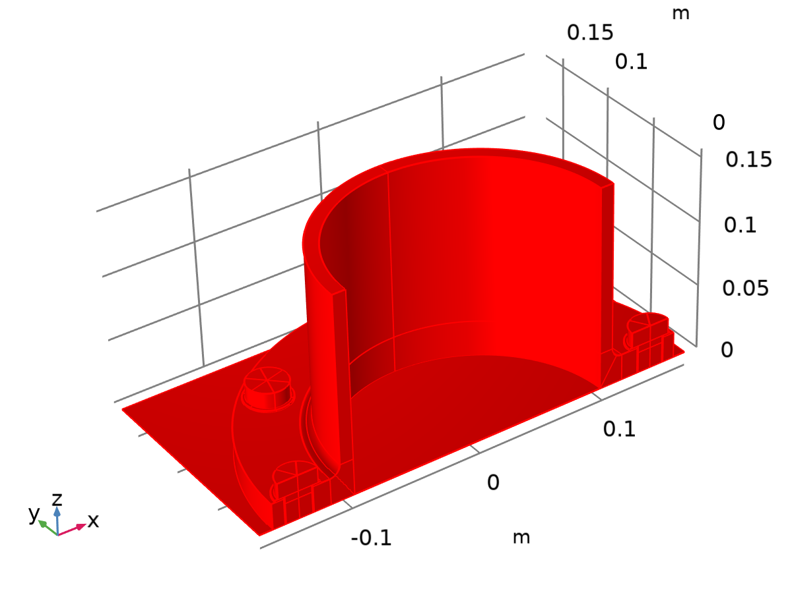

Dataset: Study 1/Solution 1

### Study 1/Solution Store 1

Solution

| **Description** | **Value** |
| --- | --- |
| Solution | Solution Store 1 (sol2) |
| Component | Component 1 (comp1) |



Dataset: Study 1/Solution Store 1

### Linearization Line (Stress Linearization 1)

Data

| **Description** | **Value** |
| --- | --- |
| Dataset | Study 1/Solution 1 (sol1) |

### Linearization Line (Stress Linearization 2)

Data

| **Description** | **Value** |
| --- | --- |
| Dataset | Study 1/Solution 1 (sol1) |

### Linearization Line (Stress Linearization 3)

Data

| **Description** | **Value** |
| --- | --- |
| Dataset | Study 1/Solution 1 (sol1) |

### Linearization Line (Stress Linearization 4)

Data

| **Description** | **Value** |
| --- | --- |
| Dataset | Study 1/Solution 1 (sol1) |

### Linearization Line (Stress Linearization 5)

Data

| **Description** | **Value** |
| --- | --- |
| Dataset | Study 1/Solution 1 (sol1) |

### Linearization Line (Stress Linearization 6)

Data

| **Description** | **Value** |
| --- | --- |
| Dataset | Study 1/Solution 1 (sol1) |

## Plot Groups

### Stress, Bolt Pretension

![[COMSOLlink[]]](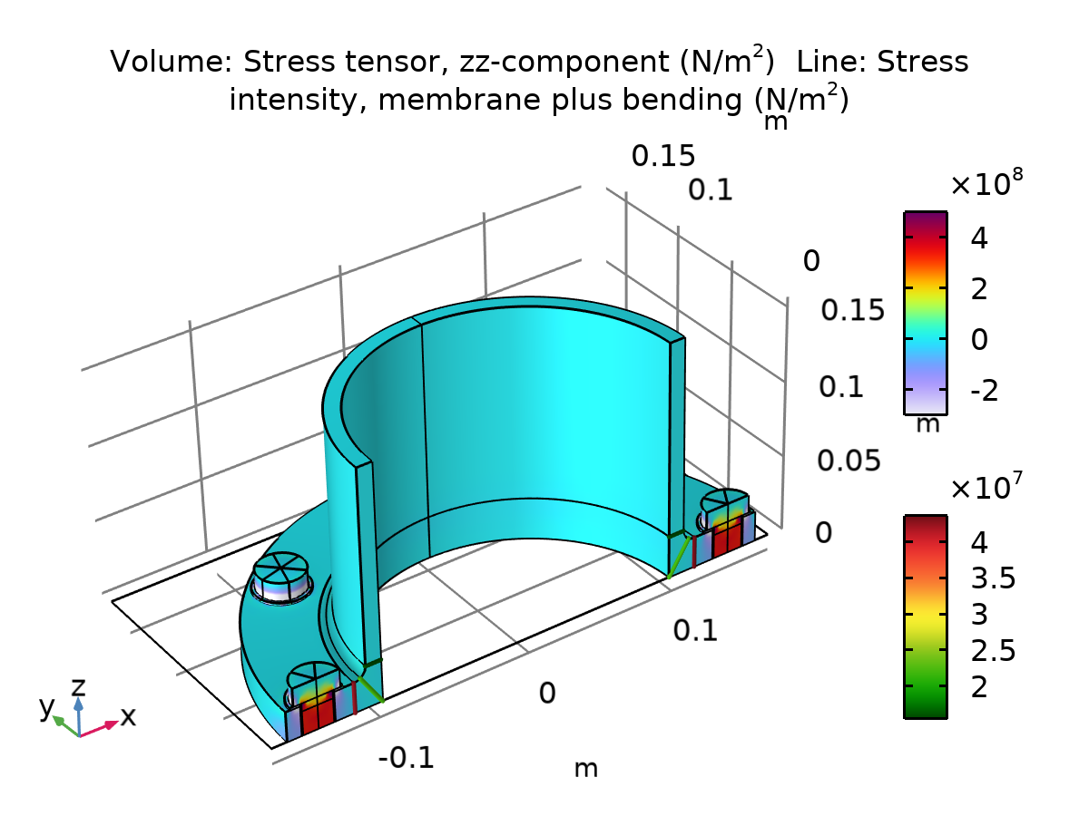)

Volume: Stress tensor, zz-component (N/m2) Line: Stress intensity, membrane plus bending (N/m2)

### Stress Linearization 1 (solid)

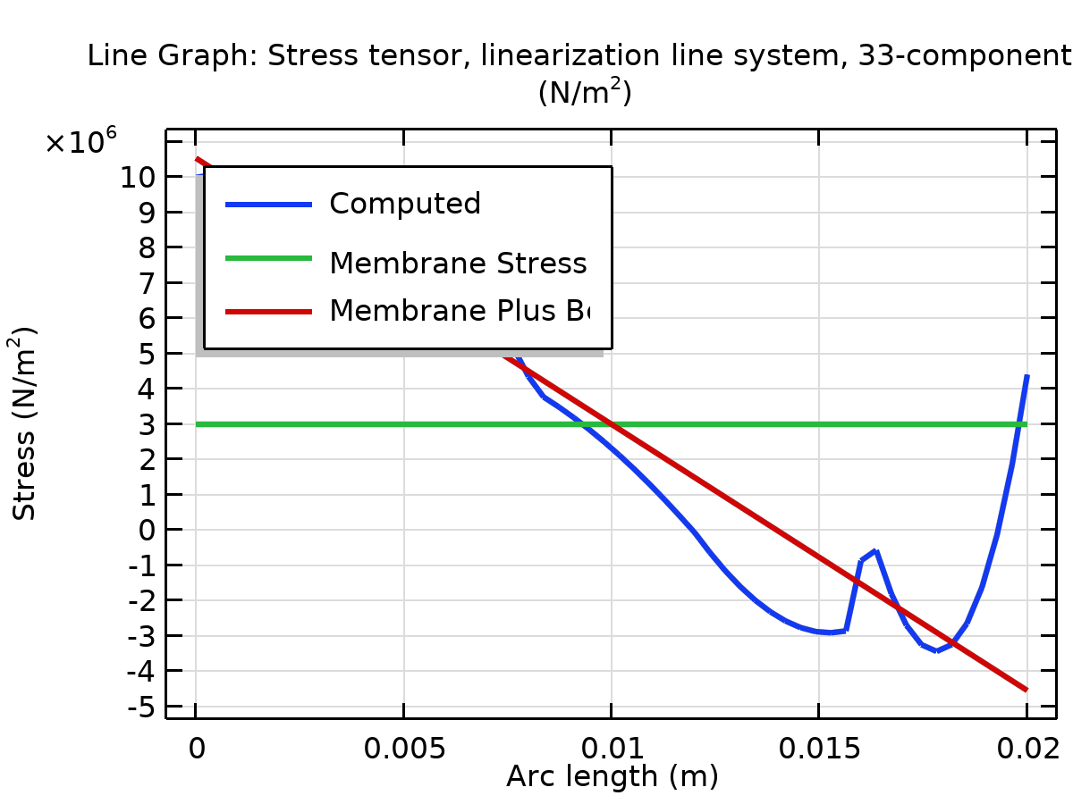

Line Graph: Stress tensor, linearization line system, 33-component (N/m2)

### Stress Linearization 2 (solid)

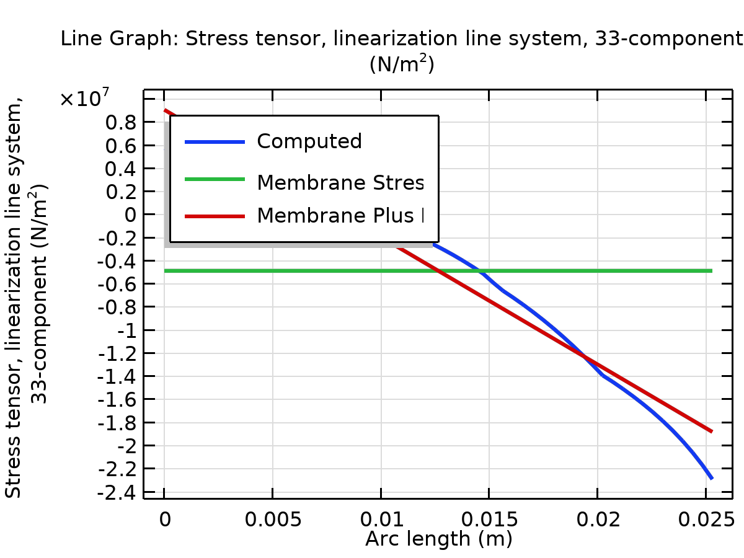

Line Graph: Stress tensor, linearization line system, 33-component (N/m2)

### Stress Linearization 3 (solid)

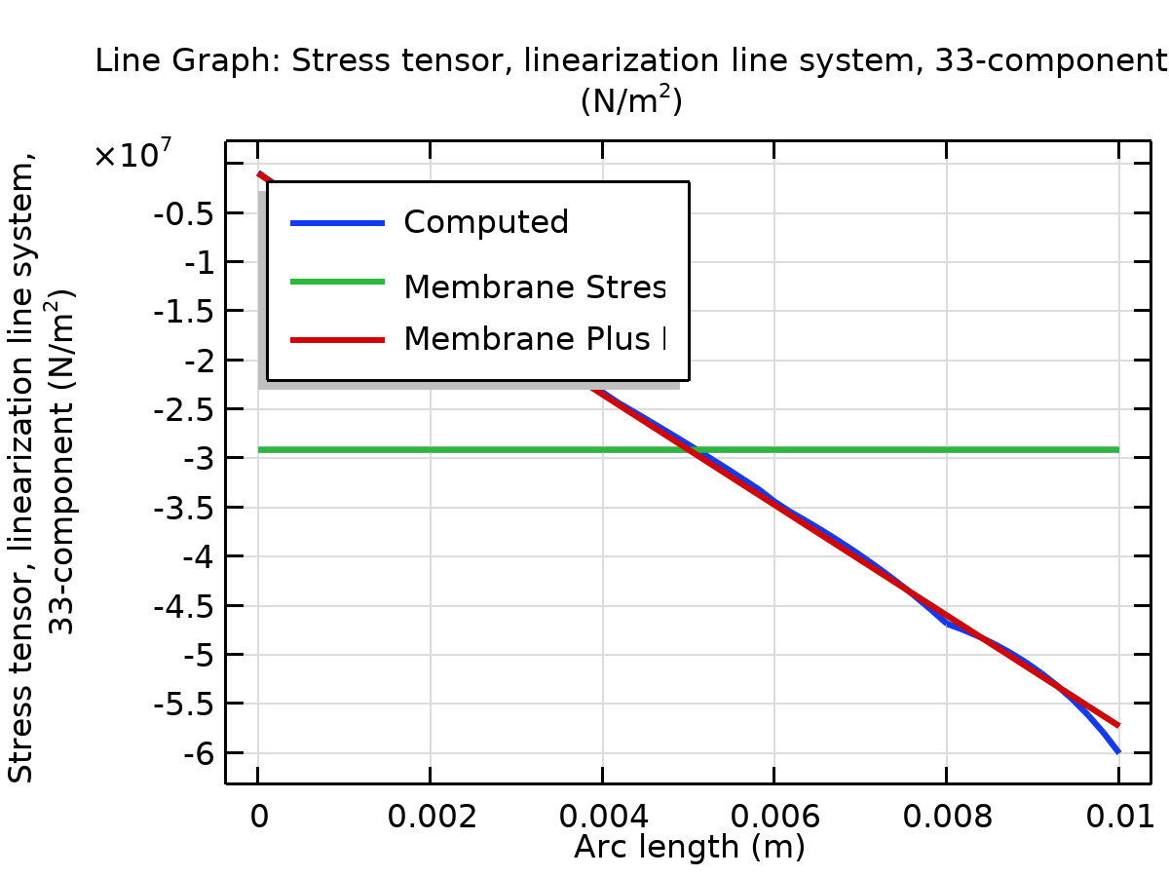

Line Graph: Stress tensor, linearization line system, 33-component (N/m2)

### Stress Linearization 4 (solid)

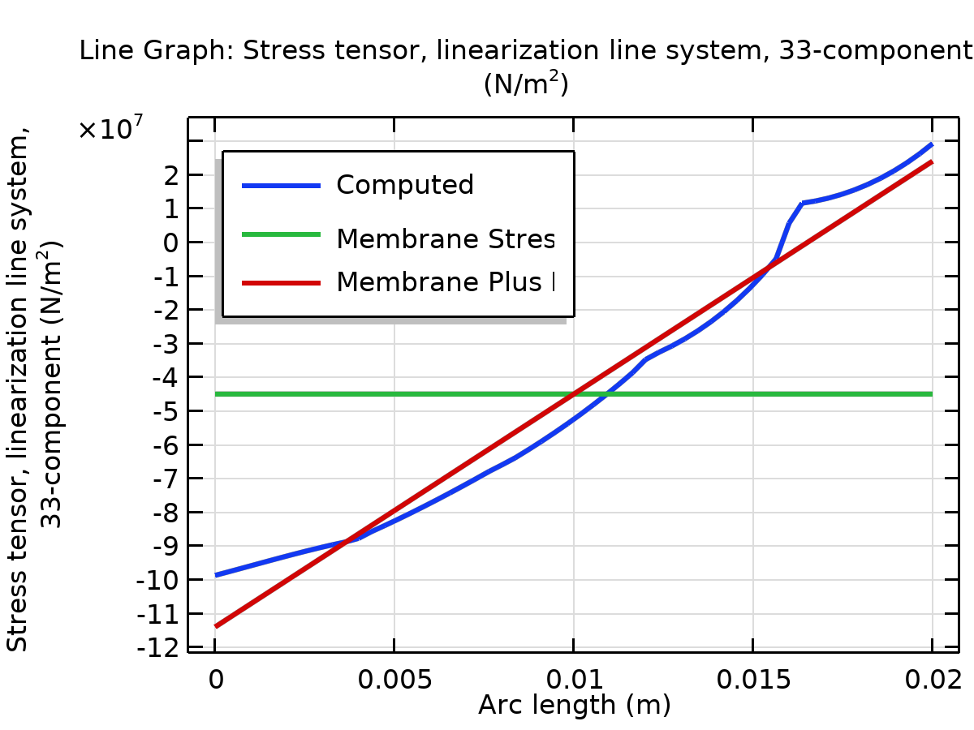

Line Graph: Stress tensor, linearization line system, 33-component (N/m2)

### Stress Linearization 5 (solid)

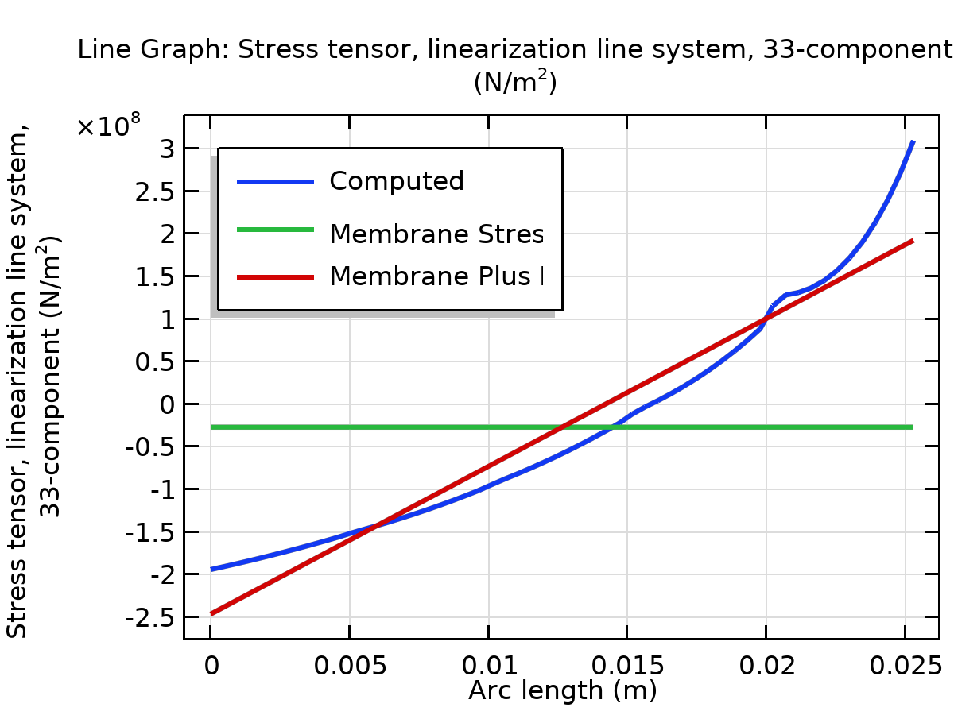

Line Graph: Stress tensor, linearization line system, 33-component (N/m2)

### Stress Linearization 6 (solid)

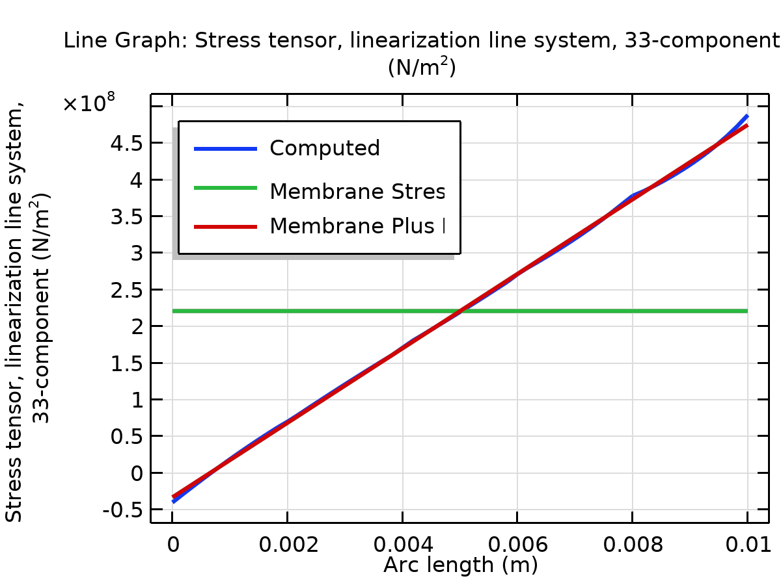

Line Graph: Stress tensor, linearization line system, 33-component (N/m2)

### Section Forces (secf1)

![[COMSOLlink[]]](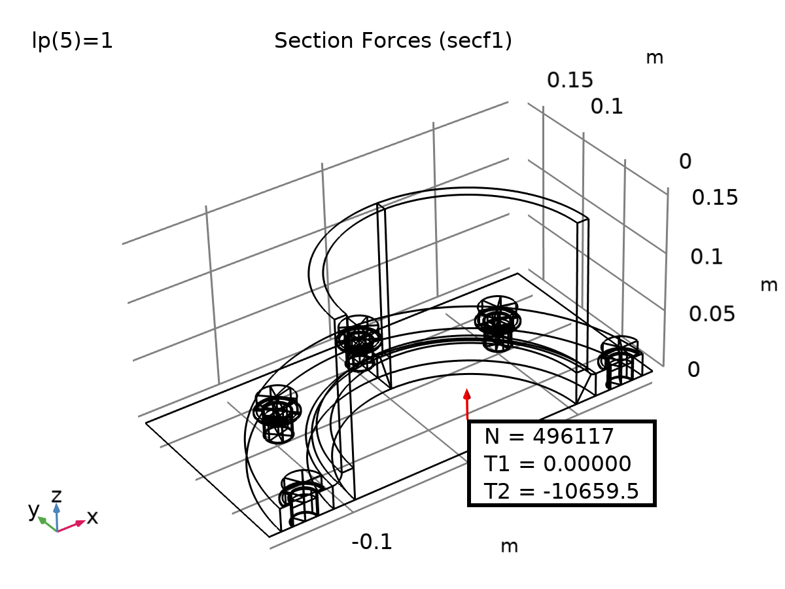)

Section Forces (secf1)

### Section Moments (secf1)

![[COMSOLlink[]]](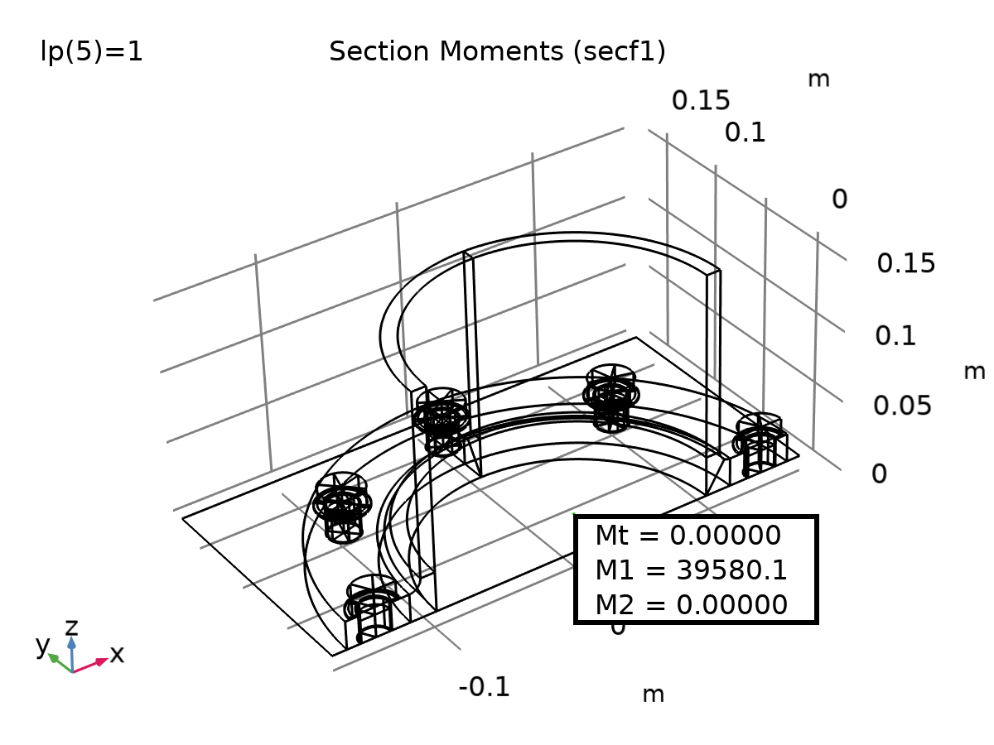)

Section Moments (secf1)

### Stress

![[COMSOLlink[]]](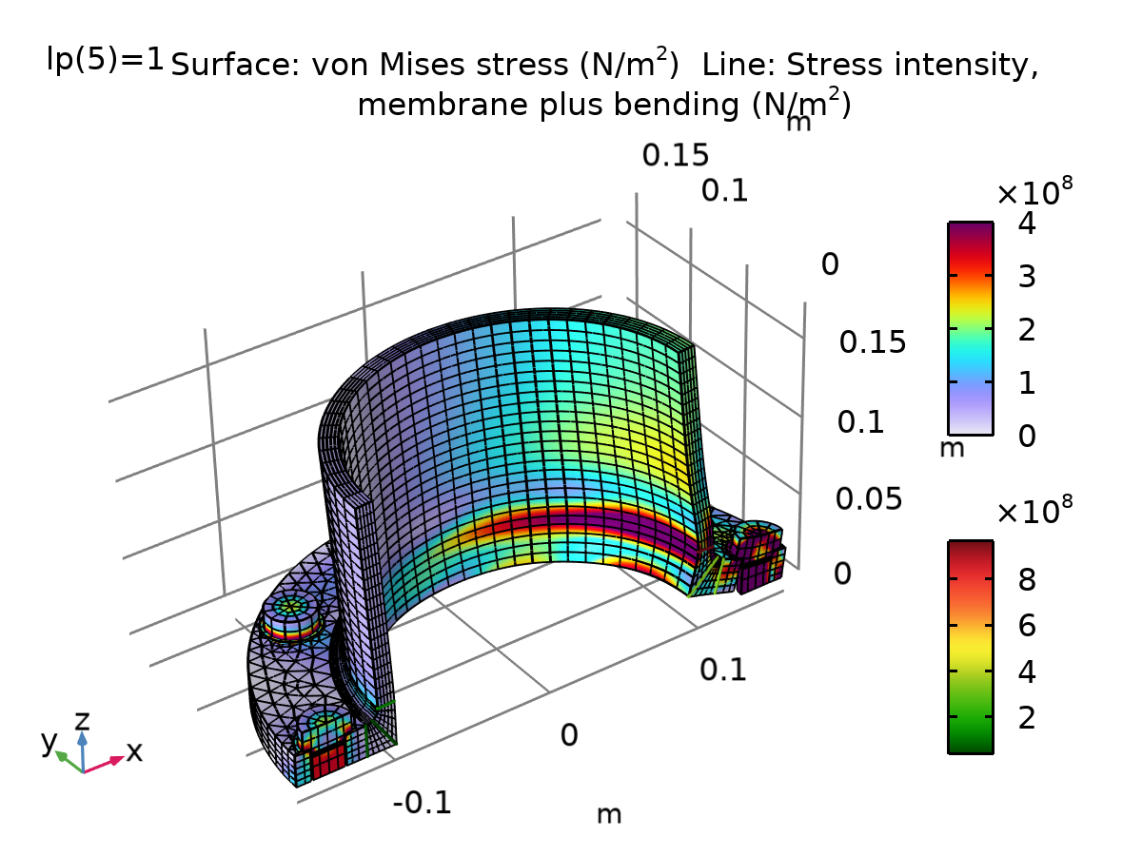)

Surface: von Mises stress (N/m2) Line: Stress intensity, membrane plus bending (N/m2)

### Bolt Force

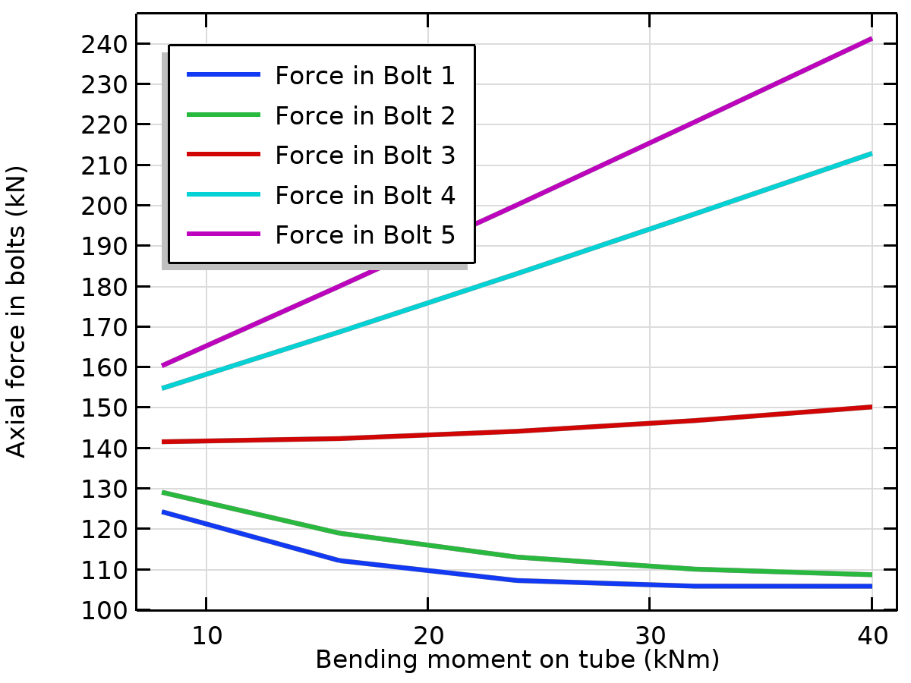

### Bolt Stress

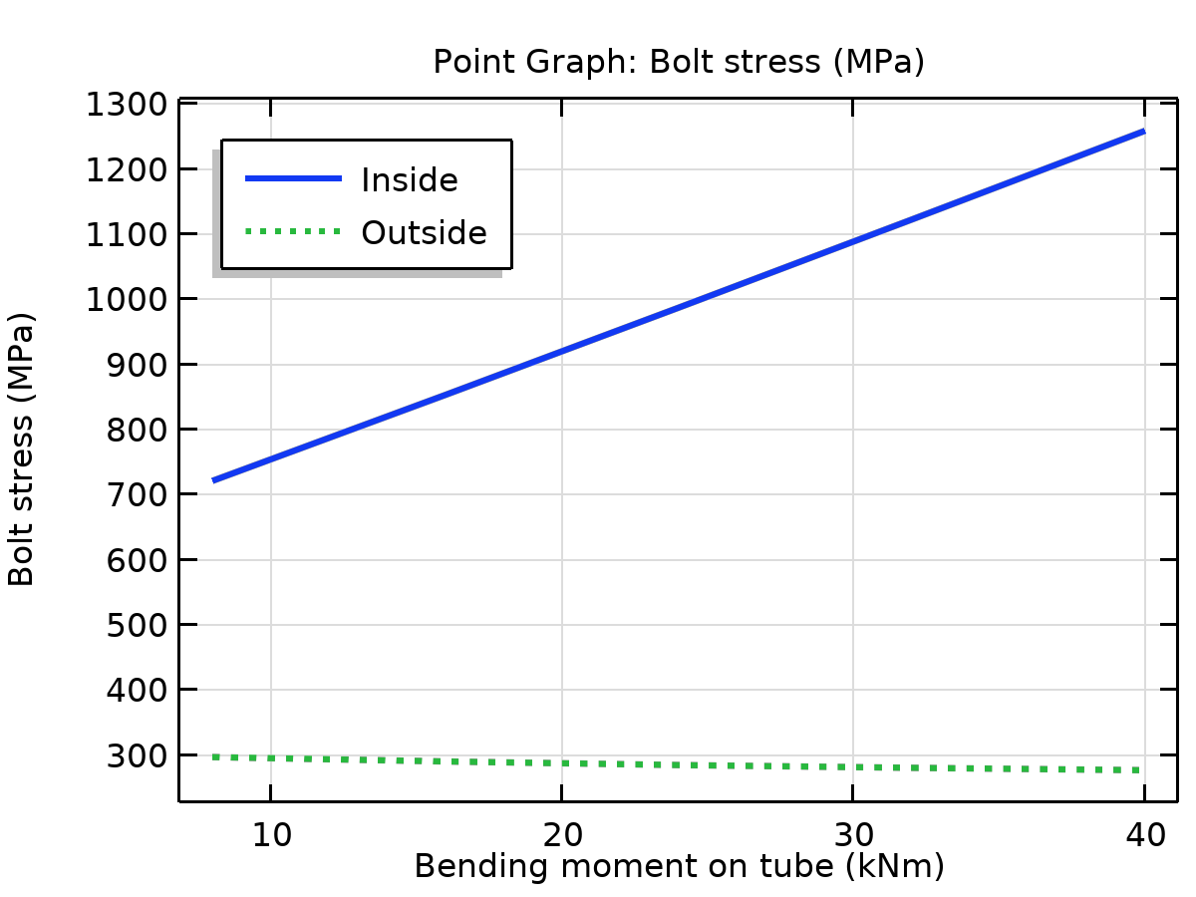

Point Graph: Bolt stress (MPa)

### Contact Pressure

![[COMSOLlink[]]](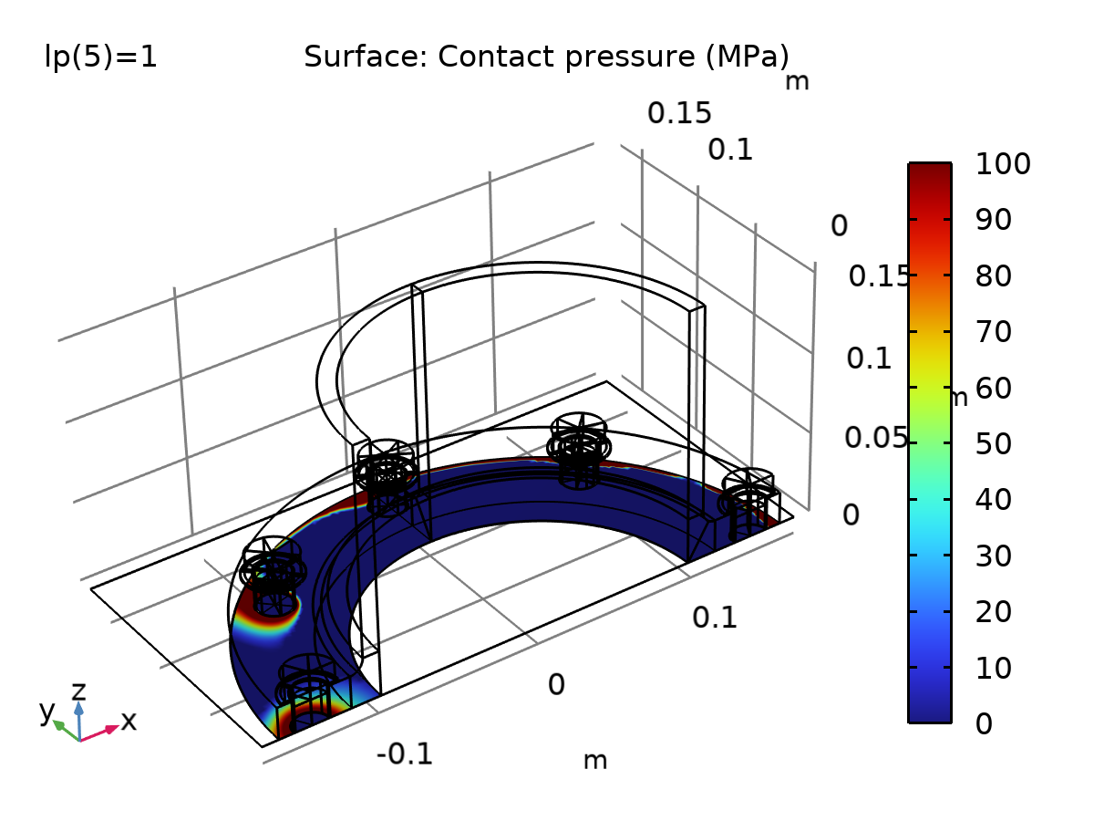)

Surface: Contact pressure (MPa)

### Boundary Loads (solid)

![[COMSOLlink[]]](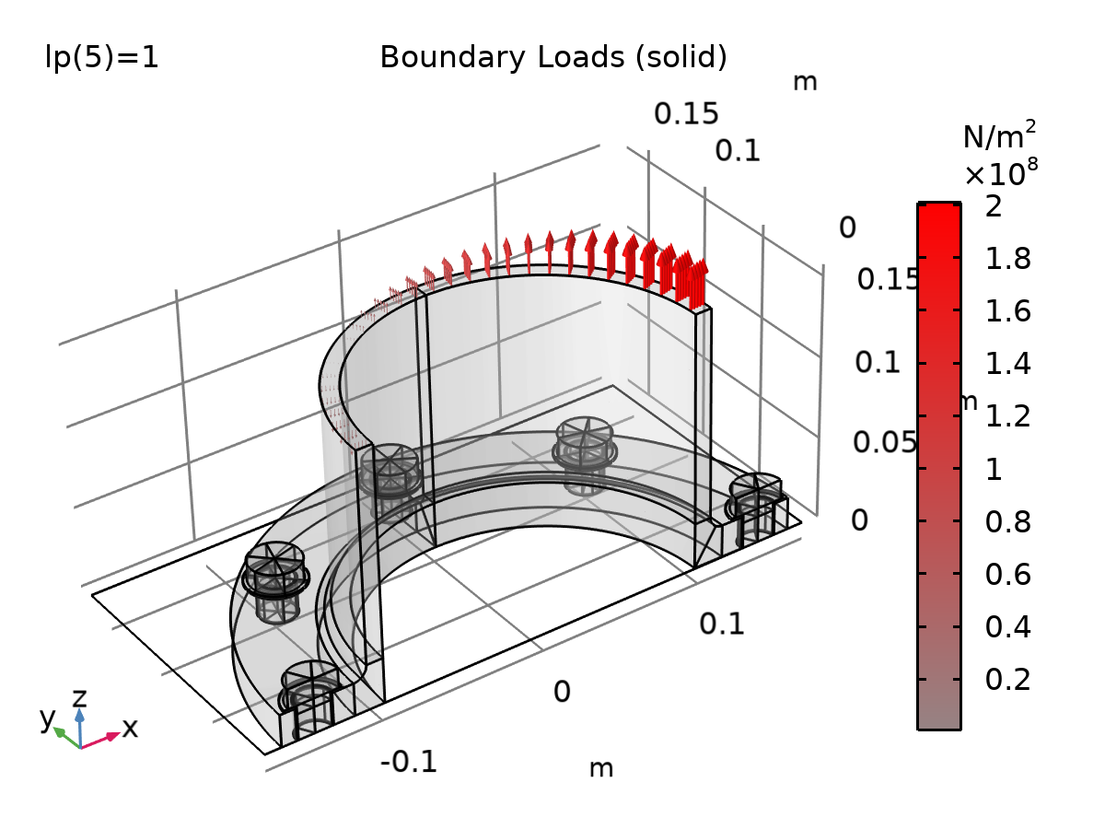)

Boundary Loads (solid)

### Displacement Plot

![[COMSOLlink[]]](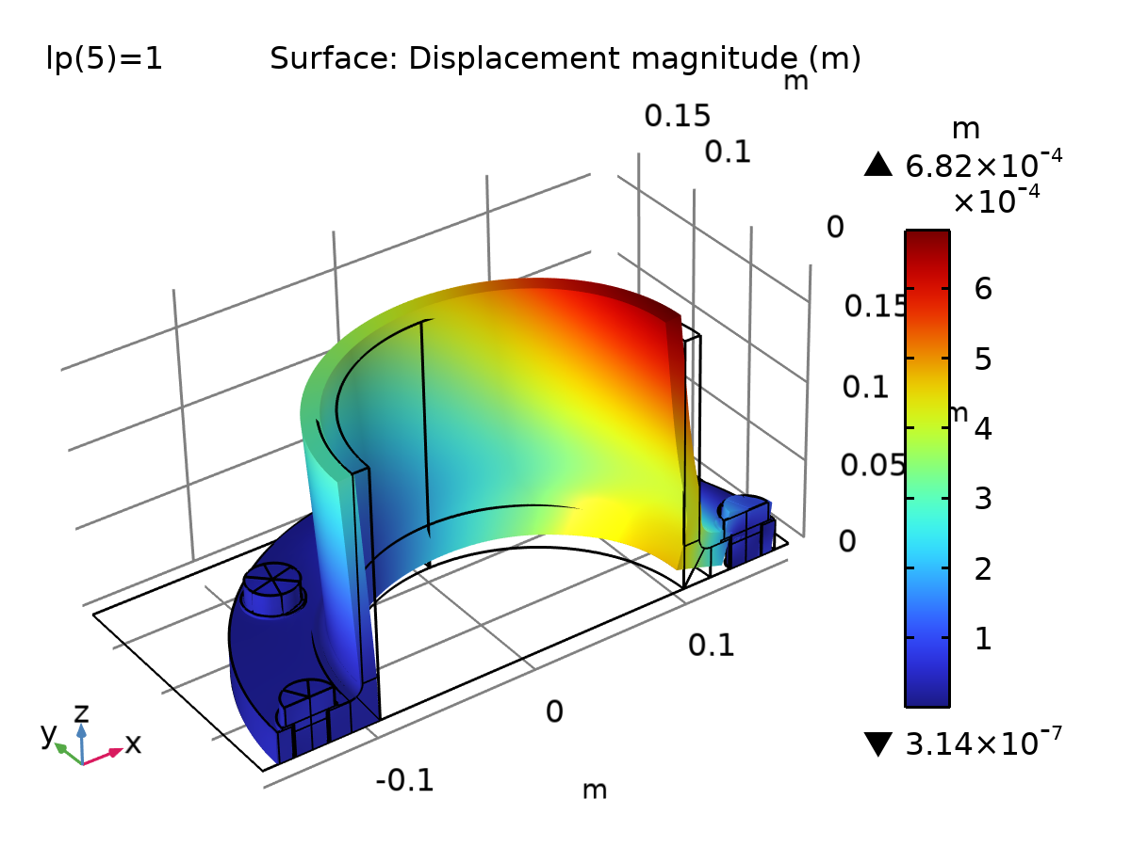)

Surface: Displacement magnitude (m)

## Evaluation Groups

### Bolt Forces: Bolt Pretension 1 (Study 1) (solid)

Data

| **Description** | **Value** |
| --- | --- |
| Dataset | Study 1/Solution 1 (sol1) |

Transformation

| **Description** | **Value** |
| --- | --- |
| Transpose | On |

Features

| **Feature** | **Column** |
| --- | --- |
| Bolt_1 |  |
| Bolt_2 |  |
| Bolt_3 |  |
| Bolt_4 |  |
| Bolt_5 |  |

Results

|  |  |  |  |  |
| --- | --- | --- | --- | --- |
| 0.2 | 0.4 | 0.6 | 0.8 | 1 |
| 1.5469E5 | 1.5178E5 | 1.4965E5 | 1.4815E5 | 1.4711E5 |
| 5.2296E-12 | 6.5938E-12 | 4.5475E-12 | 8.5265E-13 | 3.5811E-12 |
| 1.5564E5 | 1.5337E5 | 1.516E5 | 1.5021E5 | 1.4913E5 |
| 2.5166E-12 | 3.3233E-12 | 2.9999E-12 | 9.1855E-12 | 4.7043E-12 |
| 1.5848E5 | 1.5879E5 | 1.5928E5 | 1.5992E5 | 1.6068E5 |
| 1.0602E-11 | 1.8349E-12 | 1.2406E-11 | 3.867E-12 | 3.9464E-12 |
| 1.6197E5 | 1.6634E5 | 1.7126E5 | 1.7658E5 | 1.8216E5 |
| 7.714E-12 | 5.778E-12 | 9.0274E-12 | 8.3203E-12 | 6.0607E-12 |
| 1.636E5 | 1.7001E5 | 1.7718E5 | 1.8486E5 | 1.9292E5 |
| 7.6739E-12 | 1.0573E-11 | 4.5475E-13 | 6.8212E-13 | 5.9117E-12 |

#### Bolt_1

Expressions

| **Expression** | **Unit** | **Description** |
| --- | --- | --- |
| comp1.solid.pblt1.sblt1.F_bolt | N | Bolt force |
| comp1.solid.pblt1.sblt1.F_shear | N | Bolt shear force |

Expressions

| **Name** | **Value** | **Unit** | **Description** |
| --- | --- | --- | --- |
| solid.refpntx | 0 | m | Reference point for moment computation, x-coordinate |
| solid.refpnty | 0 | m | Reference point for moment computation, y-coordinate |
| solid.refpntz | 0 | m | Reference point for moment computation, z-coordinate |

#### Bolt_2

Expressions

| **Expression** | **Unit** | **Description** |
| --- | --- | --- |
| comp1.solid.pblt1.sblt2.F_bolt | N | Bolt force |
| comp1.solid.pblt1.sblt2.F_shear | N | Bolt shear force |

Expressions

| **Name** | **Value** | **Unit** | **Description** |
| --- | --- | --- | --- |
| solid.refpntx | 0 | m | Reference point for moment computation, x-coordinate |
| solid.refpnty | 0 | m | Reference point for moment computation, y-coordinate |
| solid.refpntz | 0 | m | Reference point for moment computation, z-coordinate |

#### Bolt_3

Expressions

| **Expression** | **Unit** | **Description** |
| --- | --- | --- |
| comp1.solid.pblt1.sblt3.F_bolt | N | Bolt force |
| comp1.solid.pblt1.sblt3.F_shear | N | Bolt shear force |

Expressions

| **Name** | **Value** | **Unit** | **Description** |
| --- | --- | --- | --- |
| solid.refpntx | 0 | m | Reference point for moment computation, x-coordinate |
| solid.refpnty | 0 | m | Reference point for moment computation, y-coordinate |
| solid.refpntz | 0 | m | Reference point for moment computation, z-coordinate |

#### Bolt_4

Expressions

| **Expression** | **Unit** | **Description** |
| --- | --- | --- |
| comp1.solid.pblt1.sblt4.F_bolt | N | Bolt force |
| comp1.solid.pblt1.sblt4.F_shear | N | Bolt shear force |

Expressions

| **Name** | **Value** | **Unit** | **Description** |
| --- | --- | --- | --- |
| solid.refpntx | 0 | m | Reference point for moment computation, x-coordinate |
| solid.refpnty | 0 | m | Reference point for moment computation, y-coordinate |
| solid.refpntz | 0 | m | Reference point for moment computation, z-coordinate |

#### Bolt_5

Expressions

| **Expression** | **Unit** | **Description** |
| --- | --- | --- |
| comp1.solid.pblt1.sblt5.F_bolt | N | Bolt force |
| comp1.solid.pblt1.sblt5.F_shear | N | Bolt shear force |

Expressions

| **Name** | **Value** | **Unit** | **Description** |
| --- | --- | --- | --- |
| solid.refpntx | 0 | m | Reference point for moment computation, x-coordinate |
| solid.refpnty | 0 | m | Reference point for moment computation, y-coordinate |
| solid.refpntz | 0 | m | Reference point for moment computation, z-coordinate |

### Section Forces (secf1)

Data

| **Description** | **Value** |
| --- | --- |
| Dataset | Study 1/Solution 1 (sol1) |

Transformation

| **Description** | **Value** |
| --- | --- |
| Transpose | On |

Features

| **Feature** | **Column** |
| --- | --- |
| Section Forces |  |

Results

|  |  |  |  |  |
| --- | --- | --- | --- | --- |
| 0.2 | 0.4 | 0.6 | 0.8 | 1 |
| 5.0044E5 | 5.0044E5 | 5.0043E5 | 5.0043E5 | 5.0041E5 |
| 0 | 0 | 0 | 0 | 0 |
| -1368.6 | -2705.5 | -4025.5 | -5323.2 | -6594.6 |
| 0 | 0 | 0 | 0 | 0 |
| 8018.9 | 16037 | 24053 | 32068 | 40081 |
| 0 | 0 | 0 | 0 | 0 |

#### Section Forces

Expressions

| **Expression** | **Unit** | **Description** |
| --- | --- | --- |
| solid.secf1.N | N | Axial force |
| solid.secf1.T1 | N | Shear force along 1-axis |
| solid.secf1.T2 | N | Shear force along 2-axis |
| solid.secf1.Mt | N*m | Twisting moment |
| solid.secf1.M1 | N*m | Bending moment around 1-axis |
| solid.secf1.M2 | N*m | Bending moment around 2-axis |

Expressions

| **Name** | **Value** | **Unit** | **Description** |
| --- | --- | --- | --- |
| solid.refpntx | 0 | m | Reference point for moment computation, x-coordinate |
| solid.refpnty | 0 | m | Reference point for moment computation, y-coordinate |
| solid.refpntz | 0 | m | Reference point for moment computation, z-coordinate |